

NEWSWHEEL

Newsletter for Thanet`s Premier Cycling Club
Affiliated to: British Cycling; CTT;KCA;CTC
www.thanetrc.org
March 2017

Sick List
Pete Haswell one of our senior members has an achilles tendon problem and will be out of action for several weeks. We wish him all the best for a complete recovery. Peter Huckstep is still not back in action, we`re hoping he will not be out for much longer.

News
We welcome back to the Club Emma Davis after several years absence to raise a family. We hope that her association with us will be a long and happy one.

There are still some members whose subs are outstanding, please settle up as soon as you can or, if not intending to rejoin, please inform any Committee member.
You can now pay on line via the club website, if you can renew this way it will be much appreciated as it makes things so much easier for the Treasurer. Log into the website and follow the link or alternatively send to
Dave Mastin at:- 399, Margate Road, Ramsgate, CT12 6SE.
Thank you for your co-operation.

Commissaires
There is still an acute shortage of commissaires in Kent. British Cycling South East will be running a Road Trainee Commissaires course on the 1st April this year. Without sufficient Commissaires the desired level of road racing in the South East cannot be sustained.
If you are interested in taking on this important task please contact Simon Bedford for information. simonbedford@britishcycling.org.uk or 07940 302253.

For those competing in Open TTs.

Attention Riders - an important reminder about a new regulation in force for the 2017 season:

Please be aware of the new CTT Regulation 17(b):

For 2017 all competitors in open (Type A) events will be required to return to the event HQ, hand in their number(s) and SIGN OUT.

A competitor MUST sign out him/herself. It is not permissible for another person to sign out on behalf of the competitor.

Failure to do will result in the competitor being recorded as DNF.

This regulation was passed at the CTT AGM (National Council) in December 2016 and was put in place so event organisers can ensure that all riders have returned safely and to ensure riders are available (should they be needed) for the doping control if one is in place at the event.

Racing Results Open Events (TRC Riders)

Saturday 4th February Whites Transport MTB Event Round 3

U8 U10 U12
Thorsten Cook 1 Lughaidh Cook 1 Charlie Hart 1
Grace Philpott 1st Girl Max Robinson 2 Freya Cook 2 1st Girl
Dexter Kirkness 2 Alex Dack 3 Stanley Rose 3
Millie Dack 1st Girl
Ilana Lord joint 1st Girl

U14 U16 Junior
Toby Yemm 1 Robbie Whyte (Woolwich) 1 Charlie Burgess 1
Luke Hill 2

Senior V1 V2
Dan James (NC) 1 Jez Dack 1 Richard McVey 1
Tim Yemm 2 Jo Malpass 2
Mike Kirkness 3

V3
Ian Pettitt (Deal Tri) 1

Lee Valley Winter Road series round 2 attracts 8 TRC riders.
Again very much a story of mixed fortunes for the 8 Thanet RC riders that travelled up to Redbridge (Hog Hill) today for the Lee Valley youth winter series round 2. The racing attracted a very large list of entries in the youth and junior races. Weather had been very wet and this always causes puncture problems at HH. In all 3 races there were a total of 32 punctures in total !! Lucky they brought back the lap out rule before 4 laps to go!! The first race was the under 14s. Jack Hill had a mechanical on the first time up the Hoggenberg climb and found it hard to get back in the race but fought very hard. Flynn stayed in the main group for 3 laps before losing touch for 18th. Lance Childs rode a very strong race staying with the leading group until the sprint finish up the hill to come in 12th even better as he rode with a flat tyre on the last lap! In the Under 16 race Josh Chivilo luck again was lacking as when in with the leaders suffered a puncture on the furthest position from the pits and was never able to get back in the bunch. George Pittock continued his good form with 8th place of 30ish riders to gain BC points. In the junior race we had half the junior race team out with George Bussey starting his first junior race and riding strongly before again getting the dreaded puncture. Alex Ashman again punctured late on to take a creditable mid placing. Ollie Robinson was another puncture sufferer on the 2nd lap just as a break of 2 went. He took a lap out to change wheel and then rode extremely strongly for a fine 3rd in field of 25ish. Well done everyone on a tough HH day.

George & Lance perform well at LYTL
George Pittock and Lance Childs both enjoyed success at the latest round of the London Youth Track League (LYTL) at the Lee Valley Velodrome on Thursday 9th February, This was the special events night and featured Keirin, Longest lap and even Madison for the Group 1 boys and older girls.
The two Thanet RC riders were closely matched in the 24 lap (6km) Scratch race with George finishing in 5th place and Lance in 7th.
They were unfortunately drawn together in the keirin heats. George rode his best race so far at LYTL and won the heat, with Lance contesting the sprint for 2nd but missed out to finish 4th.
The longest lap is an unusual event which involves the riders slowly riding one lap of the velodrome before track-standing at the start line waiting for the starter’s gun to fire. Riders try to maintain their composure and stay in their track stand until the gun fires, then it’s a one lap sprint to the finish line. Lance usually one of the best at track-standing, was on this occasion eliminated before the sprint while George did not start the event.
The final event was the 40 lap (10km) points race, Lance won the 2nd intermediate sprint and was delighted to see his name on the big screen, George scored points in all 4 of the sprints to finish in 3rd place overall with 8 points, with Lance in 5th place overall with 6 points.
Just two of the 10 events remaining, both George and Lance are solidly placed in the middle of the Group 2 leader board. Both riders have improved their track riding this season and as Lance has one more year in U14 he hopes to place well in the national/regional track races this year, George has a tougher prospect of performing well as a first year U16 at these events. Well done and good luck for future events as they help Thanet RC get a name for itself on the track, amongst predominantly track racing clubs.
Full results can be found here:- http://www.lytl.co.uk/race-dates—results.html

Saturday 11th February Full Gas Winter Series Lee Valley Velo Park
E,1,2,3:1 Road Race
Ollie Robinson 1st.

Sunday 12th February Ely and District CC Hardriders 25 Little Downham
Seb Dickson 57.41 (2nd place). Winner was Felix Barker (Cambridge University CC) 56.27.

Great rides, well done lads.
Saturday 25th February Whites Transport MTB Event Round 4
U8 U10 U12
Thorsten Cook 1 Lughaidh Cook 1 Luke Gibson CCCP 1
Grace Philpott 2 (1st Girl) Max Robinson 2 Charlie Hart 2
Dexter Kirkness 3= Luke Hart 3 Freya Cook 3 (1st Girl)
Dawson Kirkness 3= Thomas Crow-Brown 4= Stanley Rose 4
Ilana Lord 4= (1sr Girl) Shannon Neame 5
Millie Dack 6

U14 U16 V1
Jack Hill 1 Robbie Whyte Woolwich CC 1 Steve Gibson CCCP 1
Toby Yemm 2 Luke Hill 2 Mark Palmer 2
Louis Bennett 3 Phil Cook 4
Jez Dack 5
V2 V3 Women
Richard McVey 1 Dave Mastin 1 Alison Stagg Deal Tri 1

Junior Kuurne-Brussels-Kuurne UCI 1.1 Road Race Sunday 26th February

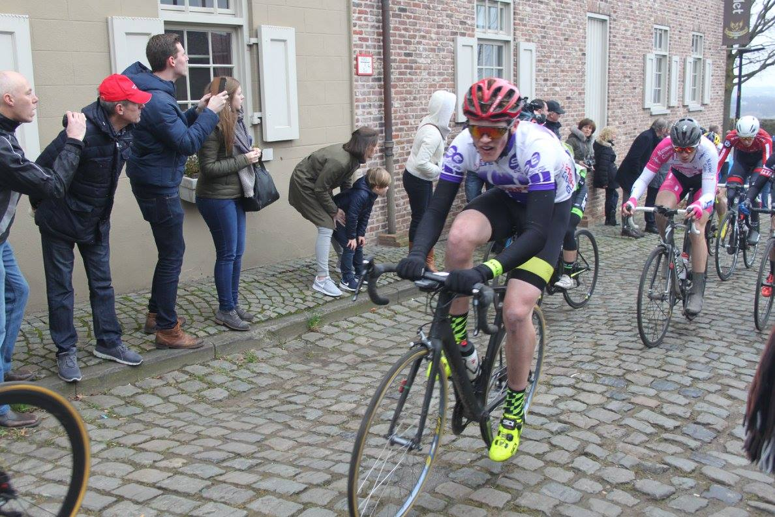
Ollie Robinson in action having a great ride for the South East Cycling Team, but unfortunately got caught behind a crash necessitating a long chase, eventually finished in the front group 52nd place out of 160 starters. 80 riders did not finish. Well done Ollie in this tough event.
The winner was Johan Tiedemann Langballe of the Danish Team Herning CK Juniors.
See Ollie`s blog on Facebook for a full account of how it went.

Forthcoming Open Events
Sunday 5th March KCA 3-up 25 Q25/12 (Hamstreet Bypass)
Sunday 19th March VTTA 30 Q30/2 (Hamstreet Bypass)
Saturday 25th March VTTA 10 Q10/22 (Harrietsham)
Sunday 2nd April KCA 25 Q25/8 (Chilham)
Saturday 8th April West Kent RC 10 Q10/22 (Harrietsham)
Sunday 9th April Sydenham Wheelers 25 Q25/20 (Harrietsham)

Event Marshalling (KCA Events)
Please note Thanet RC still need to provide Marshalls for the KCA events - The ones left are the 100 on Sunday 11 June and the 12 Hour on Sunday 25 June.
Please let me know if you can assist.
michael.friend@uk.verizon.com The KCA gives remuneration to all helpers.

Please note that if sufficient marshals are not available the event cannot take place. It`s your sport.

Dates for your Diary

TRC Social Evening
Tuesday 7 March 7.30-9.30 Bell Meadow, St Nicholas-at-Wade
QUIZ NIGHT!
Back by popular demand! This month is The Spring Classics Quiz set by Ollie Robinson, just back from an impressive ride in the Kuurne-Brussel-Kuurne Junior Race, and co-quiz master Richard Bazin.
Rick will also be there with the club 70th jerseys for those who have not collected their orders yet.

Eastbourne Weekend
This is now confirmed for the weekend 25th/26th March.
The cost of the hotel will be £56 per person per night and half price for children under the age of 12 (£28). This includes arrival refreshments, storage of bikes, an evening meal and Bed and Breakfast.
For the booking confirmation, the hotel requires a £20 deposit per room. Any twin or double room being used for single occupancy will result in a surcharge of £15 - I don't think there are any single rooms but will check. There are twin, doubles, triple and family.
Please get your deposit to Helen Hill as soon as possible helen.c.hill19@gmail.com or 07811976762.

TRC Turbo training – MANSTON VILLAGE HALL
Turbo training sessions continue on Thursdays 18:00 for 18:15 start, finish by 1930
Cyclists from other clubs are more than welcome to attend
Manston Village Hall – Preston Road, Manston. CT12 5BA.
There is parking directly outside the hall or in Preston Road.
We are not professional coaches – just offering our advice and encouragement at the session.
The sessions will help you to maintain fitness over the winter and can be good preparation for the 2017 time trial calendar

 | 2017 Go-Ride Calendar
Day | Date | Time | Venue | Event
Sat | 11th March 2017 | 14:00-15:30 | Pfizer Discovery Park | Road and MTB coaching
Sat | 18th March 2017 | 14:00-15:30 | Betteshanger Country Park | Ride out or off road coaching
Sat | 25th March 2017 | 14:00-15:30 | Pfizer Discovery Park | Road and MTB coaching
Sat | 1st April 2017 | NO SESSION RACES ON Sunday APRIL 2nd
Sun | 2nd April 2017 | 11:00-17:00 | Betteshanger Country Park (Road) | TRC/SPC Circuit road racing events
Sat | 8th April 2017 | 14.30-16:00 | Broomfield BMX | MTB and BMX coaching or ride out
Sat | 15th April 2017 | NO SESSION EASTER HOLIDAYS
Sat | 22th April 2017 | 14.30-16:00 | Betteshanger Country Park | Road circuit booked
Sat | 29th April 2017 | 14.30-16:00 | Betteshanger Country Park | Ride out or off road coaching
Sat | 6th May 2017 | 10:30-13:00 | Betteshanger Country Park (Road) | Thanet RC / Ovenden (Tour de Betteshanger)
Sat | 13th May 2017 | 14.30-16:00 | Betteshanger Country Park | Ride out or off road coaching
Sat | 20th May 2017 | 11:00-16:00 | St Nicholas at Wade-Bell Meadow | TRC / Locks Cycles Grasstrack events
Sat | 27th May 2017 | 14.30-16:00 | Betteshanger Country Park | Road circuit booked
Sat | 3rd June 2017 | 14.30-16:00 | Betteshanger Country Park | Ride out or off road coaching
Sat | 10th June 2017 | NO SESSION THANET RC OPEN 10 MILE TT
Sat | 17th June 2017 | 14.30-16:00 | Betteshanger Country Park | Ride out or off road coaching
Mon | 19th June 2017 | 18:00-20:00 | Betteshanger Country Park (Road) | Thanet RC White's Transport Summer Series 1
Sat | 24th June 2017 | 14.30-16:00 | Betteshanger Country Park | Ride out or off road coaching
Mon | 26th June 2017 | 18:00-20:00 | Betteshanger Country Park (Road) | Thanet RC White's Transport Summer Series 2
Sat | 1st July 2017 | 14.30-16:00 | Broomfield BMX | MTB and BMX coaching or ride out
Mon | 3rd July 2017 | 18:00-20:00 | Betteshanger Country Park (Road) | Thanet RC White's Transport Summer Series 3
Sat | 8th July 2017 | GHS SE TIME TRIAL AND KCA 10 MILE TT
Mon | 10th July 2017 | 18:00-20:00 | Betteshanger Country Park (Road) | Thanet RC White's Transport Summer Series 4
Sat | 15th July 2017 | 10:30-13:00 | Betteshanger Country Park (Road) | Thanet RC / Ovenden (Tour de Betteshanger)
Mon | 17th July 2017 | 18:00-20:00 | Betteshanger Country Park (Road) | Thanet RC White's Transport Summer Series 5
Mon | 24th July 2017 | 18:00-20:00 | Betteshanger Country Park (Road) | Thanet RC White's Transport Summer Series 6
Mon | 31th July 2017 | 18:00-20:00 | Betteshanger Country Park (Road) | Thanet RC White's Transport Summer Series 7
SESSIONS RESUME AGAIN IN SEPTEMBER 2017

Go- Ride Non Time Trial Race Dates 2017

Club Clothing
Robert Sissons is now looking after the club clothing. Contact him by email sissons349@btinternet.com or mobile 07704943605
Many thanks to Robert for taking this on.

Articles Wanted

TRC Anniversary Year
It is the club’s 70th anniversary. Documentaries, historic accounts, photos and lots more can be found at our dedicated anniversary page: www.thanetrc.org/70th
New Flickr albums
- Ernie Abdellah’s (Abby) first TRC scrapbook 1947-59. The glorious early days of TRC.
- The Nev’ Hodges Archive. Wilfred Neville Hodges (1917-2002) was a TRC founding member.
- Alice Haller and her late husband Gordon’s 1996 two-wheeled Pilgrimage to Santiago de Compostela.
- Morris Crow, veteran racer, at home in 2016.
Help is required- tasks are varied and interesting, some only requiring a half day of time. Please get involved. Contact: davealexrob@yahoo.com

TRC 70th Anniversary Photo Competition
Members are invited to submit (a) digital photo(s) showing club life in 2017
- Entries between Jan 1 and 18 October 2017
- JPEG format
- Entries to David Robert, club Heritage Officer, davealexrob@yahoo.com
- Limited to up to 3 entries per person
- Photos to include following info: Who, when, where, what?
- Entrants must include name/phone number/email and age if under 18
- Prizes for adults and under 18s
- Ongoing exhibition of entries can be viewed at Flickr Gallery online www.thanetrc.org/70th
- Plans to display the winners

A light-hearted look at cycling in the UK through the lens of the movie camera. Old cinema adds; pearls of wisdom from the government’s Central Office of Information; the heyday of Herne Hill and more.
Charming, quirky and informative- not to be missed!
And from the Trophy Cabinet…
For our 2017 anniversary, we share the stories behind our memorial trophies. Find out about more trophies at www.thanetrc.org/trophy-winners.shtml
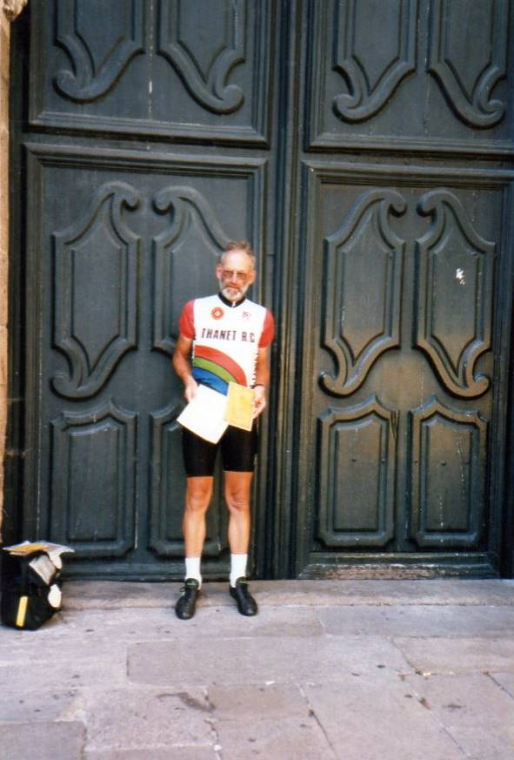
The Gordon Haller Inter-Club Team Memorial Shield: Awarded to the club with the fastest aggregate time of five riders in the inter-club 10-mile evening event held on the third evening in June. 2016 winners: Colin Robinson, Josh Chivilo, Oliver Dickson, Martin Russell and Brian Hood.
Gordon was born 27 May 1936 in Kempton, Devon. He and his wife Alice moved to Canterbury from Newbury (Gordon then riding with Newbury RC) in September 1971 for his work as a manager with British Telecom. Responding to an ad in Cyclist Magazine, Gordon immediately joined the Thanet RC winter training programme run by Jim Braginton.
He was a prolific time trialist and club racer. He also held various posts on the committee, including club secretary, treasurer and event secretary. Gordon and Alice were very keen cyclist tourers, taking the family on various journeys to France and beyond.
Gordon passed away on 28 June 2000.
The Photo shows Gordon completing Santiago de Compostela in 1996, standing at The Goldsmiths' Doorway of the Cathedral.
Discounts currently available to Club Members
Michael Kelleher MIRMT-IIST a Professional Therapist, is a club member.
He would like to offer any club members who may require help, the following treatments:-
Sports Injuries
Remedial Back Therapy
Swedish Holistic Massage
Aromatherapy
Indian Head Massage
Courses of Instruction are also available in any of the above.
Club members requiring treatment will receive, on production of proof of membership, a discount of 25% on the current fee of £40 per session.
Contact Michael on 01227 771493 Mob 07879861618, email backtherapist@yahoo.co.uk
Website:- www.michaelsmassagetherapy.co.uk

Locks of Sandwich : 10% on selected items
St Peter’s Cycles, Broadstairs: 10% on selected items
Bike Warehouse, Herne Bay, Faversham, Gillingham, Sevenoaks: 10% on selected items
Black Cat Coaching- special rates offered
Please also note anyone who arrives at Stonelees Golf Centre on a bike/walking/public transport gets free golf club hire

Ian Edginton, a former member of the club, has started his own cycle maintenance and repair business from his home at Staple near Wingham and welcomes your custom. All types of repair including wheel building are available. Contact Ian at ian.edginton123@btinternet.com or 07786425829. Ian`s father Alf, is also a very long standing and respected member of the Club

Club member Martin Hendy has his own Landscaping and Gardening business and is offering free estimates and discounted rates for Club members.
This looks like a good opportunity to get out on your bike while Martin does the garden.
Garden maintenance & fencing works
Tel 01227 368373
Mob 07958 709736
Email m.hendylandscapes@talktalk.net

Ovenden Skips 5% discount off Ovenden Skips, our Go-Ride Tour Series sponsors.

FOR SALE

Dan Martin’s Planet X Stealth Carbon White TT frame. Size 56 large. Zeus Bladed. Carbon forks. Seatpin. Headset and dual pivot brakes. All excellent condition. £200

Surosa Winter Bike (same frame as Dolan Preffisio). Blue. Size 58. Seat tube. 57 Top tube. Listed as a 58, but more like a 56. Mudguard eyes.
Campag Xenn and Mirage groupset. Campag Khamsin wheels. Aluminium frame. Alpina carbon forks. Little used. All excellent condition.
£250

Please contact Lawrence Martin on 01227 762981.

Monthly Quiz
Well done to David Robert who once again came up first with the correct answer which was the Puy de Dome in the Auvergne just outside Clermont Ferrand.

This Month`s Question:-

Born in Butte, Montana in 1973.
Moved to Belgium in 1995 and won the Tour of Namur.
In 1996 received a 3 month suspension for doping violations whilst still an amateur.
Turned pro in 1997 with Colorado Cyclist Team.
Subsequently rode with US Postal, Rabobank, Gerolsteiner, Discovery, Astana, Radio Shack and Omega Pharma Quickstep.
All his racing results from 1999 to 2007 were voided for persistent doping violations.
Retired in 2013 after being fired by Omega Pharma Quickstep as no-one else would employ him.

Name this disgrace to our great sport.

Answers to Colin (Editor) colininett@aol.com-

