

NEWSWHEEL

Newsletter for Thanet`s Premier Cycling Club
Affiliated to: British Cycling; CTT;KCA;CTC
www.thanetrc.org
January 2017

A HAPPY AND SAFE NEW YEAR TO ALL MEMBERS

News
There will be no VTTA Reliability Ride this year. Roger Burchett who ran it for many years sadly passed away last year, and no one else has come forward to replace him. If anyone is prepared to take on this event contact Carole Gandy, Group Secretary 01622 762837 or carole.gandy12@gmail.com

If you have still not paid your subs please do so as soon as possible, here is a reminder:-
Seniors (over 18) £20.00
Juniors (over 16 and under 18) £10.00 (also those in full time education)
Juveniles (under 16) £6.00
2nd Claim £12.00
Over 60 £10.00
Social £5.00
Family Membership £35.00
Family Membership includes the whole family regardless of numbers.
Please help Jim and Dave by paying as soon as you can, it makes their jobs so much easier.
You can now pay on line via the club website, if you can renew this way it will be much appreciated as it makes things so much easier for the Treasurer. Log into the website and follow the link or alternatively send to
Dave Mastin at:- 399, Margate Road, Ramsgate, CT12 6SE.
Thank you for your co-operation.

Commissaires
There is still an acute shortage of commissaires in Kent. To stop the continual cancellation of regional youth and adult races especially down here in East Kent, we need more commissaires. Competitors cannot accumulate BC points unless a commissaire is present. If you are interested we could get BC to arrange a local course which I believe is free of charge. Please let me know and I will forward your name to Simon Bedford at BC.
Colin Robinson

Racing Results Open Events (TRC Riders)

Lughaidh Cook makes podium at South Eastern and Eastern Region Cyclocross Championships
South Eastern and Eastern Region Cyclocross Championships – Cyclopark
A good crop of Thanet RC riders in the U10 race with Luke Hart riding well on the challenging course featuring off-camber sections, climbs, twists & turns and a strength-sapping sand pit. Max Robinson defied being four rows back on the start line to powerfully and skilfully carve his way through most of the field to finish a very creditable 7th. Having been gridded on the front row Lughaidh Cook got away really well but could not quite stay with the leading two riders- Oscar Amey (Team Darenth 1st) and Peter Carpenter (Sutton CC 2nd), to finish 3rd having ridden every centimetre of the course – not even getting caught in the sand. Freya was next up in the U12 race and rode with good confidence and strength to finish about 8th girl despite her dad keeping her out till midnight at Lee Valley Velodrome. Flynn and Jack put in good performance in the U14 event on the adult course which included an almost impossibly steep climb along with lots of technical challenges to come in about 30th (Jack) and 35th (Flynn) in field of 50 riders. Finally Toby Perry continued his fine performances at cycloX this year for the club with an excellent 7th place in the junior section.
Well done to all.

Whites Transport/Thanet RC Winter Series Round 2 Christmas Special

Mixed U10 U12
Thorsten Cook 1 Alex Dack 1= Charlie Hart 1
Adam Whitlock 2 Lughaidh Cook 1= Stanley Rose 2
Millie Dack 3 Max Robinson 3 Tom Crow-Brown 3=
Poppy Dunton 4= Luke Hart 4
Grace Philpott 4 Ben Hutton 6

U14 U16 Seniors
Jack Hill 1 Luke Hill 1 Max Thompson 1
Flynn Robinson 2 Hamish O`Reilly 2 Tim Yemm 2
Toby Yemm 3 Louis Bennett 3 Richard McVey 4
Finn Dunton 4= Tamzin Fox 4 George Bussey 5
Shannon Neame4= Colin Robinson 6
Eleanor Fox 6 Jez Dack 8 Phil Cook 10
Nicola Goodban 11 1st Woman Caroline Rigby 13=

East Kent Cyclo-Cross Round 4, Ford Manor Farm, Run by VC Deal, Sunday 18th December.
Summary – very clayey and very tough. Whatever the clay could adhere to – be sure it did. I was feeling quite good about taking warm up bikes for Lughaidh and Freya until I got home and had 4 to clean…..
Lots of Thanet RC riders out today – racing the U10 cat Millie and Alex Dack, Ben Hutton, Max Robinson 4th and Lughaidh Cook 2nd. In the U12s TRC had Stanley Rose, Freya Cook and Tom Hutton 4th.
The U14/16 race saw Hamish Reilly, Jack Hill, Flynn Robinson and Toby Yemm. Toby came a brilliant 2nd in U14 and Flynn 4th, Jack 6th. Hamish again on the podium in 3rd place in the U16s on a very tough course.
Finally, the ever present and increasingly good Toby Perry in action coming in 2nd in the juniors with in the V40 David Kenning and V50 Colin Robinson race just happy to finish. Thanks to our friends at VC Deal for a great day.
Post by Phil Cook and Colin Robinson

Racing Results Club Events (TRC Riders)
Boxing Day 10 Q10/31 Thanet Way
Ollie Robinson 24.15, Huck Garip 24.16, Nic Fennell 24.32, Mike Kirkness 24.42, Dan Martin 25.32, Scott Meeks 26.08, Colin Robinson 26.49, Seb Dickson 26.56, Chris Bax 27.13, Martin Russell 27.33, Matt Hall 27.42, Michael Friend 28.16, Martin Hendy 28.33, Nick Scott 28.40, Chris Childs 28.59, Olly Dickson 29.03, Charlie Burgess 29.07, Paul Kirkness 29.34, Lance Childs 30.01, Jeremy Edwards 30.07, Colin Inett 30.07, Andy Burrows 30.21, George Bussey 30.29, Simon Charles 31.06, Robert Sissons 31.31. Ollie was the fastest on a cold day with a strong headwind on the return leg. Well done to all 28 who turned out, especially Lance Childs in his first event on the Thanet Way.

Dates for your Diary

New Year 10 to start our 70th Year
Monday 2nd January Betteshanger CP (Q10/42). Entries on the line only, 11am start, sign on at the new trackside building by 1045 normal club event fees apply. Lets have a good turnout.

Cycle Jumble
There will be a Cycle Jumble at Shadoxhurst Village Hall, Ashford TN26 1LU, on Saturday 14th January from 0800 until 1300.
Admission £1, tables £10. Refreshments available.
For info contact Liz King 07545 860122 or liz@trispiritevents.com

Eastbourne Ride 2017
The weekend 25th/26th of March has been earmarked for this year`s ride. Helen Hill will be co-ordinating it, more info to come later.
Many thanks to Helen for taking this on.

TRC Turbo training – MANSTON VILLAGE HALL
Turbo training sessions recommence on Thursday 5th January at 18:00 for 18:15 start
Finish by 19:30
Why not join for 1 or more or ALL of the 22 sessions between now and next season?
Cyclists from other clubs are more than welcome to attend
For 2017 will be again using Manston Village Hall.
Manston Village Hall – Preston Road, Manston. CT12 5BA.
There is parking directly outside the hall or in Preston Road.
We are not professional coaches – just offering our advice and encouragement at the session.
The sessions will help you to maintain fitness over the winter and can be good preparation for the 2017 time trial calendar

Social Evening
The next Social Evening will be on Tuesday 3rd January at the Bell Meadow Pavilion St Nicholas at Wade. All are welcome. 7.30-9.30pm. Please come along. See David Robert`s note re this evening.

VTTA Kent Group Annual Luncheon and Prize Giving will be held on Saturday 11th February 2017 at the Weald of Kent Golf Club, Headcorn as last year, 1215 for 1330. Carvery meal £20.00 per head. Cheques payable to VTTA Kent Group to Tom Morton, 42, Chiltern End, Ashford, TN24 8QL. The Guest of Honour will be the legendary Alf Engers. Last date for bookings 28th January.
Please note that this function is on a Saturday

East Kent Cyclo Cross 2016-17 Series Dates/Venues Announced:
Racing for all categories; Under 12, Youth, Juniors, Women, Men and Vets
All entries via British Cycling (except Round 5)
Round 5 Sunday 15th January Betteshanger Cross (combined LCCA round)
For further info contact eastkentcyclocross@gmail.com ‪‬‬‬‬‬‬‬‬‬‬‬‬‬‬‬‬‬‬‬‬‬‬‬
‪‬‬‬‬‬‬‬‬‬‬‬‬‬‬‬‬‬‬‬‬‬‬‬
‪‬‬‬‬‬‬‬‬‬‬‬‬‬‬‬‬‬‬‬‬‬‬‬

‪‬‬‬‬‬‬‬‬‬‬‬‬‬‬‬‬‬‬‬‬‬‬‬

‪‬‬‬‬‬‬‬‬‬‬‬‬‬‬‬‬‬‬‬‬‬‬‬
‪‬‬‬‬‬‬‬‬‬‬‬‬‬‬‬‬‬‬‬‬‬‬‬
‪‬‬‬‬‬‬‬‬‬‬‬‬‬‬‬‬‬‬‬‬‬‬‬

‪‬‬‬‬‬‬‬‬‬‬‬‬‬‬‬‬‬‬‬‬‬‬‬

‪‬‬‬‬‬‬‬‬‬‬‬‬‬‬‬‬‬‬‬‬‬‬‬
‪‬‬‬‬‬‬‬‬‬‬‬‬‬‬‬‬‬‬‬‬‬‬‬
‪‬‬‬‬‬‬‬‬‬‬‬‬‬‬‬‬‬‬‬‬‬‬‬

‪‬‬‬‬‬‬‬‬‬‬‬‬‬‬‬‬‬‬‬‬‬‬‬

Go- Ride
Go-Ride coaching sessions will commence in March, details later.
Don`t forget the two MTB/Cross events in February, details below.

2017 race dates below.

Non Time Trial Race dates 2017

Club Clothing
Robert Sissons is now looking after the club clothing. Contact him by email sissons349@btinternet.com or mobile 07704943605
Many thanks to Robert for taking this on.

Articles Wanted
I work as Editor of Cycling World Magazine which specializes in leisure, tourism, sportives, commuting and cycling lifestyle. I’m always looking for articles. Please contact David Robert (TRC Committee member) at editor@cyclingworldmag.co.uk

TRC Anniversary Year
It is the club’s 70th Anniversary. Documentaries, historic accounts, photos and lots more can be found at our dedicated anniversary page: www.thanetrc.org/70th
Help is required- tasks are varied and interesting, some only requiring a half day of time. Please get involved. Contact: davealexrob@yahoo.com

TRC 70th Anniversary Photo Competition
Members are invited to submit (a) digital photo(s) showing club life in 2017
- Entries between Jan 1 and 18 October 2017
- JPEG format
- Entries to David Robert, club Heritage Officer, davealexrob@yahoo.com
- Limited to up to 3 entries per person
- Photos to include following info: Who, when, where, what?
- Entrants must include name/phone number/email and age if under 18
- Prizes for adults and under 18s
- Ongoing exhibition of entries can be viewed at Flickr Gallery online www.thanetrc.org/70th
- Plans to display the winners

TRC Tuesday Social 3 Jan 2017 7.30pm
A Cyclist’s Museum of Curiosities curated by David Robert (Club Heritage Officer and Editor of Cycling World Magazine)
Enjoy some of the more curious items from both David’s and the club’s collection of cycling memorabilia.
Have an interesting item of your own? Please bring along on the night. Too big/valuable/small to share? Just send David a good photo and he will add it to his presentation. Prize for the most curious! davealexrob@yahoo.com

And from the Trophy Cabinet …
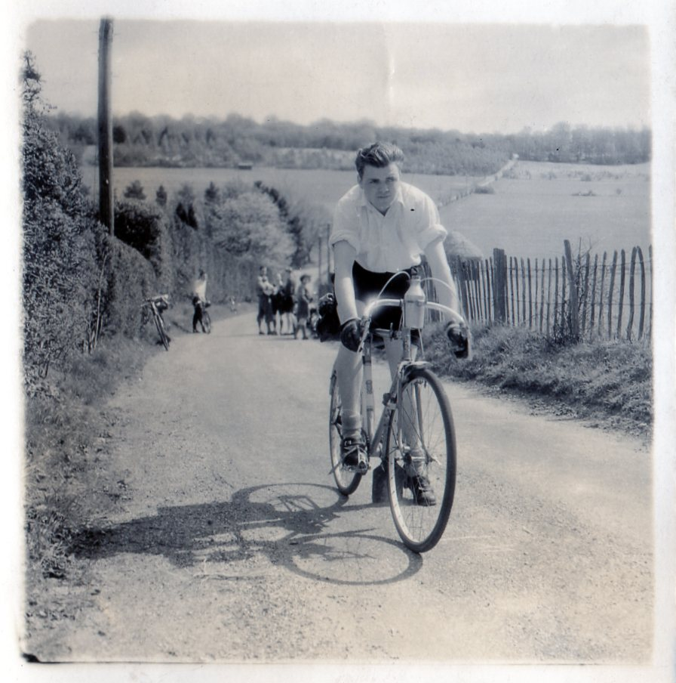

For the 2017 anniversary, we share the stories behind our memorial trophies.
Wanted: any info and photos of Bert Spickett and Glen Nichols

Dave Saffery Cup
Awarded annually for services to the club. Nominations to be submitted to the secretary for a ballot among members present at the AGM. 2016 winner: Tony Arnold
Dave Saffery (1929-2009) was one of the club’s founding members in 1947. From Margate, he was a bricklayer and then taught his trade as a Civilian Instructor in the Prison Service. He held several positions in the club including President, Chairman, Racing Secretary, Newsletter Editor and Timekeeper. Perhaps his greatest achievement was the compilation of the “History of the Thanet Road Club 1947-97”, a mammoth task which took him several years. It can be downloaded at the club’s heritage page www.thanetrc.org/70th
His last great act for the club, which was very close to his heart being a father of five and grandfather of eleven, was the formation of the Go-Ride. Dave is remembered by many, frequently talked about, always with affection.
Discounts currently available to Club Members
Michael Kelleher MIRMT-IIST a Professional Therapist, is a club member.
He would like to offer any club members who may require help, the following treatments:-
Sports Injuries
Remedial Back Therapy
Swedish Holistic Massage
Aromatherapy
Indian Head Massage
Courses of Instruction are also available in any of the above.
Club members requiring treatment will receive, on production of proof of membership, a discount of 25% on the current fee of £40 per session.
Contact Michael on 01227 771493 Mob 07879861618, email backtherapist@yahoo.co.uk
Website:- www.michaelsmassagetherapy.co.uk

Locks of Sandwich : 10% on selected items
St Peter’s Cycles, Broadstairs: 10% on selected items
Bike Warehouse, Herne Bay, Faversham, Gillingham, Sevenoaks: 10% on selected items
Black Cat Coaching- special rates offered
Please also note anyone who arrives at Stonelees Golf Centre on a bike/walking/public transport gets free golf club hire

Ian Edginton, a former member of the club, has started his own cycle maintenance and repair business from his home at Staple near Wingham and welcomes your custom. All types of repair including wheel building are available. Contact Ian at ian.edginton123@btinternet.com or 07786425829. Ian`s father Alf, is also a very long standing and respected member of the Club

Club member Martin Hendy has his own Landscaping and Gardening business and is offering free estimates and discounted rates for Club members.
This looks like a good opportunity to get out on your bike while Martin does the garden.
Garden maintenance & fencing works
Tel 01227 368373
Mob 07958 709736
Email m.hendylandscapes@talktalk.net

Ovenden Skips 5% discount off Ovenden Skips, our Go-Ride Tour Series sponsors.

FOR SALE

Dan Martin’s Planet X Stealth Carbon White TT frame. Size 56 large. Zeus Bladed. Carbon forks. Seatpin. Headset and dual pivot brakes. All excellent condition. £200

Surosa Winter Bike (same frame as Dolan Preffisio). Blue. Size 58. Seat tube. 57 Top tube. Listed as a 58, but more like a 56. Mudguard eyes.

Campag Xenn and Mirage groupset. Campag Khamsin wheels. Aluminium frame. Alpina carbon forks. Little used. All excellent condition.
£250
Please contact Lawrence Martin on 01227 762981.

Bianchi Dama Bianca Silvia women's bike for sale. 46cm (small) aluminium frame, carbon forks, Ultegra, 105, FSA mix groupset, triple chain set (50,39,30), 10 speed, Shimano WH-R500 wheels, few scratches but generally good condition. £250.
Contact Bill Hawkes (Canterbury) : 07939 039066. billthebikie@yahoo.co.uk

Monthly Quiz
Well done to David Robert who once again came up first with the correct answer which was Kenny de Ketele

This Month`s Question:-


Name this rider. Bet you don`t know this one David Robert.
Answers to Colin (Editor) colininett@aol.com

