

NEWSWHEEL

Newsletter for Thanet`s Premier Cycling Club
Affiliated to: British Cycling; CTT;KCA;CTC
www.thanetrc.org
December 2016

Sick List
Peter Huckstep recently underwent an operation and is now on the mend. We wish him all the best for a complete recovery.

News

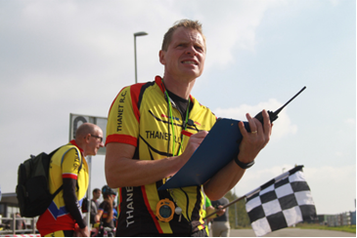

TRC Head Coach Colin Robinson is Highly Commended
We are delighted to report that the club’s Head Coach, Colin Robinson, received a Highly Commended award in the Sports Coach of the Year category at the 2016 Thanet Sports Awards at Margate Winter Gardens on Thursday 17 November.
The award is for a coach who has demonstrated a commitment to improving their skills through coaching courses; outstanding coaching ability and commitment from grassroots to excellence. Colin has also been recognized for his promotion of fair play and respect and his positive impact within the sport, individuals and our organisation.
Colin won the award in 2010 and this year he was nominated by a parent of a Go-Ride rider and supported by Luke Anderson, South East Regional Development Manager at British Cycling.
The specially invited audience heard that Colin had achieved the Level 3 Road and Time Trial Award this year and that Thanet RC is one of very few clubs in the region with youth riders who are competitive in time trials at regional and national level.
As well as formal courses, Colin is always open to new ideas and regularly attends meetings, conferences and workshops to learn about current and future developments. Colin also volunteers at British Cycling Cluster training sessions, to learn from other coaches.
Colin was complemented on both his positive impact on the sport of cycling, where he is known and well-respected nationwide, and upon Thanet RC where his achievements and those of his riders have raised the profile and increased the membership of the club. Youth riders now regularly compete in regional and national championships.
Colin also has a positive impact on the lives of individual riders – whether this is helping them to achieve their individual goals, showing them how to fix a puncture, “kudos” on Strava or transporting them and their bikes to races.
Congratulations to Colin for a well-deserved award!

Club AGM
The AGM on Friday 4th November was well attended despite the bad weather outside.
Presentations were given by all the relevant officers and were well received.
Several changes to personnel and procedures were approved.
George Jenkins, our Chairman is so busy that he has been unable to attend meetings on a regular basis. Despite this he has been invaluable in contributing to our activities at Betteshanger CP. He has now stepped down and has accepted the post of Honorary Vice President of the Club. Jim Dickson will be taking over as Chairman, so the post of Secretary is still unfilled as no-one came forward at the meeting. Please consider if you would like to take over this very important job within the Club. In view of the workload we are considering splitting this job into Membership and General Secretary.
Caroline Rigby is our new Womens Representative and has developed a new prize structure for women riders within the Club. We wish her well in her new role.
Dan Martin has resigned as Junior representative as he has gone off to University. Megan Griffiths and David Redmond will be our Junior and Youth committee representatives. Both have been involved in Go-Ride from the very beginning so have lots of experience. We welcome them to the Committee.
It was decided at the meeting that Annual Subscriptions do not need to be increased as the Club is in a healthy financial position.
Subscriptions are now due for next year, here is a reminder:-
Seniors (over 18) £20.00
Juniors (over 16 and under 18) £10.00 (also those in full time education)
Juveniles (under 16) £6.00
2nd Claim £12.00
Over 60 £10.00
Social £5.00
Family Membership £35.00
Family Membership includes the whole family regardless of numbers.
Please help Jim and Dave by paying as soon as you can, it makes their jobs so much easier.
You can now pay on line via the club website, if you can renew this way it will be much appreciated as it makes things so much easier for the Treasurer. Log into the website and follow the link or alternatively send to
Dave Mastin at:- 399, Margate Road, Ramsgate, CT12 6SE.
Thank you for your co-operation.

KCA Reliability Trial
Unfortunately we failed to win the Rootes Trophy once again. First were the San Fairy Ann CC with 150 points, we were second with 119 points, followed by Southborough and District Wheelers with 109 points.
Well done to all those who rode covering an age span of some 63 years, let`s try again next year.

KCA Annual Lunch & Prize Presentation 2016 – TRC come away with top awards
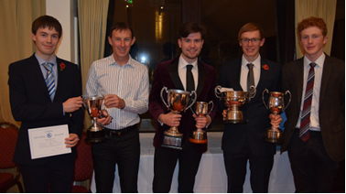

Thanet Road Club were very well represented and rewarded at the Kent Cycling Association Annual Lunch & Prize Presentation 2016 on Sunday 7th November at the Weald of Kent Golf Club.
Andy & Deborah McCall, Laurence and Dan Martin, Terry and Jenny Fearn, David Redmond, Colin and Vi Inett, Chris, Nick and Richard Fennell, Ollie Robinson, Simon Henderson, along with second claimers Chris Bax and Malcolm Adams were all on hand to witness many of the top awards come the way of Thanet Road Club.
On behalf of the club we would like to thank Ann Burden and the KCA for a fantastic meal and presentation ceremony ‘toast mastered’ by Paul Mepham.
Guest of Honour and presenting the prizes was Sheila Hardy – Chairperson of the National Council to Cycling Time Trials.
Junior Dan Martin came away with the Junior Best All Rounder (BAR) and the John Clegg 10 mile junior trophy.
Following a superb season our very own Chris Fennell came away with some key awards including the prestigious short distance BAR, 50 miles trophy and the Roy Enfield trophy.
Chris’s BAR speed was an impressive 29.944mph!
How many course record’s fell to get that – there have never been so many in one season – Chris is now planning the rest of the Kent course records for next season.
Chris and Simon along with Huck Garip also picked up the short distance BAR team prize for the club
Andy McCall, Phil Cook, Nicola Goodban, Huck Garrip, Ollie Robinson, Simon Henderson and Nick Fennell were amongst the others who also all came away with individual awards.
The photograph shows Nick, Simon, Dan, Chris and Ollie with some of their spoils!
Courtesy of Richard Fennell
KCA results courtesy of Spinwheels
Simon Henderson

Commissaires
There is still an acute shortage of commissaires in Kent. To stop the continual cancellation of regional youth and adult races especially down here in East Kent, we need more commissaires. Competitors cannot accumulate BC points unless a commissaire is present. If you are interested we could get BC to arrange a local course which I believe is free of charge. Please let me know and I will forward your name to Simon Bedford at BC.
Colin Robinson

Annual Club Dinner and Prize Presentation

This was held on the 12th of November at Minster Village Hall attended by a large number of members, guests and, for the first time, junior members.

We all enjoyed an excellent meal followed by the 70th Anniversary film produced by David Robert which was first class. The prizes were presented by our Guest of Honour Josie Heffernan from British Cycling, who has a long association with the club as her father Frank Randell is one of our founder members, he was present along with Ronnie Winters and Reg Baynham. Our other surviving founder member Ernie Abdella was unable to be present as his wife was unwell, we wish her all the best. Many thanks to our Social Secretary Helen Hill for all her hard work in organising the event and to Dave Mastin for preparing all the trophies.

Ghent 2016

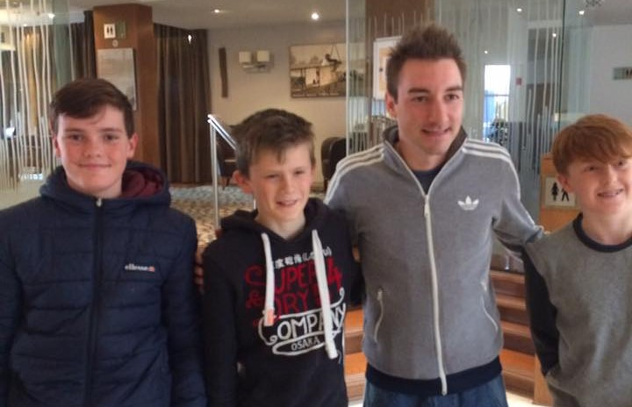

The boys with Elia Viviani in our hotel.

Eighteen members of the Club travelled to Ghent in Belgium for the famous Annual Six Day event. It was extra special this year as Mark Cavendish and Bradley Wiggins were riding together and this was to be Bradley`s final event on the track before retirement (or so he said?). We enjoyed some great racing until late on Saturday and were scheduled to travel to Koksijde on Sunday to watch the Cyclo-Cross. Unfortunately this was cancelled due to bad weather, so we decided to go to Calais hoping to arrive home early. This was not to be however, as ferries had been cancelled and all traffic diverted to the tunnel, necessitating a long wait at the terminal. The icing on the cake was that Cav and Wiggo had won the event overall, so we were able to go home happy after a great weekend. Many thanks to Colin for organising it all for us.

Thanet RC Youth Development Squad 2017 Launches 01/12/16

Stand by for relaunch!

Youth Development Squad 2017 launches tomorrow 1st Dec 2016 with our first meeting with (most of) the Squad taking place on Sat 3rd Dec.

Thanet RC is pleased to announce our Youth Development Squad riders for 2017 are:-

Joshua Chivilo

Hamish Reilly

George Pittock

Lance Childs

Jack Hill

Flynn Robinson

Toby Yemm

Finn Dunton

The Squad Co-ordinator is Chris Childs

The Squad Coach is Teresa Childs

For more information please check out our updated page on the Thanet RC website:-

http://www.thanetrc.org/youth-development-squad.shtml

Report by Teresa & Chris Childs

Racing Results Open Events (TRC Riders)
Whites Transport/Thanet RC Halloween Races 29th October

U8 U10 U12
Thorsten Cook 1 Alex Dack 1 Luke Gibson (CCP) 1=
Dexter Kirkness 2 Max Robinson 2= Charlie Hart 1=
Dawson Kirkness 4 Lughaidh Cook 2= Freya Cook 3= 1 G
Luke Hart 4 Stanley Rose 3=
Ben Hutton 6 Ferne Pierce 5= 2 G
Adam Whitlock 5=

U14 U16 Senior Men
Jack Hill 1 Luke Hill 1 Dan James (?) 1
Flynn Robinson 2 Tim Yemm 2
Toby Yemm 3= Mike Kirkness 3=
Eleanor Fox 7= 1G George Bussey 5
Rob Milnes 6
Nic Fennell 7
Olly Dickson 8

Veteran Men (40-50) Veteran Men (50+)
Steve Gibson (CCCP) 1 Mark. Langley (Sprockets) 1
Phil Cook 2 Colin Robinson 2
Jez Dack 3 Mick Bussey 3
Diana Yemm 5 1W

Women
Jo Smith 1
Jo Malpass 3

East Kent Cyclo Cross Round 3 Discovery Park Sunday 13th November

U12 U14
Charlie Hart 2 Jack Hill 3
Max Robinson 5 Winner was Joseph Blackmore (Herne Hill)
Lughaidh Cook 6
Alex Dack 7 U16
Freya Cook 9 1st Girl Toby Perry 3
Luke Hart 10 Winner was Noah Charlton (Bowlphish)
Millie Dack 14
Thorsten Cook 16
Winner was Finn Dunton (Wigmore CC)

Veteran 40-49 Women
Mark Palmer 9 Caroline Rigby 5
Winner was Stuart McGhee (Evans Cycles) Winner was Charlotte Heywood (Twickenham CC)

Senior Men
Dan Martin 14
Rob Milnes DNF
Winner was Philip Glowinski (VC Londres)

Thanet riders in strength at Full Gas Winter Track League
Three TRC riders have taken part in the weekly Full Gas track league at Lee Valley velodrome. Chris Childs is riding Wednesday nights in the C-league and enjoying being back on the boards and taking some good positions. Rob Milnes took part in his event of the season yesterday in the B-league and preformed well taking three top 6 finishes in the 4 events on the night.
Ollie Robinson after being promoted last season into the A-league alongside the likes of Tony Gibb, Alex Dowsett and Fred Wright. Ollie recovering from his broken wrist has ridden all 4 rounds so far and has been consistently top 10 in fields of 20-25 riders. This week Ollie took his best result of 4th in the win out picking up his first points of the series.
Along with Lance and George it is great to see so many of our riders racing winter track league and would encourage any others to get through their accreditation and give it a go.

George and Lance perform well at LYTL
Lance Childs and George Pittock have continued their good start to the London Youth Track League (LYTL), which is now half way through its pre-Christmas programme.
LYTL was established to provide youth and junior riders with track racing that is specific to meeting the needs of their age group. Meetings are held fortnightly at the Lee Valley Velodrome from October to March, and each meeting includes a 40 lap scratch race, 1km dash, elimination race and 40 lap points race.
Lance, in his third year at the competition, and George, in his first, are currently mid-table in Group 2 of three boys groups. There is very little between the two Thanet RC boys, who have their own friendly rivalry.
Lance and George are travelling further than most other riders, leaving straight from school and arriving home close to midnight, but they are growing in confidence, developing their track skills and look competent in a competition that includes most of the top-ranked road and track riders in their age groups.
Race results and the LYTL League table can be found at – http://www.lytl.co.uk/race-dates—results.html

Thanet RC Success at London League Round 9 Cyclocross
London CX League Round 9 Leeds Castle- promoted by Dulwich Paragon.
A tough, lumpy, agricultural course, especially for the Youth/Junior /Adult categories, saw a good number of Thanet Riders, including Thorsten, Lughaidh, Max, Charlie, Freya, Jack, Luke (VC Deal) Flynn and Toby Perry. The first race of the day was won by Oscar Amey of Team Darenth, but Lughaidh gave him something to think about for a good part of the race, before dropping off to finish a very comfortable 2nd. Max Robinson was by far the quickest rider in the twisting downhill section through the trees, handling his new bike really well to just be pipped for 5th owing to a bit of traffic 2 corners out. Thorsten found the course teeth-rattlingly hard but kept at it, trying to catch Alana Lord of VC Deal. The U12 race was really hard fought with a lot of quality in the field, Charlie rode well given he is still suffering with a cold and finished within the top half of the field. The course did not suit Freya, nor did her father’s poor attention to post-single-ring-maintenance help her as she dropped her chain at a crucial moment in the last lap. Next up, Jack, Flynn and Luke Hill, in the U14/U16 race this was run over the adult course lasting 45 mins which was a tough workout for the young riders. Jack finished ahead of Flynn who was ahead of Luke all in placings 10-20th in field of 35. Toby Perry was struggling with a cold so not sure on his finish position. Finally David Kenning a new member rode his first CycloX for the season in the Vet 40-50 race – comment from David “Best I can say about my performance in the V40s race is that I didn’t finish last… That was a really tough course and my lack of fitness didn’t help”
Post by Colin Robinson and Phil Cook

Dates for your Diary
TRC Turbo training – MANSTON VILLAGE HALL
Turbo training sessions start on Thursday 20th October at 18:00 for 18:15 start
Finish by 19:30
Why not join for 1 or more or ALL of the 22 sessions between now and next season?
Cyclists from other clubs are more than welcome to attend
For 2016 will be again using Manston Village Hall.
Manston Village Hall – Preston Road, Manston. CT12 5BA.
There is parking directly outside the hall or in Preston Road.
We are not professional coaches – just offering our advice and encouragement at the session.
The sessions will help you to maintain fitness over the winter and can be good preparation for the 2017 time trial calendar

Social Evening
The next Social Evening will be on Tuesday 6th December at the Bell Meadow Pavilion St Nicholas at Wade. Tim Ramsden from BlackCat Coaching is going to attend. Tim is happy to talk and answer questions on any topic but the following suggestions have been made : winter training and training off the bike. If anyone else has any suggestions please pass them on to me and I will let Tim know. It would be great to have a good turnout. Thanks Helen
All are welcome. 7.30-9.30pm. Please come along.

TRC Tuesday Social 3 Jan 2017 7.30pm
A Cyclist’s Museum of Curiosities curated by David Robert (Club Heritage Officer and Editor of Cycling World Magazine)
Enjoy some of the more curious items from both David’s and the club’s collection of cycling memorabilia. Have an interesting item of you own? Please bring along on the night. Too big/valuable/small to share? Just send David a good photo and he will add it to his presentation.
davealexrob@yahoo.com
VTTA Kent Group Annual Luncheon and Prize Giving will be held on Saturday 11th February 2017 at the Weald of Kent Golf Club as last year. Carvery meal and prices TBC. Organiser+

Tom Morton, 42, Chiltern End, Ashford, TN24 8QL. The Guest of Honour will be the legendary Alf Engers. Last date for bookings 8th February.
East Kent Cyclo Cross 2016-17 Series Dates/Venues Announced:
Racing for all categories; Under 12, Youth, Juniors, Women, Men and Vets
All entries via British Cycling (except Round 5)
Round 4 Sunday 18th December Venue TBC
Round 5 Sunday 15th January Betteshanger Cross (combined LCCA round)
For further info contact eastkentcyclocross@gmail.com ‪‬‬‬‬‬‬‬‬‬‬‬‬‬‬‬‬‬‬‬‬‬‬‬
‪‬‬‬‬‬‬‬‬‬‬‬‬‬‬‬‬‬‬‬‬‬‬‬
‪‬‬‬‬‬‬‬‬‬‬‬‬‬‬‬‬‬‬‬‬‬‬‬

‪‬‬‬‬‬‬‬‬‬‬‬‬‬‬‬‬‬‬‬‬‬‬‬

‪‬‬‬‬‬‬‬‬‬‬‬‬‬‬‬‬‬‬‬‬‬‬‬
‪‬‬‬‬‬‬‬‬‬‬‬‬‬‬‬‬‬‬‬‬‬‬‬
‪‬‬‬‬‬‬‬‬‬‬‬‬‬‬‬‬‬‬‬‬‬‬‬

‪‬‬‬‬‬‬‬‬‬‬‬‬‬‬‬‬‬‬‬‬‬‬‬

‪‬‬‬‬‬‬‬‬‬‬‬‬‬‬‬‬‬‬‬‬‬‬‬
‪‬‬‬‬‬‬‬‬‬‬‬‬‬‬‬‬‬‬‬‬‬‬‬
‪‬‬‬‬‬‬‬‬‬‬‬‬‬‬‬‬‬‬‬‬‬‬‬

‪‬‬‬‬‬‬‬‬‬‬‬‬‬‬‬‬‬‬‬‬‬‬‬

Go- Ride Training Sessions 2016
Provisional timetable below for the rest of this year.

Go Ride Session Date / Times 2016
Date | Time | Venue | Activity | Lead Coach |  | Coaches not availlble
Sat 3rd Dec 2016 | 2-3.30pm | Betteshanger CP | Go-Ride Session (Road Circuit booked) | TC
Sat 10th Dec 2016 | 12.30-3.30pm | Betteshanger CP | Whites MTB Winter Series round.2 | RM |  | NA
WINTER BREAK

Club Clothing
Robert Sissons is now looking after the club clothing. Contact him by email sissons349@btinternet.com or mobile 07704943605
Many thanks to Robert for taking this on.

Articles Wanted
I work as editor of Cycling World Magazine which specializes in leisure, tourism, sportives, commuting and cycling lifestyle (inc. book reviews). I am always looking for articles. Please contact David Robert (TRC Committee member) at editor@cyclingworldmag.co.uk

Help urgently needed for TRC Heritage Project contact: davealexrob@yahoo.com
It is the club’s 70th Anniversary in 2017. Help is required- tasks are varied and interesting, some only requiring a half day of time. Please get involved.

Thanet Road Club at The Freewheel Pub’s Cycling Celebration Weekend
TRC will feature at The Freewheel Pub’s Cycling Celebration Weekend 3-4 December. The cycling-themed pub in Graveney has invited two TRC members, who are both cycling magazine editors, to present “Meet the Editors” at 7pm on Saturday 3 December. There will also be a screening of the TRC 15-minute documentary, Cycling for Generations.
The two editors are David Kenning, deputy editor of Bikes Etc., and David Robert, editor of Cycling World. David Robert is also TRC’s Heritage Officer and directed the recently-premiered club documentary.
A fun-evening for all cyclists.

And from the archives… TRC Needs You! Volunteers Helen Hill and Emma Dickson at Whites MTB Winter Series Round 1, Betteshanger 29.10.16 by Dave Hayward
Love this photo Digi Dave Hayward Photos. Helen Hill and Emma Dickson

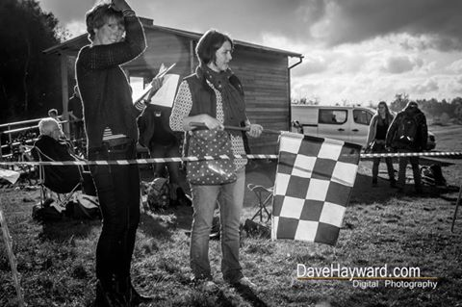
This wonderful photo is important for two reasons:
- It reminds us that archives go right up to the present day, and it is important to document the great things the club is doing.
- It is illustrative of how of volunteers are at the heart of our club. Helen and Emma are volunteering at a race, standing in front of our trackside building constructed by volunteer Tony Arnold and club helpers.

Volunteers are key to club life: Please get involved and help keep us going for another 70 years

Discounts currently available to Club Members

Michael Kelleher MIRMT-IIST a Professional Therapist, is a club member.
He would like to offer any club members who may require help, the following treatments:-
Sports Injuries
Remedial Back Therapy
Swedish Holistic Massage
Aromatherapy
Indian Head Massage
Courses of Instruction are also available in any of the above.
Club members requiring treatment will receive, on production of proof of membership, a discount of 25% on the current fee of £40 per session.
Contact Michael on 01227 771493 Mob 07879861618, email backtherapist@yahoo.co.uk
Website:- www.michaelsmassagetherapy.co.uk

Locks of Sandwich : 10% on selected items
St Peter’s Cycles, Broadstairs: 10% on selected items
Bike Warehouse, Herne Bay, Faversham, Gillingham, Sevenoaks: 10% on selected items
Black Cat Coaching- special rates offered
Please also note anyone who arrives at Stonelees Golf Centre on a bike/walking/public transport gets free golf club hire

Ian Edginton, a former member of the club, has started his own cycle maintenance and repair business from his home at Staple near Wingham and welcomes your custom. All types of repair including wheel building are available. Contact Ian at ian.edginton123@btinternet.com or 07786425829. Ian`s father Alf, is also a very long standing and respected member of the Club

Club member Martin Hendy has his own Landscaping and Gardening business and is offering free estimates and discounted rates for Club members.
This looks like a good opportunity to get out on your bike while Martin does the garden.
Garden maintenance & fencing works
Tel 01227 368373
Mob 07958 709736
Email m.hendylandscapes@talktalk.net

FOR SALE

Dan Martin’s Planet X Stealth Carbon White TT frame. Size 56 large. Zeus Bladed. Carbon forks. Seatpin. Headset and dual pivot brakes. All excellent condition. £200

Surosa Winter Bike (same frame as Dolan Preffisio). Blue. Size 58. Seat tube. 57 Top tube. Listed as a 58, but more like a 56. Mudguard eyes.
Campag Xenn and Mirage groupset. Campag Khamsin wheels. Aluminium frame. Alpina carbon forks. Little used. All excellent condition.
£250

Please contact Lawrence Martin on 01227 762981.

Monthly Quiz
Well done to David Robert who once again came up first with the correct answers which were Erik Zabel and Oscar Freire.

This Month`s Question:-

Name this rider.

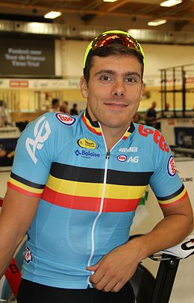

Answers to colininett@aol.com
Newswheel Editor

