NEWSWHEEL

Newsletter for Thanet`s Premier Cycling Club
Affiliated to: British Cycling; CTT;KCA;CTC
Thanetrc.org.uk
October 2016

News

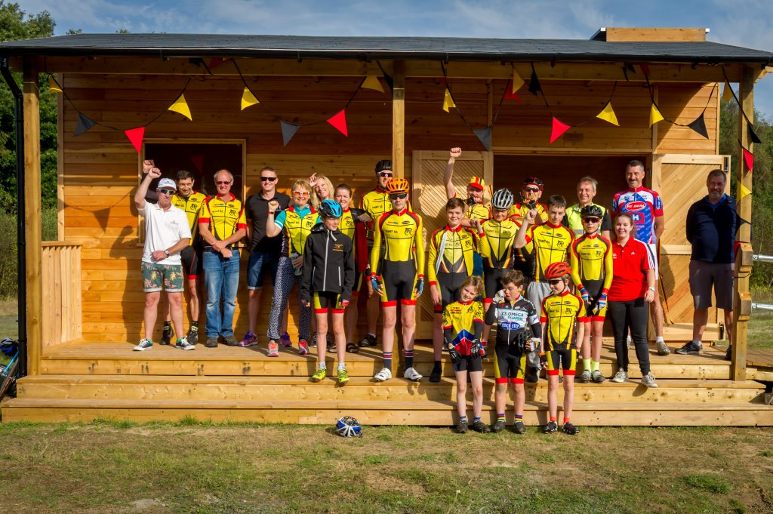

The Betteshanger trackside building was officially opened on Saturday 24th. This is a great facility and should serve us for many years to come. We are totally indebted to Tony Arnold who has guided the project through from start to finish with great skill and the help of some “labourers” from the Club. Many thanks to all involved.

Please nominate for the Thanet Sports Awards 2016
Would be great if we could get some nominations in for all the great achievements both on and off the bike within Thanet RC. See below for details – it’s fairly easy to do as I’ve done a number of these. Thanks in advance.
Colin Robinson.
Just a quick reminder to inform you that we have just over 3 weeks left for you to cast your nominations at this year’s Thanet Sports Awards event which is taking place at the winter gardens on Thursday 17 November.
https://www.thanet.gov.uk/the-thanet-magazine/campaigns/sport/thanet-sports-awards/
As mentioned previously, the event really is a great opportunity to reward and recognise either an individual, sports club or local school who has achieved great success during the last 12 months.
I have also attached the nomination form in word format if you are unable to access the form online. If all completed forms can be sent to myself that would be much appreciated.
Please do continue to share with anyone who may be interested.

Commissaires
There is an acute shortage of commissaires in Kent. To stop the continual cancellation of regional youth and adult races especially down here in East Kent, we need more commissaires. Competitors cannot accumulate BC points unless a commissaire is present. If you are interested we could get BC to arrange a local course which I believe is free of charge. Please let me know and I will forward your name to Simon Bedford at BC.
Colin Robinson

K C A Reliability Trial
Sunday 30th October 2016
The Rootes Trophy is awarded to the club with the highest points total in this event based on the following table below.
This trial is not a race but is about getting as many members as possible to finish their course within their target time. The more members who complete what they set out to complete, the more points we score. We were just beaten by the Fairies last year and we want to win the trophy again this year. There should be an appropriate target distance and time for every active member.
The courses begin at Claygate and Potters Corner A20 near Ashford and make an excellent Autumn day out for all riders.
There are no entries allowed on the line please inform Michael Friend ASAP (text to 07921 491658 or michael.friend@uk.verizon.com), who will collate entries with the club picking up the entry fee. Please contact him to let him know which distance/time you wish to be entered for.
Distance | Time Options | Points
50 km | 2 hours  2.5 hours  3 hours | 1
100 km | 4 hours  4.5 hours  5 hours | 2
100 miles | 6.5 – 7 hours | 4

Racing Results Open Events (TRC Riders)

Thanet RC at the GHS championships and National TT Series
Five local young Thanet RC riders qualified for the GHS National 10 mile time trial championships which was held in Evesham, Warwickshire at the weekend. The event is for riders aged 12 to 16 years old and Thanet RC did very well to qualify 5 riders from the South-East championships which were held in July at Betteshanger Country Park. 15 year old Joshua Chivilo was the fastest Thanet RC rider on the day recording a PB time of 23:39 for 57th place overall of 190 riders. Lance Childs did very well in 13 year old category coming 6th with a fine 25:25. Charlie Burgess in his first time trial season did very well for 26:01 and Flynn Robinson only at 12 years old recording a time of 26:24 (7th on age cat). Megan Griffiths representing Thanet RC for the 4th year running in the GHS national championships finished in 114th place with 30:31.
Pos Name Club Split Time Cat
57 Joshua Chivilo Thanet RC 0:11:36 0:23:39 15
79 Lance Childs Thanet RC 0:12:24 0:25:25 13
89 Charlie Burgess Thanet RC 0:12:33 0:26:01 16
97 Flynn Robinson Thanet RC 0:13:12 0:26:24 12
114 Megan Griffiths Thanet RC 0:14:35 0:30:31 W16
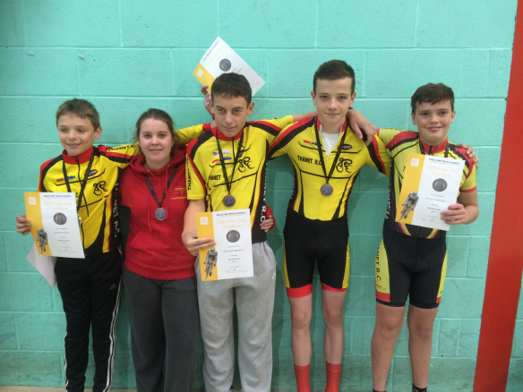

TRC at the RTTC National Classic Series Rd6/ Open Circuit Championships

This is the final round of the Classic Series and was combined with National Open Circuit Championships. Hosted by Stratford CC and held on a new course K33/cc.
The course used the same roads as the GHS event the day before, but completed a loop to form 2 laps the first being about 13.1 miles and the second slightly shorter at 12.5 miles. Making for a 25.6 mile course. The course was gently rolling with only one short climb at the start of the laps.
The weather conditions were good for the all the riders. A light southerly wind helped riders on the return part of the lap. This wind got slightly stronger for some of the later riders.
Thanet Road Club had two at this event; Chris and Nic Fennell, both try to completing their 5 Series event of the season.
Chris had a good ride with a time of 52.46 with a strong field attracted to the event managed to finish 7th. This result will also secure Chris 3rd place Overall in the series and 1st place in the Espoirs category (U23s), this is to be confirmed still however.
Nic had a great ride with a new power PB for a 25mile TT and a sub hour ride, completing both his goals for the event. Finishing with a time of 58.35 placed him 23rd, an improvement in placings from last year.
Final results of Thanet Riders was:
Chris Fennell – 52.46 – 7th
Nic Fennell – 58.35 – 23rd
The winner of the event was Ryan Perry (Lansdale Lightweights R T) with a time of 51.29
2nd – Matthew Smith (Team Bottrill) – 51.35
3rd – Matt Clinton (Mike Vaughan Cycles) – 51.45
Other local riders included:
Kevin Tye – 53.03 – 9th
Emma Lewis – 59.17 – 3rd. An excellent ride by Emma showing off very strong opposition to secure 3rd at this event. And 3rd in the Women’s Series Overall, still to be confirmed.

Sunday 11th September KCA 25 Q25/10 (Thanet Way) Huck Garip 56.12, Simon Henderson 56.56, Mike Kirkness 57.48 (PB), Scott Meeks 58.56 (PB), Mark Palmer 59.32, Colin Robinson 59.49, Chris Bax 1.01.05, Dave Danton 1.01.32, Martin Russell 1.02.56, Andy Macpherson 1.04.02, Paul Kelk 1.05.20, Paul Kirkness 1.06.58, Robert Sissons 1.07.03, Chris Childs 1.07.19, Martin Hendy 1.07.28, Dave Mastin 1.08.24, Peter Huckstep 1.08.42, Paul Griffiths 1.12.37, Simon Charles 1.13.52, Phil Cook 1.14.20, Jenny Fearn 1.23.23, Eddie Brown DNS, Ollie Robinson DNS. Winner was Andrew Meilak (Velo Refined Aerosmiths) 53.38. Well done to all who did PB`s, not sure if I`ve got them all.
Sunday 18th September VTTA 25 Q25/12 (Old Romney-Kingsnorth-Old Romney) Chris Bax 1.1.19, Paul Kelk 1.6.56, Martin Russell 1.3.44, Andy McCall 1.11.29, Colin Inett 1.13.34, Chris Fennell 51.30, Dave Danton 1.3.21, Mark Palmer 59.02, Huck Garip 56.38, Simon Henderson 56.44, Andy Macpherson 1.6.39, Rick Perkins 59.55, Paul Griffiths DNS, Dave Mastin 1.8.40, Nic Fennell 57.26. Chris Fennell was the winner.

Vuelta de Betteshanger Saturday 17th September

U8 U10 U12
Ben Hutton 1 Max Robinson 1 Stanley Rose 1
Grace Philpott 2 (1stGirl) Tom Crow-Brown 2 Tom Hutton 2
Ferne Pierce 3 (1st Girl) Eleanor Fox 3 (1st Girl)
Millie Dack 5 (2nd Girl)
Ilana Lord 6 (3rd Girl)

U14 U16
George Pittock 2 Josh Chivilo 1
Lance Childs 5 Alex Ashman 2
Flynn Robinson 6 Charlie Burgess 4
Jack Hill 7 George Bussey 5
Toby Yemm 8 Megan Griffiths 6 (1st Girl)

Well done to all competitors and thanks to Helen Hill for running the event despite no commissaire being available.

Bedgebury 17th September
Bedgebury MTB today, 5 Thanet riders in attendance today and all managed a podium finish! U8 saw Luke Hart 2nd and Thorsten Cook 3rd, U10 race was never in doubt as Lughaidh rode from front to take 1st and in the U12 race a really well fought battle ended with Charlie Hart contesting the sprint to the line to finish a very close 2nd, with Freya 4th place and 1st girl. Good strong TRC presence today amongst the Bedgebury Boars. Many thanks to Geoff Hardman and the Bedgebury Boars team for putting on a great series which saw Lughaidh pick up 2nd overall in U10 and Freya 2nd U12 girl.

Thanet RC / BlackCat Coaching / Locks Cycles Road Omnium a great success
Another huge success for Thanet RC at the road omnium event at Betteshanger Country Park today. The omnium composed of 4 events for all categories: 1) 2 mile TT
2) Crit Race
3) Street Sprints
4) Road race
Categories where youth (Under 16), Go-race men and women and elite men.
Thanks so much to all the helpers on the day we had the grand opening of the fine trackside building made by Tony Arnold and other fine Thanet RC folk.
Results on the day as follows:-
Under 8
Position Name Club TT Time TT position Crit Race Position Street sprint Position Road race position Overall Score 1 Ben Hutton Thanet RC 7.23 1 1 1 1 4
Under 10
Position Name Club TT Time TT position Crit Race Position Street sprint Position Road race position Overall Score 1 Max Robinson Thanet RC 6.37 1 1 1 1 4
2 Lughaidh Cook Thanet RC 7.02 2 2 4 2 10
3= Theo Hocking Thanet RC 7.25 3 4 3 3 13
3= Thomas Crow-Brown Thanet RC 7.04 3 4 3 3 13
1st Girl Ilana Lord VC Deal 8.11 5 5 5 5 20
Under 12
Position Name Club TT Time TT position Crit Race Position Street sprint Position Road race position Overall Score 1 Finn Dunton Wigmore CC 6.00 1 1 1 1 4
2 Tom Hutton Thanet RC 6.14 2 2 2 2 8
3 Stanley Rose Thanet RC 6.55 3 3 3 3 12
Under 14
Position Name Club TT Time TT position Crit Race Position Street sprint Position Road race position Overall Score 1 George Pittock Thanet RC 5.12 1 1 2 1 5
2 Lance Childs Thanet RC 5.38 3 2 3 2 10
3 Flynn Robinson Thanet RC 5.31 2 3 4 3 12
4 Toby Yemm Thanet RC 5.43 4 4 1 5 14
5 Jack Hill Thanet RC 5.56 5 5 5 4 19
Under 16
Position Name Club TT Time TT position Crit Race Position Street sprint Position Road race position Overall Score 1 Toby Perry Thanet RC 4.57 2 1 2 1 6
2 Joshua Chivilo Thanet RC 4.52 1 2 4 2 9
3 Charlie Burgess Thanet RC 5.24 4 3 1 3 11
5 Alex Ashman Thanet RC 5.08 3 DNF DNF DNF DNF
Go-Race (Women) Locks Series
Position Name Club TT Time TT position Crit Race Position Street sprint Position Road race position Overall Score 1= Jody Coxon Adalta CC 5.41 2 2 3 1 8
1= Nicola Goodban Thanet RC 5.22 1 1 1 5 8
3 Helen Hill Thanet RC 6.05 3 3 2 2 10
4 Diana Yemm Thanet RC 6.12 4 4 4 2 14
5 Caroline Rigby Thanet RC 6.34 5 5 5 2 17
Go-Race (Men)
Position Name Club TT Time TT position Crit Race Position Street sprint Position Road race position Overall Score 1 David Moffat Thanet RC 5.08 1 1 1 1 4
3 Dave Mastin Thanet RC 5.40 3 3 3 2 11
Elite Men
Position Name Club TT Time TT position Crit Race Position Street sprint Position Road race position Overall Score 1 Stuart Baldwin Adalta CC 4.29 1 2 4 1 8
4 Seb Dickson Thanet RC 4.32 2 4 5 2 13
6 Mike Kirkness Thanet RC 4.46 4 6 7 7 24
8 Scott Meeks Thanet RC 5.01 8 7 8 8 31

Forthcoming Open Events
Sunday 2nd October Wigmore (KCA Champs) Hill Climb QHC/11(Hollingbourne)
Sunday 9th October VTTA 15 Q15/1 (Ham Street-Bridgefield-Brenzett-Ham Street). This is a new course, all other details as in Handbook.

Club Events- TRC riders only
Evening 10 Wednesday 31st August Q10/42 (Betteshanger CP) Juniors Ollie Robinson 21.47, Dan Martin 21.58, Alex Ashman 23.29, Olly Dickson 24.13, Charlie Burgess 24.31, Lance Childs 25.34, George Bussey 26.28, Flynn Robinson 26.42, Megan Griffiths 30.25, Tom Hutton 31.22, Alex Dack 31.54, Tom Crow-Brown 34.34, Ben Hutton 37.13, Millie Dack 41.18.
Seniors Chris Fennell 19.57, Mike Kirkness 21.54, Huck Garip 22.09, Lawrence Martin 22.19, Nic Fennell 22.22, Simon Henderson 22.39, Matt Hall 22.59, Mark Palmer 23.04, Nick Scott 23.39, Chris Bax 23.51, Dave Danton 23.55, Colin Robinson 23.57, Martin Russell 24.07, Paul Kelk 24.13, Brian Hood 24.28, Michael Friend 24.31, Jim Dickson 24.44, Nicola Goodban 25.02, Paul Kirkness 25.23, Chris Childs 25.41, Robert Sissons 25.45, Peter Huckstep 26.14, Simon Charles 27.09, Jez Dack 27.22, Colin Inett 27.30, Caroline Rigby 27.35, Paul Griffiths 28.11, Malcolm Adams 28.18, Eddie Brown 28.32, Roger Dewen 29.54, Diana Yemm 30.15, Jenny Fearn 31.49. Chris was the fastest, a huge field of 63 riders on the night.
Evening 10 Wednesday 7th September Q10/42 (Betteshanger CP) Juniors Lance Childs 24012 (PB), George Pittock 24.13, Charlie Burgess 24.16, Olly Dickson 24.18, Flynn Robinson 25.46, David Redmond 25.53, George Bussey 26.17, Toby Yemm 27.32, Megan Griffiths 30.36, Tom Crow-Brown 33.52.
Seniors Chris Fennell 19.47, Huck Garip 21.51, Simon Henderson 22.04, Nic Fennell 22.07, Rob Milnes 22.35, Mark Palmer 22.37, Matt Hall 22.45, Scott Meeks 23.06, Nick Scott 23.07, Richard McVey 23.07, Chris Bax 23.38, Colin Robinson 23.53, Martin Russell 24.05, Paul Kelk 24.12, Brian Hood 24.24, Chris Childs 24.55, Martin Hendy 25.02, Jo Malpass 25.02, Paul Kirkness 25.02, Michael Friend 25.26, Peter Huckstep 25.35, Robert Sissons 25.46, Simon Charles 26.35, Caroline Rigby 26.54, Colin Inett 26.56, Paul Griffiths 27.03, Malcolm Adams 27.49, Diana Yemm 28.49, Roger Dewen 29.26, Jenny Fearn 30.36, John Sepple 31.14, Mick Bussey 31.29. Chris was the fastest. Lots of PB`s tonight.

Dates for your Diary

KCA Lunch and Prize Presentation
This will be held on Sunday 6th November 12.15 for 13.30 start at the Weald of Kent Golf Club, Headcorn TN27 9PT. To book contact Ann Burden 12, Hill View, Ashford, TN24 8QB 01233 640456/07966 470180 or annburden63@gmail.com

Social Evening
The next Social Evening will be on Tuesday 4th October at the Bell Meadow Pavilion St Nicholas at Wade 7.30-9.30pm. Please come along.
Also please note- the November Social Evening will be held on Tuesday 25th October to coincide with School holidays. All are welcome.

Club AGM
This will be held on Friday 4th November at the Bell Meadow Pavilion, St Nicholas at Wade at 7.30pm. Please come along to this important event, it is your opportunity to have your say on how we are running the Club.

Club Dinner and Prizegiving
This will be held on Saturday 12th of November at Minster Village Hall, time to be confirmed.
Important Note Would all those in possession of trophies please return them to Dave Mastin (highly polished please) ASAP so that they can be prepared for this years presentation. Thank you.

East Kent Cyclo Cross 2016-17 Series Dates/Venues Announced:
Racing for all categories; Under 12, Youth, Juniors, Women, Men and Vets
All entries via British Cycling (except Round 5)
Round 2 Sunday 16th October Bay Point Cross.
Round 3 Sunday 13th November Discovery Park Cross
Round 4 Sunday 18th December Venue TBC
Round 5 Sunday 15th January Betteshanger Cross (combined LCCA round)
For further info contact eastkentcyclocross@gmail.com ‪‬‬‬‬‬‬‬‬‬‬‬‬‬‬‬‬‬‬‬‬‬‬
‪‬‬‬‬‬‬‬‬‬‬‬‬‬‬‬‬‬‬‬‬‬‬
‪‬‬‬‬‬‬‬‬‬‬‬‬‬‬‬‬‬‬‬‬‬‬

‪‬‬‬‬‬‬‬‬‬‬‬‬‬‬‬‬‬‬‬‬‬‬

‪‬‬‬‬‬‬‬‬‬‬‬‬‬‬‬‬‬‬‬‬‬‬
‪‬‬‬‬‬‬‬‬‬‬‬‬‬‬‬‬‬‬‬‬‬‬
‪‬‬‬‬‬‬‬‬‬‬‬‬‬‬‬‬‬‬‬‬‬‬

‪‬‬‬‬‬‬‬‬‬‬‬‬‬‬‬‬‬‬‬‬‬‬

‪‬‬‬‬‬‬‬‬‬‬‬‬‬‬‬‬‬‬‬‬‬‬
‪‬‬‬‬‬‬‬‬‬‬‬‬‬‬‬‬‬‬‬‬‬‬
‪‬‬‬‬‬‬‬‬‬‬‬‬‬‬‬‬‬‬‬‬‬‬

‪‬‬‬‬‬‬‬‬‬‬‬‬‬‬‬‬‬‬‬‬‬‬

Go- Ride Training Sessions 2016
Provisional timetable below for the rest of this year.

Go Ride Session Date / Times 2016
Date | Time | Venue | Activity | Lead Coach |  | Coaches not availlble
Sat 1st Oct 2016 | 2.30-4pm | Betteshanger CP | Go-Ride Session / Training ride out | CR
Sat 8th Oct 2016 | 2.30-4pm | Betteshanger CP | Go-Ride Session (Road Circuit booked) | TC
Sat 15th Oct 2016 | 2.30-4pm | Betteshanger CP | Go-Ride Session / Training ride out | HH
Sat 22nd Oct 2016 | 10-11:30am | Betteshanger CP | Go-Ride Session / Joint VC Deal (Road circuit booked) | CR
Sat 29th Oct 2016 | 12.30-3.30pm | Betteshanger CP | Whites MTB Winter Series round.1 | HH |  | NA
Sat 5th Nov 2016 | 2-3.30pm | Betteshanger CP | Go-Ride Session (Road Circuit booked) | TC
Sat 12th Nov 2016 | 2-3.30pm | Betteshanger CP | Go-Ride Session / Training ride out | RB
Sat 19th Nov 2016 | 10-11:30am | Betteshanger CP | Go-Ride Session / Joint VC Deal (Road circuit booked) | HH
Sat 26th Nov 2016 | 2-3.30pm | Betteshanger CP | Go-Ride Session / Training ride out | CR
Sat 3rd Dec 2016 | 2-3.30pm | Betteshanger CP | Go-Ride Session (Road Circuit booked) | TC
Sat 10th Dec 2016 | 12.30-3.30pm | Betteshanger CP | Whites MTB Winter Series round.2 | RM |  | NA
WINTER BREAK

Club Clothing
Robert Sissons is now looking after the club clothing. Contact him by email sissons349@btinternet.com or mobile 07704943605
Many thanks to Robert for taking this on.

Articles Wanted
I work as editor of Cycling World Magazine which specializes in leisure, tourism, sportives, commuting and cycling lifestyle (inc. book reviews). I am always looking for articles. Please contact David Robert (TRC Committee member) at editor@cyclingworldmag.co.uk

Help urgently needed for TRC Heritage Project contact: davealexrob@yahoo.com
It is the club’s 70th Anniversary in 2017. Help is required- tasks are varied and interesting, some only requiring a half day of time. Please get involved.

And from the archives…. Here’s the menu for our 50th anniversary celebration 22 November 1997, held at Hotel St. George, Herne Bay. There was dancing until midnight to the Bob Le Roi Disco. And how about those Terry’s All Gold “for the ladies.”
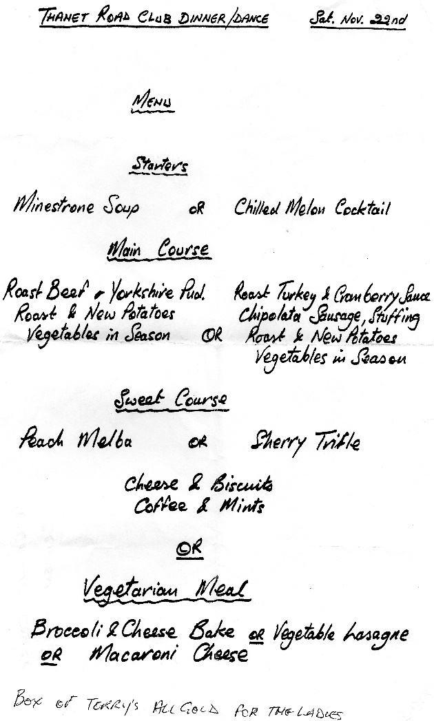

Discounts currently available to Club Members
Michael Kelleher MIRMT-IIST a Professional Therapist, is a club member.
He would like to offer any club members who may require help, the following treatments:-
Sports Injuries
Remedial Back Therapy
Swedish Holistic Massage
Aromatherapy
Indian Head Massage
Courses of Instruction are also available in any of the above.
Club members requiring treatment will receive, on production of proof of membership, a discount of 25% on the current fee of £40 per session.
Contact Michael on 01227 771493 Mob 07879861618, email backtherapist@yahoo.co.uk
Website:- www.michaelsmassagetherapy.co.uk

Locks of Sandwich : 10% on selected items
St Peter’s Cycles, Broadstairs: 10% on selected items
Bike Warehouse, Herne Bay, Faversham, Gillingham, Sevenoaks: 10% on selected items
Black Cat Coaching- special rates offered
Please also note anyone who arrives at Stonelees Golf Centre on a bike/walking/public transport gets free golf club hire

Ian Edginton, a former member of the club, has started his own cycle maintenance and repair business from his home at Staple near Wingham and welcomes your custom. All types of repair including wheel building are available. Contact Ian at ian.edginton123@btinternet.com or 07786425829. Ian`s father Alf, is also a very long standing and respected member of the Club

Club member Martin Hendy has his own Landscaping and Gardening business and is offering free estimates and discounted rates for Club members.
This looks like a good opportunity to get out on your bike while Martin does the garden.
Garden maintenance & fencing works
Tel 01227 368373
Mob 07958 709736
Email m.hendylandscapes@talktalk.net

For Sale

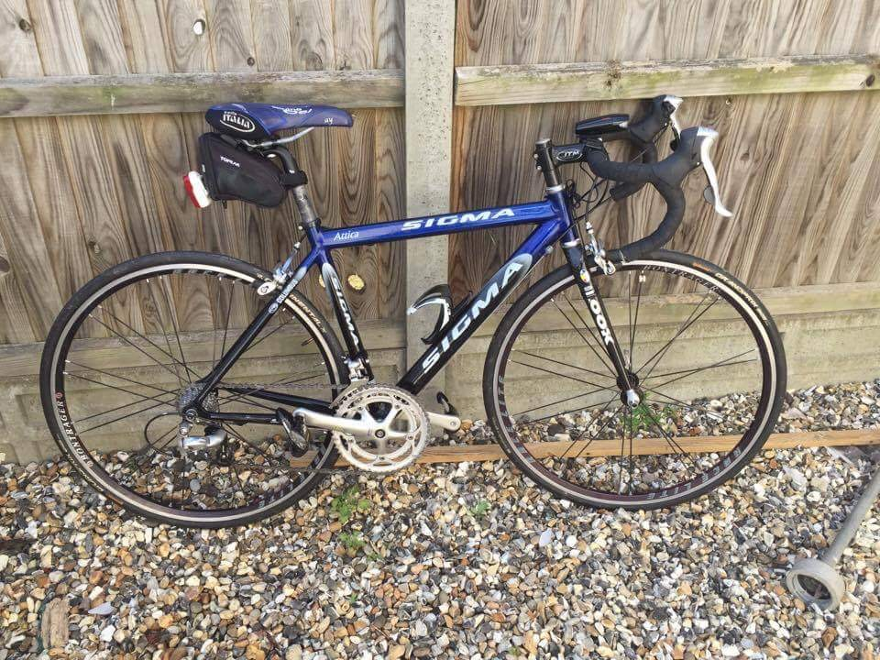

Sigma 650
9 speed Shimano Tiagra, Bontrager wheels, Look carbon forks.
Good condition, minor wear marks.
Ideal kids first racer.
£265.00

Contact Tony 07711 410051

Monthly Quiz
No one came up with the answer which was his mother who received her award for services to nursing.

This Month`s Question:-

Who was the first non-European to wear the yellow jersey in the Tour de France and what year was it?

