NEWSWHEEL

Newsletter for Thanet`s Premier Cycling Club
Affiliated to: British Cycling; CTT;KCA;CTC
Thanetrc.org.uk
August 2016

News
Once again the Annual Summer Barbecue was held at St Nicholas and was a great success. Lots of members attended and enjoyed great food and some fun events. Many thanks to Helen Hill and her team of helpers for a very enjoyable afternoon.

Members of the Club who took part in the Prudential London 100 Sunday 31st July. All got round safely.
Well done lads!

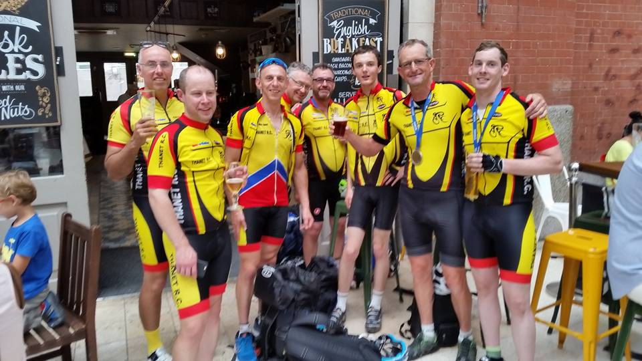

Time Trialling
The Time Trialling Section of the Club is really flourishing at the moment with lots of members participating.
This is mainly due to the phenomenal performances being produced by our star rider, Chris Fennell.
Whenever Chris takes the start line the Course record, the Club record and his own PB are under threat at all distances up to 100 miles. Indeed, in the KCA 100 he suffered 2 punctures losing an estimated 10 minutes and still broke the Club record by 8 minutes! He now holds the record for most of the Kent courses, plus all the Club records for all distances up to 100 miles with the exception of the 30 miles.
This has fostered a keen spirit in the Club with many riders improving on their own performances mainly Chris`s brother Nic who is advancing rapidly, and Nicola Goodban who has set a new ladies record for 10 miles recently. Many of our newer members are also trying their hands at time trialling with some success, and the youngsters are getting faster all the time, junior records are tumbling regularly.
So, keep it up Chris, we`re right behind you (literally).

Racing Results Open Events (TRC Riders)
Ollie SE Junior Road Race Champion
Just wanted to say a huge thank you to all helpers at the SERLL/ SE junior road race champs today Sunday 3rd July. Thanet RC co-promoted the event with our friends at Medway Velo. Thanks to Josh Chivilo, Alex Ashman, Steve Ashman, Ken Jones, Tony Arnold, Gary, Richard Bazin and Phil Cook(comm). The club riders also rode excellently with Ollie Robinson 1st in SE junior race (2nd overall) and Dan Martin 5th junior. Great performance from our riders on a testing hilly course of 100km with average speed 25mph.
George Pittock rides National Youth Road Champs.
George Pittock raced at Redbridge Cycling Centre in Essex at the 2016 National Youth Circuit Championships on Sunday 10 July.
The event is the high point of British Cycling’s calendar of youth racing, and where the national age group champions are crowned.
The 85 Under 14 Boys were selected by the organisers, the top 20 ranked riders in the UK were all on the start line and the 2km circuit, a £5m London 2012 legacy facility, included the infamous Hog Hill, which averages 8% over 300m with a maximum 10.5% near the summit.
The pace was fast from the gun with Oscar Nilsson-Julien (VC Londres) launching a solo break on the second lap and opening up a gap of over 20 seconds before the main bunch closed him down. George stayed with the main bunch for 25 minutes as a series of attacks went off the front, but then he dropped back into a small chasing group.
The race was won by Oliver Stockwell of Welwyn Wheelers, who had a lead of more than 30 seconds before the peloton reacted, but he held on to win by just a few seconds ahead of Manchester based Mossley CRT riders Robert Donaldson and Junior Jackson who took second and third respectively.
George worked well with his friend Lloyd Costello of Preston Park Youth CC (Brighton) until the group were unfortunately lapped by the leaders and pulled from the race according to British Cycling regulations.
George was pleased with his overall performance and his first appearance at the national championships. He is currently ranked 10th in the South East region (Kent, Sussex, Surrey and London) and finished where he expected to be among his closest rivals.
George has worked very hard this year, he has achieved all of his goals for the season and this was further valuable experience for him.
Spring in the Park Final Results and Report.
Thanet RC showed its strength in depth, and the commitment of its riders and their parents, with 13 riders scoring points across all age groups at the 2016 Spring in the Park youth series at Cyclopark.
Overall standings have been published for the nine week series that ended on Friday 8th July, with the best six performances deciding the overall series winners and prizes. The following is a brief round-up of Thanet RC results.
Ben Hutton (5 races) finished seventh overall in the Under 8 Boys category. Max Robinson was Thanet RC’s most prolific and most consistent performer, competing at all nine Under 10 Boys races and achieving three second place finishes, five third and one fourth, to finish second overall in the standings behind Henry Hobbs of Barking & Dagenham CC who has yet to be beaten in any race anywhere! Lughaidh Cook (8 races) finished eighth overall in the same category, with Alex Dack (1 race) 12th.
Tom Hutton (4 races) finished 19th for the Under 12 Boys.
George Pittock (7 races) headed a strong Thanet contingent of Under 14 Boys, with three fourth place finishes for equal fourth overall. New member Hamish Reilly (7 races) finished sixth overall, with Lance Childs (6 races) and Flynn Robinson (6 races) equal in eighth. Toby Yemm (1 race) was 19th.
Toby Perry (1 race) finished 23rd in the Under 16 Boys category, while Alex Ashman and Joshua Chivilo also competed but did not score points.
Millie Dack (1 race) finished equal seventh in the Under 10 Girls category.
Freya Cook (8 races) achieved one third and two fourth place finishes for fifth overall in the Under 12 Girls age group.
We would like to thank all of the above (and anybody else who we might have missed), and particularly their parents who made the commitment and the 100 mile round trip to Gravesend each week. Spring in the Park is a very well organised series of regional races, which provide great experience for our young riders.
Thanet RC was the fourth best represented club at the series after host club Team Darenth and the big London clubs Barking & Dagenham CC and Lee Valley Youth CC. Your efforts help to raise the profile of our club and to enhance its growing reputation.
Thank you and well done to everybody.

Thanet RC represent regional teams at Prudential Grand Prix
Three Thanet RC riders represented regional teams at the National Prudential Grand Prix yesterday at the Lee Valley Cycle centre road circuit. Flynn and Hamish represented the south east in the under 14 boys event. The race was fast with a number of breaks. Flynn stayed in the main group until losing contact in the last 10 mins of the 45 min race. Hamish did really well have a number of attacks off the front to stay with the main group just losing out in the sprint finish to come top 20. Alex Ashman received a place late to ride for the Surrey team in the under 16 boys race and did really well for his team staying with the main bunch to come midway through the field at the end. Well done to the boys. Post by Colin Robinson
Saturday 30th July Locks Women's Go-Race #4. Betteshanger. A very busy weekend for cycling elsewhere so a limited turnout of 4. The bunch stayed together, well done to Charmaine for sitting in there on only her 2nd race. A close sprint finish ensued with Nicola Goodban (TRC) beating Jody Coxon (Adalta) into 2nd and Alex Aherne (VC Deal) 3rd and Charmaine Pullen (Adalta) 4th. A big thank you to Andy Croucher of Locks for his continuing support, as also Ken Jones for the super Fenwick gift vouchers which all attending women benefitted from. Next race Friday 2nd Sept 6pm.
Owler Triathlon Sunday 31st July Well done to Alex Dack winner of Tristars Cat 1 and Olly Dickson 1st Under 18.
Sunday 3rd July VTTA 10 Q10/30 (Thanet Way) Chris Fennell 19.14 (PB), Simon Henderson 20.59, Bill Hawkes 21.13 (PB), Huck Garip 21.23 (PB), Nic Fennell 21.28 (PB), Scott Meeks 22.37, Colin Robinson 22.45 (PB), Chris Bax 22.59, Mark Palmer 23.01, Mike Kirkness 23.14 (PB), Martin Russell 23.36 (PB), Gary Russell 23.37 (PB), Brian Hood 24.02 (PB), Nicola Goodban 24.23 (PB), Chris Childs 24.39, Peter Huckstep 25.14, Andy McCall 25.34 (PB), Dave Mastin 25.38, Phil Cook 26.05 (PB), Paul Kirkness 26.06 (PB), Andy Burrows 26.40, Paul Griffiths 27.20, Jenny Fearn 31.06, Paul Kelk, Eddie Brown DNS. Chris Fennell was the winner. A fine day on the only event this year on the fast course produced a total of 34 3 year PB`s. Well done to all who managed it.
Thursday 7th July PMR 10 Q10/1 (Hamstreet Bypass) Martin Russell 23.18 (PB), Huck Garip 21.46, Nicola Goodban 24.30, Bill Hawkes 21.29, Dave Mastin DNS, Paul Kelk 25.01, Andy Mc Call 25.45, Colin Inett 26.12, Simon Henderson 21.29, Andy Macpherson 23.58, Chris Bax 23.33, Nic Fennell 22.06, Chris Fennell 19.17. Chris was the fastest.
Saturday 9th July GHS District Champs/KCA 10 Q10/42 (Betteshanger CP) GHS Event Toby Hammond 23.31, Joshua Chivilo 24.36, Charlie Burgess 26.46, Flynn Robinson 27.36, Lance Childs 28.00, Jack Hill 30.55, Megan Griffiths 32.25. Toby, Joshua, Charlie, Flynn, Lance and Megan all won their age groups and thus qualify for the National Final on the K33/10D in Warwickshire on September 10th. Well done to all who entered.
KCA Event Chris Fennell 20.00, Dan Martin 21.49, Nic Fennell 22.32, Colin Robinson 23.43, Richard McVey 23.46, Martin Russell 24.33, Nicola Goodban 25.31, Chris Childs 25.50, David Redmond 26.58, Heidi Hammond 27.52, Caroline Rigby 28.43, Max Robinson 32.02, Jenny Fearn 33.16. Well done to all who rode on a very blustery day.
Sunday 10th July Gravesend CC 25 Q25/8 (Molash-Canterbury-Ashford-Chilham) Chris Fennell 50.05, Simon Henderson 56.12, Huck Garip 57.48, Nic Fennell 58.24, Chris Bax 1.01.38, Dave Danton 1.0158, Martin Russell 1.02.02, Paul Kelk 1.06.43, Robert Sissons 1.10.16, Andy Burrows 1.12.28, Paul Griffiths DNS. Chris was the fastest with yet another Course Record.
Thursday 14th July PMR 10 Q10/1 (Hamstreet Bypass) Martin Russell 23.25, Rick Perkins 22.00, Huck Garip 22.07, Nicola Goodban 23.22 (PB, Club record), Mark Palmer 22.30, Dave Mastin 25.13, Bill Hawkes 20.56 (PB), Paul Kelk 24.22, Andy McCall DNS, Simon Henderson 21.40, Colin Inett 26.35, Chris Fennell 19.11, Andy Macpherson 23.48, Chris Bax 23.23, Nic Fennell 22.09 (PB). Well done to Chris Fennell with a new Course, Club Record and PB, also Nicola Goodban with a new Club Ladies Record and PB. Well done also to the others who did PB`s.
Saturday 16th July San Fairy Ann 10 Q10/22 (Harrietsham) Chris Fennell 19.44 (Course Record), Bill Hawkes 21.31, Dan Martin 21.35, Nic Fennell 22.45, Lawrence Martin 22.50, Scott Meeks 23.50, Martin Russell 24.06, Paul Kelk 25.16, Simon Henderson DNS. Well done Chris once again.
Go-Ride Racing 16th July Betteshanger CP
U8 U10 U12
- Ben Hutton 1. Max Robinson 1. Stanley Rose
- Grace Philpott (1st Girl) 2. Thomas Crow-Brown 2. Tom Hutton
3. Ferne Pierce (1st Girl) 3. Eleanor Fox (1st Girl)
4. Millie Dack

U14 U16

2. George Pittock 1. Josh Chivilo
5. Lance Childs 2. Alex Ashman
6. Flynn Robinson 4. Charlie Burgess
7. Jack Hill 5. George Bussey
8. Toby Yemm 6. Megan Griffiths (1st Girl)
No senior race- BC unable to provide Commissaire. Many thanks to Helen Hill and her helpers for putting it all together.
Sunday 17th July VTTA 50 Q50/11 (Brenzett-Camber-Lydd) Chris Bax 2.06.04, Dave Danton 2.06.01 (PB), Huck Garip 1.56.38, Dave Mastin 2.20.51, Chris Fennell 1.44.00 (PB, Course Record, Club Record), Colin Inett 2.24.45 (3yr PB, Club Age Record), Nic Fennell 1.58.02 (PB), Rick Perkins 2.01.18, Simon Henderson 1.55.02, Andy Burrows 2.27.02. Another scintillating performance by Chris.
Thursday 21st July PMR 10 Q10/1 (Hamstreet Bypass) Chris Fennell 19.01 (Course Record, PB, and Club Record), Bill Hawkes 21.00, Simon Henderson 21.30, Rick Perkins 21.33, Huck Garip 22.00, Nic Fennell 22.04 (PB), Mark Palmer 22.20, Chris Bax 22.54, Andy Macpherson 23.14, Martin Russell 23.21, Nicola Goodban 23.54, Paul Kelk 24.44, Dave Mastin 25.27, Andy McCall 26.02, Colin Inett 26.07, Malcolm Adams 27.14, Jenny Fearn 30.19(PB). Well done Chris-another super ride.
Thursday 28th July PMR 10 Q10/1 (Hamstreet Bypass) Chris Fennell 19.19, Bill Hawkes 20.47 (PB), Ollie Robinson 21.14 (PB and new Club Junior Record), Nic Fennell 21.35(PB), Simon Henderson 21.39, Rick Perkins 21.50, Huck Garip 22.00, Colin Robinson 23.06, Martin Russell 23.19(PB), Chris Bax 23.43, Andy Macpherson 23.54, Nicola Goodban 24.17, Paul Kelk 25.01, Dave Mastin 25.10, Colin Inett 26.19, Andy McCall 26.34, Malcolm Adams 27.38, Jenny Fearn 31.05. Chris is the Series Winner and Emma Lewis (Adalta CC) the Ladies Winner. Well done to all members who produced PB`s in the series.
Saturday 30th July VTTA 10 Q10/1 (Hamstreet Bypass) Huck Garip 22.17, Martin Russell 23.28, Dave Mastin 25.34, Simon Henderson 21.20, Chris Bax 23.14, Paul Kelk 24.47, Andy Burrows 26.29, Bill Hawkes 21.08, Colin Inett 26.44, Nic Fennell 22.17, Malcolm Adams 27.15, Chris Fennell 19.36. Chris was the winner once again.
Sunday 31st July West Kent RC 25 Q25/20 (Harrietsham) Paul Kelk 1.08.46, Colin Inett 1.14.02, Lawrence Martin 1.00.31, Andy Burrows 1.14.56, Simon Henderson 58.33, Huck Garip 59.51, Amdy Macpherson 1.04.11, Andy McCall DNS, Chris Fennell 52.05, Dan Martin 57.36, Nic Fennell 59.42, Chris Bax 1.02.54.
Well done to Chris for yet another victory and to Dan Martin 1st Junior.

Forthcoming Open Events
Sunday 7th August De Laune CC 25 Q25/20 (Harrietsham)
Sunday 14th August KCA 50 Q50/1 (Harrietsham)
Sunday 21st August KCA 12 hour Q/12 (Romney Marsh) Cancelled due to lack of helpers.
Sunday 28th August Catford CC 25 Q25/12 (Old Romney-Kingsnorth-Old Romney)
Sunday 11th September KCA 25 Q25/10 (Thanet Way) Promoted by Andy McCall who will require helpers on the day.

Club Events- TRC riders only
Evening 10 Wednesday 6th July Q10/42 Betteshanger CP Juniors Ollie Robinson 22.12, Olly Dickson 24.07, Josh Chivilo 24.11, Charlie Burgess 26.02, George Pittock 26.04, David Redmond 26.37, Flynn Robinson 27.43, George Bussey 28.03, Megan Griffiths 31.36, Alex Dack 32.54, Millie Dack 46.51, Max Robinson/Ryan Jackson 2-up 30.11.
Seniors Chris Fennell 19.55, Simon Henderson 21.50, Nic Fennell 22.34, Mike Kirkness 23.28, Matt Hall 23.36, Colin Robinson 23.37, Dave Danton 23.40, Michael Friend 24.24, Brian Hood 24.30, Jason Wares 24.46, Gary Russell 24.50, Chris Childs 25.51, Peter Huckstep 25.59, Paul Kirkness 26.17, Robert Sissons 26.35, Colin Inett 27.05, Jez Dack 27.08, Simon Charles 27.40, Roger Dewen 30.37, Jenny Fearn 32.08. Chris was the fastest.
TRC 4-up TTT Wednesday 13th July Q10/42 Betteshanger CP. Stanley Rose/Alex Dack/Max Robinson 46.35, Toby Anderton/Shawn Manning/Andy Hill/ Ollie Robinson 31.47, Simon Charles/Gary Russell/Nick Scott 36.37, Lance Childs/Flynn Robinson/Charlie Burgess/George Pittock 35.49, Nicola Goodban/Jenny Fearn/ Heidi Hammond/Megan Griffiths 42.39, Brian Hood/Chris Childs/Peter Huckstep/David Redmond 35.45, Dave Mastin/Robert Sissons/Paul Kelk/Paul Kirkness 36.05, Scott Meeks/Colin Robinson/Matt Hall/Martin Russell 32.27, Michael Friend/Josh Chivilo/Mike Kirkness/Olly Dickson 33.16, Richard McVey/Peter Elms/Jo Malpass/Jill Cliff 34.22. The winners were:- Adrian Lyons/Jon Lyons/Tim Kingston/Mark Whittaker 31.29.

Dates for your Diary

Club AGM
This will be held on Friday 4th November, venue to be confirmed.
Club Dinner and Prizegiving
This will be held on Saturday 12th of November at Minster Village Hall, time to be confirmed.

East Kent Cyclo Cross 2016-17 Series Dates/Venues Announced:
Racing for all categories; Under 12, Youth, Juniors, Women, Men and Vets
All entries via British Cycling (except Round 5)
Round 1 Sunday 11th September Sandwich Tech Cross.
Round 2 Sunday 16th October Bay Point Cross.
Round 3 Sunday 13th November Discovery Park Cross
Round 4 Sunday 18th December Venue TBC
Round 5 Sunday 15th January Betteshanger Cross (combined LCCA round)
For further info contact eastkentcyclocross@gmail.com ‪‬‬‬‬‬‬‬‬‬‬‬‬‬‬
‪‬‬‬‬‬‬‬‬‬‬‬‬‬‬
‪‬‬‬‬‬‬‬‬‬‬‬‬‬‬

‪‬‬‬‬‬‬‬‬‬‬‬‬‬‬

‪‬‬‬‬‬‬‬‬‬‬‬‬‬‬
‪‬‬‬‬‬‬‬‬‬‬‬‬‬‬
‪‬‬‬‬‬‬‬‬‬‬‬‬‬‬

‪‬‬‬‬‬‬‬‬‬‬‬‬‬‬

‪‬‬‬‬‬‬‬‬‬‬‬‬‬‬
‪‬‬‬‬‬‬‬‬‬‬‬‬‬‬
‪‬‬‬‬‬‬‬‬‬‬‬‬‬‬

‪‬‬‬‬‬‬‬‬‬‬‬‬‬‬

Go- Ride Training Sessions 2016
Date | Location | Time | Lead Coach
July-Sept | No sessions | Summer Break

Go- Ride Racing
The Whites Summer Series has been a great success with lots of participants, guests from other Clubs and a great atmosphere. Many thanks to Colin and all who helped. For all results, see website.

Day | Date | Event | Sponsor | Location |  | Time
Monday | 8th Aug 2016 | Thanet RC Whites Summer Series.8 | Whites Transport | Betteshanger 18.00-20.00 |  | 18.00-20.00
Saturday | 17th Sept 2016 | Vuelta a Fowlmead |  | Betteshanger | 10.30-12.30
Sunday | 25th Sept 2016 | Thanet RC Omnium | Blackcat Coaching | Betteshanger 13.00-17.00 |  | 1-5pm
Saturday | 29th Oct 2016 | Go-Ride Racing Cluster (East Kent) - Winter | Whites Transport | Betteshanger 13.00-15.30 |  | 1-3.30pm
Saturday | 10th Dec 2016 | GoRide Racing MTB series 2 of 4 | Whites Transport | Betteshanger 12.45-15.30 |  | 12.45-15.30
Women only Go-Race dates 2016
Day | Date | Event | Sponsor | Location |  | Time
Friday | 26th August 2016 | Women only road series round.5 | Locks / Ken Jones | Betteshanger 18.30-19.30 |  | 18.30-19.30
Sunday | 25th Sept 2016 | Women only road series round.6 | Locks / Ken Jones | Betteshanger 10.00-11.30 |  | 10:00-11:30

Club Clothing
Robert Sissons has kindly agreed to take over the club clothing.
His contact details will be on TRC website from 1st September.
Until then, please, continue to contact me.
Pete Huckstep. email peter.huckstep@btinternet.com phone 01843 845107 or facebook message me.

Articles Wanted
I now work as editor of Cycling World Magazine which specializes in leisure, tourism, sportives and commuting. I am always looking for stories. We also do book and film reviews. Please contact David Robert (TRC Committee member) at editor@cyclingworldmag.co.uk

TRC Heritage Project contact: davealexrob@yahoo.com
We are forming a working group for the 70th Anniversary in 2017. Please get in contact with any ideas and/or if you’d like to get involved in any way.

TRC Material Wanted for Anniversary Exhibition
We’d like TRC members and friends to lend a photo (or press cutting, or jersey, or bike, or any item) for an exhibition. Could be from any time, recent history is still of interest. Drawings and sketches are encouraged, especially from young members. Originals preferred, but scans accepted. Please provide now as this is the funding period to get them framed/exhibition ready, though the exhibition will be mounted for 2017, the 70th anniversary year. We will take care of items and return (framed if desired).
Following details required with item:
Who, what, where
A very short bit about your place in TRC and why you chose this item
And from the archives…. Lawrence Martin and Len Coomber, Beauvais 1991, Grand Prix des Gentleman. A two-up TT with a senior and a veteran.

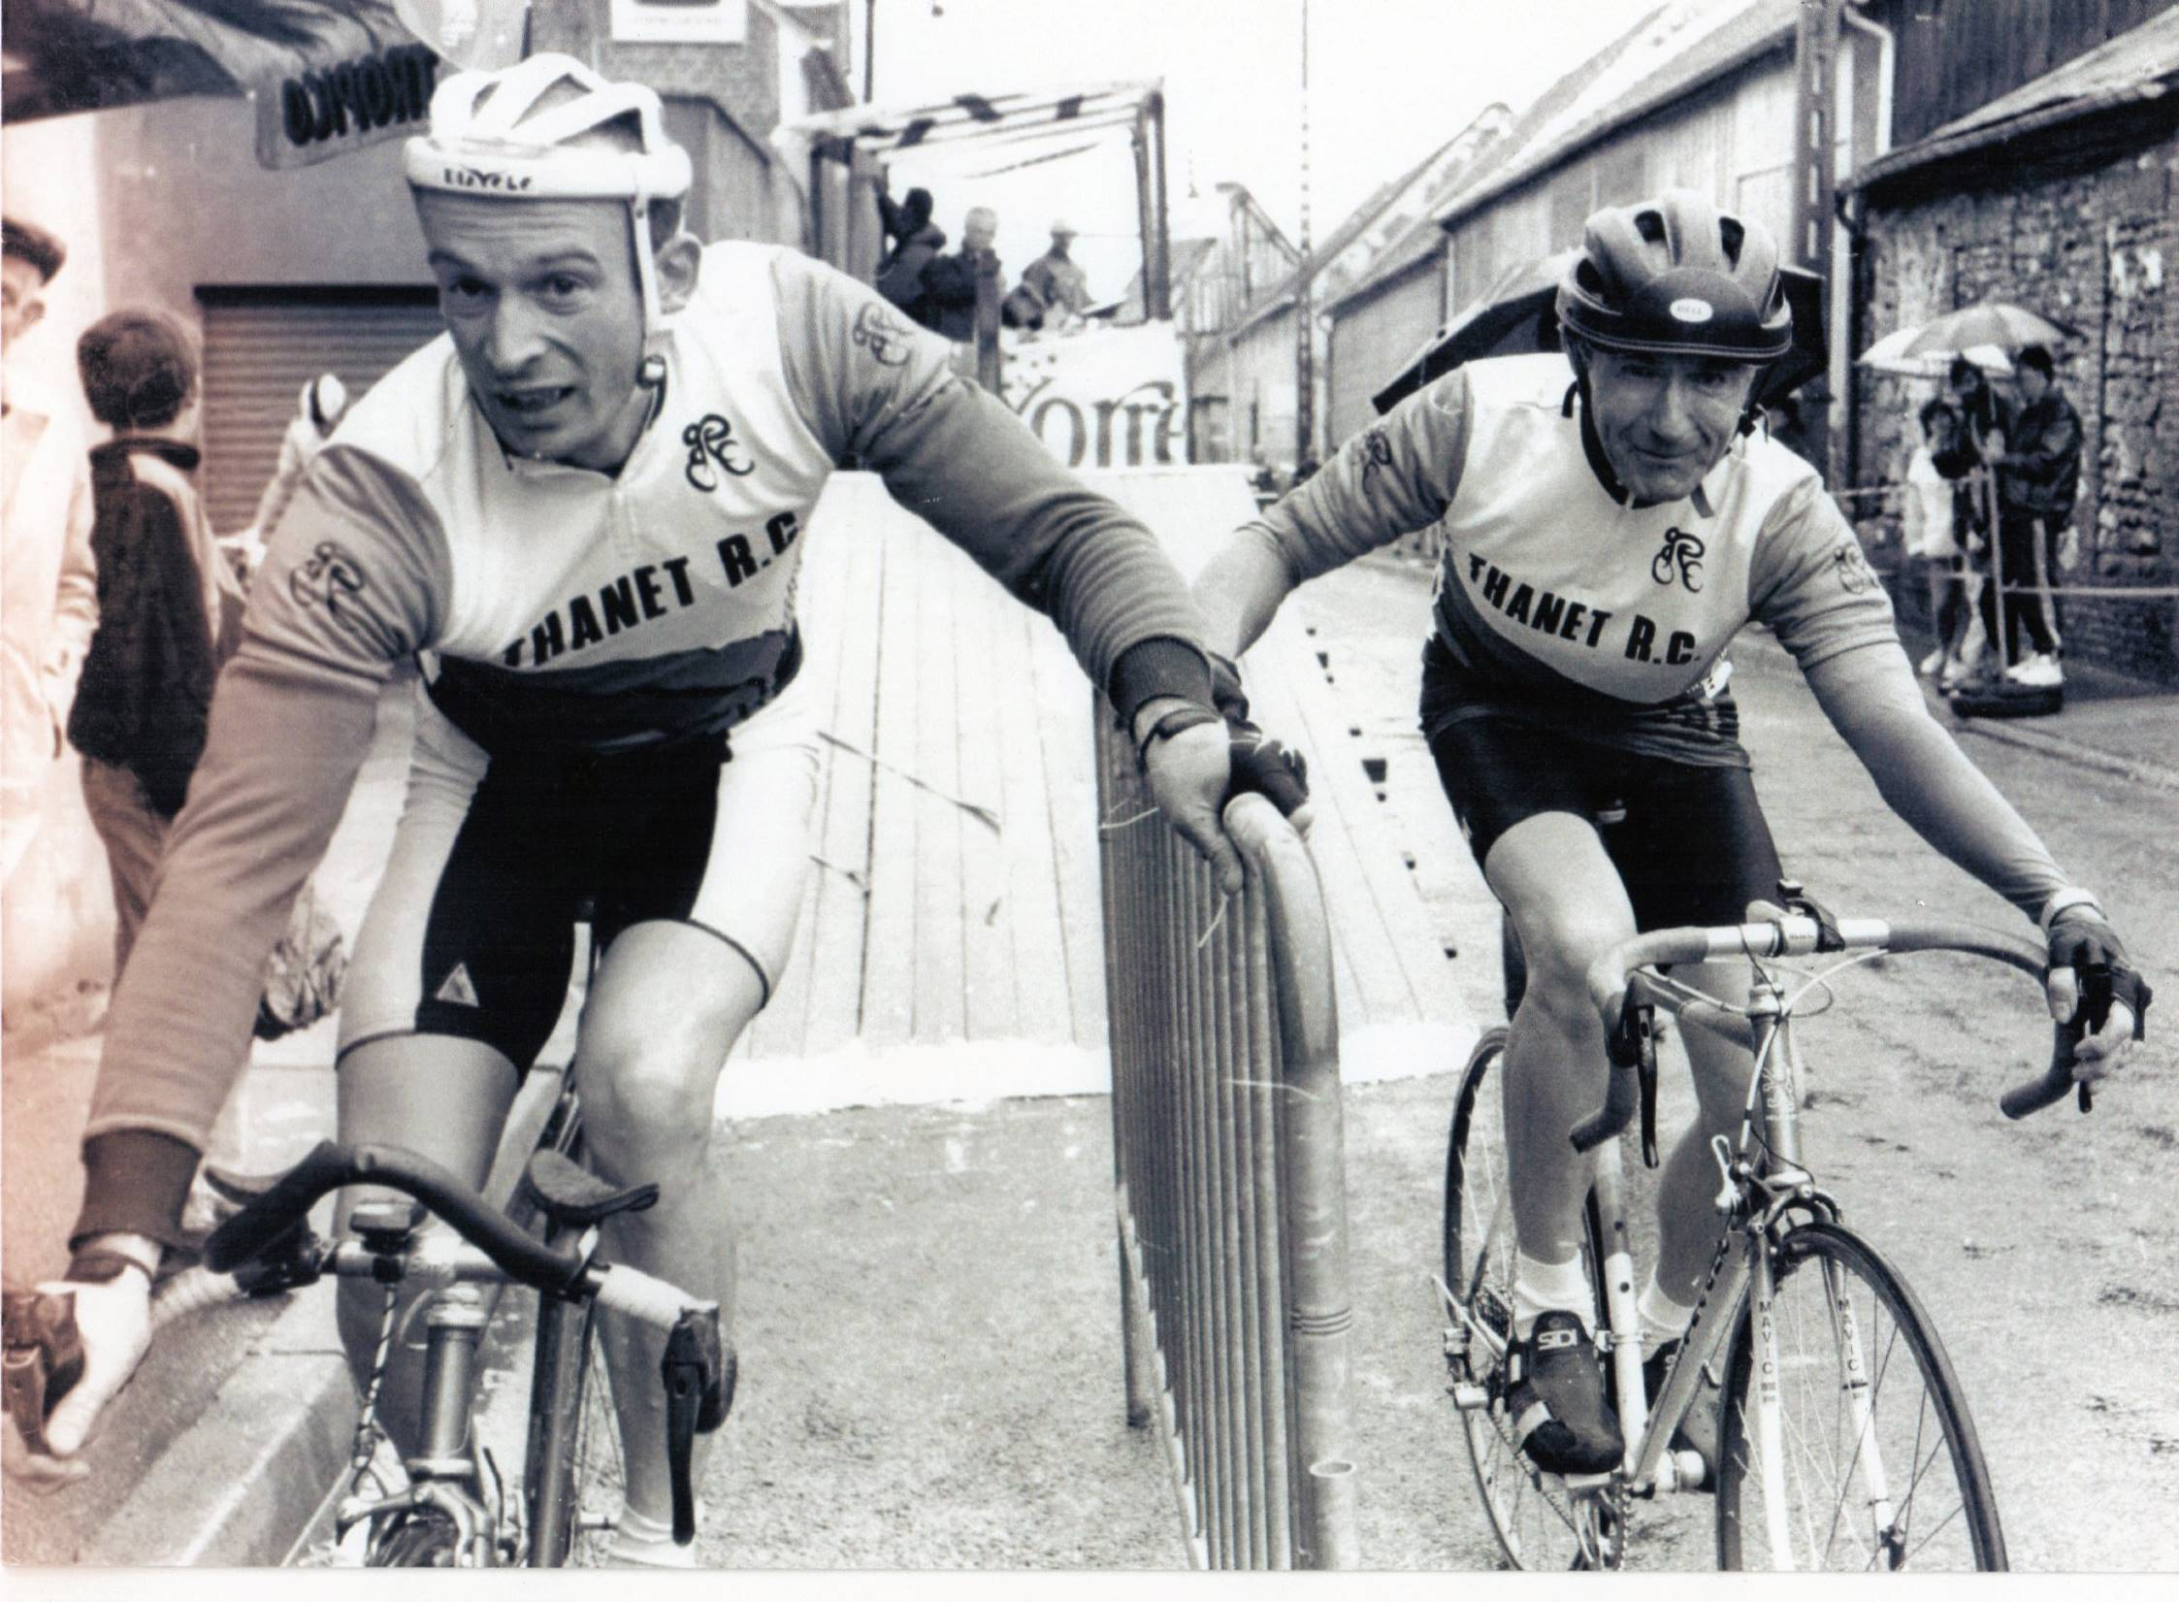

Discounts currently available to Club Members
Michael Kelleher MIRMT-IIST a Professional Therapist, is a club member.
He would like to offer any club members who may require help, the following treatments:-
Sports Injuries
Remedial Back Therapy
Swedish Holistic Massage
Aromatherapy
Indian Head Massage
Courses of Instruction are also available in any of the above.
Club members requiring treatment will receive, on production of proof of membership, a discount of 25% on the current fee of £40 per session.
Contact Michael on 01227 771493 Mob 07879861618, email backtherapist@yahoo.co.uk
Website:- www.michaelsmassagetherapy.co.uk

Locks of Sandwich : 10% on selected items
St Peter’s Cycles, Broadstairs: 10% on selected items
Bike Warehouse, Herne Bay, Faversham, Gillingham, Sevenoaks: 10% on selected items
Black Cat Coaching- special rates offered
Please also note anyone who arrives at Stonelees Golf Centre on a bike/walking/public transport gets free golf club hire
Ian Edginton, a former member of the club, has started his own cycle maintenance and repair business from his home at Staple near Wingham and welcomes your custom. All types of repair including wheel building are available. Contact Ian at ian.edginton123@btinternet.com or 07786425829. Ian`s father Alf, is also a very long standing and respected member of the Club
Club member Martin Hendy has his own Landscaping and Gardening business and is offering free estimates and discounted rates for Club members.
This looks like a good opportunity to get out on your bike while Martin does the garden.
Garden maintenance & fencing works
Tel 01227 368373
Mob 07958 709736
Email m.hendylandscapes@talktalk.net

For Sale

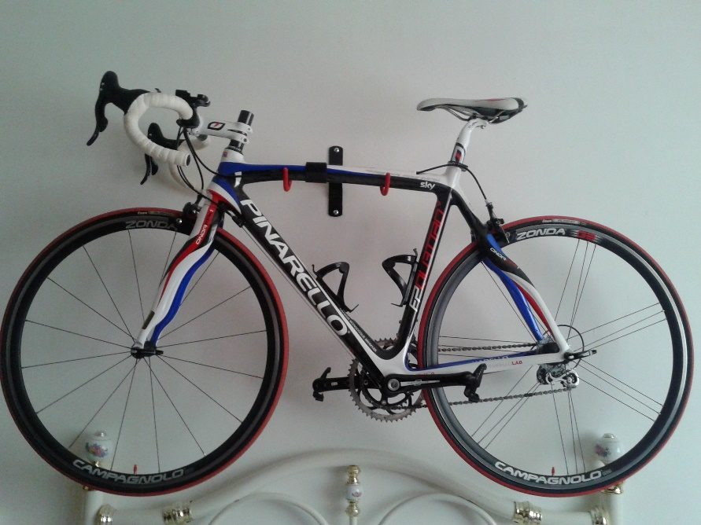

Pinarello Quattro will suit 5ft 8-6ft. British Cycling colours. Weight < 8Kg.
All carbon with Campag Centaur groupset and Campag Zonda wheels.
Look carbon pedals
I have had this for 4 years but it has hardly been ridden, less than 500 dry miles.
Showroom condition, absolutely unmarked.
Original cost £3,400 will sell for £1950.
Contact Paul Sawkins (Club member) 07956 944345

Items for Sale from Simon Henderson
-------------------+

+Individual components
Sram Red 22 Rear Derailleur, 11 speed, short cage, new and unused. RRP £272 available for £150
Sram Red 22 Front Derailleur, braze on fixing, new and unused. RRP £104 available for £50
Sram R2C gear shifters for aerobars, 11 speed, new and unused. RRP £264 available for £140
Zipp 808 ‘firecrest’ front carbon tubular wheel complete with Vittoria Corso CX tub, excellent condition, true and no marks, original decals removed, complete with skewer, original documentation. RRP £839 available for £440
Contact: simonhenderson44@btinternet.com
07813085640
01843850505

Monthly Quiz
Well done to Pete Haswell for coming up with a question that no-one (not even David Robert) could produce the answer, which was Frederick Henry Grubb who became the famous frame builder Freddie Grubb.

This Month`s Question:-

World Road Race Champion 2008 Olympic Road Race Champion 2008
Commonwealth Road Race Champion 2002 Winner Giro d`Italia 2004
Winner Tour de France 2006,2007 Winner 3 x Fleche Wallonne 2003,2005,2006
Winner Amstel Gold 2003 Winner Tour of Flanders 2007

Whose palmarés is this?

