

**NEWSWHEEL**

**Newsletter for Thanet`s Premier Cycling Club**

Affiliated to: British Cycling; CTT;KCA;CTC

**Thanetrc.org.uk**

June 2016

**News**

Message from Jim Dickson

It is with much pleasure that I announce that Caroline Rigby and Nicola Goodban will share the role of Women’s Rep on the committee until the AGM later this year.

I think that the best way of contacting Caroline or Nicola is through the club’s page on Facebook.

We wish them both well in this important role.

Well done to Sue Shields for completing the Ride the Night, Windsor-London-Windsor on Saturday night in the company of 3000 other ladies, this not long after a nasty crash on Romney Marsh only a few weeks ago.

**Racing Results Open Events (TRC Riders)**

Saturday 7th May, CC Bexley 10 Q10/24 (Isle of Grain) Dave Mastin 26.39, Colin Inett 29.26, Andy McCall 26.18, Paul Kelk 26.04, Malcolm Adams 29.11, Simon Henderson 22.44, Martin Russell 24.48, Dan Martin 22.09, Chris Bax 24.55, Heidi Hammond 28.18, Nicola Goodban 26.04, Jon Parker 20.23. Mark Foulds, Nic Fennell, Toby Hammond, Olly Dickson, Lawrence Martin, Chris Fennell all DNS. Andy Macpherson DNF as he generously stopped to help a crashed rider, well done Andy. Well done also to Dan Martin fastest Thanet rider and 1st Junior, Nicola Goodban 1st Lady and Jon Parker (2nd claim) with the fastest ride of the day 20.23, a new course record.

# [Good TRC performances at Round.1 of Summer in the Park series](https://thanetrc.wordpress.com/2016/05/07/good-trc-performances-at-round-1-of-summer-in-the-park-series/) May 6th.

Spring in the Park #1. A good turnout of Thanet RC riders tonight, not sure of placings so just an outline of racing. First off in U10 boys were Max and Lughaidh both staying in the action all the way wIth Max taking 3rd. Freya was the TRC representative in the U12 race having an exciting sprint with a Kent Velo Kids girl edging it on the line by 10cm. Then in the U14 race came Lance, George, Hamish and Flynn who sadly had to retire. Not sure of any further TRC riders as left to get the kids to bed before tomorrow’s racing at Betteshanger. Well done all. Post by Phil Cook

[TRC Road Racing and Track weekend report](https://thanetrc.wordpress.com/2016/05/09/trc-road-racing-and-track-weekend-report/)

A very busy weekend for the club riders and organisers this weekend. Firstly was the Tour D’Betteshanger kindly sponsored by Overden. The youth events run by Phil Cook saw some fantastic results for the club with 7 wins out of 10 events. Special mention to Ben Hutton, Ferne Pierce Grace Philpott, George Pittock and Alex Ashman for gaining their first wins at regional level. Thanks to all helpers on the day.  
In the afternoon was the Adalta Adult Summit races. TRC rider Ed Smith while leading unfortunately crashed out of the Go Race but no serious injuries. In the women’s race Caroline Rigby lost touch with the main peloton however kept going for 9th place. Finally Ollie in the cat 2-3-4 race gained 2nd= in a fast sprint finish almost catching Adalta winning rider Ross Bryan.  
On Sunday Ollie was again riding in the tough SERLL cat 2-3-4 road race on hilly Rolvenden circuit in 70 mile race. Ollie suffered a bit in very hot weather and sore legs from day before but still finished 19th in field of 60. Finally Rob Milnes travelled up to Ashwell for a Grasstrack event organised by Victoria’s dad Max Pendleton. Rob rode very strongly gaining 6th overall. Post by Colin Robinson

[**Lance finishes the Regional Omnium Series well**](https://thanetrc.wordpress.com/2016/05/15/lance-finishes-the-regional-omnium-series-well/)

Today was the final in the series of 4 regional youth Omniums (we attended 3 of the 4 as one clashed with the TRC Giro d’betteshanger). Round one was at Lee Valley back on the 23rd April where Lance worked hard after a slightly disappointing 4 lap TT (1km) but the step up to first year U14 meant playing catch up was pretty hard, finishing 19th out of 26.

6Round 3 (was last Sunday after the SITP race on Friday and a 2nd place in the Giro d’Betteshanger) took us down to Brighton to Preston Park to be part of the re-opening celebrations, (even managing to get on ITV local news) Lance tells me that the Preston Park track is pretty unique with an almost square shape, uphill section, downhill section to the banking in front of the pavilion, blistering heat and breezy conditions. Also at 580m (longest in the UK) a 2 lap TT was a tricky discipline to try and master on his first visit to the track. Lance worked hard, sneaking shade from other riders gazebos as the temperature soared (Thanet RC need to look at purchasing a gazebo so that we can fit in with the gazebo village that springs up at these Omniums.) As a lone rider from Thanet it was difficult as there was a lack of team mates in races but through the track league meets in 2015/2016 Lance has made a lot of friends with track riders but seeing a few more flashes of Thanet yellow on the track would be fantastic.  
At Preston Park it was evident that Preston Park/VC Jubilee riders did really well, equipped with the local track knowledge but Lance tried hard, finding the TT tough and an early exit from the elimination left him pushing to launch of the front of a fast pack to scrape a point in the points race which took the last of his energy on the day! Finally finishing the day at 20th overall.  
Today took us to Herne Hill velodrome (looking akin to a building site as work has started on the removal of the old derelict pavilion ready for rebuilding) Lance’s TT left him in the bottom 10 riders out of 33 starters, Lance dug deep and produced a solid performance in the Devil finishing 16/17th, In the scratch Lance just missed a crash, resulting in bruised elbow/arm as he got knocked by a set of handlebars but miraculously stayed upright, after a restart Lance pulled back a group to the leaders which left him spent so he finished 25th overall with just the points to go. In the points he stayed safe in the wheels and consolidated his 25th place overall for the day out of 33 riders.  
All in all Lance has really enjoyed the experience, learnt a lot, improved across all 3 of the events, travelled to some amazing facilities and made many friends along the way all preparation for next year which hopefully will see him perform stronger as a 2nd year U14. We await confirmation of his final position overall but as only the top 5 go through to the actual nationals, he wished Oscar, Innes, Billy, James and Oliver (TBC) well for their trip to the Nationals and hopes to finish closer to the top 10 next year.

Written by Teresa Childs

Saturday 14th May Southboro & District Wheelers 10 Q10/33(Leigh Green-Woodchurch Dan Martin 22.24, Chris Bax 25.03, Andy Macpherson 25.16, Paul Kelk 26.07, David Redmond 26.18, Malcolm Adams 29.24, Jenny Fearn 33.26, Lawrence Martin DNS (inj). Fastest was Kevin Tye (Velo Refined Aerosmiths) 21.07. Well done to Dan Martin, fastest Thanet rider and 1st Junior also David Redmond 2nd Junior. Well done also to Jenny Fearn who may well have been the 1st Grandmother!

Sunday 15th May San Fairy Ann 50 Q50/1 (Leeds-Ashford-Leeds) Cancelled due to roadworks.

Saturday 21st May Medway Velo 10 Q10/24 (Isle of Grain) 2-up Event Dan Martin/Andrew Buckley(Adalta CC) 21.34. Solos Martin Russell 25.02, Paul Kelk 25.29, Hamish Reilly 27.02, Nicola Goodban 26.06, Colin Inett 27.45, Colin Robinson 23.57, Heidi Hammond 31.22, Andy Macpherson 24.55. Fastest was James Mapley (Blazing Saddles) 20.43. Dan and his partner won the 2-up Event, well done to them.

[Thanet riders in the mix at Cyclopark**.**](https://thanetrc.wordpress.com/2016/05/21/thanet-riders-in-the-mix-at-cyclopark/)

[May 21, 2016](https://thanetrc.wordpress.com/2016/05/21/thanet-riders-in-the-mix-at-cyclopark/) by [thanetrc](https://thanetrc.wordpress.com/author/thanetrc/)

Round 3 of the youth spring in the park series again saw some very good results for TRC Young riders. Ben Hutton started the events in the under 8s with another good performance for 8th place. In the under 10s Max came very close to beating the non defeated Henry Hobbs of Dagenham for 2nd while Lughaigh rode very strongly for about 7th. Under 12 race had Freya again riding well to claim 5th girl position. The under 14race was very fast with lots of attacks but George worked so hard to gain 4th in a competitive field also Hamish was 8th and Flynn 12th. Finally in the under 16 race Joshua was involved in an early crash to unfortunately finish his race prematurely. Post by Colin Robinson.

[Fennells on top form at RTTC National Series](https://thanetrc.wordpress.com/2016/05/22/fennells-on-top-form-at-rttc-national-series/)

[May 22, 2016](https://thanetrc.wordpress.com/2016/05/22/fennells-on-top-form-at-rttc-national-series/) by [thanetrc](https://thanetrc.wordpress.com/author/thanetrc/)

RTTC National Series 5.

The fifth round of the RTTC National Series took place in Cross Hands in Wales, with a smaller than usual field but still included some of the strongest riders. This was sporting style course taking place over 19.5 miles. With a winding 5 mile descent almost straight of the start, a long flat centre section into a head wind followed by two climbs in the last few miles in true Series style they not to be ignored.

The weather was not looking good for the race with heavy drizzle for most of the morning. However luck was on the riders side again and a break in the cloud allow the sun to warm the temperatures and start to dry the roads.

Chris Fennell took a 2nd spot on the podium (only 6 seconds off first) and 1st place Espoir. He initially broke the course record by 1 minute and 21 seconds, with an outstanding time of 42:33, but just pipped by 6 seconds.

Nic Fennell rode a 49:30 to a 13th position. A really enjoyable but challenging course and a strong ride he thought it was well worth the 300 mile drive.

The overall winner of the event was Philip Graves (Clifton C.C. York) with a time of 42:27.  
2nd – Chris Fennell – 42:33  
3rd – Jack O’Neill – 43:11

Sunday 29th May Bigfoot CC 25 Q25/8 (Molash-Canterbury-Ashford-Chilham) Dave Mastin 1.08.27, Robert Sissons 1.11.19 (punc), Dan Martin 57.14, Simon Henderson 58.29, Andy Macpherson 1.04.34, Huck Garip 58.26, Paul Kelk 1.06.18, Andy Burrows 1.09.20, Nic Fennell 58.56 (PB), Martin Russell 1.04.34, Chris Bax 1.02.29, Chris Fennell 51.16, Ollie Robinson 57.09, Colin Robinson 1.01.36, Rick Perkins 58.53. Chris Fennell was the fastest, Ollie and Dan 1st and 2nd Juniors respectively. Well done to Colin Robinson, recording his best time for 15 years!

TRC/Locks Grasstrack Go-Ride Racing 28th May St Nicholas at Wade

Group 5 Winner Brendan Belcher (Team Darenth)

Group 4 Winner Tyler Bennett (Team Darenth), 2 Luke Hart, 3 Ben Hutton, 4 Millie Dack.

Group 3 Winner Frankie Finch (Wigmore CC)

Group 2 Winner Max Robinson, 2 Tom Hutton, 4 Alex Dack, 8 Stanley Rose.

Group 1 Winner Luke Hill, 2 George Bussey, 3 Toby Yemm, 4 Charlie Hart, 5 Jack Hill, 6 Flynn Robinson.

Adult Go-Race (fixed wheel) Winner Ollie Robinson, 3 Rob Milnes, 6 Toby Perry.

Women`s Freewheel Winner Nicola Goodban.

Men`s Freewheel Winner Phil Booth (Medway Velo).

This event was a huge success, many thanks to all those who helped to make it so. Well done to all those who competed.

**Forthcoming Open Events**

Saturday 4th June De Laune CC 10 Q10/24 (Isle of Grain)

Sunday 5th June KCA 50 Q50/11 (Ham Street-Brenzett-Brookland-Lydd)

Sunday 12th June KCA100 Q100 (Kingsnorth-Tenterden-Appledore-Rye-Romney Marsh)

**Saturday 18th June Thanet RC 10 Q10/42 (Betteshanger CP)**

Sunday 19th June KCA 25 Q25/8 (Molash-Canterbury-Ashford-Chilham)

**Sunday 26th June Thanet RC 25 Q25/10 (Thanet Way)**

**Sunday 3rd July VTTA 10 Q10/30 (Thanet Way)**

Thursday 7th July PMR 10 Q10/1 (Hamstreet bypass)

Saturday 9th July GHS District Champs/KCA 10 Q10/42 (Betteshanger CP)

Sunday 10th July Gravesend CC 25 Q25/8 (Molash-Canterbury-Ashford-Chilham)

The 3 events underlined in Bold are being promoted by Club members Steve Robertson, Dave Mastin and Colin Inett. They will be very grateful for offers of help in marshalling, pushing off etc. Please contact them if you are willing to help.

**Club Events- TRC riders only**

Evening 10 Wednesday 4th May Q10/31 Thanet Way. Chris Fennell 20.14, Dan Martin 22.04, Ollie Robinson 22.05, Simon Henderson 22.21, Nic Fennell 23.46, Colin Robinson 24.54, Mike Kirkness 24.57, Chris Bax 25.00, Gary Russell 25.33, Brian Hood 25.38, Paul Kelk 25.51, Martin Russell 25.52, Chris Childs 26.55, Martin Hendy 26.56, Peter Huckstep 27.09, Phil Cook 27.23, Nick Scott 27.50, Robert Sissons 28.08, Colin Inett 28.09, Simon Charles 29.20, John Sepple 32.14. The event attracted a very good field of 34 riders on a warm, sunny evening with light winds. Fastest was Chris Fennell with a time very close to the course record.

Evening 10 Wednesday 11th May Q10/31 Thanet Way Chris Fennell 19.54, Dan Martin 21.55, Simon Henderson 22.06, Ollie Robinson 22.09, Rob Milnes 22.42, Nic Fennell 23.12, Matt Hall 24.04, Mike Kirkness 24.17, Dave Danton 24.29, Colin Robinson 24.30, Scott Meeks 24.45, Chris Bax 24.52, Gary Russell 24.52, Martin Russell 24.53, Brian Hood 25.02, Jason Wares 25.06, Dave Moffat 25.37, Nick Scott 25.46, Chris Childs 25.56, Paul Kelk 26.02, Jo Malpass 26.14, Peter Huckstep 26.14, Robert Sissons 26.26, Martin Hendy 26.29, Phil Cook 26.31, Colin Inett 26.54, Eddie Brown 27.43, Simon Charles 28.48. A further improvement on last week with 39 riders, possibly due to the good weather and light winds. A number of PB`s were recorded and we are fairly certain that Chris Fennell has set a new course record with a superb ride of 19.54, well done to all. This is also a Club record so chapeau Chris!

Evening 10 Wednesday 18th May Q10/31 Thanet Way Chris Fennell 19.39, Simon Henderson 21.47, Ollie Robinson 21.56, Nic Fennell 22.50, Rob Milnes 22.55, Matt Hall 23.37, Chris Bax 23.50, Mike Kirkness 23.50, Martin Russell 24.08, Gary Russell 24.16, Michael Friend 24.33, Paul Kelk 24.57, Chris Childs 25.02, Nick Scott 25.16, Robert Sissons 26.21, Colin Inett 26.47, Simon Charles 28.21. Not content with setting a new Course and Club Record last week Chris has done it again, beating the previous record by 15 seconds. Great Stuff! Well done to all who did PB`s, another good night on the Thanet Way.

Evening 10 Wednesday 25th May Q10/31 Thanet Way Chris Fennell 19.50, Dan Martin 21.29, Ollie Robinson 21.58, Nic Fennell 22.29, Dave Danton 24.01, Mike Kirkness 24.16, Matt Hall 24.27, Michael Friend 24.32, Gary Russell 24.37, Martin Russell 25.04, Paul Kelk 25.31, Chris Childs 25.44, Jason Wares 25.49, Robert Sissons 26.04, Nick Scott 26.11, Frank Burniston 26.25, Peter Huckstep 26.29. Chris Fennell was the fastest. Well done to Dan Martin in setting a new Club Junior record of 21.29.

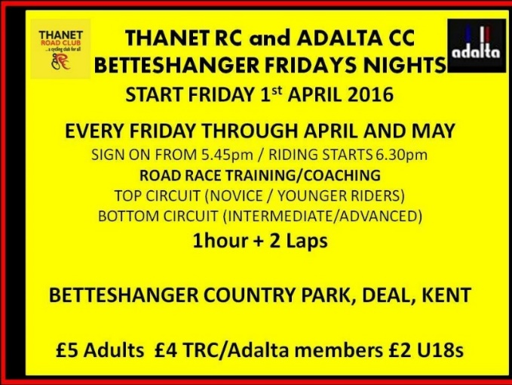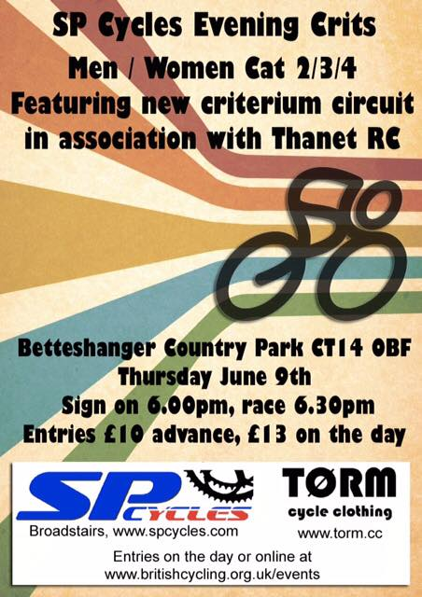

**Dates for your Diary**

**Club AGM**

This will be held on Friday 4th November, venue to be confirmed.

**Club Dinner and Prizegiving**

This will be held on Saturday 12th of November at Minster Village Hall, time to be confirmed.

**Le Tour de Sandwich Cyclo Sportive**

This will be on Sunday 12th June, see www.sandwichevents.org.uk.

**Premier Foods Victoria Park Fountain Ashford Go-Ride Youth Racing** - Sunday 12th June 2-4pm. Racing for all youth categories, novices especially welcome at a fabulous venue in Ashford, racing round the landmark fountain. Plenty of helpers would be great as we have a few crossing points to marshal, and the course to barrier tape out. I'll be there from 12.30pm and hope to see lots of TRC youth at this one-off event. PM or post if you can help. Thank you as always. Phil Cook.

[www.britishcycling.org.uk](http://www.britishcycling.org.uk)

**Divas on Wheels- a ride for the ladies**

Some of you ladies may be interested in the Divas on Wheels ride on Sunday the 12 of June at 9.45 am. The planned rides start and finish at the Freewheel Pub over a distance of either 25 or 50 miles. The Freewheel Pub is a Pub/ cafe at Graveney ME 13 9DE. Contact Deborah Kellond on 01227 812621 to book.

**East Kent Cyclo Cross 2016-17 Series Dates/Venues Announced:**

Racing for all categories; Under 12, Youth, Juniors, Women, Men and Vets

All entries via British Cycling (except Round 5)

Round 1 Sunday 11th September Sandwich Tech Cross.

Round 2 Sunday 16th October Bay Point Cross.

Round 3 Sunday 13th November Discovery Park Cross

Round 4 Sunday 18th December Venue TBC

Round 5 Sunday 15th January Betteshanger Cross (combined LCCA round)

For further info contact [eastkentcyclocross@gmail.com](mailto:eastkentcyclocross@gmail.com) Round 1. Sunday 11th September

Round 2. Sunday 16th October

Round 3. Sunday 13th November

Round 4. Sunday 18th December  
Venue TBC

Round 5. Sunday 15th January  
  
(Combined LCCA Round)

Further information contact EKCX at eastkentcyclocross@gmail.com

Round 1. Sunday 11th September

Round 2. Sunday 16th October

Round 3. Sunday 13th November

Round 4. Sunday 18th December  
Venue TBC

Round 5. Sunday 15th January  
  
(Combined LCCA Round)

Further information contact EKCX at eastkentcyclocross@gmail.com

**Round 1. Sunday 11th September**

**Round 2. Sunday 16th October**

**Round 3. Sunday 13th November**

**Round 4. Sunday 18th December  
Venue TBC**

**Round 5. Sunday 15th January  
  
(Combined LCCA Round)**

**Further information contact EKCX at eastkentcyclocross@gmail.com**

**Go- Ride Training Sessions 2016**

|  |  |  |  |
| --- | --- | --- | --- |
| **Date** | **Location** | **Time** | **Lead Coach** |
| 4th June | Betteshanger CP | 2:30pm-4pm | Richard |
| 11th June | Betteshanger CP | 2:30pm-4pm | Teresa |
| 18th June | Betteshanger CP MTB coaching | 2:30pm-4pm | Helen |
| 25th June | Ride Out/St Nicholas TBC | 2:30pm-4pm | Colin |
| 2nd July | Betteshanger CP | 2:30pm-4pm | Richard |
| 9th July | No session GHS | 2:30pm-4pm | Chris Bax |
| July-Sept | No sessions | Summer Break |  |

**Go- Ride Racing**

|  |  |  |  |  |  |  |
| --- | --- | --- | --- | --- | --- | --- |
| Day | Date | Event | Sponsor | Location | | Time |
| Sunday | 5th June 2016 | Youth Go-Cross No3 | | Betteshanger | 10.30-12.30 | |
| Monday | 20th June 2016 | Thanet RC Whites Summer Series.1 | Whites Transport | Betteshanger 18.00-20.00 | | 18.00-20.00 |
| Monday | 27th June 2016 | Thanet RC Whites Summer Series.2 | Whites Transport | Betteshanger 18.00-20.00 | | 18.00-20.00 |
| Saturday | 2nd July 2016 | Tour de Fowlmead | | Betteshanger | 10.30-12.30 | |
| Monday | 4th July 2016 | Thanet RC Whites Summer Series.3 | Whites Transport | Betteshanger 18.00-20.00 | | 18.00-20.00 |
| Monday | 11th July 2016 | Thanet RC Whites Summer Series.4 | Whites Transport | Betteshanger 18.00-20.00 | | 18.00-20.00 |
| Saturday | 16th July 2016 | Go-Ride Racing Cluster (East Kent) - Summer | | Betteshanger | 13.00-16.00 | |
| Monday | 18th July 2016 | Thanet RC Whites Summer Series.5 | Whites Transport | Betteshanger 18.00-20.00 | | 18.00-20.00 |
| Monday | 25th July 2016 | Thanet RC Whites Summer Series.6 | Whites Transport | Betteshanger 18.00-20.00 | | 18.00-20.00 |
| Monday | 1st Aug 2016 | Thanet RC Whites Summer Series.7 | Whites Transport | Betteshanger 18.00-20.00 | | 18.00-20.00 |
| Monday | 8th Aug 2016 | Thanet RC Whites Summer Series.8 | Whites Transport | Betteshanger 18.00-20.00 | | 18.00-20.00 |
| Saturday | 17th Sept 2016 | Vuelta a Fowlmead | | Betteshanger | 10.30-12.30 | |
| Sunday | 25th Sept 2016 | Thanet RC Omnium | Blackcat Coaching | Betteshanger 13.00-17.00 | | 1-5pm |
| Saturday | 29th Oct 2016 | Go-Ride Racing Cluster (East Kent) - Winter | Whites Transport | Betteshanger 13.00-15.30 | | 1-3.30pm |
| Saturday | 10th Dec 2016 | GoRide Racing MTB series 2 of 4 | Whites Transport | Betteshanger 12.45-15.30 | | 12.45-15.30 |
| **Women only Go-Race dates 2016** | | | | | | |
| Day | Date | Event | Sponsor | Location | | Time |
| Friday | 24th June 2016 | Women only road series round.3 | Locks / Ken Jones | Betteshanger 18.30-19.30 | | 18.30-19.30 |
| Saturday | 30th July 2016 | Women only road series round.4 | Locks / Ken Jones | Betteshanger 10.00-11.30 | | 10:00-11:30 |
| Friday | 26th August 2016 | Women only road series round.5 | Locks / Ken Jones | Betteshanger 18.30-19.30 | | 18.30-19.30 |
| Sunday | 25th Sept 2016 | Women only road series round.6 | Locks / Ken Jones | Betteshanger 10.00-11.30 | | 10:00-11:30 |

**Articles Wanted**

I now work as editor of Cycling World Magazine which specializes in leisure, tourism, sportives and commuting. I am always looking for stories. We also do book and film reviews. Please contact David Robert (TRC Committee member) at [editor@cyclingworldmag.co.uk](mailto:editor@cyclingworldmag.co.uk)

**TRC Heritage Project** contact: davealexrob@yahoo.com

We are forming a working group for the 70th Anniversary in 2017. Please get in contact with any ideas and/or if you’d like to get involved in any way.

TRC Material Wanted for Anniversary Exhibition

We’d like TRC members and friends to lend a photo (or press cutting, or jersey, or bike, or any item) for an exhibition. Could be from any time, recent history is still of interest. Drawings and sketches are encouraged, especially from young members. Originals preferred, but scans accepted. Please provide now as this is the funding period to get them framed/exhibition ready, though the exhibition will be mounted for 2017, the 70th anniversary year. We will take care of items and return (framed if desired).

Following details required with item:

         Who, what, where

          A very short bit about your place in TRC and why you chose this item

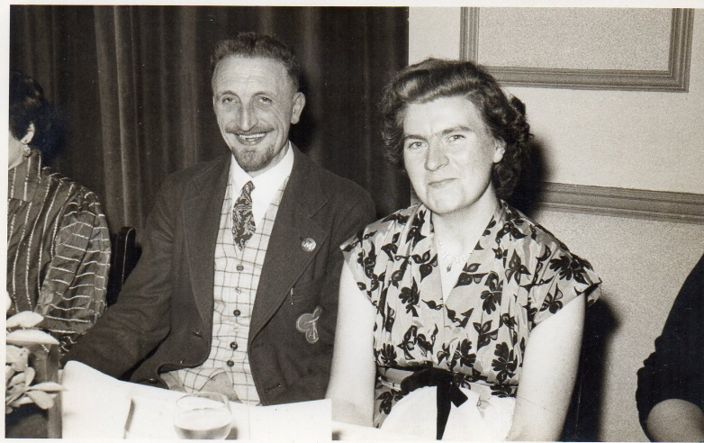

**And from the archives…**. Ted (1916-92) and Dorothy Harrison at the Thanet Road Club annual dinner, 17th January 1955. Ted was member of the Fellowship of Kent and Sussex Cyclists (founded in 1944). In 1971 he co-founded The Potterers. He was also a member Medway Road Club which amalgamated with the Medway Wheelers and Rochester Velo Club Olympique in 1968 to form the Medway Velo. Also a member of The Tricycle Association. Ted’s wife, Dorothy, (nee Hack) is also a lifelong cyclist and continues to live in Chestfield.

I have access to historic records and photos of all the above clubs. If interested contact [davealexrob@yahoo.com](mailto:davealexrob@yahoo.com)

**Bottom of FormDiscounts currently available to Club Members**

Michael Kelleher MIRMT-IIST a Professional Therapist, is a club member.

He would like to offer any club members who may require help, the following treatments:-

Sports Injuries

Remedial Back Therapy

Swedish Holistic Massage

Aromatherapy

Indian Head Massage

Courses of Instruction are also available in any of the above.

Club members requiring treatment will receive, on production of proof of membership, a discount of 25% on the current fee of £40 per session.

Contact Michael on 01227 771493 Mob 07879861618, email [backtherapist@yahoo.co.uk](mailto:backtherapist@yahoo.co.uk)

Website:- [www.michaelsmassagetherapy.co.uk](http://www.michaelsmassagetherapy.co.uk)

Locks of Sandwich : 10% on selected items

St Peter’s Cycles, Broadstairs: 10% on selected items

Bike Warehouse, Herne Bay, Faversham, Gillingham, Sevenoaks: 10% on selected items

Black Cat Coaching- special rates offered

Please also note anyone who arrives at Stonelees Golf Centre on a bike/walking/public transport gets free golf club hire

Ian Edginton, a former member of the club, has started his own cycle maintenance and repair business from his home at Staple near Wingham and welcomes your custom. All types of repair including wheel building are available. Contact Ian at [ian.edginton123@btinternet.com](mailto:ian.edginton123@btinternet.com) or 07786425829. Ian`s father Alf, is also a very long standing and respected member of the Club

Club member Martin Hendy has his own Landscaping and Gardening business and is offering free estimates and discounted rates for Club members.

This looks like a good opportunity to get out on your bike while Martin does the garden.

Garden maintenance & fencing works

Tel 01227 368373

Mob 07958 709736

Email [m.hendylandscapes@talktalk.net](mailto:m.hendylandscapes@talktalk.net)

**For Sale**

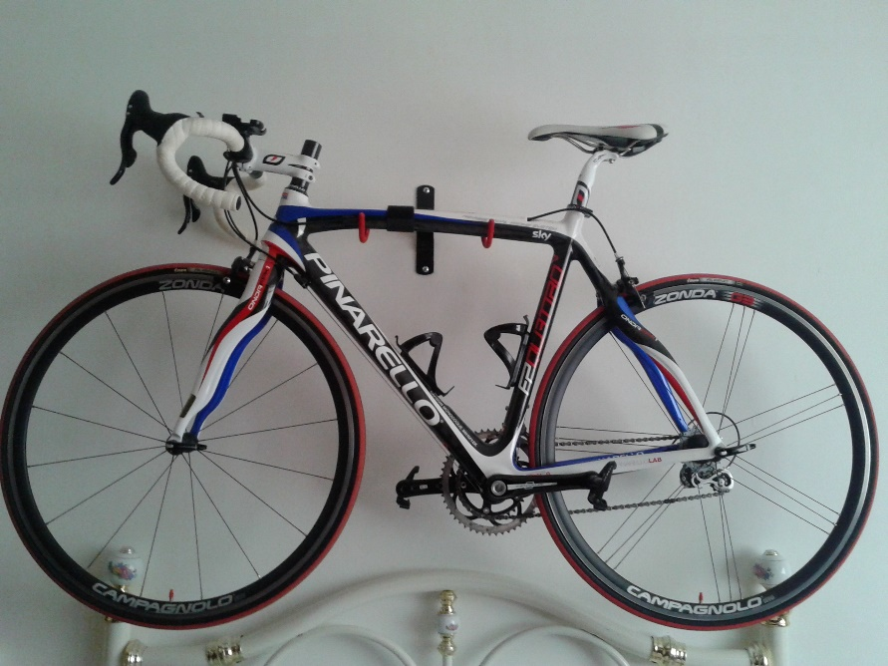

Pinarello Quattro will suit 5ft 8-6ft. British Cycling colours. Weight < 8Kg.

All carbon with Campag Centaur groupset and Campag Zonda wheels.

Look carbon pedals

I have had this for 4 years but it has hardly been ridden, less than 500 dry miles.

Showroom condition, absolutely unmarked.

Original cost £3,400 will sell for £1950.

Contact Paul Sawkins (Club member) 07956 944345

**TIME TRIAL BIKE FOR SALE (not a club member)**

Planet X Exocet frame and forks, black, medium size.

 Vision tribars with brake levers and 10 speed Dura Ace bar end shifters

 Ambrosio aero type wheels, with Shimano freehub spline

Fsa Gossamer compact chainset 50/34, 175mm cranks

 Only ridden about 10 times so as new, selling due to back problem.

Offers please, I am willing to sell the parts separately or as a complete unit.

My name is Neal and I am at Herne Common, between Canterbury and Herne Bay.

 Email: [cnl@olheco.fsnet.co.uk](mailto:cnl@olheco.fsnet.co.uk)           Tel: 01227712131

**Monthly Quiz**

Colin Robinson came up first with last month`s correct answer which was that they are all diabetics (type 1 incidentally)

Well done Colin.

This Month`s Question:-

The Giro d`Italia this year was won in some style by Vincenzo Nibali.

Three riders have won the Giro d`Italia 5 times. Who are they?