

**NEWSWHEEL**

**Newsletter for Thanet`s Premier Cycling Club**

Affiliated to: British Cycling; CTT;KCA;CTC

**Thanetrc.org.uk**

May 2016

**News**

Terrific performance by Seb Dickson riding in the British Universities and Colleges Sport 25 mile Championship on the 23rd April, when he smashed the Club Record by 1.28 with a super ride of 50.28, also winning with 2 others the Team Prize for Cambridge University. Incredibly, there were 83 rides “under the hour” in this event on the H25/17 (Cumnor-Faringdon-Besselsleigh). Well done Seb.

**Racing Results Open Events (TRC Riders)**

Sunday 3rd April, KCA 25 Q25/8 (Molash-Canterbury-Ashford-Chilham) Nic Fennell 1.01.03, Michael Friend 1.06.07, Dave Mastin 1.08.22, Dan Martin 57.39, Martin Russell 1.05.03, Simon Henderson 56.51, Huck Garip 58.58, Chris Bax 1.03.10, Dave Danton 1.04.04, Colin Inett 1.13.17, Chris Fennell 53.23, Rick Perkins 59.09, Andy McCall 1.09.20, Paul Griffiths 1.13.38, Robert Sissons DNS, Bill Hawkes DNS, Mark Palmer DNS, Andy Burrows DNF (punc). Chris Fennell was the fastest. Simon was the winner OAS so well done to them.

Saturday 9th April, West Kent RC 10 Q10/22 (Harrietsham) Michael Friend 25.37, Paul Kelk 26.13, Andy Burrows 28.33, Dave Mastin, Bill Hawkes and Andy McCall DNS. Winner was Jon Parker 20.52, well done to all who rode on a cold and wet day.

Saturday 9th April BUCS 10 E33/10 (Cambridge) Chris Fennell (University of Kent) 21.03 (6th), Seb Dickson (University of Cambridge) 21.11 (8th). Fastest was Liam Bromiley (University of Bath) 19.54.

Saturday 9th April Lea Valley CC 25 E2/25 (Newmarket) Simon Henderson 53.46. fastest was Matthew Smith (? Club) 47.57.

Sunday 10th April, Sydenham Whs 25 Q25/20 Harrietsham) Andy McCall 1.11.18, Scott Meeks 1.04.51 (CPB), Simon Henderson 57.52 (CPB), Andy Burrows 1.13.05, Dave Danton 1.04.39 (CPB), Huck Garip 1.00.10, Paul Kelk 1.09.28, Rick Perkins 1.00.17, Martin Russell 1.06.14, Chris Bax 1.04.50, Andy Macpherson 1.07.18. Robert Sissons, Mark Palmer and Michael Friend DNS. Fastest was Peter Tadros (In Gear Quickfit Trainsharp*) 54.34.*

Sunday 17th April, VTTA National Championship 30 Q30/2 (Hamstreet-Kingsnorth-Hamstreet) Andy McCall 1.25.00, Colin Robinson 1.18.34, Huck Garip 1.11.09, Simon Henderson 1.09.19, Ollie Robinson 1.12.25, Jon Parker 1.03.30, Chris Bax 1.16.28, Dave Mastin 1.22.42. Fastest was Andy Jackson (SSLLRacing Team) 1.02.36. Winner OAS was Kevin Tye (VeloRefined Aerosmiths) with a plus of 18.59.

Saturday 23rd April, Catford CC 10 Q10/19 (Tonbridge Bypass) Simon Henderson 22.19, Scott Meeks 24.09, Chris Bax 24.42, Paul Kelk 26.19. Fastest was Jon Parker (Team Bottrill TRC 2nd Claim) 19.47.

Sunday 24th April, KCA 10 Q10/22 (Harrietsham) Dan Martin 23.14, Martin Russell 26.36, Paul Kelk 27.23, Phil Cook 27.23, Andy Burrows 28.33. Bill Hawkes, Lawrence Martin, Andy McCall DNS, Simon Henderson DNS (punc). Well done to Dan, fastest Thanet rider and 1st Junior. Another horrible wet and windy morning. Overall winner was Jon Parker (Team Bottrill, TRC 2nd claim) 21.03.

Sunday 1st May, Wigmore CC 25 Q25/8 (Molash-Canterbury-Ashford-Chilham) Gary Russell 1.08.36, Dave Danton 1.03.27, Andy Macpherson (2nd claim) 1.06.45, Jim Dickson 1.07.08, Simon Henderson 58.35, Olly Dickson 1.10.01. Chris Bax (2nd claim) 1.04.16, Dave Mastin 1.07.48, Andy McCall 1.11.29, Ollie Robinson 58.24, Paul Kelk 1.07.49, Colin Robinson 1.03.33, Martin Russell 1.03.31, Dan Martin 57.44, Huck Garip 58.18, Michael Friend 1.06.40, Paul Griffiths 1.12.43, Mark Palmer DNS, Rick Perkins 58.43, Colin Inett 1.14.22, Andy Burrows 1.07.53. Well done to Dan Martin, 1st Junior and the fastest TRC rider. A super ride by Jon Parker (2nd claim) 50.48, smashing the course record by almost a minute to scoop the 1st prize and also 2nd OAS, making it a very profitable morning, well done to him also. Great turnout from the club for this event.

TRC/St Peter`s Cycles Spring Racing 3rd April BCP

TRC/SPC Men 2,3,4 Women 2,3,4

5 Ollie Robinson 5 Nicola Goodban

14 Toby Hammond 6 Caroline Rigby

21 Dan Martin Winner Freya Rawlins (Adalta)

34 Rob Milnes

42 Alistair Clifford

43 Scott Meeks

Winner Josh Wakeling (Adalta)

U8Girls U8Boys U10Girls U10 Boys

3 Caris Hart 2 Luke Hart 2 Ferne Pierce 1 Alex Dack

4 Grace Philpott 3 Ben Hutton 3 Millie Dack 2 Max Robinson

Winner Anna Lloyd Winner Milo Wills NC Winner Carys Lloyd 3 Lughaidh Cook

(Lee Valley) (Lee Valley) 5 Tom Crow-Brown

U12 Girls U12 Boys U14 Boys U16 Boys

2 Freya Cook 3 Tom Hutton 2 Lance Childs 4 Toby Perry

Winner Jasmine Cornelius 4 Charlie Hart 3 Flynn Robinson 5 Josh Chivilo

(Barking & Dagenham) Winner Daniel Lloyd 4 George Pittock 6 Alex Ashman

(Lee Valley) 7 Jack Hill 7 Charlie Burgess

Winner Ritchie Selfe 10 George Bussey

(Lee Valley) Winner Liam Hanks

(Barking & Dagenham)

[TRC](https://thanetrc.wordpress.com/2016/04/25/trc-youth-development-team-in-action-at-weekend/) Youth Development Team in Action

Flynn Robinson, George Pittock, Jack Hill (all Cat B U14) and Alex Ashman (Cat A U16) represented Thanet RC in unseasonably cold and windy conditions at the second of three CC Hackney Primavera circuit races at Lee Valley VeloPark on Saturday.April 25th

A lead group of 15 riders stayed together throughout the U14 race, with George taking a turn on the front and Flynn comfortable in the group. Joe Harris of Bigfoot CC split the group with a well-timed attack on the final 180 degree sweeping turn, followed home by Freddie Newman and Adam Churchill, both of Preston Park Youth CC, in second and third. George finished ninth in the second group with Flynn close behind in 13th. Jack found the conditions very hard, but rode well in a group of four and won the group sprint to finish 18th.

The U16s set off at a blistering pace but Alex stayed with the main group as they settled into the race, he too taking a turn on the front. He was well positioned going into the final 500m but the more experienced riders came through, leaving Alex in 17th place but very satisfied with perhaps his biggest test so far. The race was won by Jamie Lloyd of Team Corley Cycles, with Liam Hanks of Barking & Dagenham CC second and Sam Skeggs, also Team Corley Cycles, third.

Lance rode really well yesterday but found the jump to U14 difficult especially racing in a field of 28 riders, with some very twitchy riders! A disappointing 1km TT left him with a lot of work to do to make up places, but rode really well in the elimination and even launched off the front of the peloton in the final points race to almost hold off the field for points but did get caught just before the line to finish 5th just out of the points! Really gutsy ride and he’s learnt a lot and currently stands around 21st overall with 3 more Omnium rounds to go.

RTTC National Series

The third round of the RTTC National Series took place in Great Whitley near Worcester, with another large turnout of 121 riders taking to the start. This was another tough course taking place over 39.5 miles of rolling hills. With two large climbs in the last half of the course, the second climb was the toughest with an average gradient of around 11% for half a mile, starting just 6 miles from the finish.

Fortune favoured the riders with the weather, with dry roads and warm temperatures but a light north westerly breeze had a slight chill to it and enough just to deaden the speed on the returning roads.

Thanet had two riders at this third event, Chris and Nic Fennell.

Chris Fennell claimed 6th place (only 49 seconds off the podium) and 1st place Espoir with a time of 1:36.05 an improvement of 2.14 from last year’s event.

Chris has not been racing for a few weeks due to heart issues. Having seen a cardiologist he was informed that his condition is unlikely to cause physical harm, because of this he can race but has to accept that his condition can cause a lot of discomfort and ruin his race if he has an episode. He is now waiting for further tests to fully diagnose the problem and hopefully sort it out as soon as possible.

Nic Fennell rode a 1:53.36 to a 25th position. Another performance which he was pleased with and happy with the position alongside the strong field of riders drawn to these events.

The overall winner of the event was Philip Graves (Clifton C.C. York) with a time of 1:32.35.

Race report from Crits in the Park at the Cyclopark. 16th April

3rd cat race – the race started with a field of 60 riders. Dan got away in the second lap with another rider and stayed away for the reminder of the race taking 2nd place.

4th cat race – Alastair took to the start line and put in numerous attacks, the race came to a bunch sprint. Results to be confirmed but looks like a top 10 for Al!

2,3,4 race – Having attained his 2nd cat licence Ollie was the only Thanet rider to take to the start line (I decided to eat cake :)). Ollie worked hard all race and positioned himself well to win the bunch sprint and take 4th overall.

I’m super proud to ride and race with these talented junior riders. This is just the start… More to come in 2016!! Post by Rob Milnes

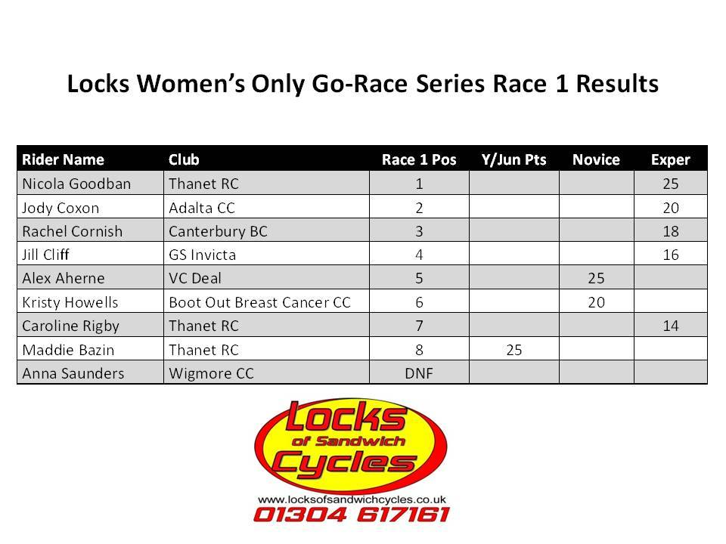

Many thanks to Locks of Sandwich and Ken Jones for sponsoring this Ladies Event.

**Help and Ride system’ for Club Time Trials 2016.**

The club organises Time Trials on Wednesday evenings from April to September every year at Fowlmead Country Park (Q10/42) and Thanet Way (Q10/31).  
This year we will again be implementing our ‘help and ride scheme’ – details are attached.  
All riders will be expected to help by committing to help at  least two club events through the season to gain eligibility to ride  
We are also hoping members will continue to help with club open event (2 up TTT, Fowlmead 10, Thanet way 25) and our commitment to KCA events – we have committed to provide 9 marshals on  13th Sept at the KCA event on Thanet Way

To make your commitment contact Michael Friend, Thanet Road Club Time Trial Secretary:-

[Michael.friend@uk.verizon.com](mailto:Michael.friend@uk.verizon.com) or 07921491658

The day before a club time trial, if an event does not have enough helpers committed a message will be posted on the club website/Face book and the event cancelled.  
No messages and the event will run as planned  
I am sure we all want to ride in 2016 so please commit your support to our club.

**Club time trials:**

£3.00 for club members/ all second claim members  
£2.00 for club member juvenile/juniors  
£4.00 for guests who support ‘ help and ride system’  
£5.00 for other guests

**Forthcoming Open Events**

Saturday 7th May, CC Bexley 10 Q10/24 (Isle of Grain)

Saturday 14th May Southboro & District Wheelers 10 Q10/33(Leigh Green-Woodchurch)

Sunday 15th May San Fairy Ann 50 Q50/1 (Leeds-Ashford-Leeds)

Saturday 21st May Medway Velo 10 Q10/24 (Isle of Grain)

Sunday 29th May Bigfoot CC 25 Q25/8 (Molash-Canterbury-Ashford-Chilham)

Saturday 4th June De Laune CC 10 Q10/24 (Isle of Grain)

Sunday 5th June KCA 50 Q50/11 (Ham Street-Brenzett-Brookland-Lydd)

**Club Events- TRC riders only**

Evening 10 Wednesday 6th April Q10/42 BCP Juniors Dan Martin 22.55, David Redmond 28.00, Lance Childs 30.20, Charlie Burgess 30.26, Tom Hutton 34.03, Max Robinson 37.07. Seniors Chris Fennell 21.35, Simon Henderson 22.41, Mark Foulds 23.40, Nic Fennell 23.50, Scott Meeks25.35, Chris Bax 25.49, Matt Hall 26.06, Martin Russell 26.08, Mike Kirkness 26.12, Colin Robinson 26.13, Brian Hood 27.14, Chris Childs 27.43, Nick Scott 27.56, Phil Cook 28.28, Martin Hendy 28.33, Peter Huckstep 28.44, Paul Griffiths 30.31, Caroline Rigby 30.35, Eddie Brown 30.44, Malcolm Adams 33.05, Rachel Hutton 34.07, Sue Shields 34.09, Frank Burniston DNF. Chris and Dan were the fastest.

Evening 10 Wednesday 13th April Q10/42 BCP. Juniors Ollie Robinson 22.47, Olly Dickson 24.36, Josh Chivilo 25.03, David Redmond 25.37, George Edmondson 26.28, Lance Childs 26.32, George Pittock 27.31, Flynn Robinson 27.38, Charlie Burgess27.46, Tom Hutton 32.27, Max Robinson 34.25. Seniors Jon Parker 20.16, Simon Henderson 22.11, Nic Fennell 23.13, Lawrence Martin 23.20, Dave Danton 24.00, Scott Meeks 24.18, Jim Dickson 24.24, Colin Robinson 24.26, Mike Kirkness 24.40, Chris Bax 24.41, Martin Russell 24.47, Michael Friend 24.58, Matt Hall 25.17, Paul Kelk 25.36, Brian Hood 25.37, Chris Childs 25.45, Frank Burniston 26.09, Nick Scott 26.33, Robert Sissons 26.48, Heidi Hammond 28.09, Eddie Brown 28.44, Rob Swinerd 29.22, Simon Challis 29.48, Rachel Hutton 31.41, Sue Shields 32.02, Jenny Fearn 32.27, Mark Foulds, Phil Cook, Rick Perkins DNF. Fastest were Ollie and Jon. A number of PB`s on a good night- Lance Childs (age record for 12 year old), Dave Danton, Nic Fennell and Sue Shields to name just a few, super ride by Jon Parker on this course.

Evening 10 Wednesday 20th April Q10/42 BCP Juniors Ollie Robinson 21.52, Dan Martin 22.04, Olly Dickson 25.42, David Redmond 26.51, George Edmondson 27.13, Lance Childs 28.38, Charlie Burgess 29.01, George Pittock 29.37, Max Robinson 34.24, Toby Yemm 34.24, Seniors Simon Henderson 22.05, Mark Foulds 22.31, Rick Perkins 22.43, Nic Fennell 22.56, Rob Milnes 23.46, Scott Meeks 24.15, Lawrence Martin 24.21, Colin Robinson 24.35, Matt Hall 25.00, Richard McVey 25.04, Mike Kirkness 25.15, Chris Bax 25.15, Martin Russell 25.17, Michael Friend 25.28, Gary Russell 26.26, Paul Kelk 26.30, Chris Childs 26.33, Nicola Goodban 26.39, Peter Huckstep 27.11, Phil Cook 27.43, Robert Sissons 27.51, Heidi Hammond 28.11, David Robert 29.09, Paul Griffiths 29.19, Eddie Brown 29.26, Caroline Rigby 29.47, Simon Charles 30.25, Malcolm Adams 30.46, Diana Yemm 34.23, Jenny Fearn 34.48, Sue Shields 35.47. Fastest rides of the evening came from the 2 Juniors Ollie and Dan, well done to all who rode on a bitterly cold and windy evening.

Evening 25 Wednesday 27th April Q10/42 BCP Juniors Ollie Robinson 54.50, Toby Hammond 59.09, Olly Dickson 1.05.49, Charlie Burgess 1.08.23, George Pittock 1.08.49, Flynn Robinson 1.13.03, Jack Hill 1.19.03, George Bussey 1.19.13, Freya Cook 1.44.19. Seniors Chris Fennell 52.22, Simon Henderson 54.52, Rob Milnes 56.59, Alastair Clifford 58.26, Rick Perkins 58.37, Nic Fennell 1.00.04, Dave Danton 1.02.13, Chris Bax 1.02.20, Matt Hall 1.03.34, Michael Friend 1.03.10, Colin Robinson 1.03.11, Scott Meeks 1.03.22, Martin Russell 1.03.31, Jim Dickson 1.06.01, Martin Hendy 1.06.03, Chris Childs 1.06.48, Brian Hood 1.07.02, Dave Mastin 1.07.03, Peter Huckstep 1.08.21, Frank Burniston 1.08.29, Phil Cook 1.10.31, Paul Griffiths 1.12.58, David Robert 1.12.58, Heidi Hammond 1.13.07, Simon Charles 1.15.36, Jenny Fearn 1.23.35, Sue Shields DNF.

47 riders turned up on a cold night with light NW winds. Several PB`s were recorded and 12 riders got under the hour. Fastest for the Juniors was Ollie Robinson (54.50) and Chris Fennell for the Seniors with an excellent 52.22. 2 more 25`s to come at BCP later in the year.

Note: next weeks 10 will be on the Q10/31(Thanet Way) 1900 start.

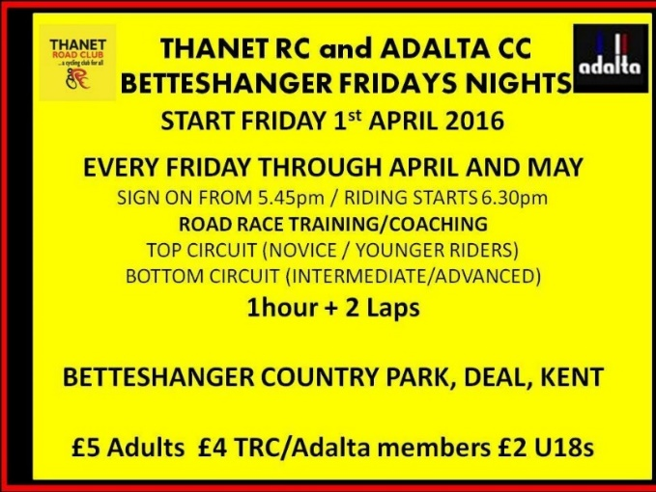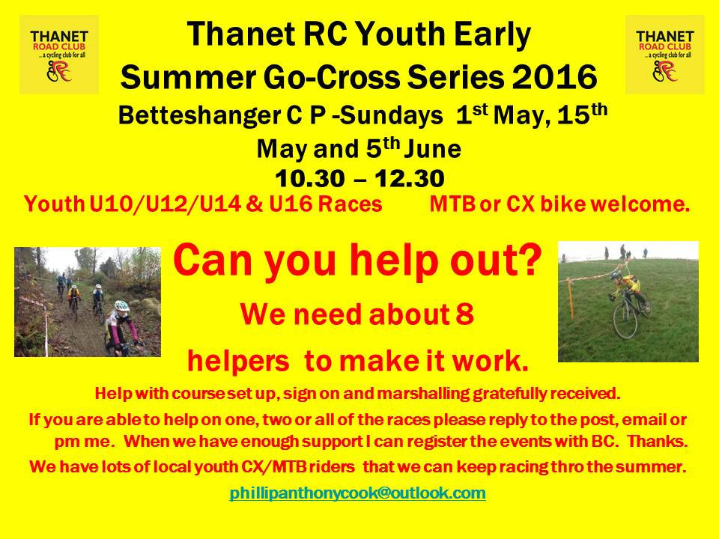

**Dates for your Diary**

**Social Evening**

The next Social Evening will be held on Tuesday 3rd May at the Bell Meadow Pavilion, St Nicholas at Wade 7.30-9.30pm. Please come along.

**Divas on Wheels- a ride for the ladies**

Some of you ladies may be interested in the Divas on Wheels ride on Sunday the 12 of June at 9.45 am. The planned rides start and finish at the Freewheel Pub over a distance of either 25 or 50 miles. The Freewheel Pub is a Pub/ cafe at Graveney ME 13 9DE. Contact Deborah Kellond on 01227 812621 to book.

**Go- Ride Training Sessions 2016**

|  |  |  |  |
| --- | --- | --- | --- |
| **Date** | **Location** | **Time** | **Lead Coach** |
| 7th May | Giro d`Fowlmead | See racing |  |
| 14th May | Betteshanger CP | 2:30pm-4pm | Helen |
| 21st May | Betteshanger CP | 2:30pm-4pm | Teresa |
| 28th May | TRC Grasstrack | See racing |  |
| 4th June | Betteshanger CP | 2:30pm-4pm | Richard |
| 11th June | Betteshanger CP | 2:30pm-4pm | Teresa |
| 18th June | Betteshanger CP MTB coaching | 2:30pm-4pm | Helen |
| 25th June | Ride Out/St Nicholas TBC | 2:30pm-4pm | Colin |
| 2nd July | Betteshanger CP | 2:30pm-4pm | Richard |
| 9th July | No session GHS | 2:30pm-4pm | Chris Bax |
| July-Sept | No sessions | Summer Break |  |

**Go- Ride Racing**

|  |  |  |  |  |  |  |
| --- | --- | --- | --- | --- | --- | --- |
| Day | Date | Event | Sponsor | Location | | Time |
| Saturday | 7th May 2016 | Giro d'Fowlmead Road Racing | | Betteshanger | 10.30-12.30 | |
| Sunday | 15th May 2016 | Youth Go-Cross No2 | | Betteshanger | 10.30-12.30 | |
| Saturday | 28th May 2016 | TRC Grasstrack Racing | | St Nicholas | 10.00-16.00 | |
| Sunday | 5th June 2016 | Youth Go-Cross No3 | | Betteshanger | 10.30-12.30 | |
| Monday | 20th June 2016 | Thanet RC Whites Summer Series.1 | Whites Transport | Betteshanger 18.00-20.00 | | 18.00-20.00 |
| Monday | 27th June 2016 | Thanet RC Whites Summer Series.2 | Whites Transport | Betteshanger 18.00-20.00 | | 18.00-20.00 |
| Saturday | 2nd July 2016 | Tour de Fowlmead | | Betteshanger | 10.30-12.30 | |
| Monday | 4th July 2016 | Thanet RC Whites Summer Series.3 | Whites Transport | Betteshanger 18.00-20.00 | | 18.00-20.00 |
| Monday | 11th July 2016 | Thanet RC Whites Summer Series.4 | Whites Transport | Betteshanger 18.00-20.00 | | 18.00-20.00 |
| Saturday | 16th July 2016 | Go-Ride Racing Cluster (East Kent) - Summer | | Betteshanger | 13.00-16.00 | |
| Monday | 18th July 2016 | Thanet RC Whites Summer Series.5 | Whites Transport | Betteshanger 18.00-20.00 | | 18.00-20.00 |
| Monday | 25th July 2016 | Thanet RC Whites Summer Series.6 | Whites Transport | Betteshanger 18.00-20.00 | | 18.00-20.00 |
| Monday | 1st Aug 2016 | Thanet RC Whites Summer Series.7 | Whites Transport | Betteshanger 18.00-20.00 | | 18.00-20.00 |
| Monday | 8th Aug 2016 | Thanet RC Whites Summer Series.8 | Whites Transport | Betteshanger 18.00-20.00 | | 18.00-20.00 |
| Saturday | 17th Sept 2016 | Vuelta a Fowlmead | | Betteshanger | 10.30-12.30 | |
| Sunday | 25th Sept 2016 | Thanet RC Omnium | Blackcat Coaching | Betteshanger 13.00-17.00 | | 1-5pm |
| Saturday | 29th Oct 2016 | Go-Ride Racing Cluster (East Kent) - Winter | Whites Transport | Betteshanger 13.00-15.30 | | 1-3.30pm |
| Saturday | 10th Dec 2016 | GoRide Racing MTB series 2 of 4 | Whites Transport | Betteshanger 12.45-15.30 | | 12.45-15.30 |
| **Women only Go-Race dates 2016** | | | | | | |
| Day | Date | Event | Sponsor | Location | | Time |
| Friday | 29th April 2016 | Women only road series round.1 | Locks / Ken Jones | Betteshanger 18.30-19.30 | | 18.30-19.30 |
| Saturday | 28th May 2016 | Women only road series round.2 | Locks / Ken Jones | Betteshanger 10.00-11.30 | | 10:00-11:30 |
| Friday | 24th June 2016 | Women only road series round.3 | Locks / Ken Jones | Betteshanger 18.30-19.30 | | 18.30-19.30 |
| Saturday | 30th July 2016 | Women only road series round.4 | Locks / Ken Jones | Betteshanger 10.00-11.30 | | 10:00-11:30 |
| Friday | 26th August 2016 | Women only road series round.5 | Locks / Ken Jones | Betteshanger 18.30-19.30 | | 18.30-19.30 |
| Sunday | 25th Sept 2016 | Women only road series round.6 | Locks / Ken Jones | Betteshanger 10.00-11.30 | | 10:00-11:30 |

**Articles Wanted**

I now work as editor of Cycling World Magazine which specializes in leisure, tourism, sportives and commuting. I am always looking for stories. We also do book and film reviews. Please contact David Robert (TRC Committee member) at [editor@cyclingworldmag.co.uk](mailto:editor@cyclingworldmag.co.uk)

**TRC Heritage Project** contact: davealexrob@yahoo.com

We are forming a working group for the 70th Anniversary in 2017. Please get in contact with any ideas and/or if you’d like to get involved in any way.

TRC Material Wanted for Anniversary Exhibition

We’d like TRC members and friends to lend a photo (or press cutting, or jersey, or bike, or any item) for an exhibition. Could be from any time, recent history is still of interest. Drawings and sketches are encouraged, especially from young members. Originals preferred, but scans accepted. Please provide now as this is the funding period to get them framed/exhibition ready, though the exhibition will be mounted for 2017, the 70th anniversary year. We will take care of items and return (framed if desired).

Following details required with item:

         Who, what, where

          A very short bit about your place in TRC and why you chose this item

And from the archives…KCA 3-up 1969. From front: Andy Davies, Jim Braginton, Fred Warner. Top of climb out of Harrietsham on A20.

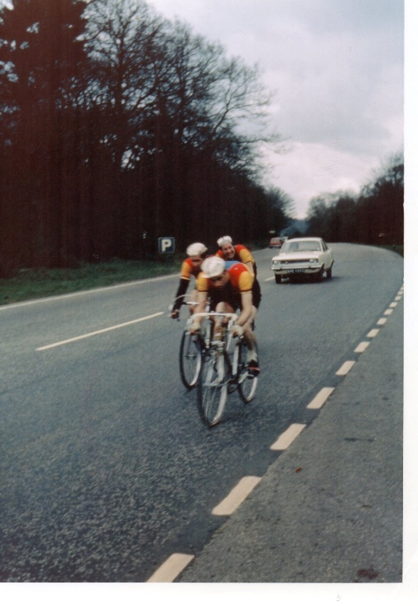

Locks of Sandwich : 10% on selected items

St Peter’s Cycles, Broadstairs: 10% on selected items

Bike Warehouse, Herne Bay, Faversham, Gillingham, Sevenoaks: 10% on selected items

Black Cat Coaching- special rates offered

Please also note anyone who arrives at Stonelees Golf Centre on a bike/walking/public transport gets free golf club hire

Ian Edginton, a former member of the club, has started his own cycle maintenance and repair business from his home at Staple near Wingham and welcomes your custom. All types of repair including wheel building are available. Contact Ian at [ian.edginton123@btinternet.com](mailto:ian.edginton123@btinternet.com) or 07786425829. Ian`s father Alf, is also a very long standing and respected member of the Club

Club member Martin Hendy has his own Landscaping and Gardening business and is offering free estimates and discounted rates for Club members.

This looks like a good opportunity to get out on your bike while Martin does the garden.

Garden maintenance & fencing works

Tel 01227 368373

Mob 07958 709736

Email [m.hendylandscapes@talktalk.net](mailto:m.hendylandscapes@talktalk.net)

**TIME TRIAL BIKE FOR SALE (not a club member)**

Planet X Exocet frame and forks, black, medium size.

 Vision tribars with brake levers and 10 speed Dura Ace bar end shifters

 Ambrosio aero type wheels, with Shimano freehub spline

Fsa Gossamer compact chainset 50/34, 175mm cranks

 Only ridden about 10 times so as new, selling due to back problem.

Offers please, I am willing to sell the parts separately or as a complete unit.

My name is Neal and I am at Herne Common, between Canterbury and Herne Bay.

 Email: [cnl@olheco.fsnet.co.uk](mailto:cnl@olheco.fsnet.co.uk)           Tel: 01227712131

**Monthly Quiz**

Richard Bazin came up first with last month`s correct answer which was George Hincapie, well done Richard.

This Month`s Question:-

There is a significant difference between Team Novo Nordisk and all the other pro Cycling Teams.

What is it?