

**NEWSWHEEL**

**Newsletter for Thanet`s Premier Cycling Club**

Affiliated to: British Cycling; CTT;KCA;CTC

**Thanetrc.org.uk**

April 2016

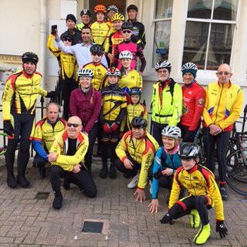

**Eastbourne Trip**

A total of 28 members took part in the Annual Eastbourne Ride. The weather was kind to us and everyone enjoyed the ride with no mishaps. We had a couple of guests Keith Ratcliff and Paul Maxwell, both former members of the Club from past years. With an age span of 67 years throughout the groups the stars of the show were the youngsters, most of whom completed the full distance including the tough climb of Beachy Head. The Savoy Court Hotel served us well once again, with excellent meals and comfortable beds. The Carwash Diner lunch stop failed to provide any food for us due to a breakdown in the gas supply, but undaunted we found a farm shop café with friendly staff and excellent food, this will be our lunch stop for next year.

The whole trip was organised by Dave Mastin who once again did a fantastic job, for which we are all very grateful, so a big thank you to him.

**News**

Many congratulations to Colin Robinson our Head Coach, who has passed the course and is now a British Cycling Level 3 Road and Time Trial Coach. Colin`s contribution to the success of the Club has been immeasurable, and I hope that all members will continue to give him their full support.

Many thanks to Maddie Bazin for taking on the role of Publicity Representative, we wish her every success.

The Time Trial schedule for 2016 can now be found on the website.

The National Handbook has now been published, this can be ordered on the Cycling Time Trials website. Click on “Shop” and select Handbook. Price is £9.00 plus £1.50 postage. This is essential if you intend entering Open Time Trials, this is an incredibly comprehensive book containing everything you would wish to know.

**Racing Results Open Events (TRC Riders)**

Sunday 28th February North Road Hardriders F7/25 (Brookmans Park) Seb Dickson 59.38. Fastest was Lloyd Chapman (Pedal Heaven RT) 57.55.

Saturday 5th March, VTTA 10 Q10/22 (Harrietsham) Andy Burrows 28.49, Oliver Dickson 26.27, Colin Inett 30.33, Chris Bax 26.24, Nic Fennell 24.42, Simon Henderson 23.06, Andy McCall, Bill Hawkes and Chris Fennell all DNS. Fastest and first OAS Keith Lea (Paceline RT) 21.50. Well done to Simon 2nd OAS and 1st Kent Vet to win the Mick Dansie Trophy.

Sunday 6th March, KCA 3-up 25 Q25/12 (Ham Street Bypass) Seb Dickson/Ollie Robinson/Simon Henderson 55.44, Jim Dickson/Michael Friend/Colin Robinson 1.05.20, Rick Perkins/Rob Milnes/Scott Meeks 1.02.32, Martin Russell/Paul Kelk/Dave Mastin 1.07.40. Great ride by Seb, Ollie and Simon to win the event from 39 other teams.

Well done to all who rode over the weekend in freezing cold and windy conditions.

A very successful weekend for Simon to celebrate his new status as a grandfather.

Sunday 13th March, PMR 25 Q25/20 (Harrietsham) Andy Burrows 1.14.28, Colin Inett 1.16.31, Simon Henderson 58.50, Andy McCall 1.15.06, Ollie Robinson 58.50, Nic Fennell 1.03.13, Chris Fennell 56.33, Mark Palmer 1.03.04, Andy MacPherson 1.07.45, Rick Perkins 1.00.10, Chris Bax 1.07.24. Fastest solo was Keith Lea (Paceline RT) 55.36.

2-up Teams Ollie Dickson/Jim Dickson 1.07.50, Rob Milnes/Colin Robinson 1.02.20. Fastest team was Peter Pav Bryan/Nick Wilson (Rye & Dist Wheelers) 55.22.

Well done to Ollie Robinson 1st Junior and Chris Fennell 3rd overall, also Rob and Colin 3rd Team.

Sunday 20th March, VC Elan Hilly 22 QS/17 (Charing-Challock-Charing) Ollie Dickson 1.06.02, Andy Burrows 1.08.27, Simon Henderson 54.46, Jim Dickson 1.03.26, Seb Dickson 53.04. Fastest was Daniel Tolhurst (PMR@Toachim House) 52.16. Well done to Seb (3rd overall), Simon (Fastest Vet), Ollie (Fastest Junior), and Simon, Seb and Jim (Fastest Team). A virtual clean sweep by the Club-great stuff.

Sunday 20th March RTTC National Series 25.6 E99/25 (Finchingfield) Chris Fennell 4th (3rd) and Nic Fennell 18th (17th). Places moved up as Alex Dowsett won, but is ineligible as he is a pro.

Saturday 19th March March Hare Classic (E-1-2-3 Road Race)

An amazing experience for Thanet RC RT riders to line up against the pros at the March Hare Classic at Cyclopark on Saturday with strong teams from Team Wiggins, NFTO and Richardson-TREK. The crit race was very long at 2 hours with total distance of over 50miles for riders. Ollie Robinson and Rob Milnes took part in the race and really noticed the step up in class, but Ollie did very well staying then attacking off the front of the second group on the road to eventually win the sprint for 13th from a group of 3 riders including local rider Michael Butler (Hargroves RT). Rob stayed in for 60mins than unfortunately lost contact with the fast moving bunch. Both riders enjoyed the experience. The winner was George Wood (Richardsons-Trek RT)

Also Alastair Clifford took part in his first road race in the 4th cat race. He did well but unfortunately got held up behind a crash near the end to miss out on a top 10 finish.

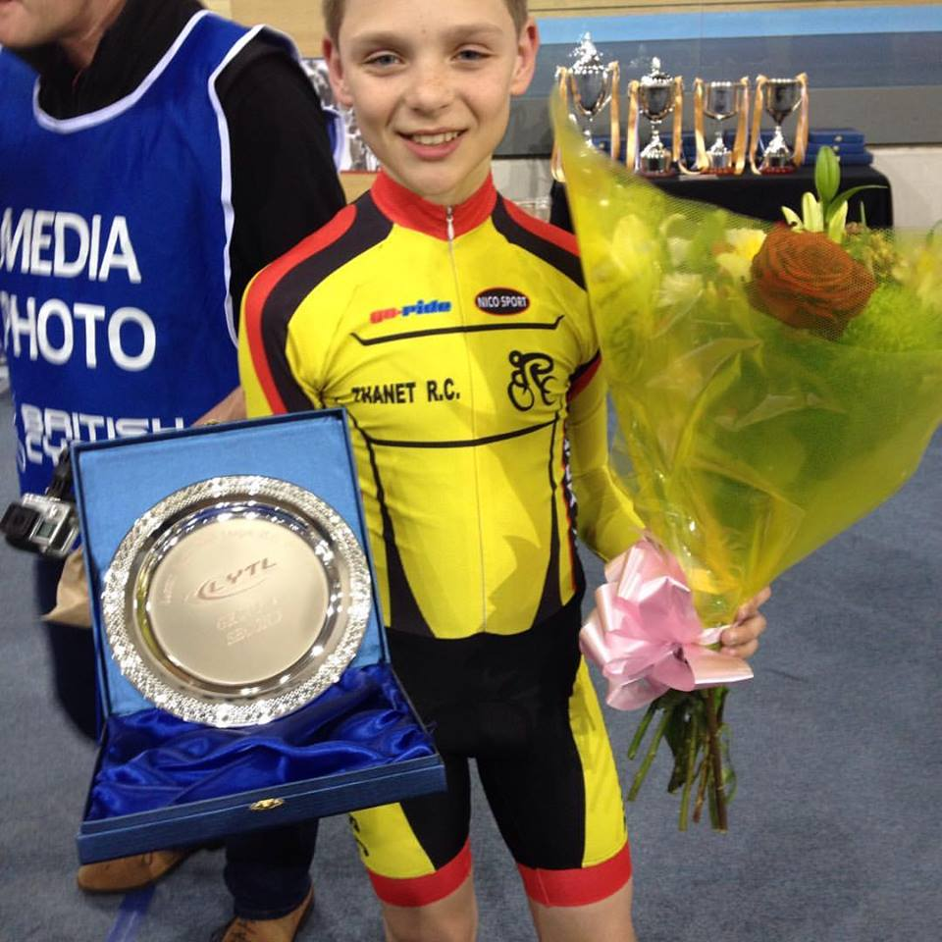

Well done to Lance Childs who received this impressive piece of silverware for his 2nd place in Group 4 of the London Youth Track League. Great performance from our youngest trackie! Mum bagged the flowers!

Busy weekend of road racing saw Ollie Robinson take TRCs first road win of 2016 with a fine victory in the SERRL 3-4 race at Bethersden on the 27th March. The 85km race stated with a single rider forming a 2min advantage after 40km then Ollie initiated an 8 rider group who rode across to the leader with 30km to go. The group stayed together until 3km then Ollie got away with a Addiscombe rider who he beat in a sprint finish after going early. Ollie has now gained enough points for his 2nd cat. Great stuff!

Also Lance Childs and George Pittock travelled up to Lee Valley for youth road events on Saturday 26th . There was a large competitive field in the U14 and U16 joint race but the boys rode very strongly to gain 11th and 12th places (TBC). Well done lads.

Monday 28th March, Thanet RC 2-up QS/3 (Manston) This event had to be cancelled due to Storm Katie which produced gales up to 70mph, thus compromising the safety of the riders.

Friday 25th March RTTC National Series Round 2- 33miles J8/3 Longnor Chris Fennell 1.26.27 (6th), Nic Fennell 1.43.45(42nd) Winner was Philip Graves (Clifton CC York) 1.23.26. Good rides from the brothers out of a field of 175 riders, especially Chris who was not feeling 100%

**Help and Ride system’ for Club Time Trials 2016.**

The club organises Time Trials on Wednesday evenings from April to September every year at Fowlmead Country Park (Q10/42) and Thanet Way (Q10/31).  
This year we will again be implementing our ‘help and ride scheme’ – details are attached.  
All riders will be expected to help by committing to help at  least two club events through the season to gain eligibility to ride  
We are expecting good support from club and non club members who want to ride.  
You will be expected to marshal on the course on which you are planning to ride the most events -   
If you can only help at other club events and would like to ride on Wednesday’s please contact the time trial secretary in the first instance.  
It is the expectation that all riders including juveniles and juniors will  help and ride. As we are not allowed to let juveniles and juniors marshal we are hoping their parents will be helping their children ride.

*.* A rider who marshals for the club at any of the events listed on the Thanet Road Club – Schedule of Time Trial Events will be awarded 5 points towards the evening points competition for the first two events they marshal and 1 point for any additional events. The Boxing Day 10 mile TT is excluded. Those riders participating in the evening points competitions who marshal at any of these events are responsible to ensure that the time trial secretary is made aware of their participation.

Non club members who ride but do not support the ‘ help and ride system’ will have to pay an increased entry fee for events until they  have helped

We are also hoping members will continue to help with club open event (2 up TTT, Fowlmead 10, Thanet way 25) and our commitment to KCA events – we have committed to provide 9 marshals on  13th Sept at the KCA event on Thanet Way

To make your commitment contact Michael Friend, Thanet Road Club Time Trial Secretary:-

[Michael.friend@uk.verizon.com](mailto:Michael.friend@uk.verizon.com) or 07921491658

The day before a club time trial, if an event does not have enough helpers committed a message will be posted on the club website/Face book and the event cancelled.  
No messages and the event will run as planned  
  
I am sure we all want to ride in 2016 so please commit your support to our club.

**Club time trials:**

£3.00 for club members/ all second claim members  
£2.00 for club member juvenile/juniors  
£4.00 for guests who support ‘ help and ride system’  
£5.00 for other guests

**Forthcoming Open Events**

Sunday 3rd April, KCA 25 Q25/8 (Molash-Canterbury-Ashford-Chilham)

Saturday 9th April, West Kent RC 10 Q10/22 (Harrietsham)

Sunday 10th April, Sydenham Whs 25 Q25/20 Harrietsham).

Sunday 17th April, VTTA National Championship 30 Q30/2 (Hamstreet-Kingsnorth-Hamstreet)

Sunday 17th April, Tricycle Assn SE 25 Q25/8 (Molash-Canterbury-Ashford-Chilham)

Saturday 23rd April, Catford CC 10 Q10/19 (Tonbridge Bypass)

Sunday 24th April, KCA 10 Q10/22 (Harrietsham)

Sunday 1st May, Wigmore CC 25 Q25/8 (Molash-Canterbury-Ashford-Chilham)

Saturday 7th May, CC Bexley 10 Q10/24 (Isle of Grain)

**Club Events- TRC riders only**

Good Friday 25th March TRC 2-up Betteshanger CP. Teams Rick Perkins/Seb Dickson 21.26, Dan Martin/Lawrence Martin 22.26, Toby Hammond/Trevor Hammond 23.16, Olly Dickson/Jim Dickson 24.13, Martin Russell/Josh Chivilo 25.26, Robert Sissons/Paul Kelk 25.59, Frank Burniston/Nick Scott26.06, Nicola Goodban/Heidi Hammond 26.33, Lance Childs/Chris Childs 26.38, Peter Huckstep/David Redmond 26.49, Brian Hood/Tony Northcott(Deal Tri) 27.43, Martin Hendy/Eddie Brown 27.46, Toby Yemm/Tim Yemm 28.59, George Bussey/Charlie Burgess 29.01, Tom Hutton/Hamish Robinson 32.12, Max Robinson/Alex Dack 32.49, Jenny Fearn/Caroline Rigby 32.52, Sue Shields/Rachael Hutton 35.40, Ferne Pierce/Millie Dack 42.08.

Solo Riders Mark Foulds 22.49, Richard McVey 24.18, Chris Bax 24.43.

The fastest ride of the day came from a solo rider James Mapley (Blazing Saddles) 21.15.

Club Evening 10 Wednesday 30th March Ollie Robinson 22.30, Rick Perkins 22.49, Mark Foulds 22.54, Seb Dickson 22.57, Dave Danton 24.43, Chris Bax 24.45, Josh Chivilo 24.55, Jim Dickson 24.55, Colin Robinson 24.58, Olly Dickson 25.01, Toby/Heidi Hammond 25.10, Michael Friend 25.10, Mike Kirkness 25.13, Martin Russell 25.24, Frank Burniston 26.06, Nick Scott 26.14, Chris Childs 26.21, Dave Mastin 26.24, Robert Sissons 26.34, David Redmond 26.41, Andy McCall 26.51, Peter Huckstep 26.51, John Burrows 26.52, Paul Kelk 26.59, Martin Hendy 27.07, Jo Malpass 27.16, Lance Childs 27.37, Thomas Fox 27.47, George Pittock 27.51, Charlie Burgess 28.00, Colin Inett 28.12, Paul Griffiths 28.38, Eddie Brown 28.52, Flynn Robinson 29.18, Simon Neame 29.49, George Bussey 30.19, Diana Yemm31.40, Jenny Fearn 32.36, Max Robinson 32.43, Vanessa Gray 33.12, Megan Griffiths 33.14, Rachael Hutton 33.23, Thomas Hutton 33.24, Sue Shields 34.39, Tia Neame 35.51, Tom Crow-Brown 46.25.

Once again, the fastest ride of the day came from James Mapley (Blazing Saddles) 21.10. An impressive turnout (56 riders) for the first event of the season.

**Club Clothing**

I will be making an order on **TUESDAY 5TH APRIL** to replenish stock.

If you require any kit, especially skinsuits, let me know before that date.

Pete 01843 845107  [peter.huckstep@btinternet.com](mailto:peter.huckstep@btinternet.com)

**Dates for your Diary**

**Social Evening**

The next Social Evening will be held on Tuesday 5th April at the Bell Meadow Pavilion, St Nicholas at Wade 7.30-9.30pm. Please come along.

**Paris-Roubaix 2016**

Thinking ahead to a fine Thanet RC social outlet. Sunday April 10th Paris-Roubaix should be exciting as Fabian Cancellera retirement year and Tom Boonen back in shape.

Outing is:-   
7.30am ish ferry to Calais.  
Cake and cafe stop en route to Arenberg Forest (beer tent and large screen there) see riders through then back in cars for dash to Roubaix for the finish in the velodrome and then kids souvenir hunt through team buses. Frites then on way back to Calais. Anyone in? Just need a few cars to book on.

Colin Robinson.

**Go- Ride Training Sessions 2016**

|  |  |  |  |
| --- | --- | --- | --- |
| **Date** | **Location** | **Time** | **Lead Coach** |
| 9th April | Betteshanger CP | 2:30pm-4pm | Helen |
| 16th April | Betteshanger CP | 2:30pm-4pm | Colin |
| 23rd April | Betteshanger CP | 2:30pm-4pm | Richard |
| 30th April | Ride Out/St Nicholas TBC | 2:30pm-4pm | Teresa |
| 7th May | Giro d`Fowlmead | See racing |  |
| 14th May | Betteshanger CP | 2:30pm-4pm | Helen |
| 21st May | Betteshanger CP | 2:30pm-4pm | Teresa |
| 28th May | TRC Grasstrack | See racing |  |
| 4th June | Betteshanger CP | 2:30pm-4pm | Richard |
| 11th June | Betteshanger CP | 2:30pm-4pm | Teresa |
| 18th June | Betteshanger CP MTB coaching | 2:30pm-4pm | Helen |
| 25th June | Ride Out/St Nicholas TBC | 2:30pm-4pm | Colin |
| 2nd July | Betteshanger CP | 2:30pm-4pm | Richard |
| 9th July | No session GHS | 2:30pm-4pm | Chris Bax |
| July-Sept | No sessions | Summer Break |  |

**Go- Ride Racing**

|  |  |  |  |  |  |  |
| --- | --- | --- | --- | --- | --- | --- |
| Day | Date | Event | Sponsor | Location | | Time |
| Sunday | 3rd April 2016 | Thanet RC / St Peters Bike Shop Spring Road Event | SPC Cycles | Betteshanger 12.00-16.00 | | 12.00-16.00 |
| Sunday | 1st May 2016 | Youth Go-Cross No1 | | Betteshanger | 10.30-12.30 | |
| Saturday | 7th May 2016 | Giro d'Fowlmead Road Racing | | Betteshanger | 10.30-12.30 | |
| Sunday | 15th May 2016 | Youth Go-Cross No2 | | Betteshanger | 10.30-12.30 | |
| Saturday | 28th May 2016 | TRC Grasstrack Racing | | St Nicholas | 10.00-16.00 | |
| Sunday | 5th June 2016 | Youth Go-Cross No3 | | Betteshanger | 10.30-12.30 | |
| Monday | 20th June 2016 | Thanet RC Whites Summer Series.1 | Whites Transport | Betteshanger 18.00-20.00 | | 18.00-20.00 |
| Monday | 27th June 2016 | Thanet RC Whites Summer Series.2 | Whites Transport | Betteshanger 18.00-20.00 | | 18.00-20.00 |
| Saturday | 2nd July 2016 | Tour de Fowlmead | | Betteshanger | 10.30-12.30 | |
| Monday | 4th July 2016 | Thanet RC Whites Summer Series.3 | Whites Transport | Betteshanger 18.00-20.00 | | 18.00-20.00 |
| Monday | 11th July 2016 | Thanet RC Whites Summer Series.4 | Whites Transport | Betteshanger 18.00-20.00 | | 18.00-20.00 |
| Saturday | 16th July 2016 | Go-Ride Racing Cluster (East Kent) - Summer | | Betteshanger | 13.00-16.00 | |
| Monday | 18th July 2016 | Thanet RC Whites Summer Series.5 | Whites Transport | Betteshanger 18.00-20.00 | | 18.00-20.00 |
| Monday | 25th July 2016 | Thanet RC Whites Summer Series.6 | Whites Transport | Betteshanger 18.00-20.00 | | 18.00-20.00 |
| Monday | 1st Aug 2016 | Thanet RC Whites Summer Series.7 | Whites Transport | Betteshanger 18.00-20.00 | | 18.00-20.00 |
| Monday | 8th Aug 2016 | Thanet RC Whites Summer Series.8 | Whites Transport | Betteshanger 18.00-20.00 | | 18.00-20.00 |
| Saturday | 17th Sept 2016 | Vuelta a Fowlmead | | Betteshanger | 10.30-12.30 | |
| Sunday | 25th Sept 2016 | Thanet RC Omnium | Blackcat Coaching | Betteshanger 13.00-17.00 | | 1-5pm |
| Saturday | 29th Oct 2016 | Go-Ride Racing Cluster (East Kent) - Winter | Whites Transport | Betteshanger 13.00-15.30 | | 1-3.30pm |
| Saturday | 10th Dec 2016 | GoRide Racing MTB series 2 of 4 | Whites Transport | Betteshanger 12.45-15.30 | | 12.45-15.30 |
| **Women only Go-Race dates 2016** | | | | | | |
| Day | Date | Event | Sponsor | Location | | Time |
| Friday | 29th April 2016 | Women only road series round.1 | Locks / Ken Jones | Betteshanger 18.30-19.30 | | 18.30-19.30 |
| Saturday | 28th May 2016 | Women only road series round.2 | Locks / Ken Jones | Betteshanger 10.00-11.30 | | 10:00-11:30 |
| Friday | 24th June 2016 | Women only road series round.3 | Locks / Ken Jones | Betteshanger 18.30-19.30 | | 18.30-19.30 |
| Saturday | 30th July 2016 | Women only road series round.4 | Locks / Ken Jones | Betteshanger 10.00-11.30 | | 10:00-11:30 |
| Friday | 26th August 2016 | Women only road series round.5 | Locks / Ken Jones | Betteshanger 18.30-19.30 | | 18.30-19.30 |
| Sunday | 25th Sept 2016 | Women only road series round.6 | Locks / Ken Jones | Betteshanger 10.00-11.30 | | 10:00-11:30 |

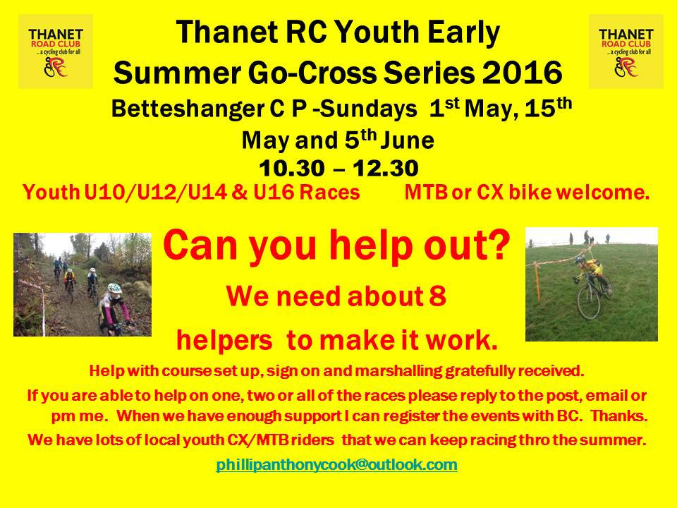

**Articles Wanted**

I now work as editor of Cycling World Magazine which specializes in leisure, tourism, sportives and commuting. I am always looking for stories. We also do book and film reviews. Please contact David Robert (TRC Committee member) at [editor@cyclingworldmag.co.uk](mailto:editor@cyclingworldmag.co.uk)

**TRC Heritage Project** contact: davealexrob@yahoo.com

We are forming a working group for the 70th Anniversary in 2017. Please get in contact with any ideas and/or if you’d like to get involved in any way.

TRC Material Wanted for Anniversary Exhibition

We’d like TRC members and friends to lend a photo (or press cutting, or jersey, or bike, or any item) for an exhibition. Could be from any time, recent history is still of interest. Drawings and sketches are encouraged, especially from young members. Originals preferred, but scans accepted. Please provide now as this is the funding period to get them framed/exhibition ready, though the exhibition will be mounted for 2017, the 70th anniversary year. We will take care of items and return (framed if desired).

Following details required with item:

         Who, what, where

          A very short bit about your place in TRC and why you chose this item

And from the archives…Lew Maxted and Brett Dennis in a KCA 2-up.

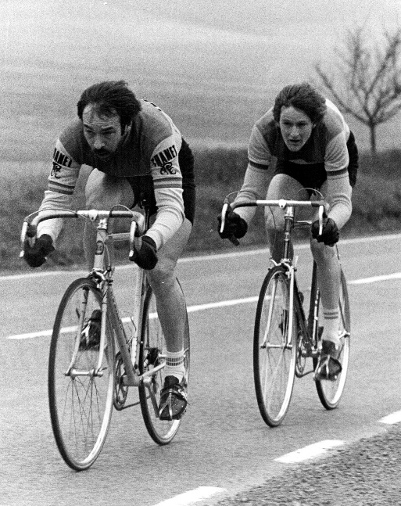

**Bottom of FormDiscounts currently available to Club Members**

Michael Kelleher MIRMT-IIST a Professional Therapist, is a keen cyclist and has recently joined the Club.

He would like to offer any club members who may require help, the following treatments:-

Sports Injuries

Remedial Back Therapy

Swedish Holistic Massage

Aromatherapy

Indian Head Massage

Courses of Instruction are also available in any of the above.

Club members requiring treatment will receive, on production of proof of membership, a discount of 25% on the current fee of £40 per session.

Contact Michael on 01227 771493 Mob 07879861618, email [backtherapist@yahoo.co.uk](mailto:backtherapist@yahoo.co.uk)

Website:- [www.michaelsmassagetherapy.co.uk](http://www.michaelsmassagetherapy.co.uk)

Locks of Sandwich : 10% on selected items

St Peter’s Cycles, Broadstairs: 10% on selected items

Bike Warehouse, Herne Bay, Faversham, Gillingham, Sevenoaks: 10% on selected items

Black Cat Coaching- special rates offered

Please also note anyone who arrives at Stonelees Golf Centre on a bike/walking/public transport gets free golf club hire

Ian Edginton, a former member of the club, has started his own cycle maintenance and repair business from his home at Staple near Wingham and welcomes your custom. All types of repair including wheel building are available. Contact Ian at [ian.edginton123@btinternet.com](mailto:ian.edginton123@btinternet.com) or 07786425829. Ian`s father Alf, is also a very long standing and respected member of the Club

Club member Martin Hendy has his own Landscaping and Gardening business and is offering free estimates and discounted rates for Club members.

This looks like a good opportunity to get out on your bike while Martin does the garden.

Garden maintenance & fencing works

Tel 01227 368373

Mob 07958 709736

Email [m.hendylandscapes@talktalk.net](mailto:m.hendylandscapes@talktalk.net)

**TIME TRIAL BIKE FOR SALE (not a club member)**

Planet X Exocet frame and forks, black, medium size.

 Vision tribars with brake levers and 10 speed Dura Ace bar end shifters

 Ambrosio aero type wheels, with Shimano freehub spline

Fsa Gossamer compact chainset 50/34, 175mm cranks

 Only ridden about 10 times so as new, selling due to back problem.

Offers please, I am willing to sell the parts separately or as a complete unit.

My name is Neal and I am at Herne Common, between Canterbury and Herne Bay.

 Email: [cnl@olheco.fsnet.co.uk](mailto:cnl@olheco.fsnet.co.uk)           Tel: 01227712131

**Monthly Quiz**

Once again David Robert came up first with the correct answer which was Russell Mockridge, well done David.

This Month`s Question:-

Who was the Tour de France rider who married podium girl Melanie Simonneau in 2003?