

**NEWSWHEEL**

**Newsletter for Thanet`s Premier Cycling Club**

Affiliated to: British Cycling; CTT;KCA;CTC

**Thanetrc.org.uk**

March 2016

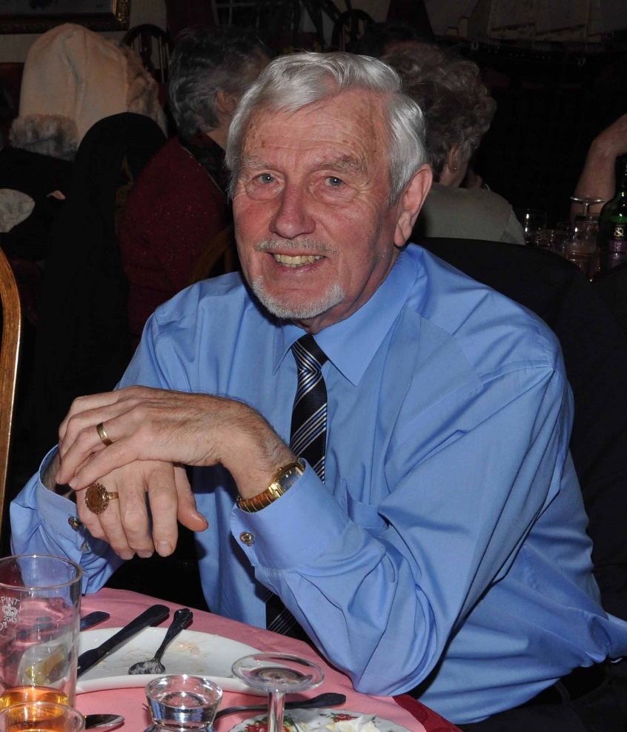

**RON IVES (1935-2016)**

I regret to announce the death of Ron Ives who has been a stalwart member of the Club for many years.

Ron was born in Bromley in 1935 and went to school there with Pete Haswell, and when Pete started racing for the Polhill in the League he became interested in the racing scene. Then National Service took over and Ron was sent off to Malaya. Some time passed and he took up cycling again and joined the West Kent Road Club, he wasn`t too keen on racing himself, so became an official. He worked initially as a carpenter and also made fishing rods for a firm in Bromley, and ended up being a Caretaker for a block of flats in Sidcup. He moved to the 34 Nomads and became a Road Race Commissaire along with Chief Commissaire and Judge the late Eddie Wingrave. Ron and Eddie worked together on many events at Crystal Palace, Herne Hill and all the top road events in the SE Division and was also involved in support of the South of England team in one of the early Tours of Britain.

He later moved down to Herne Bay where he met up with the many London riders who live round here, rode out with them and joined the Club.

Ron was always a willing helper in all the Club and KCA events and, along with Pam, would regularly turn out to marshal for us whatever the weather.

Unfortunately ill health took over and he became unable to help anymore, but was always with us in spirit. He was eventually admitted to a nursing home, but was only in there for four days when he sadly passed away.

Ron was one of the “old school” a really likeable and genuine guy, we will miss him.

To Pam we offer our deepest sympathies.

His funeral will be held on Monday the 7th of March at Thanet Crematorium at 12.40pm.

**News**

The Time Trial schedule for 2016 can now be found on the website.

The National Handbook has now been published, this can be ordered on the Cycling Time Trials website. Click on “Shop” and select Handbook. Price is £9.00 plus £1.50 postage. This is essential if you intend entering Open Time Trials, this is an incredibly comprehensive book containing everything you would wish to know.

[Betteshanger Changes to Car Parking](https://thanetrc.wordpress.com/2016/02/25/betteshanger-changes-to-car-parking/)

Betteshanger Country Park will introduce a number plate recognition system this week and then remove the barriers. Membership will go up from £30 to £40 per year next week. So if not a member get in now and save £10 for the year. Members should have provided BCP their number plates by now.

**Racing Results Open Events (TRC Riders)**

**Whites Transport/TRC MTB Racing Betteshanger CP Final Overall Results.**

U8 Girls U8 Boys U10 Boys

2. Grace Philpott 1. Luke Hart 2. Lughaidh Cook

2.= Thorsten Cook 3. Max Robinson

2.= Ben Hutton 5. Tom Crow-Brown

6. Joshua Milnes

10. Connor Beckman

11. Monty Smith

U10 Girls U12 Boys U12 Girls

1. Millie Dack 1. Charlie Hart 1. Freya Cook

2. Tom Hutton 2. Severine Smith

3. Stanley Rose

U14 Boys U16 Boys

1. Jack Hill 1. Charlie Burgess

2. Flynn Robinson 2. George Bussey

3. Toby Yemm 5. Joshua Chivilo

4. Lance Childs

5. George Pittock

6. Ethan Hart

Over 16 Men Over 16 Women

1. Rob Milnes 1. Diana Yemm

2. Phil Cook 4. Caroline Rigby

5. Mark Palmer

6. Dan Martin

9. Ollie Robinson

12. Dave Mastin

13. Peter Hutton

16. Matt Poole

17. Chris Childs

18. Ed Smith

21. Kevin Hart

The individual results for Rounds 3 and 4 can be found on the website, insufficient space to publish here.

**[LCCA Team Championships 7](https://thanetrc.wordpress.com/2016/02/07/lcca-team-championships-thanet-rc-u12-team-7th-place/)[th](https://thanetrc.wordpress.com/2016/02/07/lcca-team-championships-thanet-rc-u12-team-7th-place/) [February – Thanet RC U12 Team 7th Place](https://thanetrc.wordpress.com/2016/02/07/lcca-team-championships-thanet-rc-u12-team-7th-place/)**

LCCA Team Champs at Great Walstead School, run by Crawley Wheelers. An excellent team assembled with Luke Hart bravely riding solo. Lughaidh was no.1 rider, Charlie Hart 2, Max Robinson 3 and Freya 4.

Charlie got a brilliant start and came round the 1st corner in 4th position ahead of Lughaidh! The mud at the bottom of the course was stopping riders dead with a tough climb after, however none of the U12 Thanet Riders came a cropper in this tricky section. Lughaidh caught Charlie on the last lap and a chain coming off cost Charlie a number of places.

Max adeptly carved his way through the field riding down the fast and slippery hill section like a pro. Freya rode a very determined and solid race as her league position would suggest.

Individual results were Lughaidh 17th, Charlie 25th, Max 29th and Freya 33rd. Overall, the TRC U12 team finished 7th out of the 18 teams a really great finish to the season. Congratulations to Freya in Taking 2nd place overall in the LCCA U12 Girls Series.

**SERRL Racing 13th February**

Thanet RC again rode strongly at the latest SERLL event at Cyclopark on a cold and wet afternoon in the cat 2-3 race. [Ollie Robinson](https://www.facebook.com/ollie.robinson.12532) again showed his winter training to be working with a strong 2nd place pulling out a 40sec gap on the main group behind at the finish with a London Dynamo rider a further 45secs ahead. [Toby Hammond](https://www.facebook.com/toby.hammond.96) rode very strongly staying with the lead group for 40mins of the hour race. Race captain [Rob Milnes](https://www.facebook.com/rob.milnes1) rode strongly early on them suffered a double puncture probably caused by his new pet beagle Rupert pre race!

[**Thanet RC RT strong showing at SERLL Tenterden Event Sunday 21st March.**](https://thanetrc.wordpress.com/2016/02/21/thanet-rc-rt-strong-showing-at-serll-tenterden-event/)

The Road Race Team took another step forward by participating in their first road race on the open road. This was in the SERLL Event on the tough Woodchurch-Tenterden course. Four Race team members took part in the 80km race. A group of 5 riders got away early and eventually finished 4 mins up on the peleton where all TRC were. Ollie Robinson tried bridging gap early on and won the sprint for 6th. Dan Martin rode a strong race attempting a breakaway finishing 11th. Team manager Rob Milnes came in 17th keeping in the main group and third TRC junior rider Toby Hammond got blocked in the final sprint to again finish safely in the group. The winner was Paul Newsome (Team ASL 360). Well done everyone on their first road race.

**Help and Ride system’ for Club Time Trials 2016.**

The club organises Time Trials on Wednesday evenings from April to September every year at Fowlmead Country Park (Q10/42) and Thanet Way (Q10/31).  
This year we will again be implementing our ‘help and ride scheme’ – details are attached.  
All riders will be expected to help by committing to help at  least two club events through the season to gain eligibility to ride  
We are expecting good support from club and non club members who want to ride.  
  
You will be expected to marshal on the course on which you are planning to ride the most events -   
  
If you can only help at other club events and would like to ride on Wednesday’s please contact the time trial secretary in the first instance.  
It is the expectation that all riders including juveniles and juniors will  help and ride. As we are not allowed to let juveniles and juniors marshal we are hoping their parents will be helping their children ride.

*.* A rider who marshals for the club at any of the events listed on the Thanet Road Club – Schedule of Time Trial Events will be awarded 5 points towards the evening points competition for the first two events they marshal and 1 point for any additional events. The Boxing Day 10 mile TT is excluded. Those riders participating in the evening points competitions who marshal at any of these events are responsible to ensure that the time trial secretary is made aware of their participation.

Non club members who ride but do not support the ‘ help and ride system’ will have to pay an increased entry fee for events until they  have helped

We are also hoping members will continue to help with club open event (2 up TTT, Fowlmead 10, Thanet way 25) and our commitment to KCA events – we have committed to provide 9 marshals on  13th Sept at the KCA event on Thanet Way

To make your commitment contact Michael Friend, Thanet Road Club Time Trial Secretary:-

[Michael.friend@uk.verizon.com](mailto:Michael.friend@uk.verizon.com) or 07921491658

The day before a club time trial, if an event does not have enough helpers committed a message will be posted on the club website/Face book and the event cancelled.  
No messages and the event will run as planned  
  
I am sure we all want to ride in 2016 so please commit your support to our club.

**Club time trials:**

£3.00 for club members/ all second claim members  
£2.00 for club member juvenile/juniors  
£4.00 for guests who support ‘ help and ride system’  
£5.00 for other guests

**Forthcoming Open Events**

Saturday 5th March, VTTA 10 Q10/22 (Harrietsham)

Sunday 6th March, KCA 3-up 25 Q25/12 (Ham Street Bypass)

Sunday 13th March, PMR 25 Q25/20 (Harrietsham)

Sunday 20th March, VC Elan Hilly 22 QS/17 (Charing-Challock-Charing)

**Monday 28th March, Thanet RC 2-up QS/3 (Manston)**

Sunday 3rd April, KCA 25 Q25/8 (Molash-Canterbury-Ashford-Chilham)

Saturday 9th April, West Kent RC 10 Q10/22 (Harrietsham)

Sunday 10th April, Sydenham Whs 25 Q25/20 Harrietsham).

Please Note The highlighted event on Easter Monday will be promoted by Dave Mastin. He will be very grateful for offers of help on the day ie marshals, pushers off, tea bar etc. Thank you.

**Club Events**

The first Club event is the 2-up at Betteshanger CP Good Friday 25th March, 1600 start.

**Dates for your Diary**

Paris-Roubaix 2016

Thinking ahead to a fine Thanet RC social outlet. Sunday April 10th Paris-Roubaix should be exciting as Fabian Cancellera retirement year and Tom Boonen back in shape.

Outing is:-   
7.30am ish ferry to Calais.  
Cake and cafe stop en route to Arenberg Forest (beer tent and large screen there) see riders through then back in cars for dash to Roubaix for the finish in the velodrome and then kids souvenir hunt through team buses. Frites then on way back to Calais. Anyone in? Just need a few cars to book on.

Colin Robinson.

[**Eastbourne Weekend – 19th and 20th March 2016**](https://thanetrc.wordpress.com/2016/01/18/eastbourne-weekend-19th-and-20th-march-2016/)

This is now fully subscribed.

Dave Mastin

|  |  |  |  |  |  |  |
| --- | --- | --- | --- | --- | --- | --- |
| **Thanet RC Go-Ride and Go-Race Dates 2016**  **Go- Ride training sessions commence in March, watch this space** | | | | | | |
| Day | Date | Event | Sponsor | Location | | Time |
| Sunday | 3rd April 2016 | Thanet RC / St Peters Bike Shop Spring Road Event | SPC Cycles | Betteshanger 12.00-16.00 | | 12.00-16.00 |
| Sunday | 1st May 2016 | Youth Go-Cross No1 | | Betteshanger | 10.30-12.30 | |
| Saturday | 7th May 2016 | Giro d'Fowlmead Road Racing | | Betteshanger | 10.30-12.30 | |
| Sunday | 15th May 2016 | Youth Go-Cross No2 | | Betteshanger | 10.30-12.30 | |
| Saturday | 21st May 2016 | Thanet RC Grasstrack Event | | St Nicholas at Wade | 13.00-16.00 | |
| Saturday | 28th May 2016 | SE Youth / Junior Championships (Thanet RC) | | Betteshanger | 12.00-16.30 | |
| Sunday | 5th June 2016 | Youth Go-Cross No3 | | Betteshanger | 10.30-12.30 | |
| Monday | 20th June 2016 | Thanet RC Whites Summer Series.1 | Whites Transport | Betteshanger 18.00-20.00 | | 18.00-20.00 |
| Monday | 27th June 2016 | Thanet RC Whites Summer Series.2 | Whites Transport | Betteshanger 18.00-20.00 | | 18.00-20.00 |
| Saturday | 2nd July 2016 | Tour de Fowlmead | | Betteshanger | 10.30-12.30 | |
| Monday | 4th July 2016 | Thanet RC Whites Summer Series.3 | Whites Transport | Betteshanger 18.00-20.00 | | 18.00-20.00 |
| Monday | 11th July 2016 | Thanet RC Whites Summer Series.4 | Whites Transport | Betteshanger 18.00-20.00 | | 18.00-20.00 |
| Saturday | 16th July 2016 | Go-Ride Racing Cluster (East Kent) - Summer | | Betteshanger | 13.00-16.00 | |
| Monday | 18th July 2016 | Thanet RC Whites Summer Series.5 | Whites Transport | Betteshanger 18.00-20.00 | | 18.00-20.00 |
| Monday | 25th July 2016 | Thanet RC Whites Summer Series.6 | Whites Transport | Betteshanger 18.00-20.00 | | 18.00-20.00 |
| Monday | 1st Aug 2016 | Thanet RC Whites Summer Series.7 | Whites Transport | Betteshanger 18.00-20.00 | | 18.00-20.00 |
| Monday | 8th Aug 2016 | Thanet RC Whites Summer Series.8 | Whites Transport | Betteshanger 18.00-20.00 | | 18.00-20.00 |
| Saturday | 17th Sept 2016 | Vuelta a Fowlmead | | Betteshanger | 10.30-12.30 | |
| Sunday | 25th Sept 2016 | Thanet RC Omnium | Blackcat Coaching | Betteshanger 13.00-17.00 | | 1-5pm |
| Saturday | 29th Oct 2016 | Go-Ride Racing Cluster (East Kent) - Winter | Whites Transport | Betteshanger 13.00-15.30 | | 1-3.30pm |
| Saturday | 10th Dec 2016 | GoRide Racing MTB series 2 of 4 | Whites Transport | Betteshanger 12.45-15.30 | | 12.45-15.30 |
| **Women only Go-Race dates 2016** | | | | | | |
| Day | Date | Event | Sponsor | Location | | Time |
| Friday | 29th April 2016 | Women only road series round.1 | Locks / Ken Jones | Betteshanger 18.30-19.30 | | 18.30-19.30 |
| Saturday | 28th May 2016 | Women only road series round.2 | Locks / Ken Jones | Betteshanger 10.00-11.30 | | 10:00-11:30 |
| Friday | 24th June 2016 | Women only road series round.3 | Locks / Ken Jones | Betteshanger 18.30-19.30 | | 18.30-19.30 |
| Saturday | 30th July 2016 | Women only road series round.4 | Locks / Ken Jones | Betteshanger 10.00-11.30 | | 10:00-11:30 |
| Friday | 26th August 2016 | Women only road series round.5 | Locks / Ken Jones | Betteshanger 18.30-19.30 | | 18.30-19.30 |
| Sunday | 25th Sept 2016 | Women only road series round.6 | Locks / Ken Jones | Betteshanger 10.00-11.30 | | 10:00-11:30 |

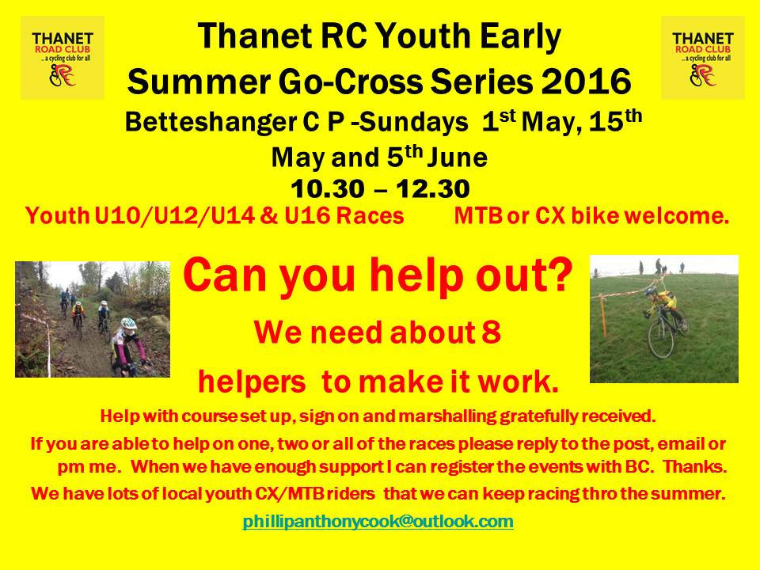

Winter Turbo Training Sessions

These continue at Manston Village Hall, Preston Road, Manston CT12 5BA, from 1800 until 1930 on Thursday evenings.

The last session will be on Thursday 24th March.

**Articles Wanted**

I now work as editor of Cycling World Magazine which specializes in leisure, tourism, sportives and commuting. I am always looking for stories. We also do book and film reviews. Please contact David Robert (TRC Committee member) at [editor@cyclingworldmag.co.uk](mailto:editor@cyclingworldmag.co.uk)

**TRC Heritage Project** contact: davealexrob@yahoo.com

We are forming a working group for the 70th Anniversary in 2017. Please get in contact with any ideas and/or if you’d like to get involved in any way.

TRC Material Wanted for Anniversary Exhibition

We’d like TRC members and friends to lend a photo (or press cutting, or jersey, or bike, or any item) for an exhibition. Could be from any time, recent history is still of interest. Drawings and sketches are encouraged, especially from young members. Originals preferred, but scans accepted. Please provide now as this is the funding period to get them framed/exhibition ready, though the exhibition will be mounted for 2017, the 70th anniversary year. We will take care of items and return (framed if desired).

Following details required with item:

         Who, what, where

          A very short bit about your place in TRC and why you chose this item

**And from the archives…** One of TRC founding members Ronnie Winters. Ronnie became a recording artist and enjoyed much success in the late 50s and 60s as Columbia Records’ 'Yodelling Cowboy' – Britain's answer to the great Slim Whitman.

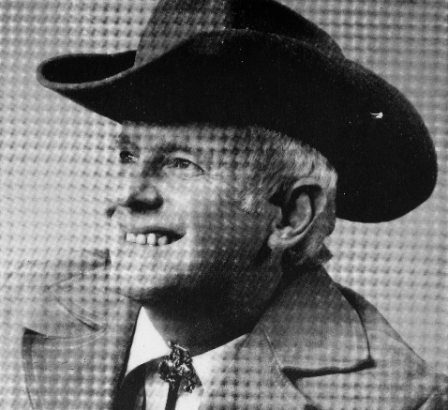

**Bottom of FormDiscounts currently available to Club Members**

Michael Kelleher MIRMT-IIST a Professional Therapist, is a keen cyclist and has recently joined the Club.

He would like to offer any club members who may require help, the following treatments:-

Sports Injuries

Remedial Back Therapy

Swedish Holistic Massage

Aromatherapy

Indian Head Massage

Courses of Instruction are also available in any of the above.

Club members requiring treatment will receive, on production of proof of membership, a discount of 25% on the current fee of £40 per session.

Contact Michael on 01227 771493 Mob 07879861618, email [backtherapist@yahoo.co.uk](mailto:backtherapist@yahoo.co.uk)

Website:- [www.michaelsmassagetherapy.co.uk](http://www.michaelsmassagetherapy.co.uk)

Locks of Sandwich : 10% on selected items

St Peter’s Cycles, Broadstairs: 10% on selected items

Bike Warehouse, Herne Bay, Faversham, Gillingham, Sevenoaks: 10% on selected items

Black Cat Coaching- special rates offered

Please also note anyone who arrives at Stonelees Golf Centre on a bike/walking/public transport gets free golf club hire

Ian Edginton, a former member of the club, has started his own cycle maintenance and repair business from his home at Staple near Wingham and welcomes your custom. All types of repair including wheel building are available. Contact Ian at [ian.edginton123@btinternet.com](mailto:ian.edginton123@btinternet.com) or 07786425829. Ian`s father Alf, is also a very long standing and respected member of the Club

**For Sale- from Trevor Trett**

DHB BIKE BOX. Great for those trips to Majorca.

£60

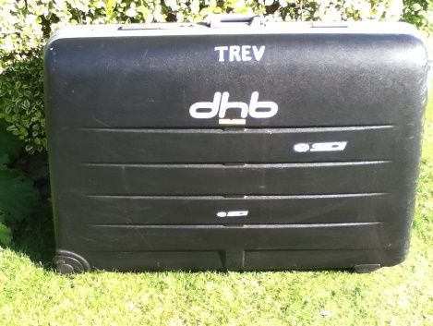

WHEEL BAGS. One Set in Silver - £15

One Set in Black - £20

BIKE BAG. J E James – Never Used £25

KARRIMOR PANNIERS. KALAHARI IBERIAN 65. These are like brand new. One has been used once. Includes liners and rack fittings. Come in original box.

£35

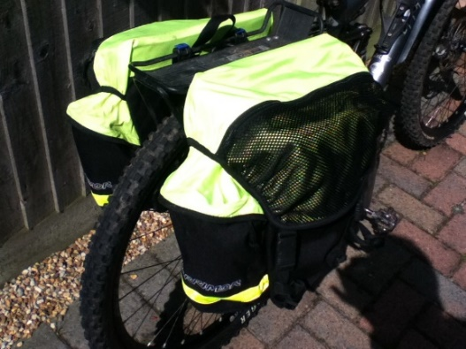

**For more details on any of these items please phone Trevor Trett – 01303 863365**

**FOR SALE – TWO STEEL BIKES**

 1.  PEUGEOT 753  White/Red/Blue   56 cm centre to top/55.5 cm centre to centre top tube

 6 speed Mavic groupset.  Campag clincher rims.  Good condition.

 £200

  2.  Mercury Tange CRO-MO White  56 cm centre to top/56.5 centre to centre top tube.

 7 speed.  Bar end changers.

Nice condition 1980’s bike.

 £100

 Ring Lawrence Martin on 01227 762918 for more information to Lynn, owner of late husband’s bikes, on 01227 740948.

**TIME TRIAL BIKE FOR SALE (not a club member)**

Planet X Exocet frame and forks, black, medium size.

 Vision tribars with brake levers and 10 speed Dura Ace bar end shifters

 Ambrosio aero type wheels, with Shimano freehub spline

Fsa Gossamer compact chainset 50/34, 175mm cranks

 Only ridden about 10 times so as new, selling due to back problem.

Offers please, I am willing to sell the parts separately or as a complete unit.

My name is Neal and I am at Herne Common, between Canterbury and Herne Bay.

 Email: [cnl@olheco.fsnet.co.uk](mailto:cnl@olheco.fsnet.co.uk)           Tel: 01227712131

**FOR SALE FROM BILL HAWKES**

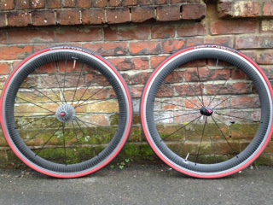

Cosmic Carbone SLS wheelset, Campagnolo freehub, de-badged (decals are readily available), bought in August 2014, light summer use only, good condition, cassette not included, Michelin Pro 4 tyres and titanium skewers included. £300.

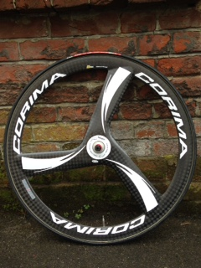

Corima 2D front trispoke, bought in August 2015, only used in one '25', very good condition, Vittoria Corsa CX tub and wheel bag included. Current rrp £735 (Winstanleys), £500 ono.

Contact : Bill Hawkes billthebikie@yahoo.co.uk

07939 039066

**Wanted**

Following the recent incident of “Mechanical Doping” in the World Cyclo-Cross Championships, Mick Cooper would like one of the motors if anyone has one for sale, or would like to know where he can obtain one. It`s all getting much harder these days!

**Monthly Quiz**

Once again David Robert came up first with the correct answer which was Luis Herrera of Columbia, well done David.

This Month`s Question:-

This question was kindly supplied by Pete Haswell:-

Who was the Australian who rode the 1948 Olympics in London, won gold at the Empire Games in 1950 in the 1000m sprint and TT. Also won the Amateur Grand Prix of Paris and then beat the pros the next day in the Open Grand Prix of Paris, beating Reg Harris in the final. They changed the rules after that. He later rode and finished the Tour de France. He returned to Australia and was unfortunately killed in a road race there.