

**NEWSWHEEL**

**Newsletter for Thanet`s Premier Cycling Club**

Affiliated to: British Cycling; CTT;KCA;CTC

**Thanetrc.org.uk**

February 2016

**News**

The Time Trial schedule for 2016 can now be found on the website. The first club event will be the 2-up 10 at Betteshanger CP on Good Friday 25th March. I now have copies of the South East District Handbook price £2.00 per copy, first come first served.

The National Handbook has now been published, this can be ordered on the Cycling Time Trials website. Click on “Shop” and select Handbook. Price is £9.00 plus £1.50 postage. This is essential if you intend entering Open Time Trials, this is an incredibly comprehensive book containing everything you would wish to know.

Many thanks to Helen Hill for taking on the position of Social Secretary, also a big thank you to Mick Cooper for all his work over the past few years.

We still have vacancies for a Funding Rep and a Publicity Rep. Please contact Jim if you are interested.

[**Thanet youngsters get invited to World Championships!**](https://thanetrc.wordpress.com/2016/01/22/thanet-youngster-get-invite-to-world-championship/)

Three of our Thanet youngsters have been selected to volunteer for the final weekend of the forthcoming World championships – Dan Martin, David Redmond and Megan Griffiths . As it is the first time they have used under-18s British Cycling is very keen to promote their Young Ambassadors so Dan is taking part in a Press Launch at the Velo Park next Tuesday. Dan is to be interviewed about the Go-Ride scheme and cycling for young people. Another exciting opportunity that has come his way by participating in the Go-Ride scheme.

Colin Robinson.

[**Dan Martin – Interview for World Track Cycling Championships**](https://thanetrc.wordpress.com/2016/01/29/dan-martin-interview-for-world-track-cycling-championships/)

Posted on [**January 29, 2016**](https://thanetrc.wordpress.com/2016/01/29/dan-martin-interview-for-world-track-cycling-championships/) by [**thanetrc**](https://thanetrc.wordpress.com/author/thanetrc/)

Following on from our young volunteers being selected to help at the world champs Dan Martin was interviewed on London Live. Check the link below for the feature

<http://www.londonlive.co.uk/news/2016-01-27/track-cycling-world-championships-come-to-london>

**Reminder**

If you haven`t already paid membership please do so as soon as possible.

Please help Jim and Dave by paying as soon as you can, it makes their jobs so much easier.

You can now pay on line via the club website, if you can renew this way it will be much appreciated as it makes things so much easier for the Treasurer. Log into the website and follow the link or alternatively send to

Dave Mastin at:- 399, Margate Road, Ramsgate, CT12 6SE.

Thank you for your co-operation.

**Racing Results Open Events (TRC Riders)**

London CX League Round 12, Cyclopark Badlands, run by Bigfoot CC. A rainy, cold, windy and pretty miserable winter’s day greeted us – perfect for CX! Lughaidh started from the third row of the grid and really got moving on the first couple of laps carving his way through the field with good lines, power bursts and dismounts to get to 5th. Lughaidh held this position to the line with a very focussed ride, which is his best this season in the series. Freya and Charlie Hart …started on the 3rd row of the grid of a large U12 field. Charlie quickly pulled away from Freya but had an incident with another rider leaving him bravely carrying an injury for the remainder of the race. Freya stayed close to the 2nd girl and series leader Emily Lines of Darenth For half the race finally managing to pull away and put some distance between them by descending the bank quickly and braking last minute for the 120 degree turn (exactly as dad had coached!). Freya managed to catch the injured Charlie on the hill before they unluckily had a bit of a coming together – thankfully without great disadvantage to either rider! Freya got away more quickly and both riders held their positions over the last lap or so finishing respectably mid-field, with Freya finishing 2nd girl ahead of the 1st and 2nd placed girls in the London CX series. Really good to see Charlie Hart out today and credit to him for seeing the race out despite being injured. Also Thanet RC’s Caroline Rigby took part in the women’s race (106th place in women and vets race) A great Thanet RC effort all round!

[**Great start to 2016 road race season at Cyclopark for Thanet RC RT**](https://thanetrc.wordpress.com/2016/01/10/great-to-2016-road-race-season-at-cyclopark-for-thanet-rc-rt/)

Saturday 9th January

Race report from the 2/3 race at the Cyclopark in torrential rain!!

Phenomenal ride by Ollie Robinson coming 3rd overall after some very classy racing beating local rider and TRC 2nd claim Jonathan Parker in a sprint from group of 3 riders. Two riders got away but the 3-up with Ollie and Jon cut the gap from 40 sec to 4 seconds on the line so very close for the win. Toby Hammond again making his debut for the Thanet RC Race Team showed great race spirt finishing the race well in tough conditions. Finally team captain Rob Milnes came in around 17th in the field of riders.

[**Mixed results at Hog Hill for Thanet youngsters.**](https://thanetrc.wordpress.com/2016/01/16/mixed-results-at-hog-hill-for-thanet-youngsters/)

Mixed results at Hog Hill today (16th January) for the first youth and junior road event of 2016. Ludhaigh Cook competed well in a large under 10 race with temperature on my cat of 1’C! Freya up next in under 12 race doing again well on a tough complete lap of the circuit including the infamous Hogenberg climb! Great in the under 14s to have 4 riders from the YDT. George Pittock top TRC rider with 13th, Flynn 17th, Jack 22nd and Toby 25th in a field of 30+ riders. Josh Chivilo competed really well in the under 16 which ended up being an hour long as mixed with the junior riders. Ollie Robinson had a terrible start crashing 10m from the start line as foot came out pedal but was given a lap out by the commissaire then with adrenaline flowing broke away on the whole field to gain 20 secs for 3 laps then came back together before Toby Hammond went on the attack gaining good time before again came back. Ollie in the sprint for 3rd but due to broken clear of earlier again foot out on the Hogenberg to come in a disappointed 12th Toby a few places behind. All good learning in competitive fields for our riders.

**Thanet trio scoring more success on the boards at Lee Valley velodrome**

It was Chris Childs, Ollie Robinson and Rob Milnes flying the flag for TRC at the FullGas track league tonight. Chris and myself put in some really strong racing showing brilliant improvements in track racing. Ollie got track league points in all the races, getting; 4th in the scratch, 2nd in the reverse win out, 1st in the second scratch and 2nd in the points. Additionally TRC coach Jo, racing for the Adalta Womens Race Team, showed just how to race on the boards winning the Points and Scratch. There really is some talent here in East Kent. Ollie and myself will be back on the boards next Tuesday doing a very special event, more to follow…

Rob Milnes.

[**SERRL 2/3 Winter race series round 3**](https://thanetrc.wordpress.com/2016/01/23/serrl-23-winter-race-series-round-3/) **January 23rd**

Four Thanet RC Race Team riders took the line at Cyclopark in a strong field of around 35. The conditions were dry but cold. The race took off from the gun. With all Race Team riders holding for 5 laps but then the attacks started coming causing splits in the group. Ollie Robinson was right side of the split, but Rob Milnes, Toby Hammond and Dan Martin didn’t mange to make the split. Ollie was working very hard to get across to a lone rider but was getting marked by other riders in the chasing group and wasn’t able to get across. Behind was Dan working hard in a the second group on the road but had to pull out due to a puncture. In the third group on the rode was Rob and Toby, eventually Rob had enough and broke away with Toby to whittle his group down to three. It came to 4 laps to go and Ollie decided to make his move and went with another rider and held the chasing pack off, Ollie took 2nd place after a very hard effort. Toby took the sprint from Rob, placing 15th and 16th respectively.

[**Ollie again makes podium at Hog Hill**](https://thanetrc.wordpress.com/2016/01/30/ollie-again-makes-podium-at-hog-hill/)

Posted on [**January 30, 2016**](https://thanetrc.wordpress.com/2016/01/30/ollie-again-makes-podium-at-hog-hill/) by [**thanetrc**](https://thanetrc.wordpress.com/author/thanetrc/)

Great performance from our riders today at Hog Hill for round 2 of the Lee valley youth CC road events. In the under 14 race George Pittock produced his best ride so far staying with the main bunch for the whole race of this testing circuit came in about 13th in the end and Flynn after an early crash came 20th in field of 25. In the under 16s Josh Chivilo again improved on his last outing in a highly competitive field and Alex Ashman in his first race of 2016 found it hard but worked hard to stay in there. Finally the juniors was a very exciting race with Toby Hammond again performing well in a very classy field of 27. Ollie Robinson produced his best ever Hog Hill ride with a superb 3rd place to put his BC points total to 22 for 2016 needing 40 for cat 2 status.

**Cyclo Cross**

Full details of all league fixtures at <http://www.londonxleague.co.uk/>

**Club Events**

**Dates for your Diary**

**Social Evening.**

The next Social Evening will be held on Tuesday 2nd February at the Bell Meadow Pavilion, St Nicholas at Wade. Please come along.

[**Eastbourne Weekend – 19th and 20th March 2016**](https://thanetrc.wordpress.com/2016/01/18/eastbourne-weekend-19th-and-20th-march-2016/)

The club’s popular Eastbourne Weekend has been arranged for the weekend of 19th and 20th March.

This involves a ride to Eastbourne on the Saturday, a stay overnight in Eastbourne, and then a return ride on the Sunday. For those who ride from, and return to Thanet, this is a ride of approximately 175 miles in total. The cost per person is £54, based on room sharing, and includes bed, breakfast, evening meal and tea/coffee and biscuits on arrival. Cost for children under 12 years of age is £27. Bikes are kept securely overnight under cover. There will be a deposit per person of £20, to be paid up front as soon as possible.

If you would like to book a place, or would like to know more about the weekend, please contact me via email, david.mastin@btinternet.com, or you can message me through Facebook.

Dave Mastin

|  |  |  |  |  |  |  |
| --- | --- | --- | --- | --- | --- | --- |
| **Thanet RC Go-Ride and Go-Race Dates 2016**  **Go- Ride training sessions commence in March, watch this space** | | | | | | |
| Day | Date | Event | Sponsor | Location | | Time |
| Saturday | 6th Feb 2016 | GoRide Whites Racing MTB series 3 of 4 | Whites Transport | Betteshanger 12.45-15.30 | | 12.45-15.30 |
| Saturday | 20th Feb 2016 | GoRide Whites Racing MTB series 4 of 4 | Whites Transport | Betteshanger 12.45-15.30 | | 12.45-15.30 |
| Sunday | 3rd April 2016 | Thanet RC / St Peters Bike Shop Spring Road Event | SPC Cycles | Betteshanger 12.00-16.00 | | 12.00-16.00 |
| Sunday | 1st May 2016 | Youth Go-Cross No1 | | Betteshanger | 10.30-12.30 | |
| Saturday | 7th May 2016 | Giro d'Fowlmead Road Racing | | Betteshanger | 10.30-12.30 | |
| Sunday | 15th May 2016 | Youth Go-Cross No2 | | Betteshanger | 10.30-12.30 | |
| Saturday | 21st May 2016 | Thanet RC Grasstrack Event | | St Nicholas at Wade | 13.00-16.00 | |
| Saturday | 28th May 2016 | SE Youth / Junior Championships (Thanet RC) | | Betteshanger | 12.00-16.30 | |
| Sunday | 5th June 2016 | Youth Go-Cross No3 | | Betteshanger | 10.30-12.30 | |
| Monday | 20th June 2016 | Thanet RC Whites Summer Series.1 | Whites Transport | Betteshanger 18.00-20.00 | | 18.00-20.00 |
| Monday | 27th June 2016 | Thanet RC Whites Summer Series.2 | Whites Transport | Betteshanger 18.00-20.00 | | 18.00-20.00 |
| Saturday | 2nd July 2016 | Tour de Fowlmead | | Betteshanger | 10.30-12.30 | |
| Monday | 4th July 2016 | Thanet RC Whites Summer Series.3 | Whites Transport | Betteshanger 18.00-20.00 | | 18.00-20.00 |
| Monday | 11th July 2016 | Thanet RC Whites Summer Series.4 | Whites Transport | Betteshanger 18.00-20.00 | | 18.00-20.00 |
| Saturday | 16th July 2016 | Go-Ride Racing Cluster (East Kent) - Summer | | Betteshanger | 13.00-16.00 | |
| Monday | 18th July 2016 | Thanet RC Whites Summer Series.5 | Whites Transport | Betteshanger 18.00-20.00 | | 18.00-20.00 |
| Monday | 25th July 2016 | Thanet RC Whites Summer Series.6 | Whites Transport | Betteshanger 18.00-20.00 | | 18.00-20.00 |
| Monday | 1st Aug 2016 | Thanet RC Whites Summer Series.7 | Whites Transport | Betteshanger 18.00-20.00 | | 18.00-20.00 |
| Monday | 8th Aug 2016 | Thanet RC Whites Summer Series.8 | Whites Transport | Betteshanger 18.00-20.00 | | 18.00-20.00 |
| Saturday | 17th Sept 2016 | Vuelta a Fowlmead | | Betteshanger | 10.30-12.30 | |
| Sunday | 25th Sept 2016 | Thanet RC Omnium | Blackcat Coaching | Betteshanger 13.00-17.00 | | 1-5pm |
| Saturday | 29th Oct 2016 | Go-Ride Racing Cluster (East Kent) - Winter | Whites Transport | Betteshanger 13.00-15.30 | | 1-3.30pm |
| Saturday | 10th Dec 2016 | GoRide Racing MTB series 2 of 4 | Whites Transport | Betteshanger 12.45-15.30 | | 12.45-15.30 |
| **Women only Go-Race dates 2016** | | | | | | |
| Day | Date | Event | Sponsor | Location | | Time |
| Friday | 29th April 2016 | Women only road series round.1 | Locks / Ken Jones | Betteshanger 18.30-19.30 | | 18.30-19.30 |
| Saturday | 28th May 2016 | Women only road series round.2 | Locks / Ken Jones | Betteshanger 10.00-11.30 | | 10:00-11:30 |
| Friday | 24th June 2016 | Women only road series round.3 | Locks / Ken Jones | Betteshanger 18.30-19.30 | | 18.30-19.30 |
| Saturday | 30th July 2016 | Women only road series round.4 | Locks / Ken Jones | Betteshanger 10.00-11.30 | | 10:00-11:30 |
| Friday | 26th August 2016 | Women only road series round.5 | Locks / Ken Jones | Betteshanger 18.30-19.30 | | 18.30-19.30 |
| Sunday | 25th Sept 2016 | Women only road series round.6 | Locks / Ken Jones | Betteshanger 10.00-11.30 | | 10:00-11:30 |

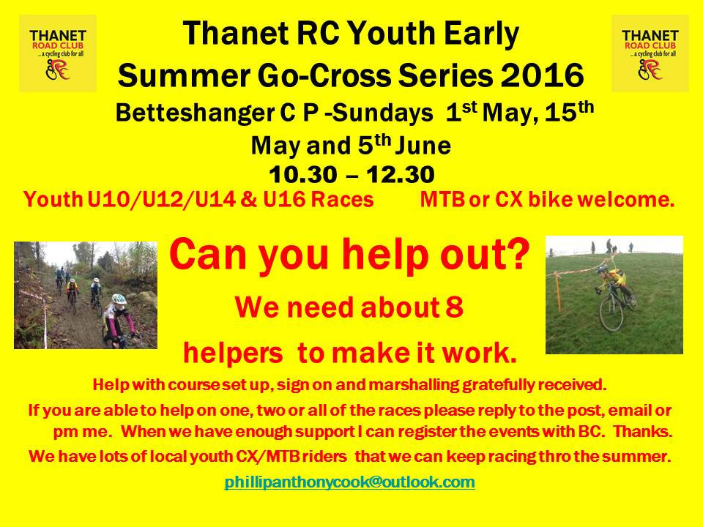

[**Thanet Wattbike racing night – 12th Feb 2016**](https://thanetrc.wordpress.com/2015/11/08/thanet-wattbike-racing-night-15th-jan-2016/)

After the great response for the Wattbike racing night [Caroline Rigby](https://www.facebook.com/caroline.rigby.1428) has kindly suggested and agreed to run a WB training night for members on Friday 12th Feb again at the Christchurch university site in Canterbury. There will be a small fee with money going to Go-Ride funds. Anyone interested email or post on Facebook so we can gauge interest and book names. Thanks Colin and Caroline.

**Wattbike Racing Night 15th January Results**

A great night`s racing thoroughly enjoyed by everyone.

Overall Result 1st Lady 1st Under 16

1st Chris Childs Nicola Goodban George Pittock

2nd Dan Martin

3rd David Robert

Well done to all who competed.

Winter Turbo Training Sessions

These continue at Manston Village Hall, Preston Road, Manston CT12 5BA, from 1800 until 1930 on Thursday evenings.

This new venue has been chosen to make the sessions more cost effective and to improve logistics for members.

Costs will be £3.50 for seniors and £2.00 for under 18`s. Riders from other clubs welcome.

We must clear the hall by just after 1930, and it must be clean (no sweat etc on the floor), please bring cloths.

**Help Please**

Volunteer required to help with balance bike sessions Jan-early March 2016 Thursdays 4.45-5.45 at Ursuline school in Westgate. Contact David Robert davealexrob@yahoo.com

**VTTA Reliability Trial**

This will be on Sunday 7th February 2016, HQ is Bethersden Village Hall, 0900 start.

33 miles in 2¾ or 3¼ hours, or 50 miles in 3, 3½ or 4 hours.

Entries £4.00 to Roger Burchett, Haytor, Stone St, Lympne, Hythe, CT21 4JY, or £5.00 on the day.

Anyone can ride, you don`t have to be a veteran.

**VTTA Kent Group Annual Luncheon and Prize Giving** will be held on Sunday 21st February 2016 at the Weald of Kent Golf Club as last year. Carvery meal and prices as last year £17.50 per head. Cheques to Tom Morton, 42, Chiltern End, Ashford, TN24 8QL. Guest of Honour to be confirmed later. Last date for bookings 8th February.

**Articles Wanted**

I now work as editor of Cycling World Magazine which specializes in leisure, tourism, sportives and commuting. I am always looking for stories. We also do book and film reviews. Please contact David Robert (TRC Committee member) at [editor@cyclingworldmag.co.uk](mailto:editor@cyclingworldmag.co.uk)

**TRC Heritage Project** contact: davealexrob@yahoo.com

We are forming a working group for the 70th Anniversary in 2017. Please get in contact with any ideas and/or if you’d like to get involved in any way.

TRC Material Wanted for Anniversary Exhibition

We’d like TRC members and friends to lend a photo (or press cutting, or jersey, or bike, or any item) for an exhibition. Could be from any time, recent history is still of interest. Drawings and sketches are encouraged, especially from young members. Originals preferred, but scans accepted. Please provide now as this is the funding period to get them framed/exhibition ready, though the exhibition will be mounted for 2017, the 70th anniversary year. We will take care of items and return (framed if desired).

Following details required with item:

         Who, what, where

          A very short bit about your place in TRC and why you chose this item

**And from the archives…** Dave Saffery (1929-2009) riding in 1949. Dave was a club founder member who held various positions including President, Chairman, Racing Secretary and Newsletter Editor. Dave wrote the history of the first 50 years of the club and was instrumental in starting the Go Ride.

Read Dave Saffery’s Club History 1947-97 [www.thanetrc.org/club-history.shtml](http://www.thanetrc.org/club-history.shtml)

See more TRC archive photos at: [www.flickr.com/photos/davealexrob/albums](http://www.flickr.com/photos/davealexrob/albums)

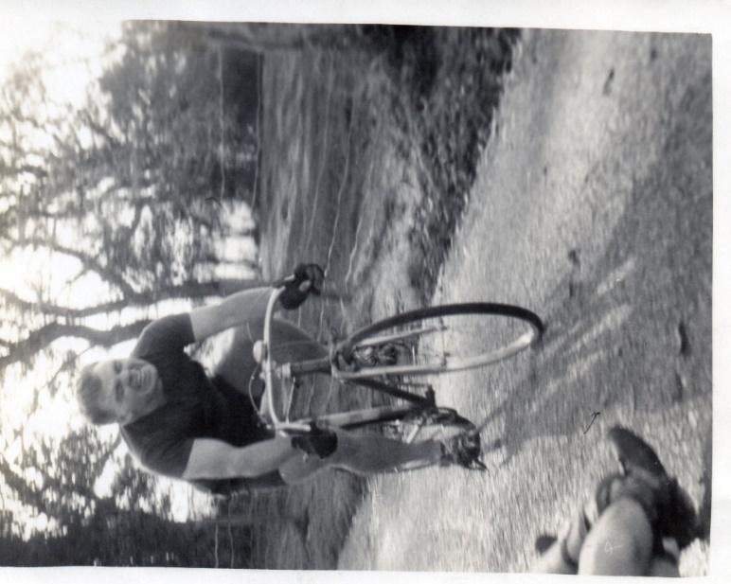

**Bottom of FormDiscounts currently available to Club Members**

Michael Kelleher MIRMT-IIST a Professional Therapist, is a keen cyclist and has recently joined the Club.

He would like to offer any club members who may require help, the following treatments:-

Sports Injuries

Remedial Back Therapy

Swedish Holistic Massage

Aromatherapy

Indian Head Massage

Courses of Instruction are also available in any of the above.

Club members requiring treatment will receive, on production of proof of membership, a discount of 25% on the current fee of £40 per session.

Contact Michael on 01227 771493 Mob 07879861618, email [backtherapist@yahoo.co.uk](mailto:backtherapist@yahoo.co.uk)

Website:- [www.michaelsmassagetherapy.co.uk](http://www.michaelsmassagetherapy.co.uk)

Locks of Sandwich : 10% on selected items

St Peter’s Cycles, Broadstairs: 10% on selected items

Bike Warehouse, Herne Bay, Faversham, Gillingham, Sevenoaks: 10% on selected items

Black Cat Coaching- special rates offered

Please also note anyone who arrives at Stonelees Golf Centre on a bike/walking/public transport gets free golf club hire

Ian Edginton, a former member of the club, has started his own cycle maintenance and repair business from his home at Staple near Wingham and welcomes your custom. All types of repair including wheel building are available. Contact Ian at [ian.edginton123@btinternet.com](mailto:ian.edginton123@btinternet.com) or 07786425829. Ian`s father Alf, is also a very long standing and respected member of the Club

**FOR SALE**

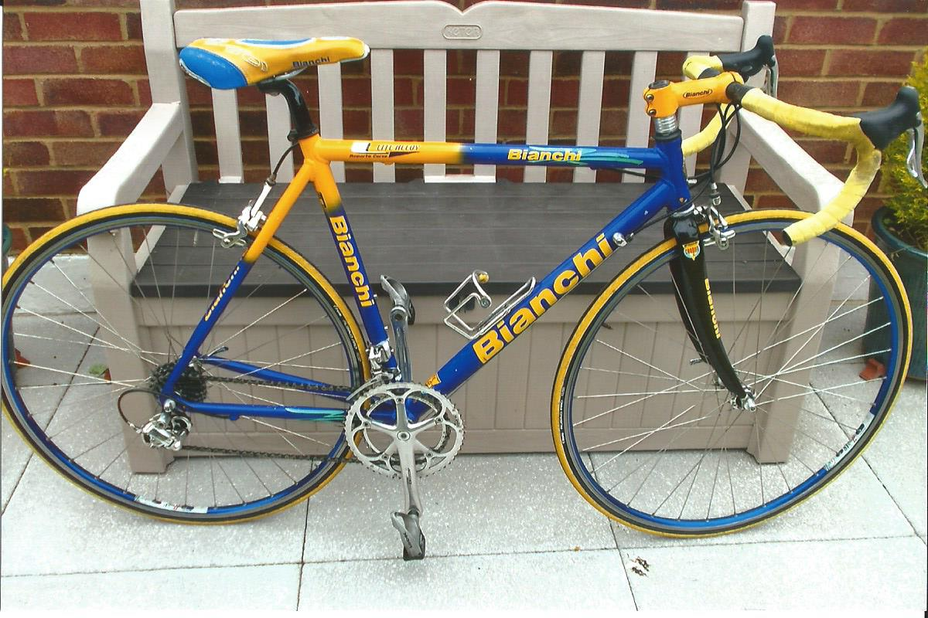

Bianchi Lite alloy 54cm (21in) frame, carbon forks, Campag 10 speed Chorus throughout, a few scratches, surplus to requirements.

Now reduced to £400 o.n.o. Contact Mick Cooper 01227 503624 or [the.coop@sky.com](mailto:the.coop@sky.com) Can be seen at Beltinge.

**For Sale- from Trevor Trett**

DHB BIKE BOX. Great for those trips to Majorca.

£60

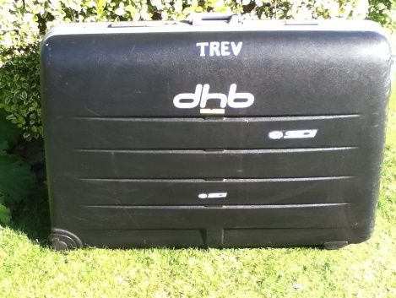

WHEEL BAGS. One Set in Silver - £15

One Set in Black - £20

BIKE BAG. J E James – Never Used £25

KARRIMOR PANNIERS. KALAHARI IBERIAN 65. These are like brand new. One has been used once. Includes liners and rack fittings. Come in original box.

£35

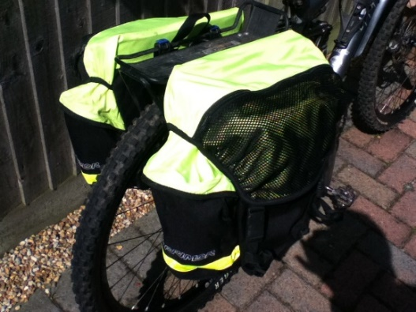

**For more details on any of these items please phone Trevor Trett – 01303 863365**

**FOR SALE – TWO STEEL BIKES**

 1.  PEUGEOT 753  White/Red/Blue   56 cm centre to top/55.5 cm centre to centre top tube

 6 speed Mavic groupset.  Campag clincher rims.  Good condition.

 £200

  2.  Mercury Tange CRO-MO White  56 cm centre to top/56.5 centre to centre top tube.

 7 speed.  Bar end changers.

Nice condition 1980’s bike.

 £100

 Ring Lawrence Martin on 01227 762918 for more information to Lynn, owner of late husband’s bikes, on 01227 740948.

**TIME TRIAL BIKE FOR SALE (not a club member)**

Planet X Exocet frame and forks, black, medium size.

 Vision tribars with brake levers and 10 speed Dura Ace bar end shifters

 Ambrosio aero type wheels, with Shimano freehub spline

Fsa Gossamer compact chainset 50/34, 175mm cranks

 Only ridden about 10 times so as new, selling due to back problem.

Offers please, I am willing to sell the parts separately or as a complete unit.

My name is Neal and I am at Herne Common, between Canterbury and Herne Bay.

Email: [cnl@olheco.fsnet.co.uk](mailto:cnl@olheco.fsnet.co.uk)

Tel: 01227712131

**Monthly Quiz**

Last month`s crossword quiz proved rather disappointing as no-one came forward with a solution. The answers were:-

1.Vincenzo Nibali 2. Jacques Anquetil 3. Carlos Sastre 4. Laurent Fignon 5. Alberto Contador 6. Oscar Pereiro 7. Pedro Delgado 8. Stephen Roche 9. Bradley Wiggins 10. Greg Lemond 11. Cadel Evans 12. Miguel Indurain 13. Jan Ullrich 14. Marco Pantani.

Making the vertical answer Bernard Hinault.

So it`s back to questions.

This Month`s Question:-

The 1984 Tour de France stage 17 from Grenoble to l`Alpe d`Huez was billed as a showdown between Bernard Hinault and Laurent Fignon, with Greg Lemond and Robert Millar also in contention.

In the end however, they were all beaten up the Alpe by a Tour debutante who won the stage by 49 seconds. Who was this rider?