

**NEWSWHEEL**

**Newsletter for Thanet`s Premier Cycling Club**

Affiliated to: British Cycling; CTT;KCA;CTC

**Thanetrc.org.uk**

October 2015

**New Members**

This month we welcome the following new members:- Daniel Van Hinsbergh, Thomas Crow-Brown, Kenton Evans, Martin Hendy and a warm welcome back to first claim membership for Chris Fennell. We hope that their association with us will be a long and happy one.

**Club Annual General Meeting**

This will be held on Friday 13th November at 7.30pm at the Bell Meadow Pavilion, St Nicholas at Wade.

Please come along and support this important event, we value your input and suggestions.

Please note the change of venue from last year.

The Annual Club dinner and Prize Presentation will also be held in November venue and date to be confirmed. Please watch your email and the website.

**Please help us to regain the Rootes Trophy awarded for the highest points total in the Reliability Trial.**

**Full details below. We need to beat the Fairies!**

**Cycling Weekly Coverage of Thanet RC Club Run**

As you may know this has had to be postponed as Chris Hovenden has had an accident and has broken his wrist so this is to be rearranged for November.

Full details to follow,

Best wishes,

Jim Dickson.

Secretary Thanet Road Club

**Thanet Sports Awards**

The annual event which is being hosted on **Thursday 19 November** is organised by Thanet District Council’s Sports Matters team, and supported by various organisations from the public, private and voluntary sector.  This year’s ceremony which will be hosted at the Winter Gardens in Margate, will celebrate all that is sport and recognise the outstanding achievements that local clubs, coaches, talented performers, schools and volunteers have given to local sport.

The event is now in its seventh year and we are encouraging nominations from all areas of the community to celebrate the achievements and efforts that our community role models play in driving sport forward in Thanet.

Nominations will be open on **Monday 3rd August** and we are looking for nominations covering a whole range of categories including:

·        **Club of the Year**

·        **Coach of the Year**

·        **Disabled Sports Person of the Year**

·        **Unsung Hero**

·        **Sportsman of the Year**

·        **Sportswoman of the Year**

·        **Young Sportsperson of the Year**

·        **Primary Sports School of the Year**

·        **Secondary Sports School of the Year**

·        **Sports Teacher of the Year**

I would be grateful if you could please circulate this to your contacts, and to any groups or individuals who are looking to put forward their nominations.

If you would like more information about this year’s event, please do get in touch.

Kind Regards

 Colin Rouse

**Sports Development Officer**

**Tel: 01843 577032**

**Mob: 07770828582**

**Web:** [**www.thanet.gov.uk/sport**](http://www.thanet.gov.uk/sport)

We also still need a Publicity Rep, mainly to submit copy to the local press, please contact any Committee member if you would like to take it on.

I have recently started work as editor of Cycling World Magazine which specializes in leisure, tourism, sportives and commuting. I am always looking for stories and can pay a bit for contributions. Please contact David Robert (TRC Committee member) at [editor@cyclingworldmag.co.uk](mailto:editor@cyclingworldmag.co.uk)

**Racing Results Club Events** (**TRC Riders)**

Evening 10 2nd September Q10/42 Betteshanger CP Juniors Olly Dickson 24.25, David Redmond 26.17, Flynn Robinson 26.57, Lance Childs 27.01, Jack Hill 28.56, Dan Van Hindsbergh 28.56, Megan Griffiths 30.01, George Pittock 30.41, Toby Yemm 33.02. Fastest was Toby Anderton (VC Deal) 24.22.

Seniors Simon Henderson 22.49, Richard McVey 23.38, Lawrence Martin 23.44, Nic Fennell 24.00, Jim Dickson 24.01, Colin Robinson 24.20, Scott Meeks 24.22, Michael Friend 24.51, Martin Russell 24.52, Dave Danton 25.15, Chris Childs 26.07, Peter Huckstep 26.23, Nick Scott 26.39, Frank Burniston 26.40, David Robert 27.14, Roger Dewen 29.59, Caroline Rigby 30.14, Diana Yemm 30.57, Jenny Fearn 31.00. Fastest was Alex Paton (Pedal Heaven) 20.47. Well done to all who rode in heavy rain after signing on in the dry!

Evening 10 9th September Q10/42 Betteshanger CP Juniors Ollie Robinson 22.16, Toby Hammond 23.44, Olly Dickson 24.49, David Redmond 26.04, Lance Childs 28.30, Dan Van Hindsbergh 28.36 (PB), George Pittock 30.08, Jack Hill 30.37, Megan Griffiths 31.12, Max Robinson 35.30, Freya Cook 38.24 (PB), Lugaidh Cook DNF. Ollie was the fastest.

Seniors Chris Fennell 20.21, Simon Henderson 22.03, Huck Garip 22.24, Lawrence Martin 22.42, Nic Fennell 23.50 (PB), Scott Meeks 23.56 (PB), Michael Friend 23.59, Jim Dickson 24.12, Chris Bax 24.33, Matt Hall 24.44, Colin Robinson 24.51, Chris Childs 25.03, Martin Russell 25.05, Paul Kelk 25.14, Peter Huckstep 26.06, Frank Burniston 26.53, Nick Scott 27.00, Heidi Hammond 27.17, David Robert 27.40, Colin Inett 27.47, Malcolm Adams 28.38, Jenny Fearn 32.42, Helen Hill 33.26, Sue Shields 40.45. Chris was the fastest.

This was the final event of the Evening 10 Series.

Annual Club Hill Climb Championship 27th September QHC/8 (St Margarets Bay) Juniors Dan Martin 2.29.7, Olly Dickson 2.33.8, Tristan Duffy 2.57.3, Alex Ashman 3.18.0, Jack Hill 3.21.1, George Bussey 3.44.6. Fastest Junior was Chris Hyde (Wigmore CC) 2.08.09, fastest Thanet Junior was Dan Martin.

Seniors Jason Oram (2nd Claim) 2.11.9, Rob Milnes 2.27.3, Nick Scott 3.14.6, Scott Meeks 3.14.8, Richard Hull 3.15.2, Matt Hall 3.17.9, Brett Dennis 3.26.8, Nicola Goodban 3.53.6, Tony Kenneally 4.00.1, James Bird 4.10.7, Helen Hill 4.30.7, Nigel Derrett 4.56.7. Rob Milnes is the new Club Hill Climb Champion. The fastest ride of the day came from Keith Watson (Adalta CC) 2.07.05. Fastest Lady was Emma Lewis (Adalta CC) 2.49.0. Well done to all who participated in this tough event.

Helen Hill has stated that she would like to donate a trophy for the Fastest Junior in the Hill Climb. This will be called the Matt Hill Trophy in memory of her late husband, who often liked to ride his bike up the St Margaret`s hill. I`m sure you would all like to join me in sincerely thanking Helen for this memorable gesture which will be awarded for many years to come. The first recipient of the Trophy will be Dan Martin.

**Racing Results Open Events (TRC Riders)**

[**Young riders do Thanet RC proud at National GHS 10 mile TT championships**](https://thanetrc.wordpress.com/2015/09/13/young-riders-do-thanet-rc-proud-at-national-ghs-10-mile-tt-championships/)

A huge well done from the club to the 4 Thanet RC riders at the GHS National championships on the A10 course in Ware, Hertfordshire. Lance Childs produced a 28.14 for 7th place in the 12 year old group. Megan Griffiths 31.11 for 5th in the 14 year old girls. Olly Dickson 25.14 for 27th under 16 and Ollie Robinson 21.46 for 7th in the 16 year old group and 11th overall of the 180 starters. Toby Anderton of VC Deal also rode recording 23.55, 9th 14 year old. Overall winner was Samuel Henning (Dr Challoners Grammar School) with 20.21, an incredible time for a 16 year old.

[**Seb Dickson gets his Category 2 Race Licence!**](https://thanetrc.wordpress.com/2015/09/01/seb-dickson-gets-his-category-2-race-licence/)

A first place in the Cyclopark Summer Series on 27th August, and a first in the SERRL event, also at the Cyclopark, on 31st August, both from solo breaks, along with 4th in a sprint finish in Saturday’s Crits in the Park event moves Seb to a 2nd cat rider.

Well done Seb!

**Race Report Cyclopark 17th September**

Rob Milnes and Ollie Robinson took to the start line of the final Fullgas 3/4 circuit race tonight at the Cyclopark. Rob attacked from the gun, getting in to the first corner safely with Ollie on his wheel, followed up by an attack from Ollie, splitting the race in to two groups. Ollie got away with another rider, sadly the break was nulled.

The race came to a bunch sprint, results to be confirmed but it looks like 5th and 6th for the Thanet guys, which way round, well we’ll have to wait for the video finish. With both guys thinking they pipped each other on the line.

[**Track Racing – Saturday 19th September**](https://thanetrc.wordpress.com/2015/09/20/track-racing-saturday-19th-septemper/)

The club was represented at two Olympic velodromes on Saturday night.

First up was Chris Childs representing TRC at Herne Hill velodrome, Chris had an amazing night, winning 3 races, 2nd in the Win Out, and also taking a prime sprint! Wins were in the 2 scratch races and the unknown distance. Well done Chris!!

Over at Lee Valley Rob and Ollie were on the boards. This was Ollie’s first indoor open track meet, he stayed with the main field and got an amazing 8th in the devil. It’s worth mentioning that Ollie was only riding an 81″ gear (that’s small) and he’d raced a crit in the morning! Rob got 4th in the devil earning some British Cycling points, which could land him his 2nd category licence, pending results coming in from the previous week. Roll on the winter track league.

Sunday 13th September KCA 25 Q25/10 (Thanet Way) Jenny Fearn 1.22.48 (PB) (3rd Lady), Paul Griffiths 1.14.45, Richard McVey DNS, Michael Friend 1.03.29 (PB), Chris Childs 1.06.46, Andy Macpherson DNS, Jim Dickson 1.02.37, Huck Garip 58.20, Olly Dickson 1.05.13 (2nd Junior), Dave Mastin 1.06.28, Chris Bax DNS, Colin Inett 1.16.00, Peter Huckstep 1.08.41, Martin Russell 1.06.19, Bill Hawkes 58.12, Paul Kelk 1.05.55, David Robert 1.12.13 (PB), Ollie Robinson 58.09 (1st Junior), Colin Robinson 1.02.06, Simon Henderson 55.56, Scott Meeks 1.01.30 (PB). Fastest was Jon Parker (PMR @Toachim House) 51.18, a new course record so well done to him, and to the Prizewinners and PB`s.

Sunday 13th September RTTC National 20 mile Circuit Championships F5C/20 Cranfield Chris Fennell 42.50, Nic Fennell 52.58. Winner was Matt Clinton (Mike Vaughan Cycles) 41.30. Well done Chris who came in 4th overall.

Sunday 20th September VTTA 25 Q25/12 (Old Romney-Hamstreet) Huck Garip 58.42, Bill Hawkes DNS, Lawrence Martin 59.44, Nic Fennell 1.04.59 (PB), Chris Bax 1.03.03, Dan Martin 58.39, Dave Danton DNS, Simon Henderson 57.44, Paul Kelk 1.05.56, Paul Griffiths 1.12.50, Chris Fennell 52.23, Colin Inett 1.13.54, Martin Russell 1.06.02, Andy Macpherson DNS. Chris was the fastest, Andrew Meilak the winner OAS. Unfortunately Peter Elms was involved in an accident with a car at Brenzett RAB and was detained overnight in hospital suffering from severe bruising and lacerations, and has been ordered to rest for 4 weeks. We wish him a complete recovery.

**Who Has Won What so far in 2015**

Evening 10 Points Seniors 1. Chris Childs 86 pts Juniors 1. Lance Childs 70 pts

2. Michael Friend 72 pts 2. Olly Dickson 65 pts

3. Matt Hall 69 pts 3. David Redmond 61 pts 3. Ollie Robinson 61 pts

Vince Evans Memorial 1. Simon Henderson 57.14

2. Huck Garip 57.35

3. Dan Martin 58.25

Mike Catlow Memorial Handicap 1. Andy Burrows 42.58

2. Jim Dickson 45.14

3. Colin Robinson 45.57

Glen Nichols Handicap 1. Nic Fennell 17.04

2. Scott Meeks 17.05

3. Chris Childs 17.11

3. Huck Garip 17.11

3. Simon Henderson 17.11

Challenge 25 Simon Henderson 56.55

Senior Hill Climb Champion 1. Rob Milnes 2.27.30

2. Dan Martin 2.28.10

3. Olly Dickson 2.33.08

Matt Hill Memorial Trophy 1. Dan Martin 2.28.10

Junior Hill Climb Champion 2. Olly Dickson 2.33.08

3. Tristan Duffy 2.57.3

Gordon Haller Memorial Ollie Robinson 23.05

Lawrence Martin 23.06

Daniel Martin 23.53

Colin Robinson 24.26

Martin Russell 24.53

Bert Spickett Memorial Handicap 1. Jason Wares 17.31

2. Scott Meeks 17.42

3. Nic Fennell 17.53

Channel Ports 4-up TTT 1. Rick Perkins 29.43

(Seniors) Rob Milnes

Seb Dickson

Huck Garip

Channel Ports 4-up TTT 1. Olly Dickson 31.11

(Juniors) Ollie Robinson

Dan Martin

Toby Hammond

Jim Braginton Memorial 2-up TT 1. Kevin Tye (Velo Refined Aerosmiths) 19.19

Andrew Meilak

Ray Jesset Memorial Open 10 1. Gary Record (West Kent RC) 21.34

Best Over 60 1. Dave Mastin 22.42mph

2. Andy Burrows 22.00mph

3. Colin Inett 20.97mph

100 Mile Champion 1. Simon Henderson 4.03.38

2. Rick Perkins 4.14.33

12 Hour Champion 1. Richard Hull 222.38 miles

2. Meadhbh Cook 147.384 miles

These are the results so far. Riders are reminded that they can claim for Club Awards, details can be found on pages 6-11 of the Club Handbook.

**CLUB CLOTHING**

We now have some winter Club Clothing in stock.

Contact   [peter.huckstep@btinternet.com](mailto:peter.huckstep@btinternet.com)  OR  01843 845107

**Forthcoming Open Events**

Sunday 4th October Wigmore CC Hill Climb QHC/11 (Hollingbourne)

Sunday 11th October VTTA 15 Q15/20R (Charing-Leeds-Charing)

**Dates for your Diary**

KCA Annual Lunch and Prize Presentation

This will be on Sunday 1st November at Smarden Charter Hall 12.00 midday for 13.15. Tickets the same as last year £17.50, under 18`s £8.00.

Special Guest will be Sean Yates of Team Tinkoff-Saxo.

Contact Ann Burden 07966 470180 or [ann@aburden7.wanadoo.co.uk](mailto:ann@aburden7.wanadoo.co.uk) or [annburden68@gmail.com](mailto:annburden68@gmail.com)

Alternatively Pat Hill 01580 291737 or [patchill@tiscali.co.uk](mailto:patchill@tiscali.co.uk)

Sunday 4th October Youth/Adult Road Racing (Oktoberfest) at Cyclopark (Gravesend), Thanet RC organising so any helpers/riders much appreciated.

Saturday 17th October Youth Road events at Betteshanger CP (Phil Cook organising)

Saturday 24th October Youth/Adult Cyclocross/MTB events at Betteshanger CP. Round 1 of 4 Whites Transport Winter Series.

**K C A Reliability Trial**

**Sunday 25 October 2015**

The Rootes Trophy is awarded to the club with the highest points total in this event based on the following table below.

This trial is not a race but is about getting as many members as possible to finish their course within their target time. The more members who complete what they set out to complete, the more points we score. Thanet Road Club won the trophy in 2013 and we are very keen to make a good showing again this year. There should be an appropriate target distance and time for every active member.

The courses begin at Claygate and Potters Corner A20 near Ashford and make an excellent Autumn day out for all riders.

We need to get all entries in to the KCA by 6 Oct 15, there are no entries allowed on the line. Michael Friend (michael.friend@talktalk.net), our new Time Trial Secretary, will collate entries with the club picking up the entry fee. Please contact him to let him know which distance/time you wish to be entered for.

|  |  |  |
| --- | --- | --- |
| Distance | Time Options | Points |
| 50 km | 2 hours  2.5 hours  3 hours | 1 |
| 100 km | 4 hours  4.5 hours  5 hours | 2 |
| 100 miles | 6.5 – 7 hours | 4 |

**Club Social Evening**

The next one will be on Tuesday 6th October at the Bell Meadow Pavilion 7.30-9.30 as usual. Please come along.

**An Evening with Graeme Obree**  
24 October The Village Hotel, Maidstone

Cost £50pp or £450 for a table of 10 to include a superb 4 course meal

All proceeds will be donated to Help for Heroes

Call the Village Hotel on **0871 222 4598**

HOLDER OF THE 1HR RECORD X2 - 1993 (51.596KM) & 1994 (52.713KM)

**WORLD 4000M PURSUIT CHAMPION X2**

 How did Graeme make the step from club cyclist to an international superstar of cycling. What attributes did he possess which pushed him above and beyond the ordinary and created a cycling legend?

Fellow cyclist Sir Chris Hoy comments: "Graeme is a genius in the true sense of the word. His uncanny ability to tackle problems from an angle that no-one else could have thought of, makes him a one-off. An original. He sees the world in a different way to us mere mortals and comes up with ideas and solutions which make you laugh, shake your head and say 'why didn't I think of that?!'"

An individual beyond reproach, an innovator, an incredible athlete with an indestructible determination are just some of the elements of Graeme's character. To understand the rest you really need to hear it from the man himself - Graeme is a brilliant speaker with a truly captivating story.

**Cyclo Cross**

Full details of all league fixtures at <http://www.londonxleague.co.uk/>

[**Cycling World Christmas Card Competition**](https://thanetrc.wordpress.com/2015/09/11/cycling-world-christmas-card-competition/)

Cycling World magazine is running a competition to design a Christmas Card to go out as a free gift with our December issue. The two best will be printed in a pack with other two cards by famous cycling-inspired artist Deepa Mann-Kler <http://www.cycleprints.co.uk/>  
Theme: The World of Cycling at Christmas  
Medium: Any artwork- painted, illustrated, photo, graphic etc.  
Size: A6 14.8 by 10.5 cms  
Ages: all ages encouraged to enter  
Deadline: by 14 0ctober 2015  
Prizes: Will be tailored to the winner  
Entries to: [editor(at)cyclingworldmag.co.uk](mailto:editor@cyclingworldmag.co.uk) or Editor, Cycling World, Myrtle Oast, Kemsdale Road, Fostall, Kent ME13 9JL  
Good luck

**Heritage Project Update (by David Robert)**

View photos from The Club Heritage Project at:

<https://www.flickr.com/photos/davealexrob/collections/>

Download the history of the club 1947-97. Link at the bottom of the history page:

<http://thanetrc.org/club-history.shtml>

**Thanet Road Club Photos Wanted for Anniversary Exhibition**

Could TRC members lend a photo for an exhibition in anniversary year 2017- **photos required now** for framing. Following details required with photo:

* Who, what, where?
* A bit about you as club member and why you chose this photo.

All photos and enquiries to David Robert, 07824 399126, 01227 281087, [davealexrob@yahoo.com](mailto:davealexrob@yahoo.com)

**And from the archives:**

Always happy to honour our timekeepers and marshals here’s a photo by Mike Kneller. Spotted so far LtoR: Jim Linton (with board), Jim Braginton (with board), Steve Hyman and Shaggy from Scooby-Doo, or maybe Brett Dennis.

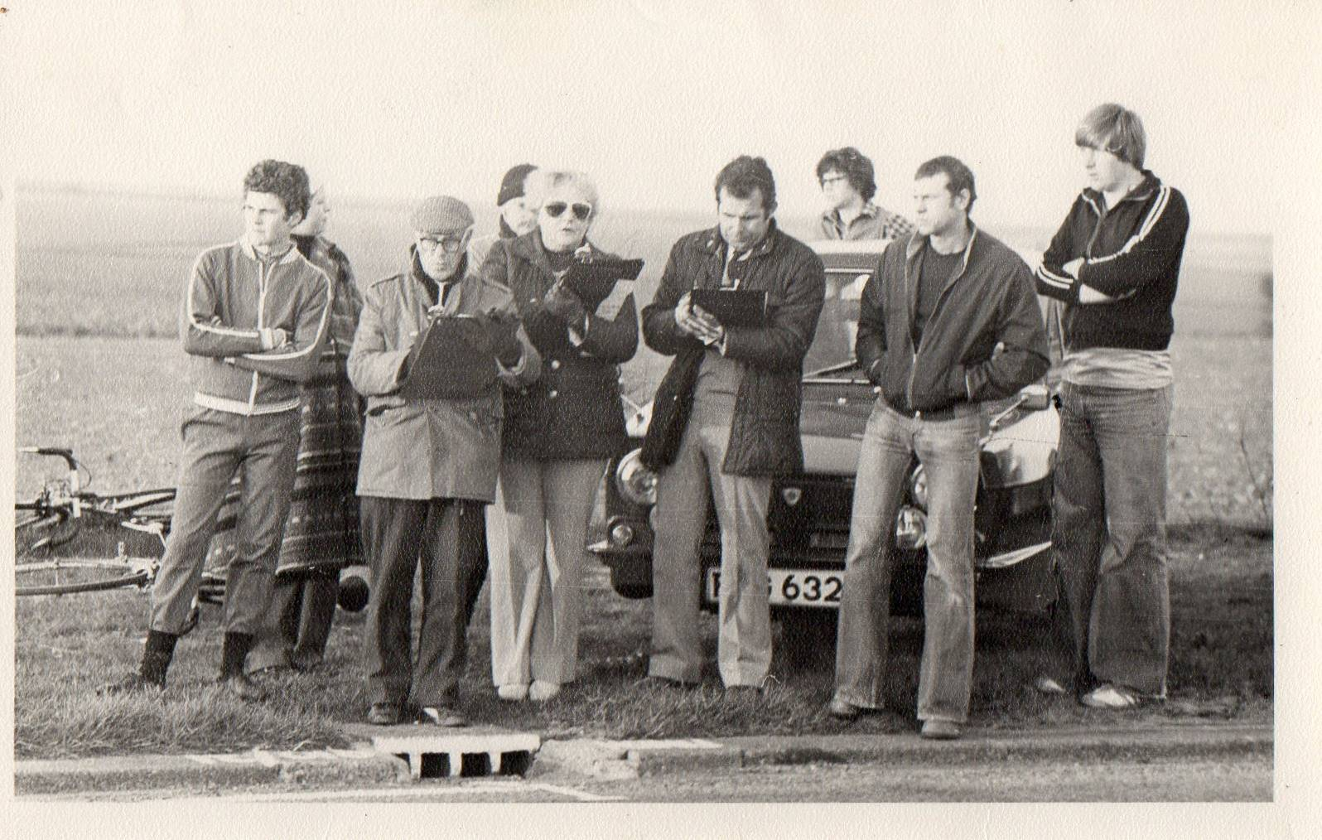

**Bottom of FormDiscounts currently available to Club Members**

Locks of Sandwich : 10% on selected items

St Peter’s Cycles, Broadstairs: 10% on selected items

Bike Warehouse, Herne Bay, Faversham, Gillingham, Sevenoaks: 10% on selected items

Black Cat Coaching- special rates offered

Please also note anyone who arrives at Stonelees Golf Centre on a bike/walking/public transport gets free golf club hire

Ian Edginton, a former member of the club, has started his own cycle maintenance and repair business from his home at Staple near Wingham and welcomes your custom. All types of repair including wheel building are available. Contact Ian at [ian.edginton123@btinternet.com](mailto:ian.edginton123@btinternet.com) or 07786425829. Ian`s father Alf, is also a very long standing and respected member of the Club

**FOR SALE**

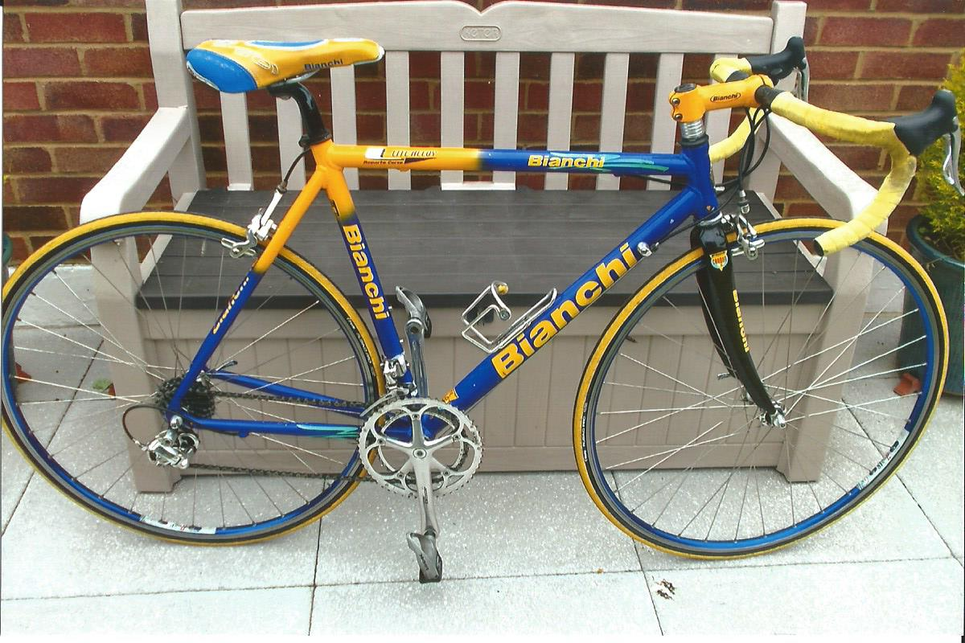

Bianchi Lite alloy 54cm (21in) frame, carbon forks, Campag 10 speed Chorus throughout, a few scratches, surplus to requirements.

Now reduced to £400 o.n.o. Contact Mick Cooper 01227 503624 or [the.coop@sky.com](mailto:the.coop@sky.com) Can be seen at Beltinge.

Harry McCully has a large collection of vintage bikes and equipment which he would like to dispose of to anyone who is interested. Far too much to list here, but contact Harry at 01304 380605, 07749537601 or [mccullyjan@aol.com](mailto:mccullyjan@aol.com)

**Monthly Quiz**

Well done to Dave Mastin who came up first with the correct answer which was Lycra.

Many thanks to Richard Bazin for his technical answer- I would expect no less from a chemist!

This Month`s Question

“A Sunday in Hell” has been hailed as the finest cycling film ever made.

It tells the story of the 1976 Paris-Roubaix race.

Who was the winner?