

**NEWSWHEEL**

**Newsletter for Thanet`s Premier Cycling Club**

Affiliated to: British Cycling; CTT;KCA;CTC

**Thanetrc.org.uk**

September 2015

**New Members**

This month we welcome the following new members:- Frank Burniston, Alexander Ashman and Matthew Stenier. We hope that their association with us will be a long and happy one.

**News**

**Cycling Weekly Coverage of Thanet RC Club Run – Sunday 6 Sep 15.**

Some members will know, or remember, Chris Hovenden who rode with Thanet Road Club as a junior some time ago. Chris is now Tech Writer for Cycling Weekly and he would like to include Thanet Road Club in the “Ride With …” section of the magazine. The focus is motivated by the hard work our club has done to promote young riders and the with our heritage project.

Considering the required time frame and the time-trial calendar, that occupies so many of our older cyclists through the summer, we are planning on the date of Sunday 6 Sep 15 for Chris and a CW photographer to visit.

It would be good to get as many members as possible out, in club kit, on that date. This includes younger members who might not usually join the club run. It may be that we will make a slight change to the arrangements for the club run on this date in order to bring all the Thanet riders together as a club before the ride. Full details to follow,

Best wishes,

Jim Dickson.

Secretary Thanet Road Club

**Thanet Sports Awards**

The annual event which is being hosted on **Thursday 19 November** is organised by Thanet District Council’s Sports Matters team, and supported by various organisations from the public, private and voluntary sector.  This year’s ceremony which will be hosted at the Winter Gardens in Margate, will celebrate all that is sport and recognise the outstanding achievements that local clubs, coaches, talented performers, schools and volunteers have given to local sport.

The event is now in its seventh year and we are encouraging nominations from all areas of the community to celebrate the achievements and efforts that our community role models play in driving sport forward in Thanet.

Nominations will be open on **Monday 3rd August** and we are looking for nominations covering a whole range of categories including:

·        **Club of the Year**

·        **Coach of the Year**

·        **Disabled Sports Person of the Year**

·        **Unsung Hero**

·        **Sportsman of the Year**

·        **Sportswoman of the Year**

·        **Young Sportsperson of the Year**

·        **Primary Sports School of the Year**

·        **Secondary Sports School of the Year**

·        **Sports Teacher of the Year**

I would be grateful if you could please circulate this to your contacts, and to any groups or individuals who are looking to put forward their nominations.

If you would like more information about this year’s event, please do get in touch.

Kind Regards

 Colin Rouse

**Sports Development Officer**

**Tel: 01843 577032**

**Mob: 07770828582**

**Web:** [**www.thanet.gov.uk/sport**](http://www.thanet.gov.uk/sport)

Michael Friend has kindly agreed to take over the role of Time Trial Secretary from Simon Henderson. Many thanks to Michael for agreeing to take over this important role within the Club. Also many thanks to Simon for an efficient job over the last few years.

We also still need a Publicity Rep, mainly to submit copy to the local press, please contact any Committee member if you would like to take it on.

I have recently started work as editor of Cycling World Magazine which specializes in leisure, tourism, sportives and commuting. I am always looking for stories and can pay a bit for contributions. Please contact David Robert (TRC Committee member) at [editor@cyclingworldmag.co.uk](mailto:editor@cyclingworldmag.co.uk)

**Racing Results Club Events** (**TRC Riders)**

Evening 10 5th August Q10/42 Betteshanger Country Park Juniors Ollie Robinson 21.59, Toby Hammond 23.20, David Redmond 25.43, Flynn Robinson 26.54, Lance Childs 27.24, George Bussey 30.07, Toby Yemm 31.29, Max Robinson 32.07.

Seniors Chris Fennell 20.22, Simon Henderson 22.26, Mark Palmer 23.01, Richard McVey 23.01, Matthew Hall 23.31, Sean O`Regan 23.33, Chris Bax 23.49, Michael Friend 23.50, Jason Wares 24.01, Colin Robinson 24.03, Dave Danton 24.04, Martin Russell 24.06, Nicola Goodban 24.40, Paul Kelk 24.48, Robert Sissons 24.49, Chris Childs 24.51, Nick Scott 25.30, Peter Huckstep 25.38, Colin Inett 26.48, Heidi Hammond 26.52, Malcolm Adams 27.21, David Robert 27.29, Steve Langman 27.32, Diane Yemm30.28, Pip McVey 31.00, Jenny Fearn 31.15, Roger Dewen 31.19, Sue Shields 33.53, Frank Burniston DNF, Trevor Hammond DNF, Nic Fennell DNF. Chris was the fastest.

Evening 10 12th August Q10/42 Betteshanger CP Juniors Ollie Robinson 21.57, Toby Hammond 24.00, Olly Dickson 26.16, Lance Childs 28.36.

Seniors Chris Fennell 20.34, Simon Henderson 22.17, Huck Garip 22.59, Mark Palmer 23.01, Michael Friend 23.45, Chris Bax 24.18, Colin Robinson 24.28, Matthew Hall 24.44, Nic Fennell 24.44, Martin Russell 24.52, Scott Meeks 24.55, Jim Dickson 24.56, Brian Hood 25.05, Nicola Goodban 25.30, Chris Childs 25.59, Peter Huckstep 26.02, Robert Sissons 26.06, Heidi Hammond 27.09, Colin Inett 28.07, David Robert 28.24, Roger Dewen 31.52, Jenny Fearn 32.43. Chris was the fastest.

Evening 10 19th August Q10/Betteshanger CP Juniors Dan Martin 22.09 (PB), Olly Dickson 24.14, David Redmond 26.14, Lance Childs 28.16, Megan Griffiths 29.44, George Pittock 30.58, Toby Yemm 31.19.

Seniors Chris Fennell 20.10, Simon Henderson 22.20, Lawrence Martin 22.38, Mark Palmer 22.49, Matthew Hall 24.06, Chris Bax 24.07, Jim Dickson 24.12, Michael Friend 24.25, Brian Hood 24.35 (PB), Dave Danton 24.42, Nic Fennell 24.49, John Orchard 24.50, Robert Sissons 25.20, Paul Kelk 25.36, Chris Childs 25.49, Peter Huckstep 26.09, Tim Yemm 26.10, Nick Scott 26.26, Frank Burniston 26.56, Colin Inett 27.21, Paul Griffiths 27.27, David Robert 27.38, Malcolm Adams 27.51, Diana Yemm 30.15, Roger Dewen 30.42, Jenny Fearn 31.05, Pip McVey 31.24, Sue Shields 32.50 (PB). Chris was the fastest. Well done to those who recorded PB`s especially Dan Martin the fastest Thanet rider, upping the stakes in the Martin Family rivalry.

Evening 10 26th August Q10/42 Betteshanger CP Juniors Olly Dickson 25.15. Seniors Jim Dickson 24.29, Michael Friend 24.47, Chris Bax 25.06, Paul Kelk 26.18, Chris Childs 26.51, Peter Huckstep 27.00, David Robert 28.11, Caroline Rigby 31.29. Fastest was Jason McGowan a visitor from the West Country(Bike Chain Ricci) 21.57. A small field due to heavy rain during the day, however it was dry for the event but high winds and a dirty track had to be contended with. Jason`s father a former member of the Club also rode and clocked 31.08.

VC Deal 2-up and Solo 10 27th August Q10/42 Betteshanger CP Chris Bax/Michael Friend 24.18, Dave Mastin 25.55, Colin Inett 27.53.

Club 1 hour Time Trial 28th August Q10/42 Betteshanger CP Richard McVey 25.32 miles, Michael Friend 24.09 miles, Dave Danton 23.00 miles, Brian Hood 22.80 miles, Dave Mastin 22.41 miles, Peter Huckstep 22.41 miles (est), Colin Inett 21.00 miles, David Redmond (jun) 20.80 miles, David Robert 20.38 miles, Jenny Fearn 20.05 miles, Jack Hill (jun) 20.00 miles, Lance Childs (jun) 19.50 miles, Caroline Rigby 19.20 miles, Helen Hill 17.50 miles (est), Terry Fearn 16.47 miles. Winner was Jason McGowan (Bike Chain Ricci) 26.90 miles. Impressive ride!

**Racing Results Open Events (TRC Riders)**

Sunday 26th July Thanet RC Jim Braginton Memorial 2-up (postponed from Easter Monday) QS/3 Manston Lawrence Martin/ Dan Martin 21.01, David Redmond/Toby Anderton (VC Deal) 24.23, Chris Childs/Lance Childs 25.38, Paul Griffiths/Megan Griffiths 28.27, Colin Robinson/Ollie Robinson DNS, Matt Poole/Rob Milnes DNS. Fastest were Kevin Tye/Andrew Meilak (Velorefined Aerosmiths) 19.19. Many thanks to Richard Braginton for his generous sponsorship of this event once again.

Saturday 1st August VTTA 10 Q10/1 (Hamstreet Bypass) Meadhbh Cook 32.56, Lawrence Martin 22.44, Huck Garip 22.22, Dan Martin 22.34, Martin Russell 24.43, Chris Bax 23.53, Andy Burrows DNS, Bill Hawkes 21.49, Paul Kelk 24.47, Malcolm Adams 26.45, Andy Macpherson 24.23, Colin Inett 27.11. Fastest was Andrew Meilak (Velorefined Aerosmiths) 20.51.

Sunday 16th August KCA 50 Q50/11 (Romney Marsh) Course changed from Q50/1 Colin Inett 2.32.09, Andy Burrows 2.19.22, Chris Bax 2.10.59, Simon Henderson 1.56.51, Huck Garip 1.58.16, Jim Dickson 2.16.39, Richard McVey 2.04.07, Robert Sissons 2.25.45, Andy Macpherson DNS. Fastest was Kevin Tye (Velorefined Aerosmiths) 1.47.55.

Sunday 23rd August KCA/VTTA Group Champs 12 hour Q12 (Around Kent). Meadhbh Cook 147 miles TBC, full results not available yet. Well done Meadhbh the only Thanet entrant for taking on this tough event.

[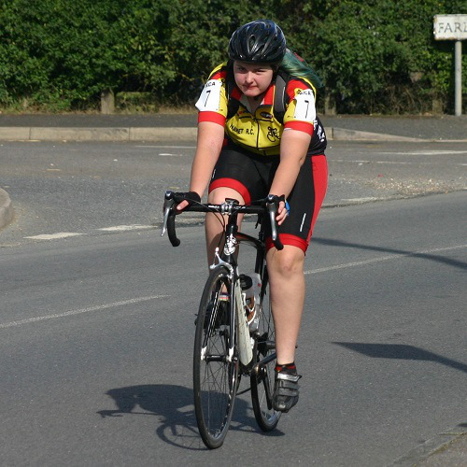](http://i1.wp.com/spinwheels.org/wp-content/uploads/2015/08/07-Meadhbh-Cook.jpg?resize=500,500)

Sunday 30th August Catford CC 25 Q2512 (Old Romney-Hamstreet) Simon Henderson 57.14, Huck Garip 57.35, Dan Martin 58.25, Lawrence Martin 59.19, Jim Dickson 1.04.16, Andy Macpherson 1.04.49 Olly Dickson 1.06.07, Paul Kelk 1.07.51, , David Robert 1.14.39, Chris Bax DNF, Andy Burrows DNF, Bill Hawkes DNS, Ollie Robinson DNS, Colin Robinson DNS. Winner was Kevin Tye (Velo Refined) 51.52

[Thanet RC at the Cyclopark](https://thanetrc.wordpress.com/2015/08/20/thanet-rc-at-the-cyclopark/)

Posted on [August 20](https://thanetrc.wordpress.com/2015/08/20/thanet-rc-at-the-cyclopark/)

Thanet RC Race Team were in action tonight at the Cyclopark. Seb and Rob took to the line in the 3/4 race. Seb had a few attacks off the front with Rob trying to slow the group, the breaks didn’t stick and it came down to a bunch sprint. Seb was nailing it on the front for the last lap, with Rob holding the wheel. The sprint went early, initiated by LVVP riders, Seb and Rob reacted well…on the line Seb got a very well deserved 2nd and Rob 6th ( Results to TBC). Well done to local rider and friend of TRC Craig Joy on 3rd place and attaining his cat 2 licence.

[Thanet RC Race Team win!!](https://thanetrc.wordpress.com/2015/08/27/thanet-rc-race-team-win-2/) [August 27, 2015](https://thanetrc.wordpress.com/2015/08/27/thanet-rc-race-team-win-2/)

Another win for Seb Dickson tonight at the Cyclopark, in the 3/4 race! A fast start with attacks from the gun made for a tough race, however Seb made his move taking two riders with him. Seb kept the pace high establishing a convincing gap. Seb broke away from the other two riders and held the field off to the finish, riding to a solo victory! Great Work Seb!

**White`s/Thanet RC Summer Series Overall Results**

**Group Winners**

U8 Boys Max Robinson

U8 Girls Millie Dack

U10 Boys Stanley Rose

U10 Girls Freya Cook

U12 Boys Flynn Robinson

U12 Girls Hannah Bennett

U14 Boys Toby Anderton (VC Deal)

U16 Boys Ollie Robinson

U16 Girls Maddie Bazin

Well done to all who competed in another very successful season.

Full results are on the Club website.

**[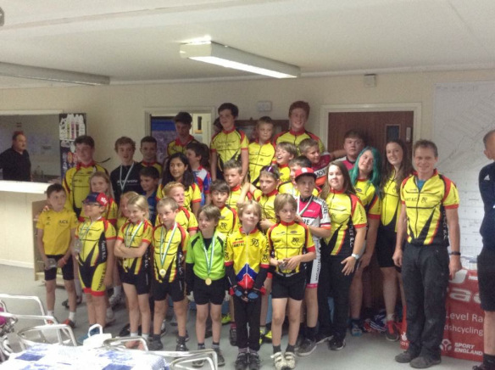](https://thanetrc.files.wordpress.com/2015/08/image.jpeg)**

A picture of the presentation evening, you can see how much they all enjoyed it!

Many thanks to Colin and all those who contributed to the success of this series also Whites for their sponsorship.

**Friday Night Ladies Series**

All rounds of this series are now complete, thanks to all the ladies who participated and made it so enjoyable.

Here are the results for the Thanet riders:-

Youth/Junior

1. Maddie Bazin.
2. Meadhbh Cook.
3. Megan Griffiths.
4. Tia Neame.

Novice

4. Heidi Hammond.

5. Caroline Rigby.

8. Sarah Fisher.

10. Caroline Dack.

13. Diana Yemm.

Winner was Jill Cliff (GS Invicta)

Experienced

1. Nicola Goodban.

Many thanks to Phil Cook and all his helpers for pulling it all together.

**CLUB CLOTHING**

We will be making a winter order SOON.

Please contact us if you require anything.

Thanks,

Pete and Barbara

email peter.huckstep@btinternet.com

Home phone 01843 845107

**Forthcoming Open Events**

Sunday 13th September KCA 25 Q25/10 (Thanet Way)

Sunday 20th September VTTA 25 Q25/12 (Old Romney-Hamstreet)

Sunday 27th September Bigfoot CC Hill Climb QHC/1 (Exedown)

Sunday 4th October Wigmore CC Hill Climb QHC/11 (Hollingbourne)

**Dates for your Diary**

**Club Hill Climb**  Don`t forget the Club Hill Climb on Sunday 27th September at St Margarets Bay, 0915 start. A great hangover cure!

**Club Social Evening**

The next one will be on Tuesday 1st September at the Bell Meadow Pavilion 7.30-9.30 as usual. Please come along

**Cyclo Cross**

Sunday the 6th September sees the first round of the 2015/16 Cyclefit – London and South East Cyclo-Cross League once again hosted by VC Jubilee and Brighton Excelsior at Stanmer Park in Brighton (BN1 9SE). I am hoping you will be able to pass this email on to any of your club members who may be interested in entering. The online registration and race entry is now open at –

[http://www.riderhq.com/events/68777/london-league-rd1–sussex-league-rd1](http://www.riderhq.com/events/68777/london-league-rd1--sussex-league-rd1)

Race and entry details are –

|  |  |  |  |  |  |
| --- | --- | --- | --- | --- | --- |
| Race and Entry Details | | | Race entry Fees | | League Registration (for season) |
| Age cat | Time | Duration | Online ** | On the Day |
| Under 10 | 10:30 | 10 Mins | n/a | £1 |  |
| Under 12 | 10:45 | 15 Mins | n/a | £1 |  |
| Youth (U14 & U16) | 11:15 | 30 Mins | £6 | £7 | £10* |
| Vet Men 40 | 12:45 | 40/45 Mins | £15 | £18 | £10* |
| Junior Women | 12:46 | 40/45 Mins | £9 | £11 | £10* |
| Senior & Vet Women | 12:46 | 40/45 Mins | £15 | £18 | £10* |
| Vet Men 50 | 12:47 | 40/45 Mins | £15 | £18 | £10* |
| Junior Men | 14:00 | 60 Mins | £9 | £11 | £10* |
| Senior Men | 14:00 | 60 Mins | £15 | £18 | £10* |

Non British Cycling Members pay a £3 surcharge on top of entry. (Not under 10/12)

*Members of any club promoting a league event will receive a £3 refund

As we did last year the course for U10 and U12 races will be separate from the others so that course practise is available for Youths and Adults whilst the younger ones are racing. Also with online entry open earlier this year we hope the queues we saw at sign on last year won’t be repeated. There will be some course changes this year resulting in less climbing but other than that things pretty much as last year with the same friendly atmosphere, great racing and fabulous catering. We have free parking available but do ask for a donation to reward the young marshal who has to sit there all day. Full directions available when booking online or email me.

Full details of all league fixtures at <http://www.londonxleague.co.uk/>

Dave Gerrey

Club Contact – VC Jubilee

**A blast from the past-some not with us any more, some very much with us, how many do you know?**

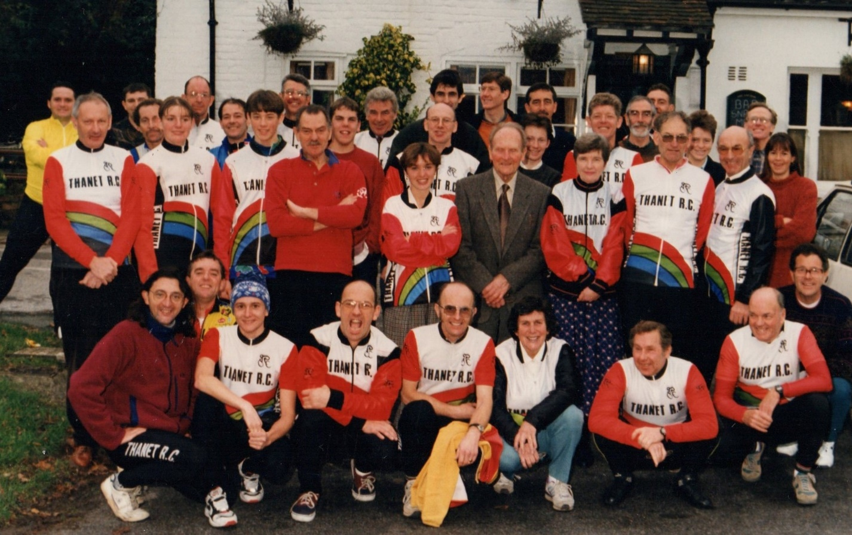

**Road Racing Training and Coaching Sessions: Joint promotion with Adalta CC.**

Road Racing training and coaching evenings will be run every Friday night from April until mid-September at Fowlmead   
These are training events … THEY ARE NOT RACES … so please ride with respect for others.  
Please pay your fees BEFORE riding; the riders will typically split into two groups; one on the upper circuit (Beginners/Younger riders-Coaching given on group riding and fitness drills) and one on the lower (Intermediate and advanced groups)

6.30pm-7.30pm. Cost is £5 non-members. £4 members of Thanet and Adalta (these are organised jointly) and £2 for under 18s

**Bottom of Form**

**Discounts currently available to Club Members**

Locks of Sandwich : 10% on selected items

St Peter’s Cycles, Broadstairs: 10% on selected items

Bike Warehouse, Herne Bay, Faversham, Gillingham, Sevenoaks: 10% on selected items

Black Cat Coaching- special rates offered

Please also note anyone who arrives at Stonelees Golf Centre on a bike/walking/public transport gets free golf club hire

Ian Edginton, a former member of the club, has started his own cycle maintenance and repair business from his home at Staple near Wingham and welcomes your custom. All types of repair including wheel building are available. Contact Ian at [ian.edginton123@btinternet.com](mailto:ian.edginton123@btinternet.com) or 07786425829. Ian`s father Alf, is also a very long standing and respected member of the Club.

**FOR SALE**

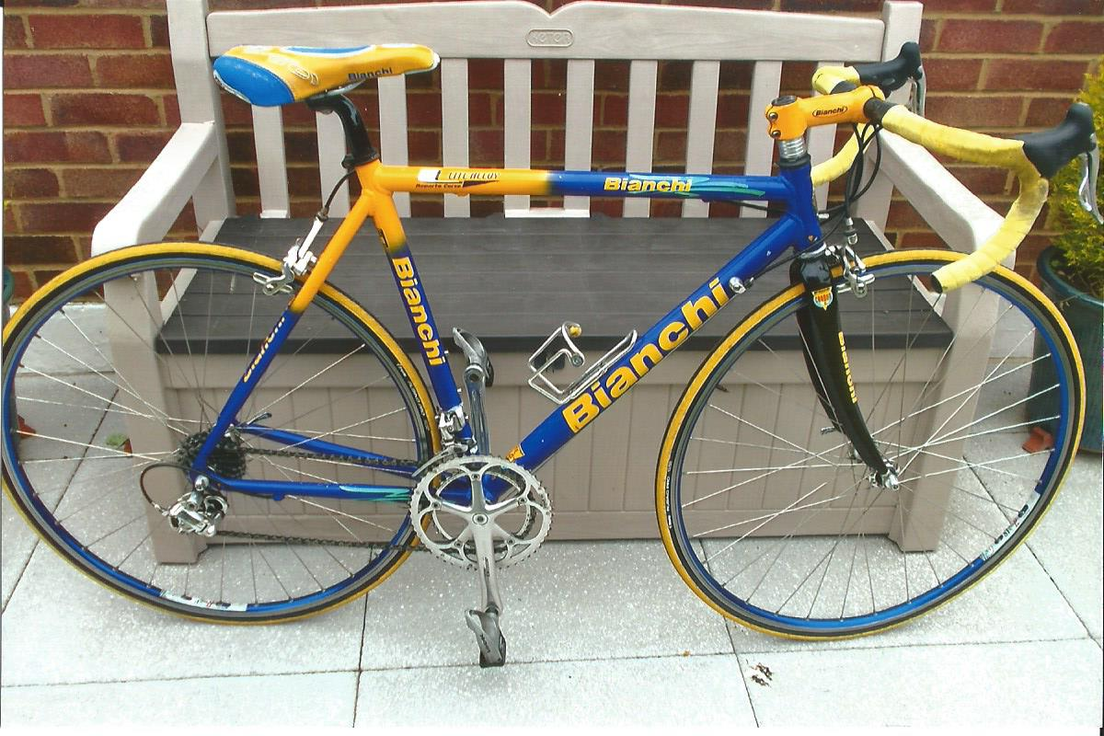

Bianchi Lite alloy 54cm (21in) frame, carbon forks, Campag 10 speed Chorus throughout, a few scratches, surplus to requirements.

Now reduced to £400 o.n.o. Contact Mick Cooper 01227 503624 or [the.coop@sky.com](mailto:the.coop@sky.com) Can be seen at Beltinge.

Harry McCully has a large collection of vintage bikes and equipment which he would like to dispose of to anyone who is interested. Far too much to list here, but contact Harry at 01304 380605, 07749537601 or [mccullyjan@aol.com](mailto:mccullyjan@aol.com)

**Monthly Quiz**

Well done to our distinguished French member Raymond Leruez who came up first with the correct answer which was Johnny Hoogerland who was awarded the Mountains jersey at the end of the stage.

This Month`s Question

What was invented by Joseph Shrivers in the Dupont Laboratories, Virginia, USA in 1958?