

**NEWSWHEEL**

**Newsletter for Thanet`s Premier Cycling Club**

Affiliated to: British Cycling; CTT;KCA;CTC

**Thanetrc.org.uk**

August 2015

**New Members**

This month we welcome the following new members:- Lisa Brundle, Jonathan Smith, Isabella and Jude Hill, Severine and Monty Smith, Charlie Burgess, Maxwell Dawkins, Noah Orchard, Phillip Ridley and Sue Shields. We hope their association with us will be a long and happy one.

**News**

We are pleased to announce that Thanet RC has been successful in achieving re-accreditation of Sport England’s Club Mark. This demonstrates that the club is observing best practice in child protection, coaching and competition, equity and club management. Thanks must go to all our club volunteers who have made this award possible.

On Sunday 19th a large number of members attended the Summer Party and Barbeque. This was a great afternoon with plenty of activities for the younger members and some first class food.

Many thanks to all who worked so hard to make it such a success, especially Rob and George Edmondson our cooks.

**Thanet Sports Awards**

The annual event which is being hosted on **Thursday 19 November** is organised by Thanet District Council’s Sports Matters team, and supported by various organisations from the public, private and voluntary sector.  This year’s ceremony which will be hosted at the Winter Gardens in Margate, will celebrate all that is sport and recognise the outstanding achievements that local clubs, coaches, talented performers, schools and volunteers have given to local sport.

The event is now in its seventh year and we are encouraging nominations from all areas of the community to celebrate the achievements and efforts that our community role models play in driving sport forward in Thanet.

Nominations will be open on **Monday 3rd August** and we are looking for nominations covering a whole range of categories including:

·        **Club of the Year**

·        **Coach of the Year**

·        **Disabled Sports Person of the Year**

·        **Unsung Hero**

·        **Sportsman of the Year**

·        **Sportswoman of the Year**

·        **Young Sportsperson of the Year**

·        **Primary Sports School of the Year**

·        **Secondary Sports School of the Year**

·        **Sports Teacher of the Year**

I would be grateful if you could please circulate this to your contacts, and to any groups or individuals who are looking to put forward their nominations.

If you would like more information about this year’s event, please do get in touch.

Kind Regards

 Colin Rouse

**Sports Development Officer**

**Tel: 01843 577032**

**Mob: 07770828582**

**Web:** [**www.thanet.gov.uk/sport**](http://www.thanet.gov.uk/sport)

At the recent Committee meeting Simon Henderson stated that he will be resigning as Time Trial Secretary at the next AGM. If anyone would like to take on this very important job within the Club please contact Simon or any Committee member, Simon will be pleased to familiarise you with the job. Many thanks to Simon for his excellent work over the past years.

We also still need a Publicity Rep, mainly to submit copy to the local press, please contact any Committee member if you would like to take it on.

**Heritage Project Update (David Robert)**

Filming for the Heritage Project has come to an end, though it will take a while to edit. Thanks to everyone for their cooperation. Photos can be viewed at (new ones added inc. BBQ):

<https://www.flickr.com/photos/davealexrob/collections/>

You can now download the history of the club 1947-97. See the link at the bottom of the history page on website (link below). Does anyone fancy writing the next 20 years?

<http://thanetrc.org/club-history.shtml>

Please attend the social night on Tuesday 4 August 7.30 at Bell Meadow Pavilion, St-Nicholas-at-Wade. As it is the summer hols young members are encouraged to attend. Using the buddy lift system, vets will be present too.

During the Tuesday social there will be a chance to meet me if anyone wants to volunteer for the heritage project and/or club anniversary celebrations (70 years in 2017). Young volunteers/members are encouraged to get involved as there is funding to support them in working with vets on biographical pieces. This can count as volunteering hours and can support school work. If you can’t make it but are still interested email me davealexrob@yahoo.com

**… and from the archives**

The photo shows Jim Braginton (far left), former Race Secretary, presenting a team prize to (L to R) Ian Posnett, Brett Dennis and Lew Maxted. Chosen this month as Ian Posnett, now director of WW Martin, has just sponsored the TRC Race Team, helping young racers as he once was himself. Notice Brett’s top: a purchase from an early Pete Murphy cycle jumble. Nothing like that at a recent one at the Freewheel!

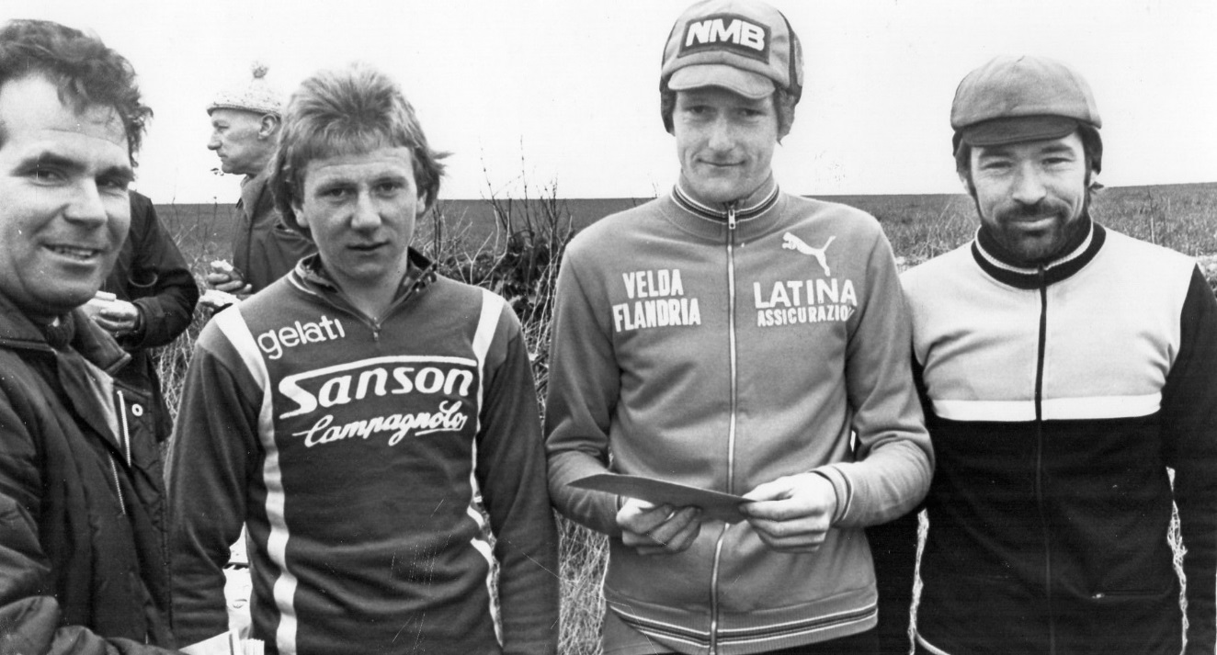

I have recently started work as editor of Cycling World Magazine which specializes in leisure, tourism, sportives and commuting. I am always looking for stories and can pay a bit for contributions. Please contact David Robert (TRC Committee member) at [editor@cyclingworldmag.co.uk](mailto:editor@cyclingworldmag.co.uk)

**Can your help attract Club Sponsors?**

Club sponsorship is going well but there are still races and aspects of the club that require sponsors. Do you work for a company or know someone in a company that could be a potential sponsor? If so contact David Robert (TRC Funding and Sponsorship Officer) for details on the club's new sponsorship packages.davealexrob@yahoo.com

**Racing Results Club Events** (**TRC Riders)**

Evening 10 1st July Q10/31 Thanet Way Martin Glynn 21.47, Simon Henderson 22.20, Seb Dickson 22.41, Mark Palmer 23.37, Matt Hall 23.58 (PB), Scott Meeks 24.17 (PB), Nic Fennell 25.13, Martin Russell 25.29, Paul Kelk 25.43, Robert Sissons 25.51, Chris Childs 25.56, Peter Huckstep 26.39, David Robert 28.47 (PB). Martin was the fastest, well done to those who did PB`s

Evening 10 8th July Q10/31 Thanet Way Cancelled due to bad weather.

Evening Channel Ports 4-up TT 15th July Q10/42 Fowlmead Freya Cook/ Stanley Rose/Alex Dack/Max Robinson 48.49, David Redmond/Sam Johnson/Callum O`Regan, 36.30, Meadhbh Cook/Megan Griffiths/Helen Hill/Maddie Bazin 40.57, Lance Childs/George Pittock/Toby Yemm/Jack Hill 42.56, Pip McVey/Jenny Fearn/Paul Griffiths/David Robert 43.21, Brian Hood (composite with Deal Tri) 36.02, Dave Mastin/Martin Russell/Paul Kelk 33.51, Chris Childs/Michael Friend/Scott Meeks/Jason Wares 33.41, Rick Perkins/Huck Garip/Seb Dickson/Rob Milnes 29.43, Lawrence Martin/Jim Dickson/Colin Robinson/Trevor Hammond 32.09, Olly Dickson/Dan Martin/Ollie Robinson/Toby Hammond 31.11, Robert Sissons (solo) 35.59.

Times taken on the 3rd rider to finish.

Fastest Senior Team and winners of the Channel Ports Senior Trophy were Rick Perkins/Huck Garip/Seb Dickson/Rob Milnes.

Fastest Junior Team and winners of the Channel Ports Junior/Juvenile Trophy were Olly Dickson/Dan Martin/Ollie Robinson/Toby Hammond.

Fastest Ladies Team were Jo Smith/Zoe Bartlett/Nicola Goodban/Heidi Hammond (Bird on a bike).

Many thanks to Channel Ports for their sponsorship of this popular event.

Evening 10 22nd July Q10/42 Fowlmead Juniors Ollie Robinson 22.19, Dan Martin 22.54, Toby Hammond 24.09, David Redmond 26.16, Lance Childs 30.06, Max Robinson 34.18, Meadhbh Cook DNF.

Seniors Simon Henderson 22.20, Lawrence Martin 22.47, Huck Garip 23.10, Richard McVey 23.21, Trevor Hammond 23.33, Chris Bax 24.06, Matthew Hall 24.06, Brian Hood 24.42, Paul Kelk 25.02, Colin Robinson 25.30, Robert Sissons 25.38, Chris Childs 26.06, Peter Huckstep 26.45, Phil Cook 27.21, Heidi Hammond 27.46, Nick Scott 27.48, Paul Griffiths 28.08, David Robert 28.48. Ollie was fastest on the night by 1 second.

Evening 10 29th July Q10/42 Fowlmead Juniors Ollie Robinson 22.04, Dan Martin 22.17, David Redmond 26.06, Calum O`Regan 26.49, Flynn Robinson 27.41, Lance Childs 28.18, Max Robinson 34.17.

Seniors Huck Garip 22.25, Richard McVey 23.10, Sean O`Regan 23.42, Chris Bax 23.52, Michael Friend 24.04, Matt Hall 24.05, Colin Robinson 24.06, Brian Hood 24.57, Nic Fennell 24.59, Martin Russell 25.00, Paul Kelk 25.06, Chris Childs 25.51, Peter Huckstep 25.58, John Orchard 26.11, Nick Scott 27.09, Colin Inett 27.26, David Robert 27.51, Malcolm Adams 28.14, Caroline Rigby 30.19, Roger Dewen 31.47, Jenny Fearn 31.49. Fastest on the night was Ross Bryan (Adalta CC) 21.39.

VC Deal/Deal Tri 2-up 10 30th July Fowlmead Dave Mastin/Peter Huckstep 25.15, Michael Friend/Chris Bax 23.38, Toby/Trevor Hammond 22.56, Huck Garip (solo) 22.42.

[**Whites Regional Summer Series Overall Results**](https://thanetrc.wordpress.com/2015/07/27/whites-regional-summer-series-round2-and-overall-results/)

Thanks to Rob Milnes and Phil Cook event organisers and all other helpers over the 2 Race Series Regional Youth Events at Fowlmead sponsored by Whites Transport.

Results are of riders who completed both series:-

U8 Boys Max Robinson =2nd Winner Henry Hobbs (Barking and Dagenham)

Lughaidh Cook 5th

U8 Girls Millie Dack 2nd Winner Anna Lloyd (Lee Valley Youth CC)

U10 Boys Stanley Rose 3rd Winner Max Capamagan (Barking and Dagenham)

U10 Girls Freya Cook 2nd Winner Leah Warrilow (Barking and Dagenham)

U12 Boys Flynn Robinson 2nd

Lance Childs 3rd Winner Noah Hobbs (Barking and Dagenham)

Toby Yemm 4th

U12 Girls Winner Melissa Warrilow (Barking and Dagenham)

U14 Boys Josh Chivalo 3rd Winner Liam Hanks (Barking and Dagenham)

U14 Girls Winner Molly Kanchesky (Barking and Dagenham)

U16 Boys Ollie Robinson 1st

Toby Hammond 2nd

Calum O`Regan 3rd

David Redmond 4th

George Bussey 6th

Charlie Burgess 7th

U16 Girls Maddie Bazin 2nd Winner Hannah Graveney (Kent Velo Kids)

Well done to all who entered and especially Ollie who saved the day for TRC.

**Racing Results Open Events (TRC Riders)**

Thursday 2nd July PMR 10 Q10/1 (Hamstreet Bypass) Chris Fennell 20.15, Simon Henderson 21.49, Bill Hawkes 21.49, Ollie Robinson 22.12, Rick Perkins 22.20, Colin Robinson 24.04, Martin Russell 24.16, Chris Bax 24.32, Dave Mastin 24.47 (PB), Andy Macpherson 25.00, Paul Kelk 25.14, Andy Burrows 26.34, Colin Inett 26.41, Malcolm Adams 27.44, Nicola Goodban DNS, Andy McCall DNS, Gary Harrison DNS. Winner was Peter Tadros (In Gear Quickfit Trainsharp RT) 20.11, a new course record. Well done to Dave Mastin on his PB.

Sunday 5th July VTTA Kent 10 Q10/30 (Thanet Way) Chris Fennell 19.49 (PB), Simon Henderson 21.20, Ollie Robinson 21.44 (PB), Huck Garip 21.52 (PB), Bill Hawkes 22.10, Colin Robinson 22.57 (PB), Matt Hall 23.06 (PB), Michael Friend 23.12 (PB), Jim Dickson 23.45, Olly Dickson 23.54, Chris Bax 23.56, Martin Russell 24.08, Paul Kelk 24.19, Dave Mastin 24.29 (PB), Dave Danton 24.31, Chris Childs 24.39 (PB), Peter Huckstep 24.55 (PB), Andy Burrows 25.15, Malcolm Adams 26.06, Pip McVey 30.00 (PB). Fastest was Peter Tadros (In Gear Quickfit RT) 19.40 (PB). A good day on the Thanet Way with 34 PB`s being recorded.

Thursday 9th July PMR 10 Q10/1 (Hamstreet Bypass) Chris Fennell 20.26, Bill Hawkes 21.43, Simon Henderson 21.52, Chris Bax 24.11, Martin Russell 24.12, Dave Mastin 24.25 (PB), Nick Fennell 24.55, Paul Kelk 25.18, Andy Burrows 26.47, Colin Inett 27.32, Malcolm Adams 27.58, Andy McCall DNS apol. Chris Fennell was the fastest.

Saturday 11th July GHS SEDC Dist Champs also KCA 10 Q10/42 (Fowlmead) GHS Regional Championships Meadhbh Cook 32.14, Megan Griffiths 31.32 (age group winner), Lance Childs 31.06 (age group winner), David Redmond 27.11, Olly Dickson 25.25, Toby Hammond 24.45 (age group winner), Ollie Robinson 23.53 (age group winner). Megan Griffiths, Ollie Robinson, Toby Hammond and Lance Childs have qualified for the National Final to be held on the F10/10 in Ware, Hertfordshire on September 12th.

KCA Event Caroline Rigby DNF, Pip McVey 33.50, Jenny Fearn 33.16, Sarah Fisher 30.54, Flynn Robinson 28.23, Heidi Hammond 28.46, Malcolm Adams 28.16, Nicola Goodban 25.53, Peter Huckstep 26.37, Chris Childs 26.16, Dave Mastin 26.08, Paul Kelk 25.25, Jim Dickson 24.26, Martin Russell 25.10, Trevor Hammond 23.53, Lawrence Martin 22.48, Dan Martin 23.30, Richard McVey 23.06. Fastest was Adrian Lyons (GS Invicta) 22.15.

Sunday 12th July Gravesend 25 Q25/8 (Chilham) Huck Garip 57.31, Chris Bax 1.02.49, Andy Burrows 1.08.56, Bill Hawkes 56.21, Paul Kelk 1.06.21, Martin Russell 1.05.10, Dave Mastin 1.05.59, Andy Macpherson 1.04.49, Simon Henderson 56.26, Paul Griffiths 1.12.35, Jim Dickson 1.02.58, Dave Danton 1.04.50. Fastest was Andrew Meilak (Velo Refined) 54.03.

Thursday 16th July PMR 10 Q10/1 (Hamstreet Bypass) Nicola Goodban 24.58(PB), Andy Burrows 26.08, Simon Henderson 21.25, Dave Mastin 24.21(PB), Andy Macpherson 24.00(PB), Colin Robinson 24.31, Ollie Robinson 22.16, Paul Kelk 24.41, Malcolm Adams 27.08, Colin Inett 26.19, Chris Fennell 19.43 (PB and Course Record), Nic Fennell 24.30, Andy McCall DNS, Bill Hawkes 21.39(PB), Chris Bax 23.50, Martin Russell 24.15, Rick Perkins 22.19(PB). A good night on Hamstreet, well done to Chris Fennell on a new Course Record and all the others who recorded PB`s.

Sunday 19th July VTTA 50 Q50/11 (Romney Marsh) Simon Henderson 1.54.38 (PB), Richard McVey 1.58.52, Huck Garip 1.56.16 (PB), Rick Perkins 2.00.45 (PB), Colin Inett 2.25.26, Colin Robinson 2.10.57 (PB), Meadhbh Cook 3.11.16, Andy Burrows DNF. Fastest was Andrew Meilak (Velo Refined) 1.50.02 (PB). A good day if rather wet on the marsh, well done to all those recording PB`s, and to Meadhbh Cook on her first 50 taking the Junior Prize.

Thursday 23rd July PMR 10 Q10/1 (Hamstreet Bypass) Chris Fennell 19.58, Bill Hawkes 21.24 (PB), Simon Henderson 21.47, Ollie Robinson 22.09, Colin Robinson 23.59, Martin Russell 24.05, Chris Bax 24.14, Andy Macpherson 24.26 (PB), Nic Fennell 24.26, Dave Mastin 24.31, Paul Kelk 24.39, Andy Burrows 26.39, Colin Inett 26.57, Andy McCall DNS, Mark Palmer DNS. Chris was the fastest. However, the ride of the evening came from Theo Tadros the 13 year old son of Peter who did 25.02 on a 77” fixed gear, an amazing performance, no doubt we will see more of this young man in the future.

Saturday 25th July San Fairy Ann 10 Q10/22 (Harrietsham) cancelled due to Operation Stack.

Saturday 1st August National 25 Championships H25/21 Chris Fennell 51.08, Jon Parker 51.15, Seb Dickson 51.56. Fastest was Ryan Perry (Langdale Lightweights RT) 48.04. Well done to Seb coming 26th in a new Club Record (51.56).

Sunday 26th July Thanet RC 2-up (postponed from Easter Monday) QS/3 Manston Results in next edition.

[**Ollie and Lance on the podium is South-East track champs.**](https://thanetrc.wordpress.com/2015/07/19/ollie-and-lance-on-the-podium-is-south-east-track-champs/)

Both Ollie and Lance produced outstanding performance to both gain 3rd places in their age groups in the South-East track championships at Herne Hill today. Racing was in a omnium format with sprints, points, scratch, devil races. This is the first time the club have achieved so well in track racing well done boys. Also Rob Milnes raced in the adult races and again showed good form competing against many 1st cat riders. His best position was 6th in the pursuit. Second claim friend of the club Jo Smith again showed her class winning most of the ladies races on the day. If you fancy a go at track Teresa Childs has organised a session at Herne Hill on 9th August ( contact Teresa to book place).

[**Thanet riders again on podium**](https://thanetrc.wordpress.com/2015/07/30/thanet-riders-again-on-podium/)

Thanet RC riders again produced podium rides at the Full Gas road series at Cyclopark tonight (Thurs 30th). In the under 12s Lance was 2nd and Flynn 3rd in a sprint finish. In the under 16 race Ollie and a NFTO youth rider distanced the field but Ollie lost out in the sprint. Rob Milnes was our only adult rider in the cat 3-4 race and raced near the front covering many break attempts finally gaining 8th place and more BC points for himself and the club. Well done guys.

[**Richard Hull completed 376.34 miles in the RTTC National 24hr Championship**](https://thanetrc.wordpress.com/2015/07/20/richard-hull-completed-376-34-miles-in-the-rttc-national-24hr-championship/)

Thanet Road Clubs Richard Hull completed 376.34 miles in the RTTC National 24hr Championship (Mersey Road Club) at the weekend.

His excellent ride for 38th place was against a lot of younger riders.

Event winner was Michael Broadwith (Arctic Tacx RT) 537.35 miles

1st Lady (20th) Lynne Biddulph (Born to Bike – Bridgetown cycles) 412.45

Results here: <http://www.cyclingtimetrials.org.uk/event/787>

Richard writes:-

Thank you very much. I am very pleased with the result, in all although I have only ridden 2 events so far this year it has been good. Both events, the Newbury 12 hr and the Mersey Roads 24 hr have been personal bests for me, beating distances that I had previously set 15 and 20 years ago respectively. On the 24 the weather turned bad at 3 in the morning, through to 9. At 5 o'clock it was torrential and at that point I can remember crying my eyes out, it really does get that desperate, however I had a good service crew in the form of my Daughter Sandra and her partner  Paul. They pulled me through. In the end my miles were 376.38 which for me was amazing as I was never that good. My previous best being a mere 311. However to put it into perspective there were lots of riders in the high 400s and 2 riders doing over 500. The winning mileage was 537, just 4 short of competition record.

Next year ???? I would love to make 400, who knows.

Well done to Richard, it requires a huge amount of dedication and guts to complete a 24 hour Time Trial.

**CLUB CLOTHING**

We have, in the previous yellow, red and blue club kit.1x medium short sleeved jersey and 1 pair of

small bibshorts. Each at a giveaway £5.

We also have some pairs of white cycling socks with the Nico Sports logo

in black.They are all large, they fit me at size 44 (or uk size10 in old money)

and are only £2 a pair.

Pete Huckstep. Contact [peter.huckstep@btinternet.com](mailto:peter.huckstep@btinternet.com)

**Forthcoming Open Events**

Saturday 1st August VTTA 10 Q10/1 (Hamstreet Bypass)

Sunday 16th August KCA 50 Q50/11 (Romney Marsh) Course changed from Q50/1.

Sunday 23rd August KCA/VTTA Group Champs 12 hour Q12 (Around Kent).

Sunday 30th August Catford CC 25 Q2512 (Old Romney-Hamstreet)

Sunday 13th September KCA 25 Q25/10 (Thanet Way)

**Dates for your Diary**

Coaching sessions will begin again in September (Watch out for my mail messages, website, Facebook group page). Just wanted to remind you of a few dates:

Bedgebury visit (Sat 1st August) - Teresa Childs organising (**now cancelled**)

**Friday 21st August Women`s Only Friday Night Lock`s Race Series Round 5, Fowlmead**. Sign on from 1800, 1840 Start. Entry on the line only. No licence required. Come on ladies!

**Herne Hill track club session (Sun 9th August) -** Teresa Childs organising

**Whites Summer Series** go-ride racing 5 of 6 road race Mon 3rd August (Fowlmead)

**Whites Summer Series** go-ride racing 6 of 6 road race Mon 10th  August (Fowlmead) - Prize giving night

Happy summer break

Colin

**Club Social Evening**

The next one will be on Tuesday 4th August at the Bell Meadow Pavilion 7.30-9.30 as usual. Please come along

**A Charity Cycle Ride in aid of the KENT AIR AMBULANCE**

**Organised by Medway Velo**

Take up the challenge of a 30km (18 mile) or 100Km (62 mile) cycle ride. Riding on good quality roads in the heart of the kent countryside. A feed station will be in place for the 100km route and all finishers will receive a medal.

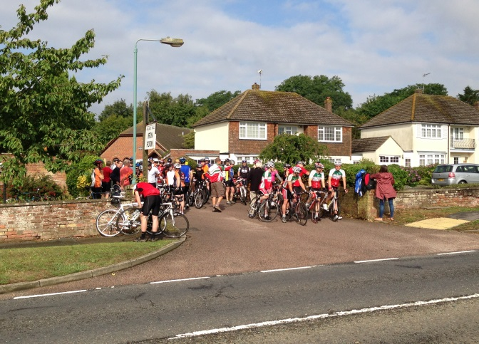

**Sunday 30th August 2015. Starting from 9.30am.**

Starting and finishing at “The Iron Rooms” Boughton Aluph Village Hall, Near Ashford. TN25 4HP

Book in advance at £10.00 per adult & £5.00 per child (under 14)

Entry on the day is £15.00 per adult or £7.50 per child (under 14)

(Children under 14 should be accompanied by an adult. Children under 10 ride free but must be accompanied by an adult)

All proceeds from the day will be donated to

THE KENT AIR AMBULANCE TRUST AFR No: 26558

The county’s only air ambulance; providing an essential life saving service to every person, living, working and travelling through Kent 365 days a year.

The Kent air ambulance trust does not receive any financial aid from the Government, NHS or National Lottery. Every penny of the £1.5 million needed to provide Kent with such a service comes from voluntary donations from the people of Kent.

Contact Adam Mumford (event organiser) on 07568 352328 or email me at adam.mumford@blueyonder.co.uk or go to [www.medwayvelo.org.uk/kaa](http://www.medwayvelo.org.uk/kaa) for more information.

We emphasise that this is NOT a race but a day for you and your friends to enjoy cycling

at your own leisure. It is also a day to raise hundreds of pounds for the Kent Air Ambulance.

**Road Racing Training and Coaching Sessions: Joint promotion with Adalta CC.**

Road Racing training and coaching evenings will be run every Friday night from April until mid-September at Fowlmead   
These are training events … THEY ARE NOT RACES … so please ride with respect for others.  
Please pay your fees BEFORE riding; the riders will typically split into two groups; one on the upper circuit (Beginners/Younger riders-Coaching given on group riding and fitness drills) and one on the lower (Intermediate and advanced groups)

6.30pm-7.30pm. Cost is £5 non-members. £4 members of Thanet and Adalta (these are organised jointly) and £2 for under 18s

**Bottom of Form**

**Discounts currently available to Club Members**

Locks of Sandwich : 10% on selected items

St Peter’s Cycles, Broadstairs: 10% on selected items

Bike Warehouse, Herne Bay, Faversham, Gillingham, Sevenoaks: 10% on selected items

Black Cat Coaching- special rates offered

Please also note anyone who arrives at Stonelees Golf Centre on a bike/walking/public transport gets free golf club hire

Ian Edginton, a former member of the club, has started his own cycle maintenance and repair business from his home at Staple near Wingham and welcomes your custom. All types of repair including wheel building are available. Contact Ian at [ian.edginton123@btinternet.com](mailto:ian.edginton123@btinternet.com) or 07786425829. Ian`s father Alf, is also a very long standing and respected member of the Club.

**FOR SALE**

For Sale: Turbo trainer, fan resistance model. £20.00.  Contact Reg  Baynham (ex Thanet RC member) 01843 821618

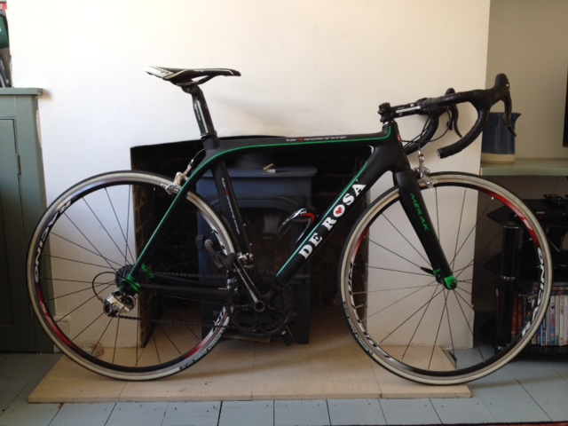

**De Rosa Merak Evolution** (black, green trim) 55cm, Campagnolo Athena 11 speed, Fulcrum R5 wheels, Prologo saddle. Good condition, great frame with upgrade potential.  £1000 ono. Contact Bill Hawkes : 07939 039066. or [billthebikie@yahoo.co.uk](mailto:billthebikie@yahoo.co.uk) (Canterbury**).**

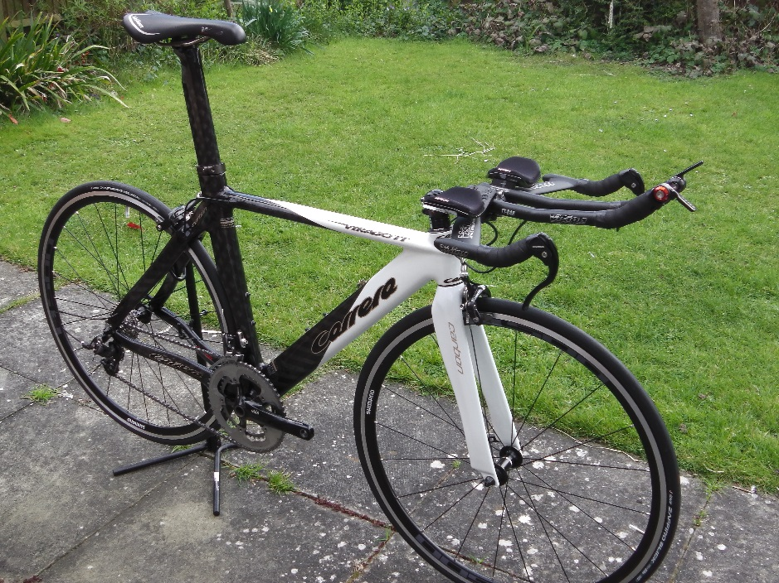

**Carrera Virago Carbon TT Bike (size medium) - £550 ono**

* full carbon fibre monocoque aero frame with internal cable routing
* carbon aero forks
* SRAM Rival 20 speed gearing
* SRAM TT 500 shifters
* Vision titanium railed TT saddle
* Vision adjustable alloy aero bars (comes with riser kit)
* 53/39 Truvativ Elita GXP cranks (172.5)
* Brand new Shimano RS501 wheels + new tyres
* seat tube = 52cm (Centre to top) and 52.4cm top-tube

Martin Glynn can be contacted on 07800 814982 or by email: martin@martinandsam.plus.com

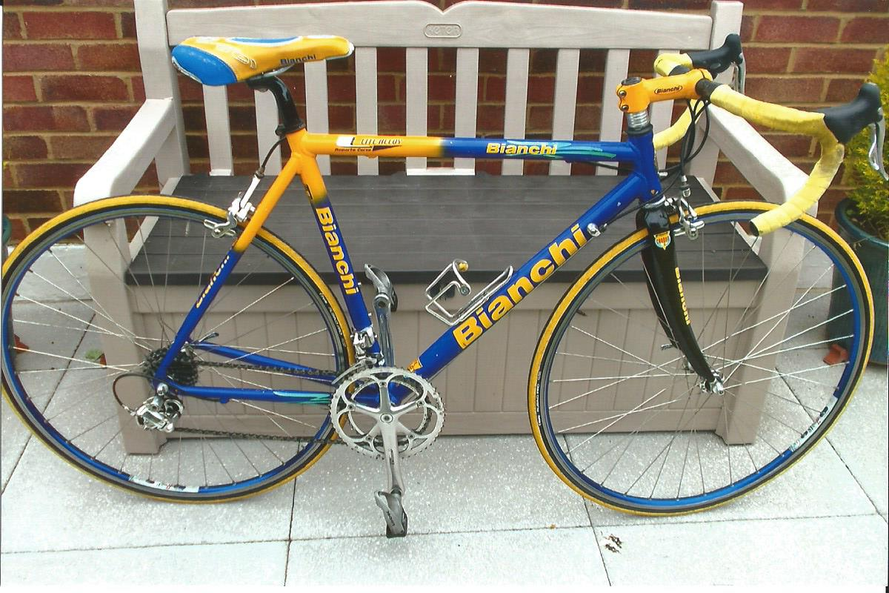

Bianchi Lite alloy 54cm (21in) frame, carbon forks, Campag 10 speed Chorus throughout, a few scratches, surplus to requirements.

Now reduced to £400 o.n.o. Contact Mick Cooper 01227 503624 or [the.coop@sky.com](mailto:the.coop@sky.com) Can be seen at Beltinge.

Harry McCully has a large collection of vintage bikes and equipment which he would like to dispose of to anyone who is interested. Far too much to list here, but contact Harry at 01304 380605, 07749537601 or [mccullyjan@aol.com](mailto:mccullyjan@aol.com)

**Monthly Quiz**

Well done to Gill Griffith who came up first with the correct answer which was Tom Simpson.

This Month`s Question

On Stage 9 of the 2011 Tour de France a rider was struck by a media car and catapulted into a barbed wire fence sustaining severe lacerations which required 33 stitches. Despite this he completed the Tour. Who was this tough guy and what jersey was he awarded at the end of the stage?