

**NEWSWHEEL**

**Newsletter for Thanet`s Premier Cycling Club**

Affiliated to: British Cycling; CTT;KCA;CTC

**Thanetrc.org.uk**

July 2015

**New Members**

This month we welcome the following new members:- Andrew Livesey, Billy Wardle, Marcus Wardle, Ferne Peirce, Giotto McCourt Welsh, John Orchard, Jon Griffin, Josh Chivilo, Nicolas Fennell, Paul Hayward, and a warm welcome back after several years to Paul Kirkness. We hope their association with us will be a long and happy one.

**Sick List**

Shay Giles a former member, who will be known to all of you involved in time trialling, has been in hospital in Ireland for a month suffering from a severe back problem which necessitated an operation. Shay held nearly all the club records (until Seb Dickson arrived on the scene) for many years. We wish him all the best for a complete recovery.

**News**

Congratulations to Sarah Beevers (now Sarah Fisher) on her recent marriage. We wish her and Martin all the best for the future.

At the recent Committee meeting Simon Henderson stated that he will be resigning as Time Trial Secretary at the next AGM. If anyone would like to take on this very important job within the Club please contact Simon or any Committee member, Simon will be pleased to familiarise you with the job. Many thanks to Simon for his excellent work over the past years.

We also still need a Publicity Rep, mainly to submit copy to the local press, please contact any Committee member if you would like to take it on.

**Can your help attract Club Sponsors?**

Club sponsorship is going well but there are still races and aspects of the club that require sponsors. Do you work for a company or know someone in a company that could be a potential sponsor? If so contact David Robert (TRC Funding and Sponsorship Officer) for details on the club's new sponsorship packages.davealexrob@yahoo.com

**Racing Results Club Events** (**TRC Riders)**

Evening 10 27th May Q10/31 Thanet Way Chris Fennell 21.01, Simon Henderson 22.11, Huck Garip 23.08, Rob Milnes 23.23, Chris Bax 24.23, Matt Hall 24.29, Michael Friend 24.31, Dave Danton 24.53, Jason Wares 24.57, Martin Russell 25.32, Scott Meeks 25.41, Paul Kelk 25.45, Dave Anderson 25.46, Robert Sissons 25.51, Chris Childs 26.43, Nic Fennell 26.59, Nick Scott 27.09, George Bussey DNF. Chris was the fastest.

Evening 10 3rd June Q10/31 Thanet Way Chris Fennell 20.19, Michael Friend 24.07, Chris Bax 24.09, Scott Meeks 24.29, Matt Hall 24.42, Dave Anderson 24.54, Martin Russell 25.03, Peter Huckstep 25.33, Chris Childs 25.34, Robert Sissons 25.35, Nic Fennell 25.47, Nick Scott 25.59. Chris was the fastest.

Evening 10 10th June Q10/31 Thanet Way Chris Fennell 20.25, Rob Milnes 23.15, Chris Bax 24.34, Matt Hall 24.34, Scott Meeks 24.48, Martin Russell 24.50, Dave Danton 24.54, Brian Hood 25.04, Michael Friend 25.12, Paul Kelk 25.37, Robert Sissons 25.47, Chris Childs 26.06, Colin Inett 27.39. Chris was the fastest.

Evening 10 17th June Q10/31 Thanet Way Chris Fennell 20.51, Simon Henderson 23.09, Jason Wares 24.42, Matt Hall 24.59, Michael Friend 24.59, Scott Meeks 25.10, Brian Hood 25.23, Chris Bax 25.28, Nic Fennell 25.36, Martin Russell 25.48, Paul Kelk 26.18, Robert Sissons 26.41, Chris Childs 26.43, Andy Burrows 26.57, Nick Scott 27.31, Colin Inett 28.25. Chris was the fastest. Well done to Jason Wares who takes the Bert Spickett Memorial Handicap Award following this event.

Evening 10 24th June Q10/31 Thanet Way Colin Inett 26.59, Nick Scott 26.20, Chris Childs 25.57, Scott Meeks 24.24, Matt Hall 24.00 (PB), Paul Kelk 25.13, Peter Huckstep 26.39 (mech problem), Brian Hood 24.48, Michael Friend 24.18, Dave Anderson 25.02, Andy Burrows 25.55, Robert Sissons 25.36, Dave Danton 24.53, Huck Garip 22.36. Fastest was Mark Foulds (Bowlphish) 21.53.

Matt Hall leads the Senior Evening Points Competition with 53 points followed by Chris Childs with 45 points.

Ladies Friday Night Lock`s Series

After Race 3 The Youth/Junior category is led by Maddie Bazin, the Novice category by Jenny Tomkins (Ashford Road CC), and the Experienced category by Nicola Goodban. This has been very well supported. Well done the ladies. A speedy recovery to those who crashed during the last event.

VC Deal/Deal Tri 2-up 25th June Q10/42 Fowlmead Rick Perkins/Ollie Robinson 21.51, Trevor/Toby Hammond 23.06, Michael Friend/Jason Wares 23.38, Colin and Flynn Robinson 24.43, Dave Mastin/Colin Inett 26.10, Sarah/Martin Fisher 27.34. Solo riders Bill Hawkes 22.26, Huck Garip 22.40, Seb Dickson 22.49. Fastest ride of the evening came from Mark Foulds/Richard McVey 21.44

**Racing Results Open Events (TRC Riders)**

Saturday 30th May VTTA National 10 mile Championship V718 (South Cave) Simon Henderson 20.30. A great PB by Simon coming 39th out of 140 riders. Fastest was Steve Irwin (N Lancs RC) 18.40. Well done Simon.

Sunday 7th June KCA 50 Q50/11 (Brenzett-Lydd) Andy McCall 2.26.35, Simon Henderson 1.58.26, Paul Kelk 2.24.24, Jim Dickson 2.17.10 (mech problem), Huck Garip 2.00.13, Dave Mastin 2.17.47, Chris Bax 2.09.56, Andy Burrows 2.21.42. Fastest was Jon Parker (PMR) 1.47.13.

Sunday 14th June KCA 100 Q100 (Romney Marsh area Simon Henderson 4.03.38 (PB), Chris Bax 4.31.28, Andy McCall DNS, Rick Perkins 4.14.33 (PB). Fastest was Andrew Meilak (Velorefined) 3.45.12. Well done to Simon and Rick on their PB`s.

Saturday 20th June Thanet RC 10 Q10/42 (Fowlmead) Flynn Robinson 28.15, Colin Robinson 24.26, Jenny Fearn 33.11, Pip McVey 32.52, Sarah Beevers 30.41, Caroline Rigby 32.00, Megan Griffiths 30.02, Lance Childs 28.15, David Redmond 26.32, Malcolm Adams 30.01, Colin Inett 27.30, Peter Huckstep 26.35, Dave Mastin 25.42, Paul Kelk 25.59, Michael Friend 25.13, Martin Russell 24.53, Olly Dickson 25.27, Mark Palmer DNS, Lawrence Martin 23.06, Dan Martin 23.53, Ollie Robinson 23.05, Richard McVey 23.07. Fastest was Gary Record (West Kent RC) 21.34.

Sunday 21st June VTTA Kent 25 Q25/8 (Chilham) Cancelled to due promoter`s illness.

Sunday 28th June Thanet RC 25 Q25/10 (Thanet Way) Huck Garip 58.06, Dave Danton 1.05.34, Simon Henderson 57.06, Ollie Robinson 59.49, Paul Kelk 1.06.29, Peter Huckstep 1.08.41, Bill Hawkes 57.06, Chris Bax 1.02.42, Jim Dickson 1.02.55, Robert Sissons 1.08.03, Jenny Fearn 1.24.11, Olly Dickson 1.06.47, Chris Childs 1.08.01, Scott Meeks 1.03.47, Paul Griffiths 1.12.52, Colin Robinson 1.02.40, Andy Burrows 1.07.09, Michael Friend 1.04.30, Colin Inett 1.11.25, Martin Russell 1.05.22, Nic Fennell 1.07.04. Fastest was Chris Fennell (2nd Claim) 51.47, only 1 second outside the course record, great ride. Also well done to Ollie Robinson (Fastest Junior), Huck, Simon and Bill (Fastest Team) and Simon (2nd Vet OAS).

  Lance Childs took part in the Herne Hill U12 Omnium back in April finishing 3rd Overall and then competed in 2 of the 3 rounds of the National Track series and despite missing the Welwyn round he finished a very respectable 11th overall in the U12 National series not bad for his first year on the track and much of the competition coming from “track” clubs like VCL & Preston Park.

Chris has been “enjoying” the Herne Hill Vets League, after 3 rounds he is currently placed 4th overall in the league and has scored points in each of the 3 rounds, with 2 more rounds to go in July and August he’s hoping to continue that run of good results.  He was especially pleased with last weekend’s 2nd place in the group C’s “A” Keirin final, given that he’d never experienced riding Keirin before.

Chris and Lance hope to see more Thanet RC riders riding track in the coming months as the club plan another club visit to Lee Valley and hopefully a Go-ride visit to Herne Hill sometime in the near future (details to follow) and wife & mum (Track widow) Teresa Childs passed her 2 day course on the 30th/31st May at Herne Hill, and is pleased to announce that she is now a qualified Level 2 Track specific coach and looking forward to supporting more Thanet RC club members in their quest to do more track riding.

The Cook family are also extremely active at the moment alternating between Fowlmead, Crystal Palace, Herne Hill, Cyclopark, Hog Hill and anywhere else where events are being held. Well done to Freya, Lughaidh, and Meadhbh for producing some excellent results.

[**UCI World Cycling Tour :: Tour of Cambridgeshire TT**](https://thanetrc.wordpress.com/2015/06/08/uci-world-cycling-tour-tour-of-cambridgeshire-tt/)

The Enervit Tour of Cambridgeshire, 6 & 7 June 2015, Peterborough

The UK’s first true fully closed road Gran Fondo and Time Trial events.

Four members of The Thanet RC Race Team made the trip up to Peterborough yesterday, for the inaugural Tour of Cambridge UCI World Cycling Tour closed road Time Trial, a 28km closed road Time Trial, on a rolling course in very strong winds.

The event was run from the Peterborough Show Ground with the 700 riders starting inside the main hall from a pro start ramp at 30 second intervals. The event had all the trappings of a pro race and it was great so have 4 Thanet riders representing the club at this prestigious event.

First up was Simon putting in the fastest Thanet time of the day of 40:01 giving him 10th in his age group and qualifying for the worlds. Up next was the youngest member of the race team, Dan Martin, Dan managed a 41:37, winning a UCI gold medal, UCI Jersey and a qualifying place in the worlds! After a short wait it was time for Rick to step up on to the start ramp, Rick put in a super strong ride earning a 40:51 and 17th in his age group and also qualifying for a place at the world championships. The final race team rider to roll off the starting ramp was Rob, going well and enjoying the rolling course everything was pointing towards a good time. Sadly with three miles to go Rob picked up a rear wheel puncture…not wanting a DNF, Rob pushed on and got a 42:24.

A well organised event, recommended to all members in 2016. The big question now is will any of the Thanet riders make the trip to Denmark to represent the club in the World Championships later this year???

Event Website is here: <http://www.tourofcambridgeshire.com/>

[**Thanet RC youth racing weekend round up.**](https://thanetrc.wordpress.com/2015/06/14/thanet-rc-youth-racing-weekend-round-up/)

Full weekend of racing for Thanet RC youngsters. Firstly was Cyclopark on Friday night where Lance, Meadhbh, Lughaidh and Freya continue to represent the club with great performances. Ride of the night though was Toby who sprinted to his first podium finish in 3rd in the under 16s. Next Freya and Lughaidh took the trip to Eastbourne for the closed circuit crits and Freya won the under 10 girls and Lughaidh 2nd in the under 8 boys. The Cook family have also travelled to Crystal Palace for Tuesday night racing and have been successful there. Finally the Robinsons made the long trip to Cardiff for round 5 of the National Youth races of a highly technical town centre crit circuit used the following day for the Velothon pro race. Max after a fall secured Thanet RCs first National podium in 3rd in under 8s and enjoyed the bubbly on the podium! Flynn came in about 20th in field of 65 in the under 12s and Ollie on an off day finished about 50th in high class under 16 field of 80 riders.

[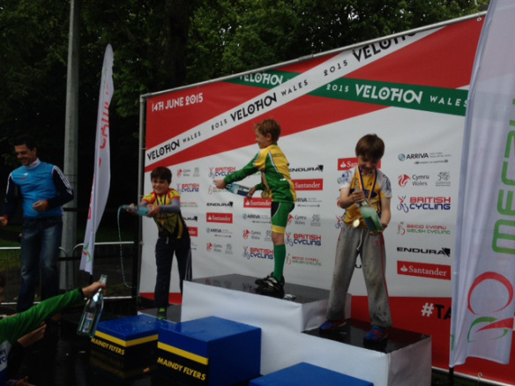](https://thanetrc.files.wordpress.com/2015/06/image1.jpeg)

**CLUB CLOTHING**

We have, in the previous yellow, red and blue club kit.1x medium short sleeved jersey and 1 pair of

small bibshorts. Each at a giveaway £5.

We also have some pairs of white cycling socks with the Nico Sports logo

in black.They are all large, they fit me at size 44 (or uk size10 in old money)

and are only £2 a pair.

Pete Huckstep. Contact [peter.huckstep@btinternet.com](mailto:peter.huckstep@btinternet.com)

**Forthcoming Open Events**

Thursday 2nd July PMR 10 Q10/1 (Hamstreet Bypass)

**Sunday 5th July VTTA Kent 10 Q10/30 (Thanet Way)**

Thursday 9th July PMR 10 Q10/1 (Hamstreet Bypass)

Saturday 11th July GHS SEDC Dist Champs also KCA 10 Q10/42 (Fowlmead)

Sunday 12th July Gravesend 25 Q25/8 (Chilham)

Thursday 16th July PMR 10 Q10/1 (Hamstreet Bypass)

Sunday 19th July VTTA 50 Q50/11 (Romney Marsh)

Thursday 23rd July PMR 10 Q10/1 (Hamstreet Bypass)

Saturday 25th July San Fairy Ann 10 Q10/22 (Harrietsham)

Saturday 1st August VTTA 10 Q10/1 (Hamstreet Bypass)

**Club 4-up Time Trial**

Don't forget the first Weds night back at Fowlmead is the Thanet RC 4 up TT in the past some of the teams have been a little unevenly matched so if you are able to attend on Weds 15th July post your name to Teresa on Facebook and we'll try and group some TT riders together that's adults (men & women) and juniors. This is an entry on the line event commencing at 6.30pm

**Schedule of Go-Ride and Regional Racing Events**

As this schedule is often subject to changes, I have decided to omit it from this newsletter, so that an up to date schedule can be found in one place to avoid confusion.

This can now be found on the Club website under Event Schedule. Many thanks to David Robert for maintaining it.

**Go-Ride Coaching Dates**

|  |  |  |  |
| --- | --- | --- | --- |
| Saturday | 4th July 2015 | Fowlmead | 14:30-16:00 |
| Saturday | 11th July 2015 | Bedgebury Trip | All day |
| Saturday | 18th July 2015 | Fowlmead | 14:30-16:00 |
| BREAK UNTIL SEPTEMBER |  |  |  |

**Thanet RC Summer BBQ Sunday 19th July.**

Times to follow but will be afternoon. All members and friends most welcome. Costs again to be decided but will be £5-7 head. At St Nicholas at Wade Bell Meadow. PM on Facebook or email Colin R if you can come and number in party.

**Heritage News**

Having been awarded £9,900 from the Heritage Lottery Fund work has begun on filming aspects of Thanet Road Club life and recording memories of some of our veteran riders. Please take the following opportunity to meet our club vets, including some who formed the club back in 1947 at the next social evening.

Tuesday 7 Jul 7.30pm at The Bell Meadow Sports Pavilion, St. Nicholas-at-Wade

Volunteers needed to help scan old documents and photos. Also do you have any old documents, photos, film footage? Contact David Robert- [davealexrob@yahoo.com](mailto:davealexrob@yahoo.com)

And here is a bit of  club history:

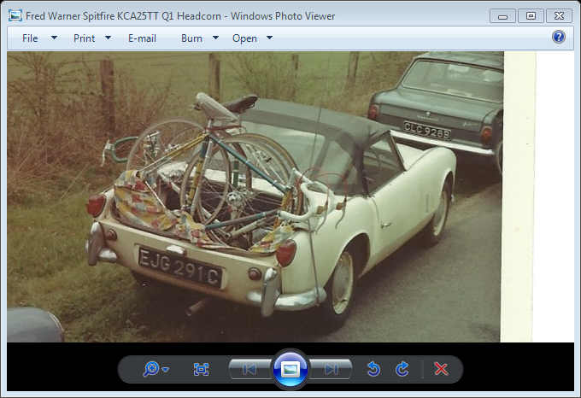

Who needs a bike rack when you can take the boot cover off your Spitfire? This is how Fred Warner who rode with TRC 1960-1972, went to a KCA 25m Time Trial in Headcorn.

**Articles for Cycling Magazine**

This month I begin a new job as editor of Cycling World Magazine, which specializes in touring and leisure  So if anyone has an interesting ride planned and fancies writing about it (small fee given) do get in touch. David Robert [davealexrob@yahoo.com](mailto:davealexrob@yahoo.com)

**Bottom of Form**

**Club Social Evening**

The next one will be on Tuesday 7th July at the Bell Meadow Pavilion 7.30-9.30 as usual. Please come along

**Road Racing Training and Coaching Sessions: Joint promotion with Adalta CC.**

Road Racing training and coaching evenings will be run every Friday night from April until mid-September at Fowlmead   
These are training events … THEY ARE NOT RACES … so please ride with respect for others.  
Please pay your fees BEFORE riding; the riders will typically split into two groups; one on the upper circuit (Beginners/Younger riders-Coaching given on group riding and fitness drills) and one on the lower (Intermediate and advanced groups)

6.30pm-7.30pm. Cost is £5 non-members. £4 members of Thanet and Adalta (these are organised jointly) and £2 for under 18s

**Discounts currently available to Club Members**

Locks of Sandwich : 10% on selected items

St Peter’s Cycles, Broadstairs: 10% on selected items

Bike Warehouse, Herne Bay, Faversham, Gillingham, Sevenoaks: 10% on selected items

Black Cat Coaching- special rates offered

Please also note anyone who arrives at Stonelees Golf Centre on a bike/walking/public transport gets free golf club hire

Ian Edginton, a former member of the club, has started his own cycle maintenance and repair business from his home at Staple near Wingham and welcomes your custom. All types of repair including wheel building are available. Contact Ian at [ian.edginton123@btinternet.com](mailto:ian.edginton123@btinternet.com) or 07786425829. Ian`s father Alf, is also a very long standing and respected member of the Club.

**FOR SALE**

**Carbon Wheelset**  The wheels are Synchro carbon clincher wheelset 46 mm (Shimano hubs), purchase price £999 at St Peter`s Cycles on the 24th April, selling at £700 (ono). Covers included. I used them for only 5 hours but find they do not suit my style of riding. Contact Raymond Leruez [leruez@hotmail.com](mailto:leruez@hotmail.com)

For Sale: Turbo trainer, fan resistance model. £20.00.  Contact Reg  Baynham (ex Thanet RC member) 01843 821618

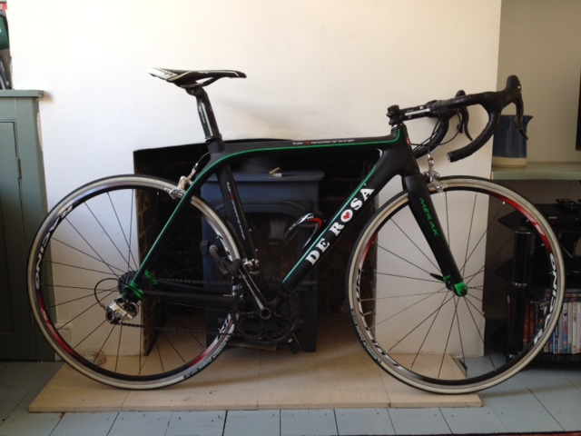

**De Rosa Merak Evolution** (black, green trim) 55cm, Campagnolo Athena 11 speed, Fulcrum R5 wheels, Prologo saddle. Good condition, great frame with upgrade potential.  £1000 ono. Contact Bill Hawkes : 07939 039066. or [billthebikie@yahoo.co.uk](mailto:billthebikie@yahoo.co.uk) (Canterbury**).**

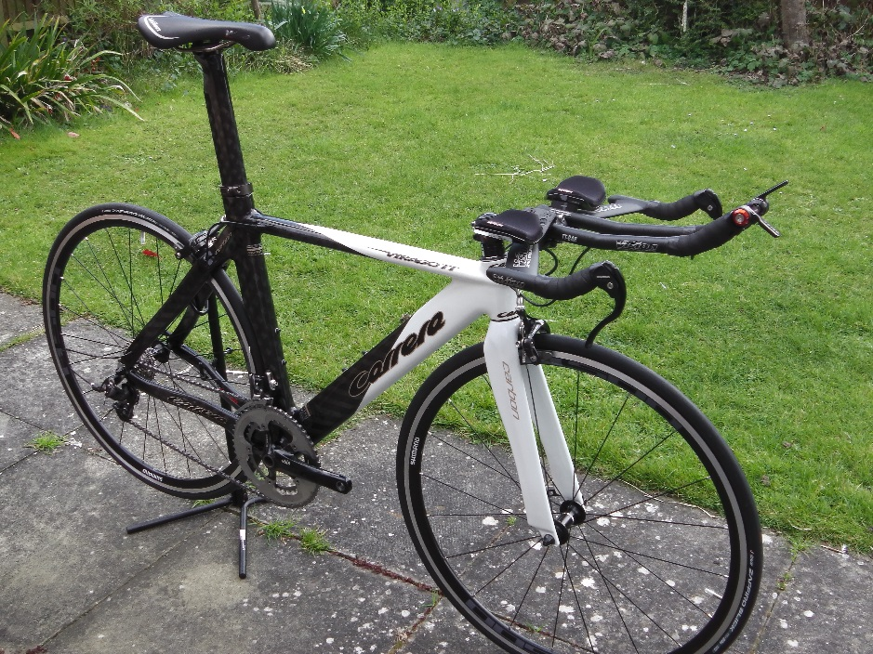

**Carrera Virago Carbon TT Bike (size medium) - £550 ono**

* full carbon fibre monocoque aero frame with internal cable routing
* carbon aero forks
* SRAM Rival 20 speed gearing
* SRAM TT 500 shifters
* Vision titanium railed TT saddle
* Vision adjustable alloy aero bars (comes with riser kit)
* 53/39 Truvativ Elita GXP cranks (172.5)
* Brand new Shimano RS501 wheels + new tyres
* seat tube = 52cm (Centre to top) and 52.4cm top-tube

I can be contacted on 07800 814982 or by email: martin@martinandsam.plus.com

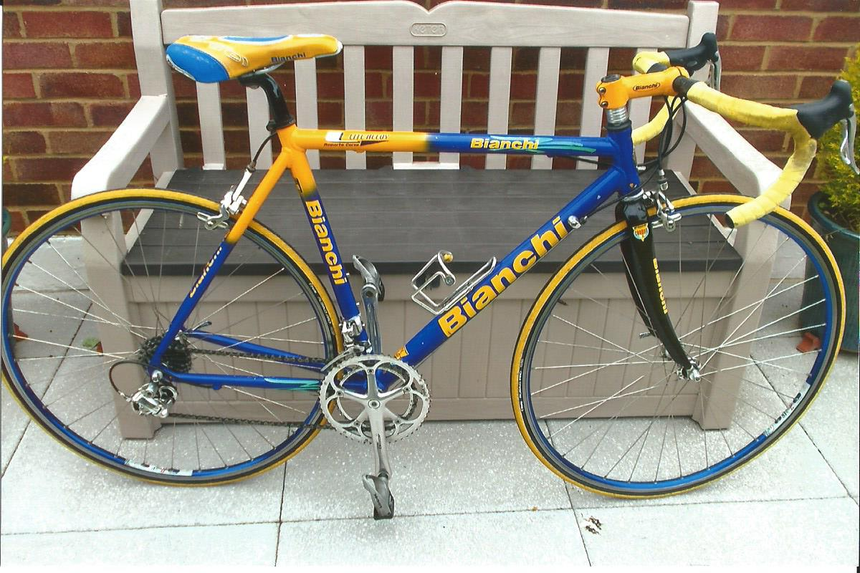

Bianchi Lite alloy 54cm (21in) frame, carbon forks, Campag 10 speed Chorus throughout, a few scratches, surplus to requirements.

£450 o.n.o. Contact Mick Cooper 01227 503624 or [the.coop@sky.com](mailto:the.coop@sky.com) Can be seen at Beltinge.

Harry McCully has a large collection of vintage bikes and equipment which he would like to dispose of to anyone who is interested. Far too much to list here, but contact Harry at 01304 380605, 07749537601 or [mccullyjan@aol.com](mailto:mccullyjan@aol.com)

**Monthly Quiz**

Well done to Michael Friend who came up first with the correct answer which was Chris Hoy.

However, Lance Childs has pointed out to me that Francois Pervis has also ridden under 1 minute in the 2013 World Cup at Aguascalientes, Mexico and holds the record with 56.303 seconds.

As I took the question from a book published in 2011, well done to Lance for spotting this and keeping me up to date.

This Month`s Question

Only one British cyclist has ever won three of the “Monument” races. Who was it and what were they?