

NEWSWHEEL

Newsletter for Thanet`s Premier Cycling Club
Affiliated to: British Cycling; CTT;KCA;CTC
Thanetrc.org.uk
May 2015

New Members
This month we welcome the following new and renewed members:- David Anderson, Stephen Monnery, Bin McCourt Welsh, Jeremy Edwards, Fergus Rogers, Nicholas Scott, Jerry Sykes, Steven Dowling, Callum and Sean O`Regan, Tony Morris and Sarah Robertson. We hope that their association with us will be a long and happy one.

News
Well done to our Chairman George Jenkins who has qualified in his Age Group to represent Team GB in the European Duathlon Championships in Spain in late April.
Run 5, TT 20 and run 2.5 over a closed but hilly road course near Madrid.
We wish him all the best for a successful event.

Dan Martin successfully completes his BC Level 1 course
Well done to Dan Martin for successfully completing his British Cycling Level 1 coaching course at the weekend. Dan has helped with the running and organisation of the Thanet RC GoRide sessions and races over the last few years and it is wonderful he has gone on the achieve this award. Dan is now able to coach small groups of riders at our Fowlmead sessions and act as a role model to hopefully move them on into becoming successful bike riders. Well done Dan from all at Thanet RC.
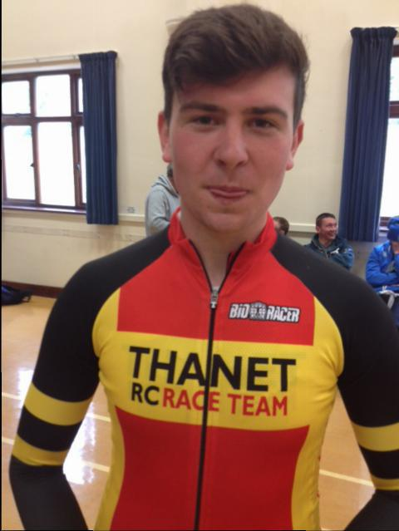

Can your help attract Club Sponsors?
Club sponsorship is going well but there are still races and aspects of the club that require sponsors. Do you work for a company or know someone in a company that could be a potential sponsor? If so contact David Robert (TRC Funding and Sponsorship Officer) for details on the club's new sponsorship packages.davealexrob@yahoo.com

Sunday Club Runs
The rota of Ride Leaders can be found on our website http://www.thanetrc.org/social-riding.shtml
Please be prompt for the meet up so you can depart with the correct group.

Club clothing
We now have a stock of short and long sleeved jerseys, gilets and
bibshorts.
Pete and Barbara
Email contact peter.huckstep@btinternet.com

Racing Results Club Events (TRC Riders)
Evening 10 1st April Q10/42 Fowlmead Juniors Ollie Robinson 24.06, Toby Hammond 26.09, Olly Dickson 27.00, David Redmond 28.36, Lance Childs 32.33, Meadbh Cook 33.32, Freya Cook 42.16. Good ride by Ollie on a blustery evening, well done to Freya on her first “10”.
Seniors Simon Henderson 23.10, Chris Bax 25.23, Jim Dickson 25.25, Colin Robinson 25.27, Trevor Hammond 25.52, Rob Milnes 25.56, Dave Danton 26.06, Michael Friend 26.21, Matthew Hall 26.46, Chris Childs 27.03, Robert Sissons 27.39, Peter Huckstep 28.07, Nicola Goodban 28.13, Colin Inett 29.50, David Robert 30.44, Sarah Beevers 32.11. Well done everyone on a tough evening.
TRC 2-up 10 3rd April Q10/42 Fowlmead Lawrence/Dan Martin 22.46, Colin/Ollie Robinson 23.10, Seb Dickson/Sam Bradford (PMR) 23.45, Chris Bax/Shay Giles (VC Elan) 24.14, Olly/Jim Dickson 24.19, Martin Russell/Paul Kelk 25.14, Andy McCall/Dave Mastin 25.21, Sam Johnson/David Redmond 25.55, Lance/Chris Childs 26.45, Colin Inett/Peter Huckstep 26.51, George Pittock/Flynn Robinson 29.52, Nicola/Max Robinson 36.14, Toby/Barnaby Wollon 47.23, Jenny Fearn (solo) 32.23. Fastest were Dave Williams (Bottechia UK)/Mark Whittaker (GS Invicta) 21.57. It was great to see the large number of parents riding with their children, well done all.
Evening 10 8th April Q10/42 Fowlmead Juniors Ollie Robinson 23.41, Dan Martin 24.15, Olly Dickson 25.35, David Redmond 26.27, Lance Childs 28.34, Flynn Robinson 29.28, Meadhbh Cook 30.27, Tia Neame 34.18, Freya Cook 37.42, Max Robinson 37.52, Lughaidh Cook 40.49. Ollie was the fastest, well done.
Seniors Seb Dickson 20.58, Chris Fennell (Catford CC) 21.10, Simon Henderson 22.25, Rick Perkins 23.19, Lawrence Martin 23.21, Rob Milnes 23.40, Shawn Manning 23.52, Michael Friend 24.10, Chris Bax 24.20, Jim Dickson 24.28, Colin Robinson 24.38, Martin Russell 25.14, Gary Russell 25.33, Robert Sissons 25.37, Matthew Hall 25.38, Paul Kelk 25.50, Chris Childs 25.52, Jason Wares 26.03, Peter Huckstep 26.54, Jo Malpass 27.45, Nic Fennell 27.47, Paul Griffiths 27.56, Colin Inett 28.17, Steve Langman 28.26, Simon Neame 29.24, Sarah Beevers 30.28, Pip McVey 31.48, Jenny Fearn 33.00, David Robert DNF. Another super ride by Seb, the course record must be under threat if he continues like this!
Evening 10 15th April Q10/42 Fowlmead Juniors Ollie Robinson 22.00, Dan Martin 22.12, Toby Hammond 23.07, Olly Dickson 23.30, George Edmondson 24.18, David Redmond 25.33, Sam Johnson 25.56, Lance Childs 27.50, Tristan Duffy 28.31, Megan Griffiths 28.34, Maddie Bazin 29.00, George Pittock 29.38, Calum O`Regan 31.23, Max Robinson 45.14, Tia Neame DNF.
Seniors Simon Henderson 22.13, Lawrence Martin 22.17, Rick Perkins 22.44, Trevor Hammond 22.47, Rob Milnes 22.50, Colin Robinson 23.01, Chris Bax 23.12, Jim Dickson 23.33, Michael Friend 23.45, Matthew Hall 24.08, Robert Sissons24.14, Gary Russell 24.14, Nic Fennell 24.16, Jason Wares 24.27, Gary Harrison 24.37, Martin Russell 24.40, Paul Kelk 24.48, Dave Danton 24.53, Chris Childs 25.36, Peter Huckstep 25.40, Nick Scott 26.22, Steve Wright 26.37, Colin Inett 26.47, Steve Langman 26.55, Rob Edmondson 27.36, Simon Neame 27.41, Paul Griffiths 27.55, Heidi Hammond 28.22, Malcolm Adams 29.09, Sarah Beevers 29.09, Bill Edmonson 29.32, Pip McVey 31.02, Roger Dewen 31.17, Jenny Fearn 31.41, Jeremy Edwards 33.32. Fastest was David Hewett (Cambridge University CC) 20.31. A fine warm evening produced a record entry of 88 riders and many PB`s were recorded. Many thanks to Dave Mastin, Andy McCall, Terry Fearn and all the other helpers for the excellent way they coped with this huge influx.
Evening 10 22nd April Q10/42 Fowlmead Juniors Ollie Robinson 22.42, Dan Martin 23.12, Olly Dickson 24.46, Toby Hammond 24.51, David Redmond 26.36, Lance Childs 29.37, Callum O`Regan 29.45, Flynn Robinson 30.02, Tristan Duffy 30.22, George Pittock 31.38. Ollie was the fastest.
Seniors Simon Henderson 22.19, Lawrence Martin 23.10, Huck Garip 23.12, Trevor Hammond 24.29, Chris Bax 24.29, Jim Dickson 24.32, Colin Robinson 24.37, Martin Russell 25.04, Paul Kelk 25.04, Matthew Hall 25.13, Gary Harrison 25.38, Nic Fennell 25.45, Robert Sissons 26.02, Jo Smith 26.19, Chris Childs 26.20, Peter Huckstep 26.46, Nicola Goodban 26.50, Nick Scott 28.02, Paul Griffiths 28.18, David Robert 29.17, Sarah Beevers 29.28, Simon Neame 29.32, Heidi Hammond 29.57, Malcolm Adams 31.38, Jenny Fearn 34.02. Simon was the fastest.
Evening 25 29th April Q10/42 Fowlmead Juniors Ollie Robinson 59.58, Toby Hammond 1.05.56, George Edmondson 1.12.23, Lance Childs 1.18.45, Flynn Robinson 1.19.17, George Pittock 1.25.01, Meadhbh Cook 1.27.34, Olly Dickson DNF. Great ride by Ollie.
Seniors Richard McVey 58.57, Rick Perkins 1.00.04, Jim Dickson 1.04.08, Colin Robinson 1.04.32, Gary Harrison 1.04.56, Dave Danton 1.05.44, Martin Russell 1.06.27, Michael Friend 1.06.55, Robert Sissons 1.08.11, Chris Childs 1.08.39, Steve Langman 1.10.29, Peter Huckstep 1.10.39, Jo Malpass 1.12.10, Heidi Hammond 1.18.40, Sarah Beevers 1.19.04, Jenny Fearn 1.25.57, Matt Hall, Chris Bax, Trevor Hammond, Dave Anderson all DNF. Fastest was Mark Whittaker (GS Invicta) 57.52.

Great start to the women’s series Thanet RC are promoting in 2015 with sponsorship from Ken Jones/Locks Cycles. Fowlmead 24th April.
20 riders took part in a fun and competitive race of 40 mins with lots of Thanet RC members involved.
Huge thanks to Phil Cook for organising and all the helpers on the night. Thanet RC took the 1st and 2nd positions with Maddie Bazin and Nicola Goodban with Nicola also taking the prime sprint. Next round is Friday 29th May same place/time.
Maddie Bazin 1st, Nicola Goodman 2nd, Sarah Beevers 7th, Megan Griffiths 9th, Tia Neame 11th, Meadhbh Cook 12th, Diana Yemm 14th, Caroline Dack 16th.
Well done all the ladies.

Racing Results Open Events (TRC Riders)
VTTA 10 Saturday March 7th Q10/22 (Harrietsham)
Colin Inett 29.47, Simon Henderson 22.36, Ollie Robinson 23.31 (1st Juv), Brian Hood 26.35, Colin Robinson 25.18, Andy McCall 27.07, Bill Hawkes 22.56, Andy Burrows 28.06, Chris Bax 25.11, Ollie Dickson 26.18. Fastest was Michael Barnes (Velo Refined Aerosmiths) 21.50. A good turnout on a chilly morning from the Club on the first open event of the year. Well done to Simon getting 2nd prize OAS, and the Team Prize OAS with Brian Hood.
KCA 3-up 25 Sunday March 8th Q25/12 (Hamstreet)
Seb Dickson/Simon Henderson/Martin Glynn 54.39, Martin Russell/Paul Kelk/Gary Russell 1.06.02, Rick Perkins/Rob Milnes 59.18. Mark Palmer DNF (puncture). Winners were Michael Broadwith/Tim Bayley/Danny Axford 51.39. Super ride by Seb, Simon and Martin for 2nd place. A good recovery by Martin, Paul and Gary after Paul hit a pothole and was catapulted into a ditch.
PMR 25 Sunday March 15th Q25/20 (Harrietsham)
Andy Burrows DNS, Andy McCall 1.12.55, Colin Inett 1.18.28, Simon Henderson 59.27, Jim Dickson 1.09.03, Oliver Dickson 1.11.39, Chris Bax 1.06.12. Teams Paul Kelk/Martin Russell 1.08.25, Colin/Ollie Robinson 1.02.11, Dan Martin/Rob Milnes 1.02.45. Fastest Solo was Mike Piper (Abellio SFA RT) 56.46. Fastest Team was Malcolm Davies/Nick Malins (4T+ Velo Club) 56.17.
VC Elan Hilly Sunday 22nd March QS/7 (Challock-Chilham) Andy Burrows 1.10.16, Simon Henderson 55.38, Jim Dickson 1.01.49, Olly Dickson DNS (ill), Seb Dickson 50.15. An absolutely sensational ride by Seb to win the event by almost 4 minutes. Also well done to him, Dad and Simon who took the Team prize.
KCA 25 Sunday 5th April Q25/8 Chilham Andy McCall 1.10.28, Colin Inett 1.16.34, Chris Bax 1.03.52, Mark Palmer DNS, Andy Burrows 1.10.42, Olly Dickson 1.11.27, Simon Henderson 58.32, Rick Perkins 1.01.06, Robert Sissons 1.09.38, Paul Kelk 1.09.52, Jim Dickson 1.05.03. Fastest was Seth Kay (PMR@Toachim House) 56.42. Well done to Simon (3rd overall, 2nd OAS), Olly (2nd Junior) and Simon, Rick and Jim (Fastest Team).--
Saturday 11th April West Kent RC 10 Q10/22 (Harrietsham) Bill Hawkes 22.21, Darren Mitchell 24.05, Jim Dickson 24.56, Olly Dickson 25.24, Andy McCall 26.28, Andy Burrows 27.30. Fastest was Jon Parker (PMR) 20.44. Well done Olly-Fastest Junior.
Sunday 12th April Sydenham Wh 25 Q25/20 (Harrietsham) Martin Russell 1.08.28, Olly Dickson 1.07.32, Colin Inett 1.16.28, Jim Dickson 1.06.09, Robert Sissons 1.10.25, Chris Bax 1.03.52, Andy Burrows 1.11.36, Simon Henderson 58.07, Andy McCall 1.11.31, Rick Perkins 1.01.55. Fastest was Peter Tadros (In Gear Quickfit Trainsharp) 54.47.
More super rides from Seb
Seb Dickson rode 20:01 on the H10/17R course outside Oxford to break the club record which has stood for 29 years. This gave him the silver medal in a field of 240 riders in the British Universities Championship and helped Cambridge University to team gold. Well done Seb!
He also did another phenomenal ride in the BUCS 25 Mile Championships clocking 52.46 for 4th place and securing Team Gold for Cambridge. Another club record gone!
Sunday 19th April De Laune 25 Q25/20 (Harrietsham) Simon Henderson 58.36, Lawrence Martin 1.
01.41, Ollie Robinson 1.02.52, Colin Robinson 1.04.30, Chris Bax 1.04.30, Dan Martin 1.05.05, Jim Dickson 1.05.08, Martin Russell 1.08.41, Olly Dickson 1.09.06, Dave Mastin 1.09.51, Robert Sissons 1.10.00, Paul Kelk 1.10.32, Andy McCall 1.11.52, Andy Burrows 1.12.12. Fastest was Jon Parker (PMR) 53.53. Well done Ollie Robinson (1st Junior).
Saturday 25th April Catford CC 10 Q10/19 (Tonbridge Bypass). Jon Parker 19.39, Simon Henderson 21.22, Chris Bax 23.03, Olly Dickson DNS. Jon was the fastest.
Sunday 26th April KCA 10 Q10/22 (Harrietsham) Lawrence Martin 23.52, Andy McCall 26.39, Andy Burrows 27.30, Olly Dickson 26.33, Gary Russell 26.01, Jim Dickson 25.02, Chris Bax 24.20, Darren Mitchell 23.55, Paul Kelk 26.23, Simon Henderson 22.01, Dave Mastin 25.46, Bill Hawkes 21.57. Great ride by Bill who won on the day.
Sunday 3rd May Wigmore 25 Q25/8 (Molash-Chilham-Ashford) Dave Danton 1.06.59, Huck Garip 58.55, Chris Childs DNS, Simon Henderson 56.55, Colin Inett 1.13.16, Paul Griffiths 1.13.47, Ollie Robinson 57.54, Jim Dickson 1.07.07, Colin Robinson 1.02.34, Andy Macpherson 1.05.01, Andy McCall 1.09.52, Richard McVey DNF, Olly Dickson 1.06.13, Rob Milnes 1.01.13, Rick Perkins 59.24, Bill Hawkes DNS, Dave Mastin 1.05.18, Chris Bax 1.01.54. Fastest was Seth Kay (PMR@Toachim House) 51.50. Well done to Ollie Robinson 1st Junior.
Forthcoming Open Events
Saturday 9th May CC Bexley 10 Q10/24 (Isle of Grain)
Sunday 10th May VTTA 30 Q30/2 (Ham Street Bypass)
Saturday 16th May Southborough 10 Q10/33 (Tenterden)
Sunday 17th May San Fairy Ann 50 Q50/1 (Leeds-Ashford)
Saturday 23rd May Medway Velo 10 Q10/24 (Isle of Grain)
Sunday 24th May Bigfoot CC 25 Q25/8 (Chilham)
Saturday 30th May De Laune 10 Q10/24 (Isle of Grain)
Saturday 6th June 7Oaks Tri 10 Q10/22 (Harrietsham)
Sunday 7th June KCA 50 Q50/11 (Brenzett-Lydd)

On Saturday 20th June Steve Robertson will be promoting a 10 on behalf of the Club at Fowlmead. He will be looking for helpers on the day. Please contact Steve if you are willing to help. Steve.robertson@douglaswestwood.com

Schedule of Go-Ride and Regional Racing Events
As this schedule is often subject to changes, I have decided to omit it from this newsletter, so that an up to date schedule can be found in one place to avoid confusion.
This can now be found on the Club website under Event Schedule. Many thanks to David Robert for maintaining it.

Go-Ride Coaching Dates
Day | Date | Location | Time
Saturday | 4th April 2015 | NO SESSION - EASTER | 14:30-16:00
Saturday | 11th April 2015 | Fowlmead | 14:30-16:00
Saturday | 18th April 2015 | Fowlmead | 14:30-16:00
Saturday | 25th April 2015 | Fowlmead | 14:30-16:00
Saturday | 2nd May 2015 | Fowlmead | 14:30-16:00
Saturday | 9th May 2015 | See Racing Events | see list
Saturday | 16th May 2015 | Fowlmead | 14:30-16:00
Saturday | 23rd May 2015 | See Racing Events | see list
Saturday | 30th May 2015 | Fowlmead | 14:30-16:00
Saturday | 6th June 2015 | Fowlmead | 14:30-16:00
Saturday | 13th June 2015 | Fowlmead | 14:30-16:00
Saturday | 20th June 2015 | Fowlmead (Off Road only) | 14:30-16:00
Saturday | 27th June 2015 | See Racing Events | see list
Saturday | 4th July 2015 | Fowlmead | 14:30-16:00
Saturday | 11th July 2015 | Bedgebury Trip | All day
Saturday | 18th July 2015 | Fowlmead | 14:30-16:00
BREAK UNTIL SEPTEMBER

Dates for your Diary
Meadhbh Cook’s 12 hour challenge for Nepal earthquake appeal
Thanet RC’s young rider Meadhbh Cook will be undertaking a 12 hour time trial at Fowlmead on 22nd May (8am-8pm). If you would like to donate to this cause (Nepal appeal) and support Meadhbh please follow the link below. Also Meadhbh would love to have any supporting riders on the day to help her round
https://www.justgiving.com/Meadhbh-Cook-12hrchallenge/
Get your Colleagues Cycling to Work
I work for Sustainable Transport charity Sustrans who are launching Kent Smarter Travel Challenge this month with workplaces in Kent competing to clock up the most sustainable and active journeys during June.
The Challenge runs from 1-30 June and aims to get workplaces changing their travel behaviour. Challengers log journeys as part of a workplace team- logging bus, train, walking, cycling, electric vehicle and car share journeys. Even working at home or attending a virtual meeting count.
Challengers will have access to feedback on how many calories they’ve burned and the amount of money they’ve saved on each journey by choosing healthy, green and cheap alternatives to driving alone, or even by not traveling at all.
Individual challengers will be judged on the number of journeys they complete while workplaces are judged on the overall rate of participation in the team with the winners sharing in great prizes which include vouchers from Amazon, Waitrose, Cotswold Outdoor or Halfords and days out in Kent.
To register for the Kent Smarter Travel Challenge and get your workplace involved please visit the Challenge website at https://kenttravel.getmeactive.org.uk/
David Robert (TRC Sponsorship and Funding Officer, Balance Bike Coach
Balance Bike Race at Grasstrack Event
There will be a Balance Bike Race at the Grasstrack event Sat 23 May, Bell Meadow, St Nicholas-at-Wade. Bike set up at 1.10, for 1.30 start. Balance bikes provided or bring own. Helmet required. Only £1.
Posted David Robert- Balance Bike Coach

Belgium Trip
Anyone still wishing to join us will have to arrange their own travel but there is spare capacity at the hostel. This will be from Weds 27th to Friday 29th May. Contact Steve Langman Home 01843 864948 Mob 07702 515779 if you are interested.

Club Social Evening
The next one will be on Tuesday 5th May at the Bell Meadow Pavilion 7.30-9.30 as usual. Please come along

Road Racing Training and Coaching Sessions: Joint promotion with Adalta CC.
Road Racing training and coaching evenings will be run every Friday night from April until mid-September at Fowlmead
These are training events … THEY ARE NOT RACES … so please ride with respect for others.
Please pay your fees BEFORE riding; the riders will typically split into two groups; one on the upper circuit (Beginners/Younger riders-Coaching given on group riding and fitness drills) and one on the lower (Intermediate and advanced groups)
6.30pm-7.30pm. Cost is £5 non-members. £4 members of Thanet and Adalta (these are organised jointly) and £2 for under 18s

Discounts currently available to Club Members
Locks of Sandwich : 10% on selected items
St Peter’s Cycles, Broadstairs: 10% on selected items
Bike Warehouse, Herne Bay, Faversham, Gillingham, Sevenoaks: 10% on selected items
Black Cat Coaching- special rates offered
Please also note anyone who arrives at Stonelees Golf Centre on a bike/walking/public transport gets free golf club hire

Help required for club history film
Archive Material Required:
Any photos, newspaper cuttings, club records which feature the club riders who gave their names to our memorial cups: Vince Evans, Mike Catlow, Jim Linton, Gordon Haller, Bert Spickett and Jim Braginton.
Will take good care of items. Will scan/copy and then return.
Contact David Robert davealexrob@yahoo.com; 07824 399126

For Sale
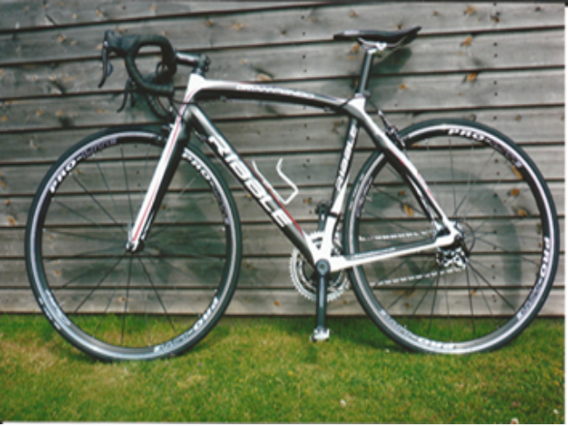
Ribble bike for sale, 53cm (M) carbon frame less than 1 year old, Campag groupset and wheels, immaculate condition. Will suit someone 5′ 9 to 5′ 10. Too big for me. Over £900.00 new, now reduced to £550.00 o.n.o.
John Barton 01843 834066.

De Rosa Merak Evolution (black, green trim) 55cm, Campagnolo Athena 11 speed, Fulcrum R5 wheels, Prologo saddle. Good condition, great frame with upgrade potential. £1000 ono. Contact Bill Hawkes : 07939 039066. or billthebikie@yahoo.co.uk (Canterbury).

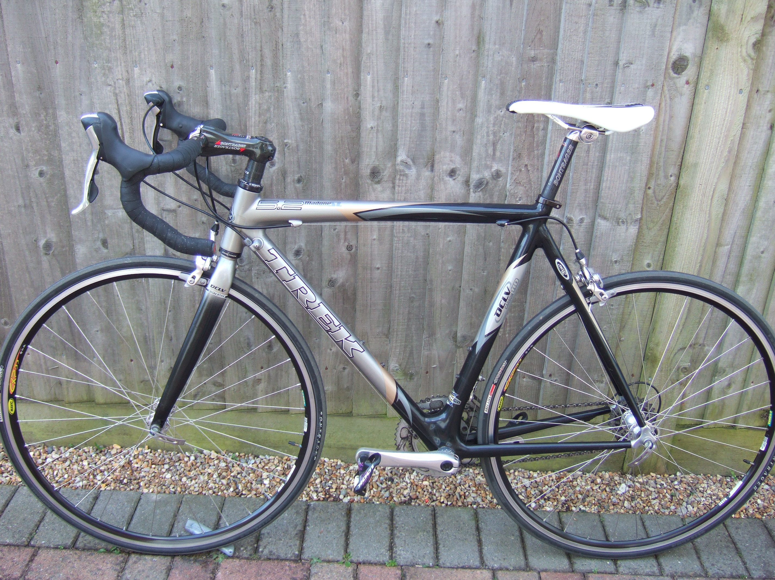

TREK MADONE 5.2 SL.
56 cm Carbon frame, forks,bars, stem and seat post. Ultegra Groupset but with Shimano Compact Chainring. New B/B, H/S and brake pads. Mavic CXP33 Harry Rowland built wheels. £550. Trevor: 01303 863365

Monthly Quiz
I must have made last month`s question too difficult as no-one came up with the answer. It was Raimondo Rumsas who had just finished 3rd in the 2002 Tour riding for Lampre-Farnese Vini.

This months is somewhat easier:- Which former Olympic Gold Medalist is currently pursuing a career as a jockey?

