NEWSWHEEL

Newsletter for Thanet`s Premier Cycling Club
Affiliated to: British Cycling; CTT;KCA;CTC
Thanetrc.org.uk
June 2014

News
Thanet RC Tour of Flanders 27th May

A total of 24 members travelled via Eurotunnel and onwards to the Outsider Youth Hostel in Oudenaarde. Once settled in and out on the road the first thing that became apparent was the consideration that Belgian motorists show towards cyclists, something sadly absent in the UK. Day one we rode the Red route, splitting up into 2 groups, a total of 65 miles which takes in roads used in the Tour of Flanders with lots of climbs, the most formidable of which was the Kapelmuur climb in Geraardsbergen. Fortunately the cobbles were dry at this point and we all managed to reach the summit in one piece. The weather, although not cold, was continuously overcast with frequent drizzle, and it was getting rather murky when we got back to the hostel. Day two we rode the Blue route which although shorter was a different proposition with numerous cobbled sections and climbs including the infamous Koppenberg which proved a huge challenge as the cobbles were wet and slippery. In the end only Joshua Outram and Ollie Robinson managed to ride all the way up, the rest of us either fell off or were compelled to stop, so well done to them. This really brought home to us the sheer skill and resilience demonstrated by the professionals in these conditions. With a total age span of 63 years throughout the group, the highspot was the way the youngsters performed they showed a lot of us the way home and were a credit to the Club. Everyone agreed it was probably the hardest 2 days they had ever had, but were eager to come back again and have another go next year. Many thanks to Steve and Colin for organising the trip and Rob Edmondson and Kevin Johnson for producing the superb breakfast.

Scott`s Charity Ride

Scott Oldman recently took part in a 256 mile ride from Sittingbourne to Paris, a charity ride to raise money for a local children's hospice in Sittingbourne. 100 cyclists set off from the Sittingbourne based hospice on 30th April for the four day journey. The 1st day they cycled to Dover catching a ferry to Calais and staying in Coquelles. The next day they cycled to Abbéville and the next day to Beauvais finally on the Saturday they arrived in Paris passing the Arc de Triomphe to the Eiffel Tower.
Here is Scott at the end of the ride. Well done indeed for a very worthy cause.

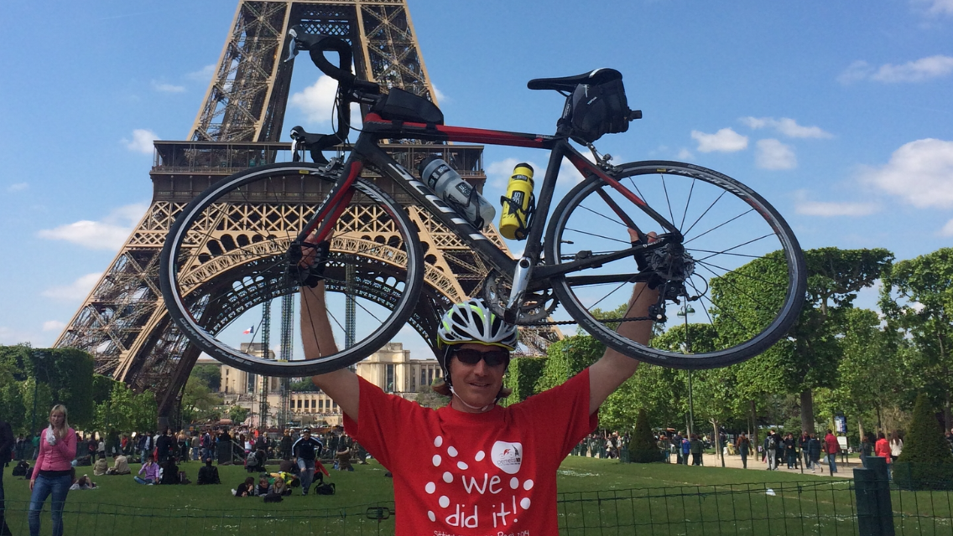

Fowlmead Fridays
These sessions are now in full swing and are proving very successful. Adalta CC have come in with us to help, many thanks to them.

Racing Results (Club members times only)

Open Events
Sunday 4th May Wigmore CC 25 Q25/8 Chilham
Seb Dickson 55.56 (PB), Simon Henderson 58.36, Mark Palmer 1.00.01, Rick Perkins 1.01.10, Chris Bax 1.02.08, Andy Macpherson 1.04.23, Colin Robinson 1.05.06, Jim Dickson 1.05.48(PB), Ollie Dickson 1.06.13, Ollie Robinson 1.07.45, Paul Griffiths 1.12.29(PB), Colin Inett 1.13.22, Robert Sissons DNF, Andy McCall DNS. Fastest was Kevin Tye (VeloRefined Aerosmiths) 52.56. Well done to the lads who did PB`s.

Sunday 4th May RTTC TT Series Round 4 L/52 Keswick 31.2 miles Jon Parker 1.08.21 (3rd), Chris Fennell 1.08.25 (4th). Fastest was Matt Bottrill (www.drag2zero.com) 1.04.08. Well done lads after a long journey.

Monday 5th May VTTA National Championship 10 F11/10 Tring Simon Henderson 20.56 (+5.54-50th). Joint winners were Derek Stewart (Deeside Thistle), and Rob Pears (Bath CC) both +7.57. Well done to Simon on a PB.

Saturday 10th May CC Bexley 10 Q10/24 Isle of Grain. Simon Henderson 22.54 (3rd overall, 1st 50-59 age group), Dave Mastin 27.35, Andy Macpherson 25.39, Gary Harrison 26.13 (1st 60-69 age group), Malcolm Adams 30.04. Well done all in near gale force conditions. Fastest was Mike Piper (Abellio SFA RT) 21.36.

Sunday 11th May VTTA 30 Q30/2 Harrietsham A20 Robert Sissons 1.23.48, Simon Henderson 1.10.17, Colin Inett 1.31.39, Chris Bax 1.17.28. Simon was the fastest and also 1st OAS with a plus of 12.06, a terrific ride in difficult conditions once again.

Saturday 17th May Southborough 10 Q10/33 Leigh Green-Woodchurch. Andy McCall 27.27, Pip McVey DNS, Mark Palmer 23.05, Dave Mastin 26.10, Malcolm Adams 28.23, Simon Henderson 23.15, Chris Bax 24.13, Gary Harrison 25.17. Fastest was Peter Tadros (InGear Quickfit Trainsharp) 21.01.
Sunday 18th May San Fairy Ann 50 Q50/1 Harrietsham Andy Macpherson 2.21.49, Ollie Dickson 2.35.19, Simon Henderson 2.02.19, Jim Dickson 2.24.04, Seb Dickson 2.05.08. Fastest was Kevin Tye (VeloRefined Aerosmiths) 1.51.49. Well done to Ollie-Fastest Junior.

Saturday 31st May De Laune 10 Q10/24 Isle of Grain Jon Parker 20.43, Rick Perkins 23.34, Chris Bax 24.14, Colin Robinson 24.22, Martin Russell 24.44, Gary Russell 24.53, Ollie Robinson 25.09, Paul Kelk 25.40, Andy Burrows 26.36, Dave Mastin 26.50, Andy McCall 27.44, Malcolm Adams 27.54, Andy Macpherson DNS, Colin Inett DNS, Mark Palmer DNS, Robert Sissons DNS. Jon Parker was the fastest.

Forthcoming Open Events
Saturday 7th June 7Oaks Tri 10 Q10/22 Harrietsham.
Sunday 8th June KCA 50 Q50/11 Ham St-Lydd.
Saturday 14th June San Fairy Ann 10 Q10/22 Harrietsham.
Sunday 15th June KCA 100 Q100 Kingsnorth/Camber/Brenzett.
Saturday 21st June Thanet RC 10 Q10/42 Fowlmead.
Sunday 22nd June VTTA 25 Q25/8 Chilham.
Sunday 29th June Thanet RC 25 Q25/10 Thanet Way.
Thursday 3rd July PMR 10 Q10/1 Hamstreet.
Saturday 5th July GHS/KCA 10 Q10/42 Fowlmead.
Sunday 6th July VTTA 10 Q10/30 Thanet Way.

Please note: The events on the 21st June, 29th June and 6th July are all being promoted by Club members. They will require helpers (marshals etc) on the day. If you are willing to help please contact Steve Robertson (01795 594734 or steve@dw-1.com) for 21st June, Dave Mastin (01843 596774 or david.mastin@btinternet.com) for 29th June, Colin Inett (01304 840700 or colininett@aol.com) for the 6th July.
Please help if you can. Many thanks.

Club Events

Evening 10 7th May Q10/31 Thanet Way Chris Fennell 21.47, Simon Henderson 22.12, Chris Bax 24.17, Gary Russell 24.54, Martin Russell 25.01, Michael Friend 25.04, Paul Kelk 25.09, Matthew Hall 25.33, Peter Huckstep 26.15, Gary Harrison 26.39, Colin Inett 27.00, Chris Childs DNF. Chris was the fastest (on a road bike!)
Evening 10 14th May Q10/31 Thanet Way Chris Fennell 20.51, Simon Henderson 21.45, Rob Milnes 23.55, Chris Bax 23.59, Gary Russell 24.17, Gary Harrison 24.32, Martin Russell 24.36, Paul Kelk 24.55, Robert Sissons 25.03, Matthew Hall 25.09, Chris Fairbrass 25.09, Michael Friend 25.21, Dave Danton 25.26, Scott Oldman 25.43, Brian Hood 26.00, Colin Inett 26.51, Andy McCall 26.57, Chris Childs 26.58. Chris Fennell was the fastest.
Evening 10 21st May Q10/31 Thanet Way Chris Childs 26.38, Chris Bax 23.46, Michael Friend 26.03, Matthew Hall 25.32. Fastest was Ben Bedding (Adalta CC) 23.10. A much reduced field on a very wet night.

Go-Ride Racing

Six Thanet RC youth riders made the trip for the first round of the spring in the park series at Cyclopark tonight. Max was in a photo finish for 1st in the under 8 s race in field of 18. In the under 12 race Flynn came 11th and George top 20 of 38 riders. Toby performed really strongly in the under 14 race finishing a good top 10. Finally the two Ollies took part in the under 16s with a great ride for Robinson in 3rd and Dickson 10th. Well done to all and a repeat again at the Giro tomorrow at Fowlmead.

Great racing May 10th at Fowlmead even through the weather was not too kind!
Max wins under 8s with Alex and Joshua in 2nd and 3rd, Ludhaidh Cook in 5th.
Freya 1st and Shannon 2nd in under 10 girls race
Lance 3rd, Flynn 4th, George 7th and Jack 8th in Under 12s boys. Hannah 2nd for the girls.
Toby 3rd and Luke 9th in the under 14 boys and 1st for Megan and 2nd for Meadhdh Cook for the girls.
Finally in the under 16s Ollie.R claim 2nd, Olly.D 9th, George 10th , David 12th and Reef 13th. With Tia 2nd for the girls.

Spring in the Park Round 3 23rd May
Only 4 Thanet riders tonight at cyclopark. Max rode strongly for 2nd in the under 8 race. Both Flynn and Lance performed well in the competitive under 12 s both coming top 10 in a field of 30. Ollie finished the night off well with a win in the under 16s in a fast uphill sprint finish.

Spring in the Park Round 4 30th May
Again Thanet riders performed well at the latest round at Cyclopark tonight. Max came 3rd just missing the early break in the under8s. In the under 12 George rode strongly and under 14 s Toby did a lot of work in the pack to bring an initial break back so found it hard in the final sprint. In the under 16 s Ollie came an excellent 2nd just losing out to George Jensen with Dan doing really well in his first cyclopark event for top 10.
Many thanks to Lisa, Tansy and Laurence for marshalling tonight on Thanet RCs volunteering night.

Thanet RC Go-Ride Dates 2014 (Revised)
Day | Date | Event | Location | Time | Head Coach/Organiser | Coaches NOT available
Saturday | 7th June | Duathlon vs Thanet AC, Deal Tri | Fowlmead | 1200-3.00
Saturday | 14th June | Go Ride Session.13 | Fowlmead | 14.30-16.00 | Colin Robinson
Saturday | 21st June | Go Ride Session 14 | Fowlmead | 14.30-16.00 | Teresa Childs
Monday | 23rd June | Thanet RC Summer Series.1 | Fowlmead | 18.00-20.00 | Colin Robinson
Saturday | 28th June | Go Ride Session.15 | Fowlmead | 14.30-16.00 | Helen Hill
Monday | 30th June | Thanet RC Summer Series.2 | Fowlmead | 18.00-20.00 | Colin Robinson
Saturday | 5th July | Tour de Fowlmead | Fowlmead | 1030-1230
Monday | 7th July | Thanet RC Summer Series.3 | Fowlmead | 18.00-20.00 | Colin Robinson
Saturday | 12th July | Go Ride Session.16 | Fowlmead | 14.30-16.00 | Richard Bazin
Monday | 14th July | Thanet RC Summer Series.4 | Fowlmead | 18.00-20.00 | Colin Robinson
Sunday | 20th July | THANET RC SUMMER PARTY +RIDE OUT | St Nicholas at Wade | 0900-1600
Monday | 21st July | Thanet RC Regional Summer Series.1 | Fowlmead | 18.00-20.00 | Colin Robinson
Monday | 28th July | Thanet RC Regional Summer Series.2 | Fowlmead | 18.00-20.00 | Colin Robinson
Monday | 4th Aug | Thanet RC Summer Series.5 | Fowlmead | 18.00-20.00 | Colin Robinson
Monday | 11th Aug | Thanet RC Summer Series.6 | Fowlmead | 18.00-20.00 | Colin Robinson
Saturday | 23rd Aug | Vuelta a Fowlmead | Fowlmead | 10.30-12.30
Saturday | 20th September | Grasstrack Event | Marlowe Academy | TBA | TRC
Saturday | 25th October | TRC Halloween Cyclox (Interclub round 1) | Fowlmead | TBA | TRC
Sunday | 14th December | TRC Christmas MTB (Interclub Round 2) | Fowlmead | TBA | TRC

I have an opportunity for young Go Ride volunteers if they need to make up some hours. Tony is going to Spain and will miss a couple of balance bike sessions. I require 1/2 vols for each date:
Thurs 19 June 4.30ish-6 Ursuline Sports Hall
Thurs 26 June 4.30ish -6 Ursuline Sports Hall

Anyone interested can contact me directly.
David Robert
Wheely Groovy: pedal-powered electricity
01227 281087
07824 399126
info@wheelygroovy.co.uk
www.wheelygroovy.co.uk
www.facebook.com/WheelyGroovy
T @WheelyGroovy

Dates for your Diary
Spring in the Park Youth Series
Fridays from 9th May at Cyclopark, see flyer on page 6.

Club Social Evening
This will be on Tuesday 3rd June at the Bell Meadow Pavilion 7.30-9.30 as usual. Please come along.

Forthcoming local Events
Whipstake Summer MTB Race Series 2014:-
1st June Frinsted
13th July 6 hour Endurance Frinsted
21st September Frinsted
See wssmtb.co.uk for info.

For Sale
Planet x Stealth carbon TT frame (no forks) size medium in red, one season old, complete with new carbon seat post and new Planet x tt seat - £200.00 Contact Paul Kelk on 07802 615886 or email: paulkelk@btinternet.com

Bill Hurlow Bike For Sale
22" lugless Hurlow bike in vgc for sale. Re-sprayed in red by Nelson. Shimano triple chainset and 6 speed gears, Mavic hubs and rims, Universal brakes, Cinelli bar and stem. All reasonable offers considered by Reg Baynham, former club member. Contact Reg on 01843 821618.

Fizik Ares Saddle with K:IUM Rails
Specially designed for Time Trials
Shorter nose enabling the rider to get the shoulders of the saddle further forward
Shell: Nylon Carbon Reinforced with optimised material distribution foam mould
Rail: K:ium
Integrated Clip System: Yes
Length: 240mm
Width: 140mm
Weight: 165g
£50.00
Contact
Simon Henderson
Thanet Road Club Time Trial Secretary
Mob:07813085640
Work: 01304 646847
Home: 01843 850505

Kask K31 Time Trial helmet size Medium (53 - 61cms) with 2 visors one smoke (Currently on the helmet) and one mirrored boxed complete with new set of fixing screws. Less than a year old, well looked after (Some of the standard sticker decals have been removed) Fantastic condition (visors have some slight marking around screw in area from use). From a smoke & Pet free home £100 ONO Collection from Deal or a Thanet RC TT.

LAS Pista CXT Helmet Track/Stubby Time Trial Helmet complete with adjustable smoke visor size Medium. Less than a year old, well looked after (Some of the standard sticker decals have been removed) Great condition (slight marking on the front of the helmet from visor movement during use this does not effect the helmet at all) From a smoke & Pet free home £40 ONO Collection from Deal or a Thanet RC TT.
Contact Teresa Childs 01304 366789 or teresa.childs@talk21.com

Ribble bike for sale, 53cm (M) carbon frame less than 1 year old, Campag groupset and wheels, immaculate condition. Will suit someone 5′ 9 to 5′ 10. Too big for me. Over £900.00 new, will accept £650.00 o.n.o.
John Barton 01843 834066.

Giant OCR4 aluminium compact road bike 21″ frame. Good condition, Mavic rims, new hubs, rebuilt last year.
£250.00 no offers.
Claud Butler aluminium road bike 21″ frame, excellent condition, one year old, upgraded with new Shimano gears and levers 7 speed. Kenda Campaign tyres. £300.00 no offers.
Both the above contact Brian Thomas 01304 611432.

Quote for the Month

Nothing hisses quite so sweetly as a rival`s puncture.
Tim Krabbe (author) in The Rider.

